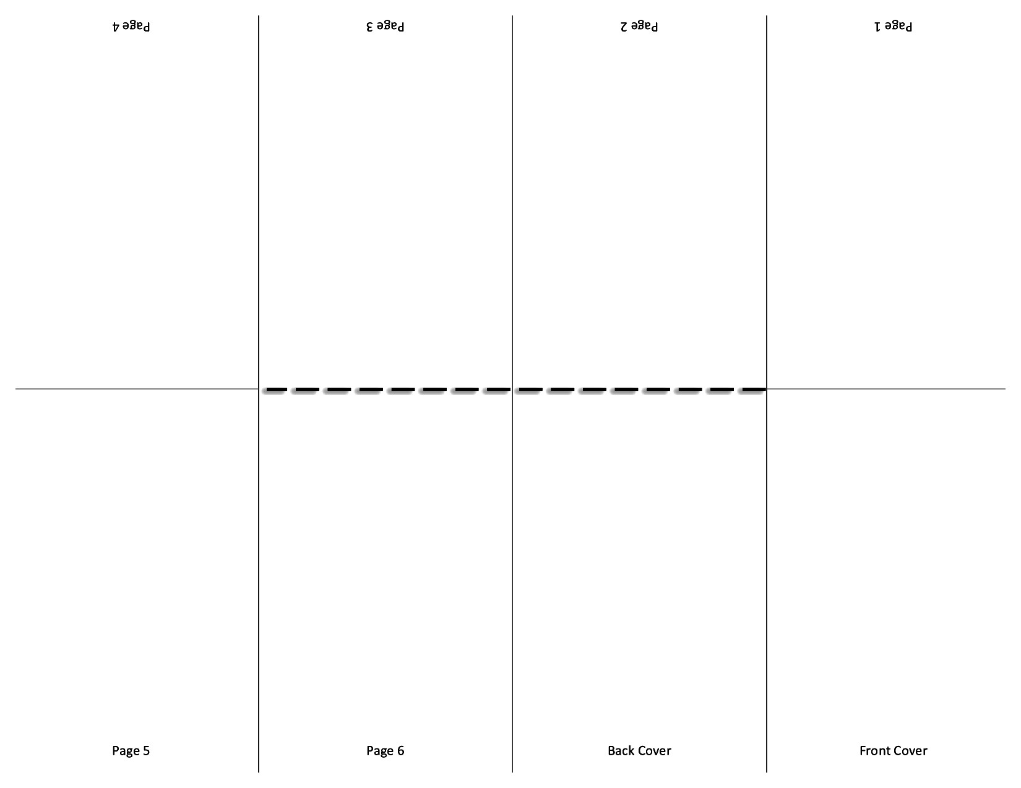

Estimation Study

**Q0: Open Ended**

**QE1: Estimate a population given a year**

**QE2: Estimate a year given a population**

**QI1: Estimate an increase in population between two years (additive)**

**QI2: Estimate how many times larger the population is between two years (multiplicative)**

**QI3: Estimate how many years it takes for the population to double (multiplicative)**

**Graph Comprehension**

1. Literal reading the data

2. Reading between the data

3. Reading beyond the data

**Two Scenarios**

Log2 vs Linear



**Data generation**

**Plot creation**

**Randomization (12 Q’s)**

**302 Participants**

*Would like to conduct more research on participants ability to read between the y-axis tick marks on the logarithmic scale.*

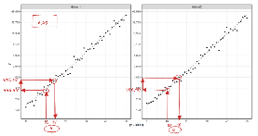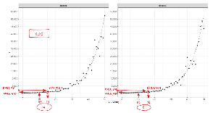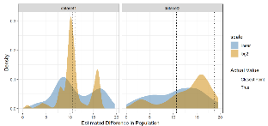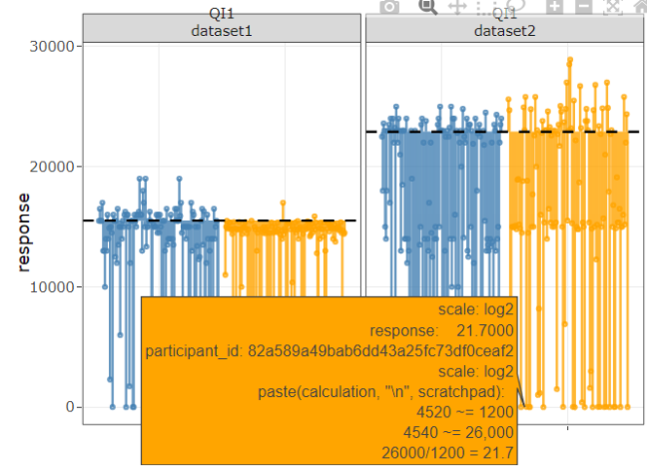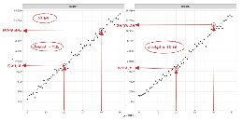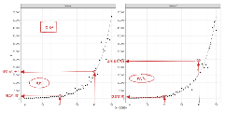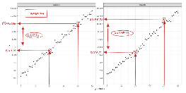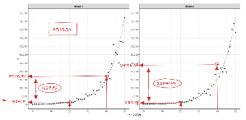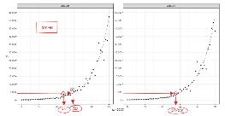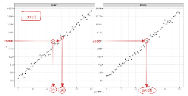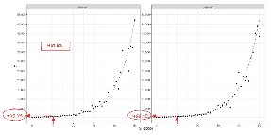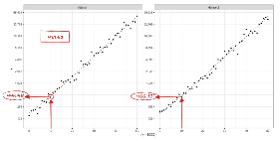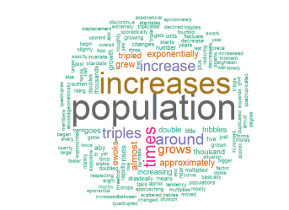

Log2 Scale

Linear Scale

**Rounding Errors & Anchoring Literature**

Strong Anchoring at 5 and 10

1. Understanding logarithmic logic is difficult.
   * Misunderstanding in QI1 and QI2.
2. Anchoring, anchoring, anchoring!
   * On the log2 scale, but the base 10 is still strong.
3. Participants were reading the data points rather than the trends, with a few exceptions. Differences in results across datasets.
4. Log vs Linear Scale
   * Linear scale had greater variability in general (not always)
   * Log scale was occasionally more accurate (doubling)
   * Dependent on the values being asked. Would want to test more values for each type of question.

*Would like to code the calculation and scratchpad logic…does order of question matter (QI1 vs QI2)?*

*Would like to conduct more research on participants ability to read between the y-axis tick marks on the logarithmic scale. Might need to have smaller magnitudes to do this.*

Linear variability > Log variability Log scale is more accurate… maybe

Anchoring: 16384/1024 = 16 25000/2500 = 10

15000 is still a common point.

Larger variability on linear scale and data set 2.

Lack of basic understanding of the logarithmic scale interpretation (maybe annotate a few select points)

**Main Points**

Anchoring & Estimation on points is strong:

* 16384 - 1024 = 15360, but that 15000 is still strong.
* Data set 2 has higher estimates

Less variability on the log scale for data set 1. Tendency to underestimate from closest point and overestimate from true value.

Look at participant logic through Calculation & Scratchpad. A little all over.

Exception where participants are overestimating – especially on log scale for dataset 1. Might be estimating to the visual trend. Anchoring to 4096?

Anchoring happens (500 vs 512)

Participants are reading the data points, not basing estimates on the visual trend.

Linear variability > Log variability