Reviewer Comment
The addition of the alpha statistic is a good step for incorporating the results of the Rorschach test more clearly into the manuscript. I would also like to see the results from the Rorschach displayed next to and included in the analysis of the target vs. null results. I think that would bolster your case. For example, in target medium vs. null high, the target gets a lower frequency of responses than the most common Rorschach choice for high on the linear scale, but a substantially higher frequency on the log scale. I can see that from flipping back and forth from Fig. 7 to 8, but it would be easier and more persuasive if they were on the same figure. I’ve eyeballed the results and put them in a few tables here, each of which helps me see the null comparison more easily, and each of which emphasizes different aspects.
Low target Medium target High target
Low background (lin v. top Rors): NA 75% v. 45% 93% v. 45%
Mod background (lin v. top Rors): 15% v. 30% NA 35% v. 30%
High background (lin v. top Rors): 55% v. 18% 5% v. 18% NA
Low background (log v. top Rors): NA 45% v. 30% 90% v. 30%
Mod background (log v. top Rors): 40% v. 20% NA 75% v. 20%
High background (log v. top Rors): 80% v. 18% 50% v. 18% NA
Top Rorschach Low target Medium target High target
Low background (lin v. log): 45% v. 30% NA 75% v. 45% 93% v. 90%
Mod background (lin v. log): 30% v. 20% 15% v. 40% NA 35% v. 75%
High background (lin v. log): 18% v. 18% 55% v. 80% 5% v. 50% NA
% correct – top Rorschach: Low target Medium target High target
Low background (lin v. log): NA 30% v. 15% 48% v. 60%
Mod background (lin v. log): –15% v. 20% NA 5% v. 55%
High background (lin v. log): 37% v. 62% –13% v. 32% NA
The Rorschach test gives you more information that you’re using. You’ve shown the alpha statistics and used those to conclude “the test is fine.” But as this table shows, the null results from the Rorschach differ for the different scenarios, and thus put the other results in greater context. For instance, for the high target against the moderate background, the raw results say that ~35% of respondents got the right target on a linear scale vs. 75% on the log scale. That’s a difference, for sure, but it’s much more stark when compared to the null test. 35% right was only 5% more than the null – which is not clearly a significant difference – whereas 75% was 55% more than the null. That’s a much bigger difference than the raw results suggest. I suggest incorporating the Rorschach results into your main analysis.
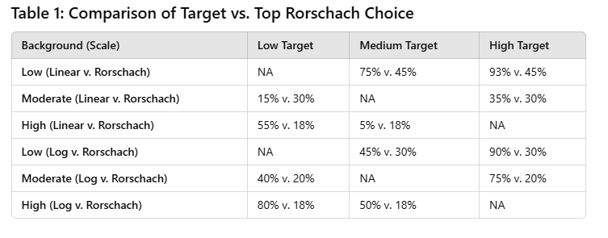
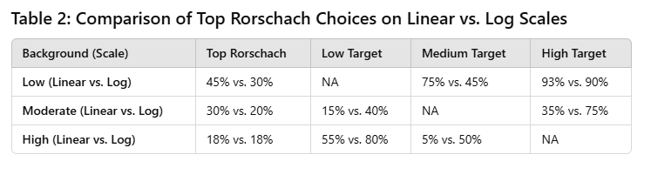
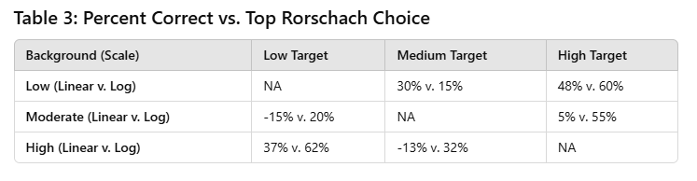

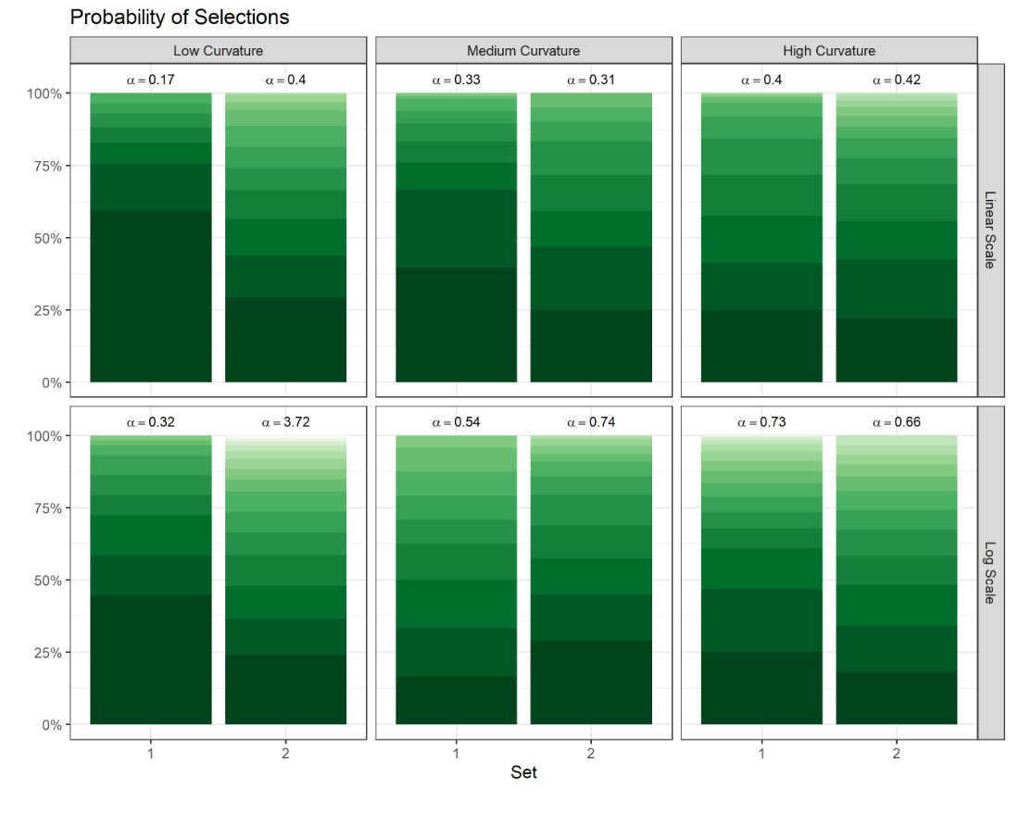

Figure 7. Observed probabilities of panel selections for the 'Rorschach' lineups. The darker shade (bottom) denotes panels chosen more frequently than others. The annotated text provides the calculated $α$ parameter of the Dirichlet distribution that represents individuals’ selections for the Rorschach plots.

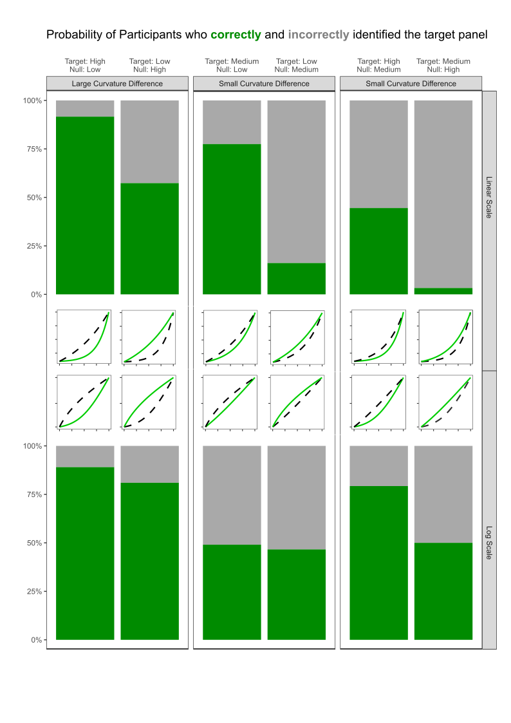
Figure 8. The observed accuracy for identifying the target panel for each curvature combination scenario with the accuracy for the linear scale shown on the top and the accuracy for the log scale shown on the bottom. The thumbnail figures below each plot display the curvature combination as shown in \\cref{fig:curvature-combination-example} on both scales.

Additional figures for exploring: the bars are now broken apart by set (we had two sets per parameter combo) and the dashed lines represent the Rorschach plot associated with the null curvature level.
Linear Scale
- Low curvature null background
  - Easier to pick out the target than the top Rorschach no matter if it is medium or high curvature
- Medium curvature null background
  - Harder to pick out the low curvature (line) than the top Rorschachs
  - Mixed reviews on picking out a high curvature… Was set 1 or 2 just weird generation?? See last page for this lineup investigation.
- High curvature null background
  - Pretty easy to pick out low curvature (a line) – easier than top Rorschachs
  - Harder to pick out the medium curvature than the top Rorschachs
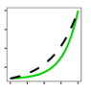
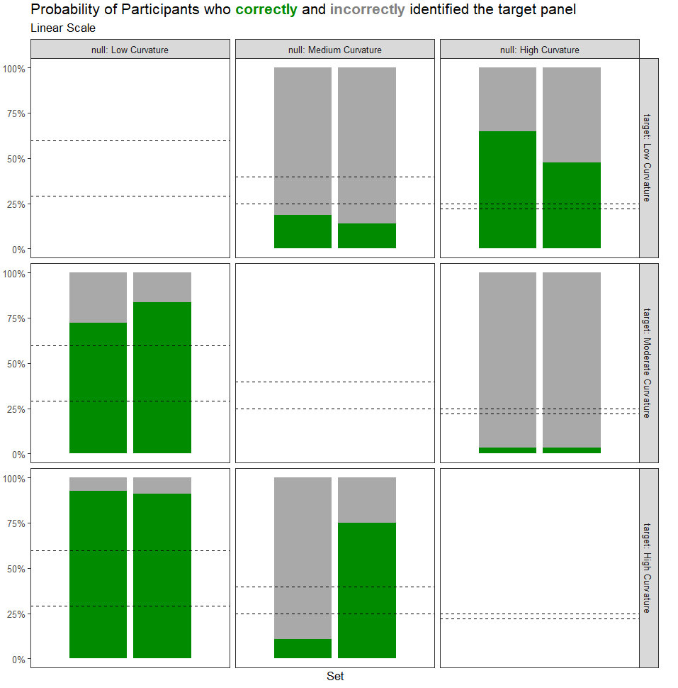
Log Scale
- In general, it is easier to pick out the target than the top Rorschach on the log scale (across the board). There is one exception with low curvature background and a moderate target. Could this also be a weird data generation?
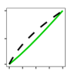
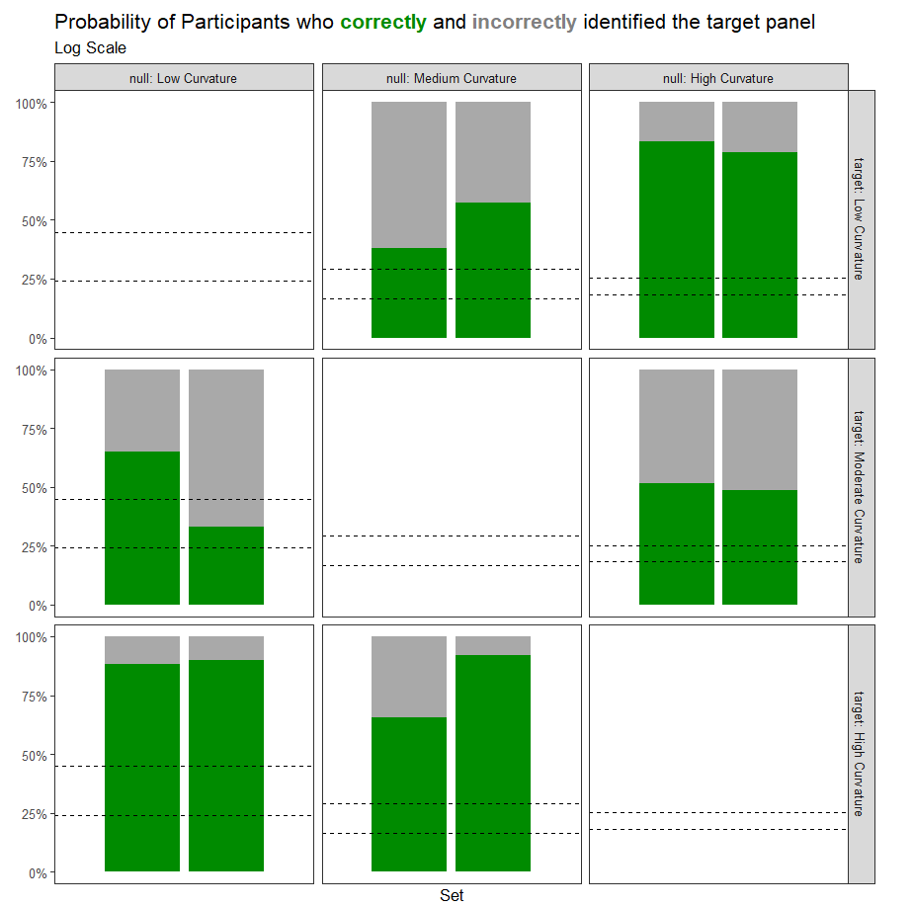

Weird lineups:
- Null: Medium Curvature, Target: High Curvature
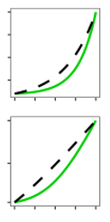
  - Linear
    - Set 1: 19458f4a249031b8179c02b343dffe30 (plot 12)
    - Set 2: 35c0c87a6158fa1687b8ff46e56443e6 (plot 14)
  - Log
    - Set 1: 5ecce62e937c1598e901631b3a1821d2 (plot 12)
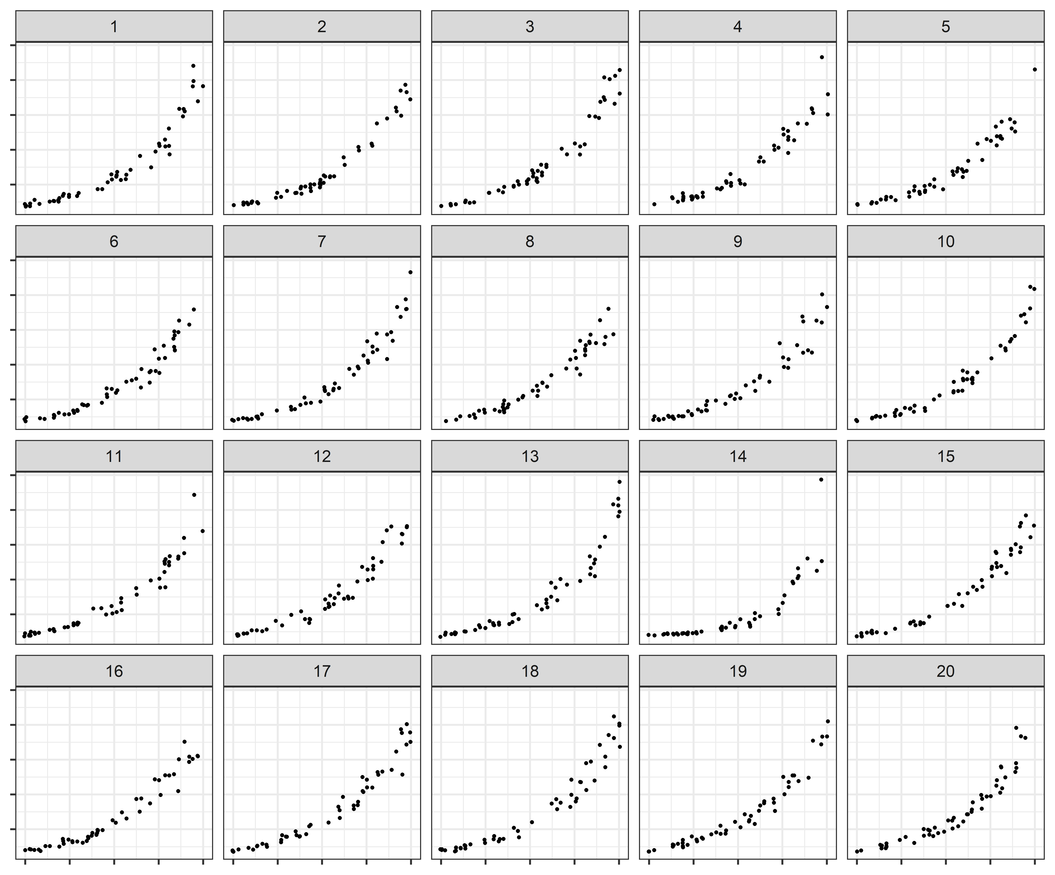
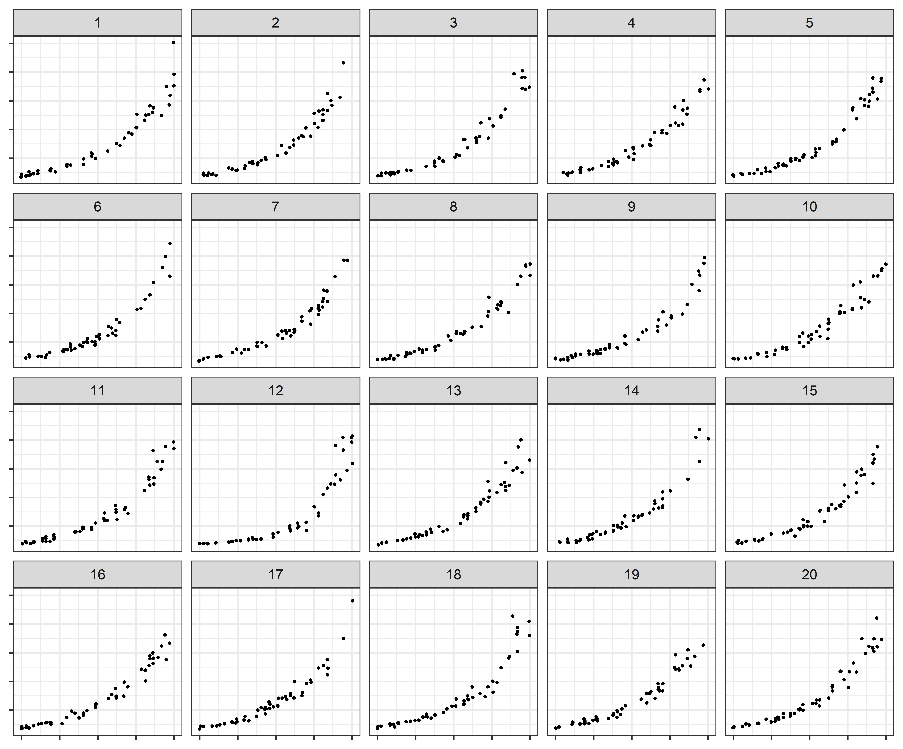
    - Set 2: ef16f06ed4708fcd12a6249492a1e12a (plot 14)

Looking at reasonings, in set 2 (where people picked the target with 90%ish accuracy, many indicated “outliers” for linear…
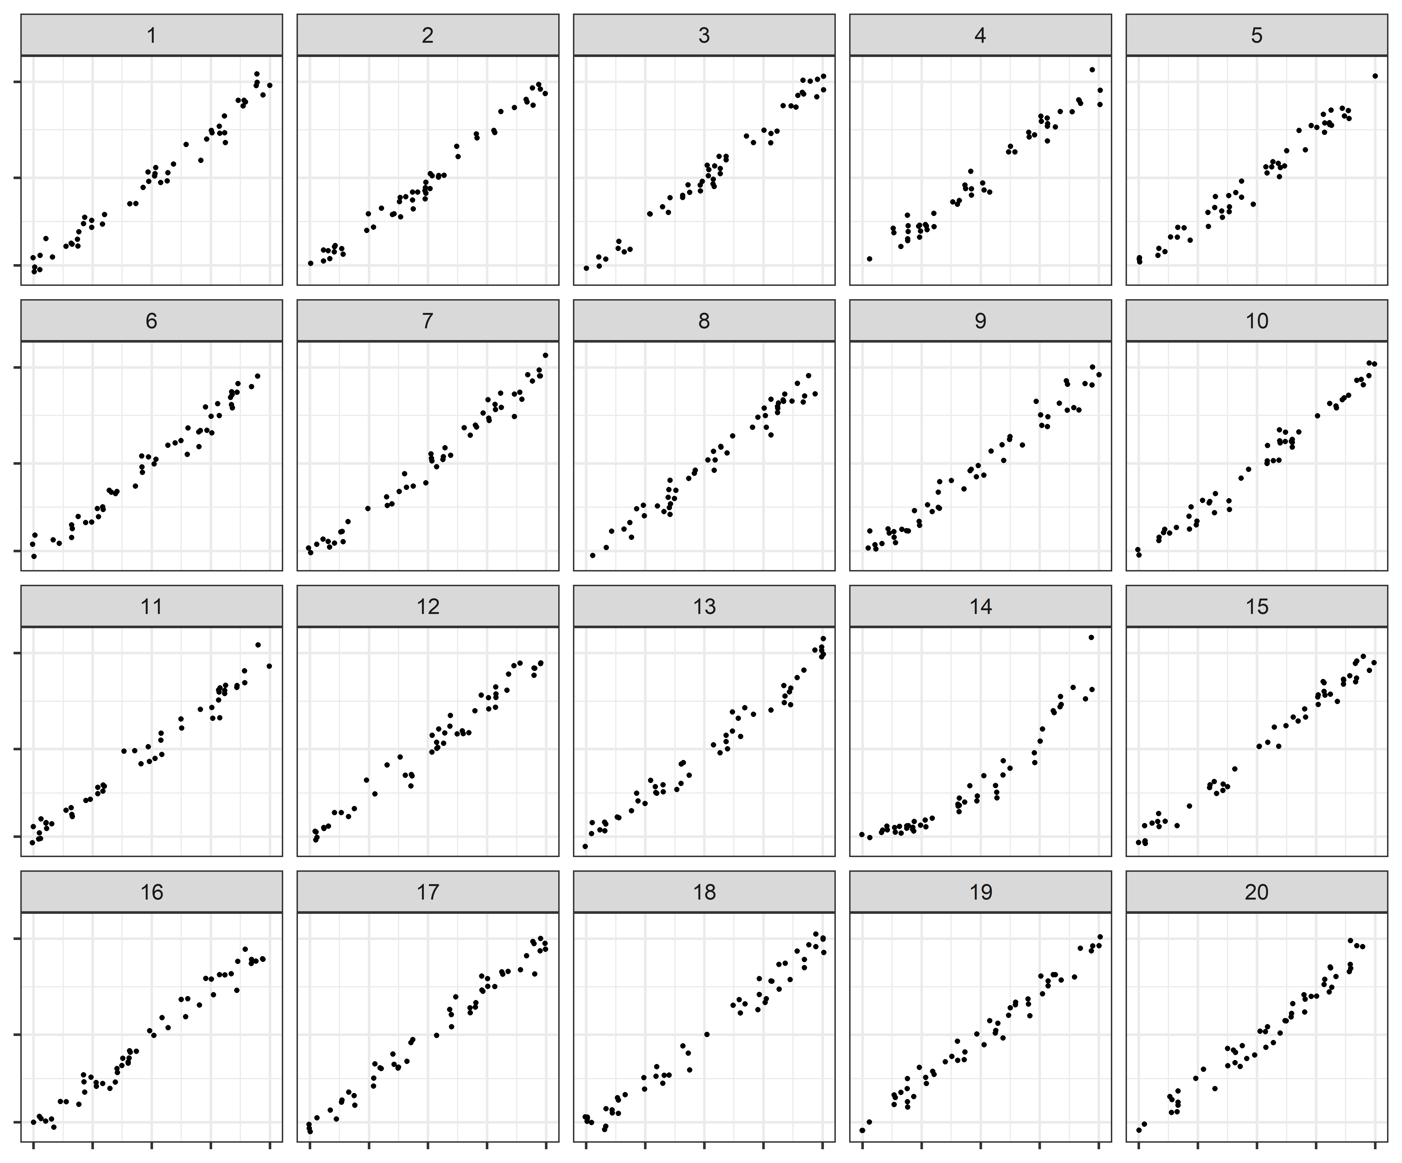
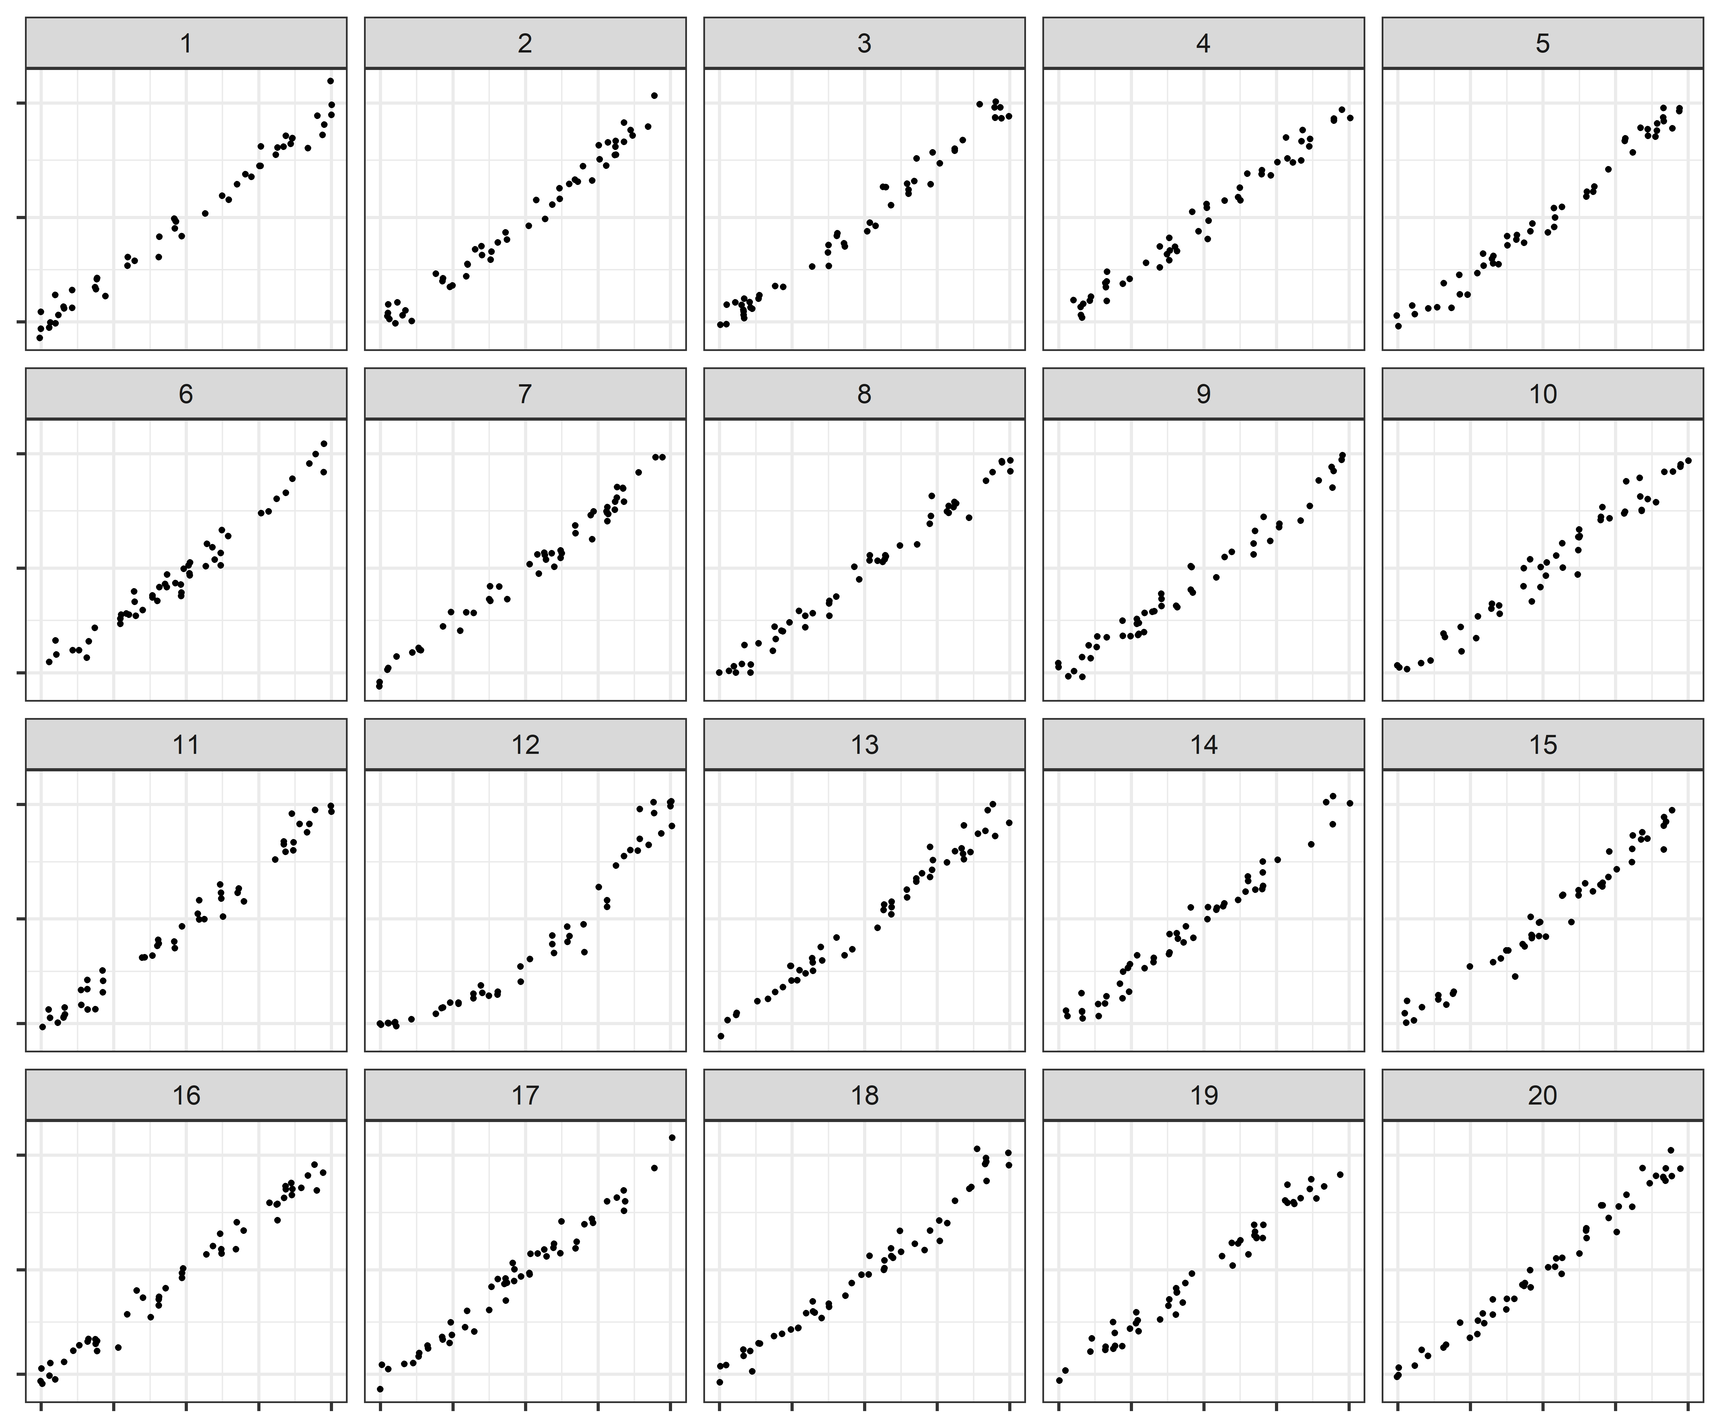
LOG SCALE – the outliers don’t matter as much anymore.
Weird lineups:
- Null: Low Curvature, Target: Medium Curvature
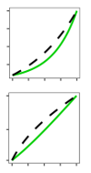
  - Linear
    - Set 1: a22fa470f1028ba1fa6fc5d121887a46 (plot 13)
    - Set 2: 20d0abf28998f59ada75cce6b4999158 (plot 1)
  - Log
    - Set 1: 5e448cd61317e5499aee6d7ea7906c64 (plot 13)
    - Set 2: d6bc919b68b3711ec58a7d2d12363647(plot 1)
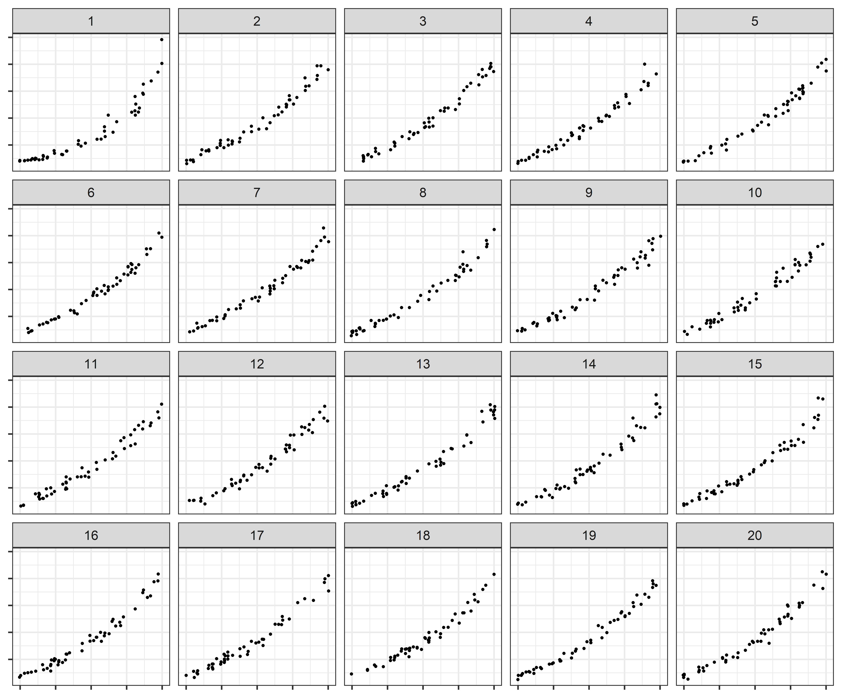
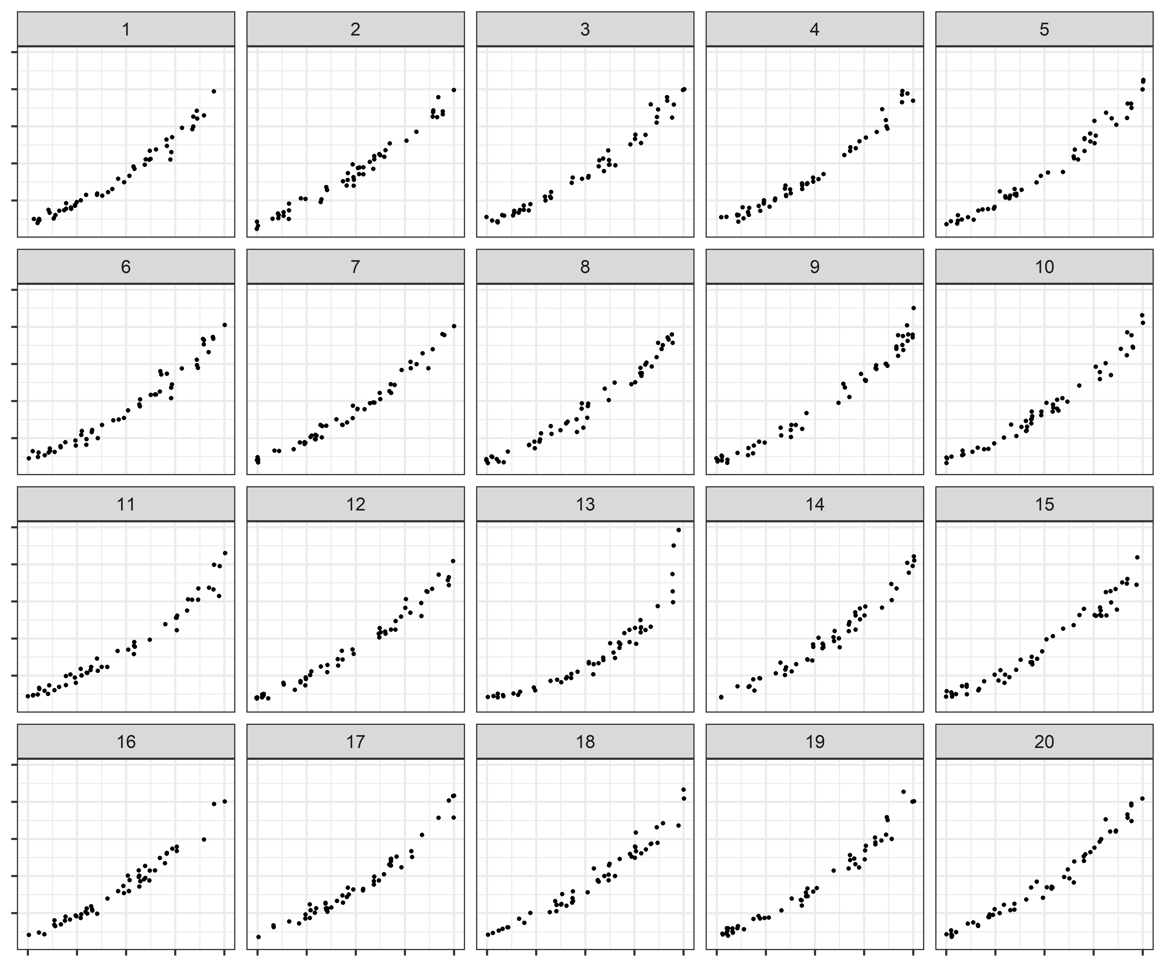

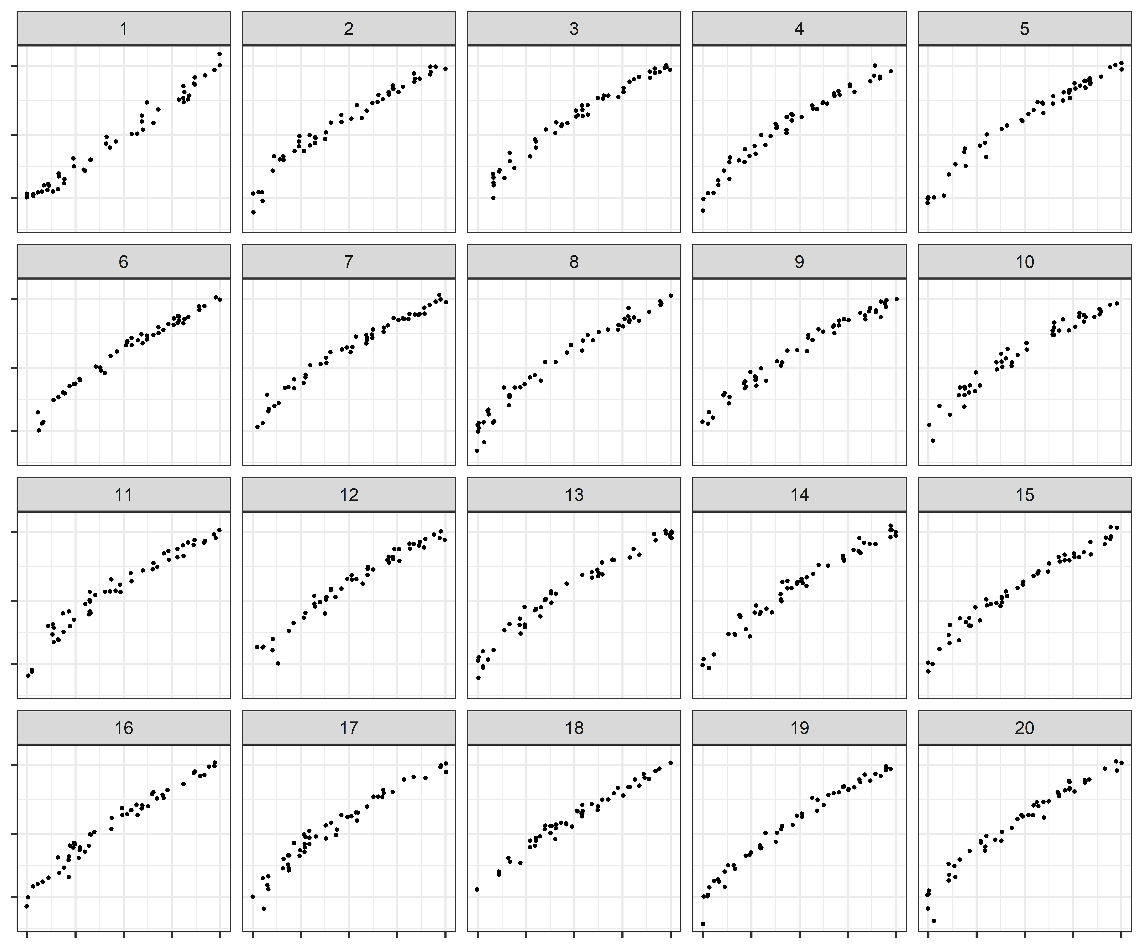
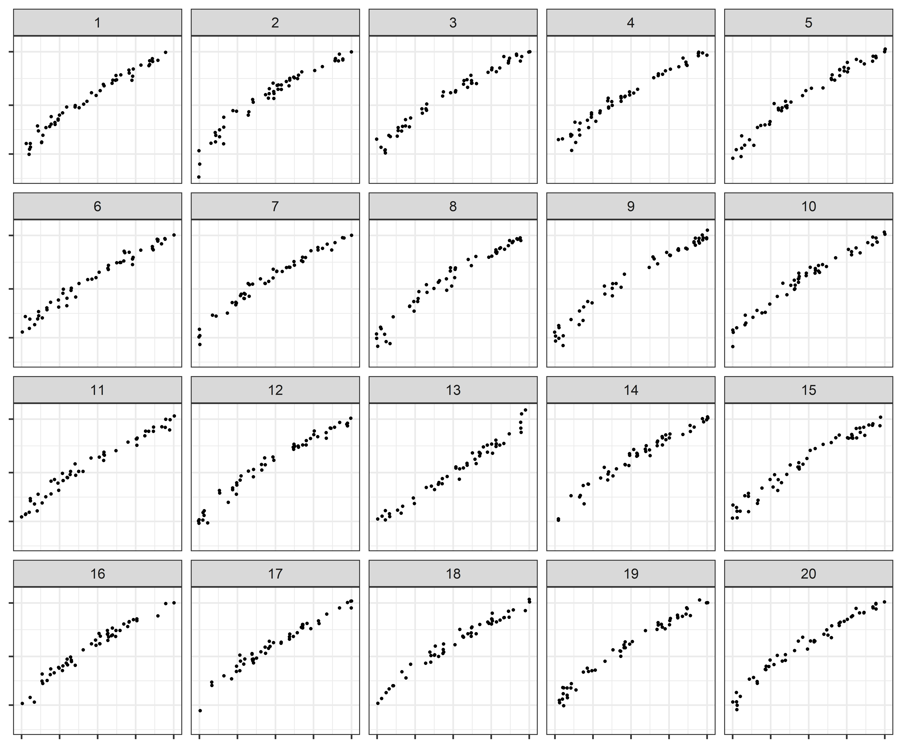
I’m not sure if panel 1 is overlooked? This could be an interesting research question sometime….

