‘Eye Fitting Straight Lines’

Manuscripts

Modern Era (2022)

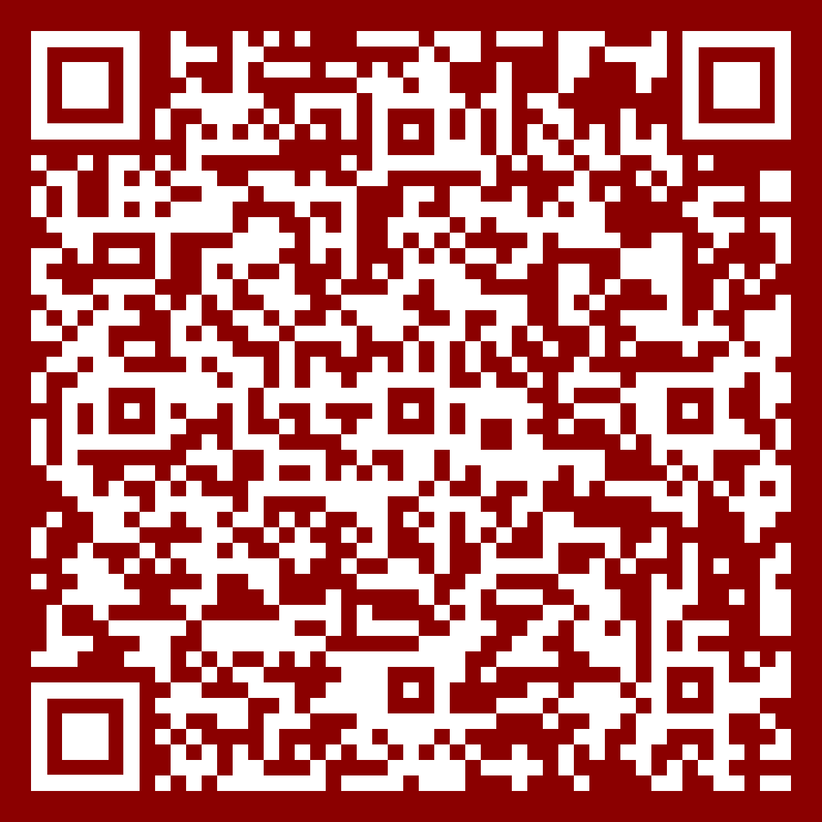

Original (1981)



Try Drawing!



Try Drawing!