Homework 4: Fatal Injuries in the Iliad

Chi-square Test

Homer’s Iliad is an epic poem, compiled around 800 BCE, that describes several weeks of the last year of the 10-year siege of Troy (Ilion) by the Achaeans. The story centers on the rage of the great warrior Achilles. But it includes many details of injuries and outcomes, and is thus the oldest record of Greek medicine. The data report 146 recorded injuries for which both injury site and outcome are provided in the Iliad (Hutchinson, 2013). The top 6 rows of the recorded injuries is shown below:

**Research Question:** Is the location of an injury associated with whether the injury was fatal?

1. Identify the explanatory and response variables in the context of this study.
2. How would you describe the orientation of this bar plot? Filled Stacked Dodged

|  |
| --- |
|  |

1. Based on the plot does there appear to be an association between the variables? Explain your answer.

We can summarize the recorded injuries in a contingency table:

| InjurySite | Fatal | Nonfatal | Total |
| --- | --- | --- | --- |
| Body | 61 | 6 | 67 |
| Head/neck | 44 | 1 | 45 |
| Limb | 13 | 21 | 34 |
| Unknown | 37 | 1 | 38 |
| Total | 155 | 29 | 184 |

1. Which injury location has the smallest number of observations?
2. Were there more fatal injuries or nonfatal injuries overall?
3. What proportion of body injuries were fatal?
$${\hat{p}}_{\text{fatal|body}}=$$

4. What proportion of limb injuries were fatal?
$${\hat{p}}_{\text{fatal|limb}}=$$

5. Set up the null and alternative hypotheses to test the research question.
6. In the table below, fill in the *expected* counts.

| Lethal | Body | Head/neck | Limb | Unknown |
| --- | --- | --- | --- | --- |
| Fatal |  |  |  |  |
| Nonfatal |  |  |  |  |

1. Use the observed and expected counts to compute the Chi-square test statistic.

$$X^{2}=$$

After running 100 simulations under the assumption the location of an injury is not associated with whether the injury was fatal, I obtained the following distribution.

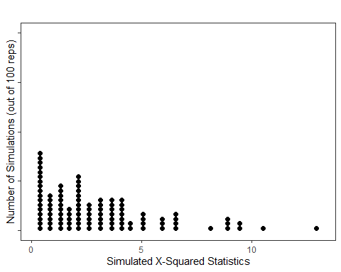

1. Use the simulated distribution of the Chi-square test statistic under the assumption location of an injury is not associated with whether the injury was fatal to estimate your p-value and make a decision about your null hypothesis.
2. Is it appropriate to conduct a Chi-square Test using the Chi-square distribution to test our research question?
3. How many degrees of freedom would the Chi-square distribution for our Test Statistic follow?
4. Select the correct code/output for the Chi-square Test to investigate this question.

chisq_test(x = iliad,  
 response = Lethal,  
 explanatory = InjurySite)

# A tibble: 1 × 3  
 statistic chisq_df p_value  
 <dbl> <int> <dbl>  
1 67.7 3 1.34e-14

chisq_test(x = iliad,  
 response = Lethal)

# A tibble: 1 × 3  
 statistic chisq_df p_value  
 <dbl> <dbl> <dbl>  
1 86.3 1 1.56e-20

chisq_test(x = iliad,  
 response = Lethal,  
 p = c("Fatal" = 0.84,  
 "Nonfatal" = 0.16  
 )  
)

# A tibble: 1 × 3  
 statistic chisq_df p_value  
 <dbl> <dbl> <dbl>  
1 0.00783 1 0.929

1. Write a solution and make sure to include the chi-square test statistic, degrees of freedom, the p-value, and a conclusion written in everyday language.

|  |
| --- |
| Canvas Quiz |
| Make sure to complete the Homework Quiz on Canvas. |