Activity 6.1: Random Block Effect vs Paired t-test
  - Color Interference
 Note
Submit via Gradescope, don’t forget to assign pages to the questions in the outline!

The abstract of the article Studies of interference in serial verbal reactions in the Journal of Experimental Psychology reads:
In this study pairs of conflicting stimuli, both being inherent aspects of the same symbols, were presented simultaneously (a name of one color printed in the ink of another color—a word stimulus and a color stimulus). The difference in time for reading the words printed in colors and the same words printed in black is the measure of interference of color stimuli upon reading words. The interference of conflicting color stimuli upon the time for reading 100 words (each word naming a color unlike the ink-color of its print) caused an increase of 2.3 seconds or 5.6% over the normal time for reading the same words printed in black.
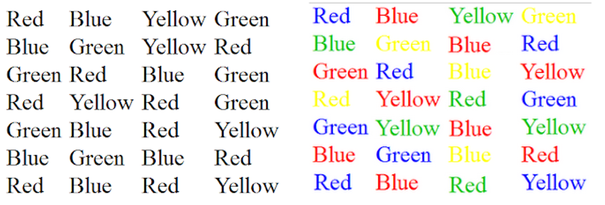
The article reports on the results of a study in which seventy college undergraduates were given forms with 100 names of colors written in black ink, and the same 100 names of colors written in another color (i.e., the word purple written in green ink). The total time (in seconds) for reading the 100 words printed in black, and the total time (in seconds) for reading the 100 words printed in different colors were recorded for each subject. The order in which the forms (black or color) were given was randomized to the subjects.
The data found on Canvas in two formats 06-color-interference-long.csv and 06-color-interference-wide.csv.
 Technology Tip
Use 06-color-interference-wide.csv
- JMP: Performing a Paired t-Test https://community.jmp.com/t5/Learning-Library/Performing-a-Paired-t-Test/ta-p/271914
- R: t.test(paired = TRUE)

a. Using the skills from your Stat I/II course, conduct a paired t-test. Report the following:
- Supporting evidence: t = __________; df = ________; p = __________)
- Estimated mean difference in time ($μ_{blacktext}$ – $μ_{colortext}$): __________________
- Estimated standard error of the mean difference in time: _____________________
 Warning
Ensure subject is categorical in JMP/R.

b. Thinking about this in the experimental design framework, draw a blueprint and identify the following:
- Blueprint:
- Treatment structure:
- Design structure:

c. Why is it important the researchers randomized the order in which the forms (black or different color) were given to subjects?
Tip
Use 06-color-interference-long.csv for the rest of the assignment.

d. Based on your treatment and design structure above, write out the skeleton ANOVA. For each source of variability, indicate whether it is a fixed or random effect.

e. Now, fit the appropriate Linear Mixed Model (LMM) in JMP/R. Report the following:
- ${\hat{σ}}_{blk}^{2}=$ _____________ and ${\hat{σ}}_{ϵ}^{2}=$ _______________
- Supporting evidence: F = __________; df = ____, _____; p = __________
- Estimated difference in mean time between black and colored text (i.e., ordered difference report/pairs): ________________
- Estimated standard error in the difference in mean time between black and colored text (i.e., ordered difference report/pairs): _____________

f. Compare your results between (a) and (e). What do you notice?

