**Data Descriptions**

[Childcare Costs](https://github.com/rfordatascience/tidytuesday/blob/master/data/2023/2023-05-09/readme.md)

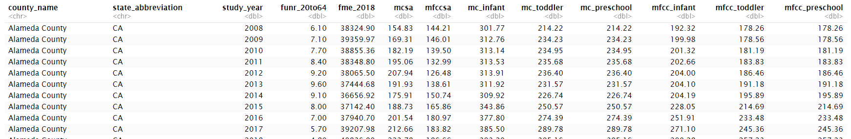

From 2008 to 2018, the Women’s Bureau, an agency within the U.S. Department of Labor, collected information on childcare prices at the county level. Using a market rate survey, the researchers collected prices charged by regulated childcare providers for full-time care and additional fees charged to parents, such as registration fees. Each state was responsible for conducting and reporting MRS results every three years as part of their participation in the federal Child Care and Development Fund program. We accessed the data via the *National Database of Childcare Prices* (NDCP), a comprehensive federal source of childcare prices. The dataset contains the weekly median price for full-time childcare for one child by childcare provider type, age of children, and county-level characteristics for each study year. The childcare provider type is separated by center-based care, where providers care for larger groups of similarly aged children in non-residential settings, and home-based care, where providers care for small groups of mixed-age children in a home-based or residential setting. Each cost and setting are further broken down into four ages: Infants (0-23 months), Toddlers (24-35 months), Preschool (36-60 months), and School-age (5-12 years) for before and after-school care. Additionally, we will work with county characteristics, including the unemployment rate and the median earnings expressed in 2018 dollars for females of 20 to 64 years old. We narrowed the focus of our study to California counties only, resulting in a total of 58 counties. It is important to acknowledge that the data collected in this study inherently assumes a family structure of “both parents,” consisting of one man and one woman. However, we recognize that this depiction does not mirror the diverse realities of all loving families.

**References**

*National Database of Childcare prices*. DOL. (n.d.). <https://www.dol.gov/agencies/wb/topics/featured-childcare>

**Potential Research Questions:**

1. For all counties in California, in 2018, how does the average median weekly childcare cost differ between a childcare setting and an at-home setting for infants?
   * *Tentative analysis plan* (1) grab California and 2018 only (2) t-test between the mc_infant and mfcc_infant variables. (Hmms) Maybe we need to pivot data? What if we wanted to include year?
2. For all counties in California, how is the county-level unemployment rate of females ages 20 to 64, associated with the median weekly childcare cost for infants that attend a center-based facility? How about an at-home setting?
   * *Tentative analysis plan* (1) grab California only (2) linear regression between the funr_20to64 and mc_infant/mfcc_infant variables (Hmms) Maybe pivot the mc_infant/mfcc_infant and take an interaction with facility type? What do we do with the year? Select one? Average?
3. For the central coast counties, how does the average median weekly childcare cost differ between the four age groups – infants, toddlers, preschoolers, and school-aged children – in a center-based care setting?
   * *Tentative analysis plan* (1) grab central coast counties and center-based care only (2) ANOVA (3) I think we need to pivot to create an age group (4) ahhh year??

**Discussion Questions**

1. What questions do you still have about the data?
2. Are there any places where my writing could be improved?
3. Critique the questions. What additional considerations might I need? Are there any questions you would want to add?