SCIENCE PROJECT

- Eavanshi Arora
- 201501115

BASICS

Before we begin, we will have a look at some basic definations that will help us in understanding the following concepts.

1.) Polynomial Sequence - A sequence of polynomials indexed by the nonnegative integers 0, 1, 2, 3, ..., in which each index is equal to the degree of the corresponding polynomial.

Alternative Defination - A sequence of polynomials , for i=0, 1, 2, ..., where is exactly of degree i for all i.

2.) Second-order linear differential equation - A second order differential equation is an equation involving the unknown function y, its derivatives y' and y'', and the variable x.

3.) Moment of Inertia - Moment of inertia is the rotational analogue to mass. The mass moment of inertia about a fixed axis is the property of a body that measures the body's resistance to rotational acceleration.

1.) LAGUERRE POLYNOMIAL

- Laguerre's equation : xy’’ + (1-x)y’ + ny = 0 which is a second-order linear differential equation).

- Laguerre polynomials are solution to Laguerre’s equation.

This equation has nonsingular solutions only if n is a non-negative integer.
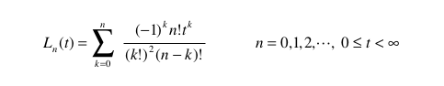
- Defination :

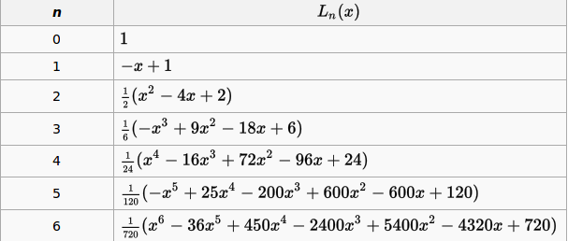
- First few Laguerre polynomials are as given in the table below:

- The Laguerre polynomials arise in quantum mechanics, in the radial part of the solution of the Schrodinger equation for a one-electron atom.
- They further enter in the quantum mechanics of the Morse potential and of the 3D isotropic harmonic oscillator.
- Their graphs are as shown below:
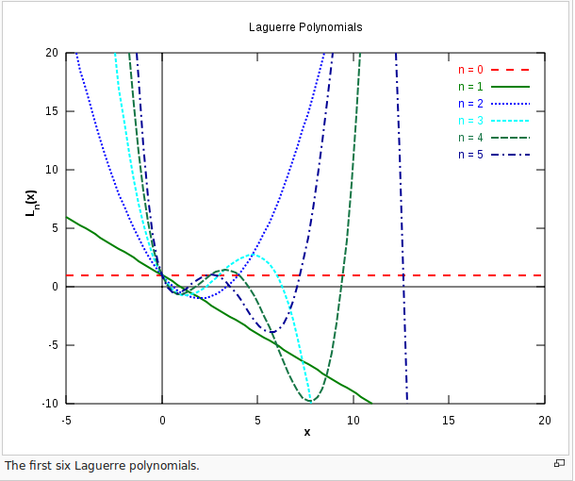
- Also,
One can also the first two polynomials of Laguerre polynomials are:
L(0)(x) = 1
L(1)(x) = 1-x
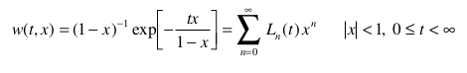
- Generating Function:

- Using Recurrance Relation :
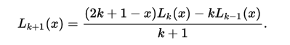
The recurrance relation for any k>=1 can be given as:
The closed form is:
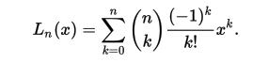
Extending it to Generality:
More generally, the name Laguerre polynomials is used for solutions of :
xy’’ + (α+1-x)y’ + ny = 0 ,
for any arbitary real α.

2.) HERMITE PLOYNOMIAL

- Hermite polynomials were defined by Laplace.

- There are two different ways of standardizing the Hermite polynomials:
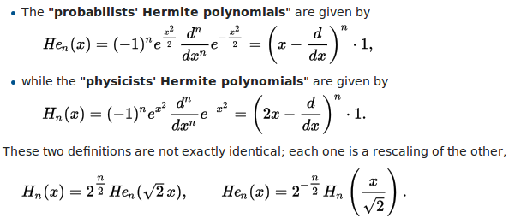

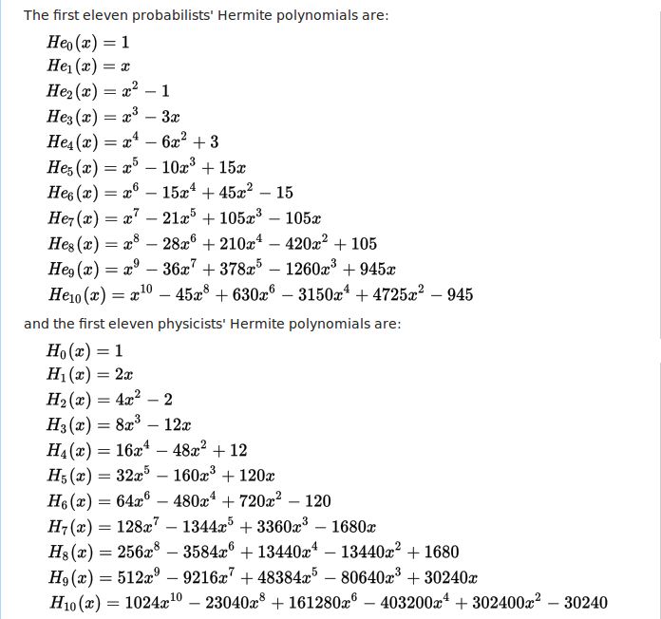
- The first Eleven Hermite polynomials are shown below:
GRAPHS
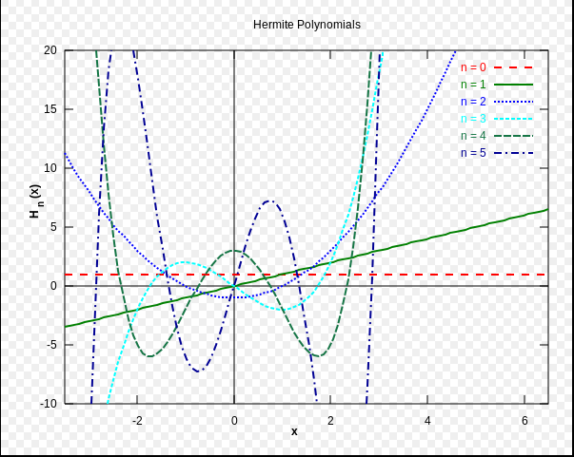
- The first six probabilists' Hermite polynomials Hen(x).
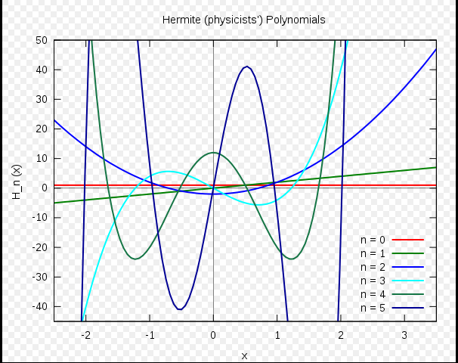
- The first six (physicists') Hermite polynomials Hn(x).

3.) MOMENT OF INERTIA MATRIX

Defination: We defined Moment of Intertia above. Also,
- Moment of momentum - Moment of momentum measures an objects tendency to continue to spin, it describes the rotary inertia of a system in motion about an axis.
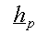
The moment of momentum, about a fixed point o is
defined as : r x mv
Where:
r is the position expressed as a displacement vector from the origin
x represents the vector cross product
mv is the linear momentum (mass x velocity)
- Now, moment of momentum , h0 can be expressed as:
h0 = [I]w
where I is the Inertia Matrix.
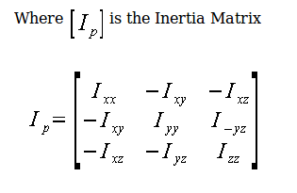
- I can be expressed as :
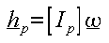
- Problems where the moment of momentum vector, h is parallel to are easier to solve, so the moment of momentum can be
expressed as

