Database Systems

Assignment 2
- Eavanshi Arora
- 201501115

1) System Configuration

Processor: Intel® Core™ i5-5200U CPU @ 2.20GHz × 4
Memory : 7.7 GiB
Hard Disk: 405.4 GB
Base System: Ubuntu 16.04.2 LTS 64-bit

2)Results

1) File Size (MB) vs Time (s)
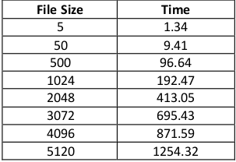
Fixed Memory allocated – 50 MB
2) Main Memory (MB) vs Time (s)
Fixed File Size – 512 MB

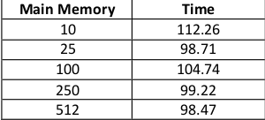
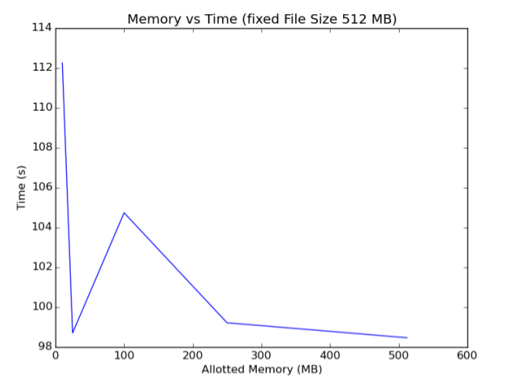
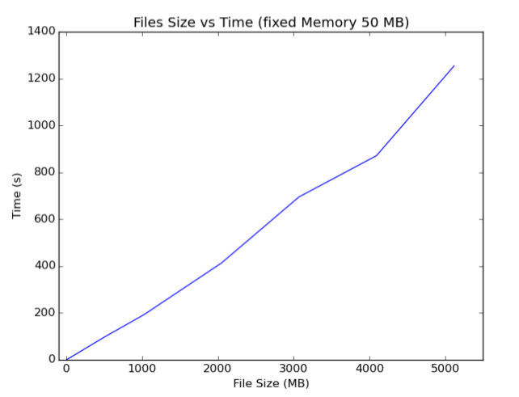
3.) Graphs

