**Group Name**: Alpha Team

**Team Members**: Edgar Arroyo, Jordany Gonzalez, Andres Melendez, Jeffrey Reid

7 / 17 / 2024

Milestone 3

**Report 1: Monthly Client Additions**

* **Description**: This report shows the number of new clients added each month over the past six months.
* **Screenshot**:

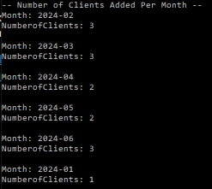

**Report 2: Average Assets Per Client**

* **Description**: This report calculates the average amount of assets held by each client.
* **Screenshot**:



**Report 3: Clients with High Transaction Volume**

* **Description**: This report identifies clients who have more than 10 transactions per month.
* **Screenshot**:

