**CPE 327 SOFTWARE ENGINEERING,**

**SOFTWARE CONFIGURATION MANAGEMENT LAB SHEET**

***DUE ON FRIDAY 17 SEPTEMBER AT NOON***

**This is not a group assignment. It can be done either with one partner or**

**by yourself. If you do this by yourself, you will need 2 github accounts.**

*Updated 10 September 2021*

There are many different software configuration management tools. In this lab we will be using GitHub, which is a very popular online development environment based on the **git** software configuration management system. **git** is open source SCM software created by Linus Torvalds, the original developer of Linux, to help his world-wide team manage changes to the Linux kernel (the core modules of the Linux OS). Read about the history of **git** here: <https://en.wikipedia.org/wiki/Git>

Do not confuse **GitHub** with **git**! GitHub is an online environment that provides SCM services using **git** plus other kinds of services (such as continuous integration and deployment). It is a commercial company that was bought by Microsoft in 2018. You can read about the history of GitHub here: <https://en.wikipedia.org/wiki/GitHub> There are other online environments that compete with GitHub, for instance GitLab ([https://gitlab.com](https://gitlab.com/)).

The **git** SCM is fundamentally a command-line-based system. One thing that GitHub does is offer a more user-friendly graphical UI. It also provides a platform for working with other developers who can be anywhere in the world.

There are also local (non-web-based) GUIs available for **git**.

Unlike some SCM systems, which are client-server based, **git** was designed for distributed software development which is common in open source projects. The most important difference from many client-server SCM tools (such as CVS, the Concurrent Version System) is that **git** relies much more on branching and merging. Each developer has a full copy of the source code repository, which is treated typically treated as a branch from the main line of development. When a developer is finished with her work, she first commits her changes to her local repository, then as a second operation, attempts to merge the changes into the main line of development. The software relies heavily on automated processes for conflict identification or resolution. (It is possible for multiple developers to all be working in the main line – the “origin master”, but this is not common in practice. However, the lab exercise uses this simpler scenario.)

Another difference between **git** and CVS is that CVS stores source code in text format if possible, only recording the deltas (differences) between one version and the next (except for binary files under SCM control, such as images). In contrast, **git** works by maintaining snapshots that are entire files, not just initial files plus changes, as binary objects signed with unique hash values. This prevents tampering but also means that problems due to file corruption can be difficult to fix (so backing up the **git** repository is really important!).

In this lab, you will practice using the basic capabilities of GitHub to manage some software. Follow the instructions below to complete this lab. Note that the screen shots in these instructions date from several years ago. You may find that the current user interface for both git and GitHub looks somewhat different. We decided not to update the screen shots, as a learning experience. In the real world, web applications change their organization frequently. You need to be able to adapt!

Installation and preparation

1. Sign up for a GitHub account [https://github.com](https://github.com/)
2. If you are working on your own, create a second account with a different user name.
3. Download and install git software. GitHub won’t work on your local computer if you don’t install git. Install Git for Windows, Mac or Linux depending on your computer’s operating system. (See <http://git-scm.com/downloads>)
4. Run all git commands on the Git Bash shell (terminal). This provides a Linux-like command line environment if you are running the software on Windows or a Mac.

Example Workflow Steps

1. Create a blank repository in GitHub with no readme file. Print hub status.

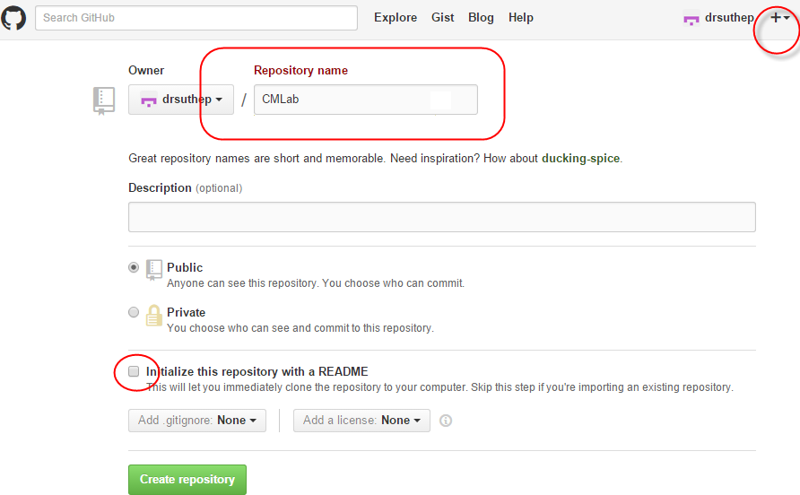

1. Unpack the zip file that includes the files you will be putting under git control, from the *src* directory in the zip. Move the src files into your work directory. Make a git repository in that work directory, then push it to the GitHub repository.

* In this example, the files are unpacked in ***d:/data/dropbox/cpe333/gitlab***. Go there first using ‘cd’ to change directory.

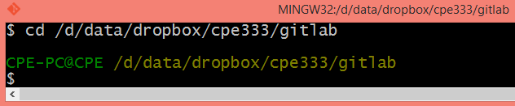

* List the contents using ‘ls’

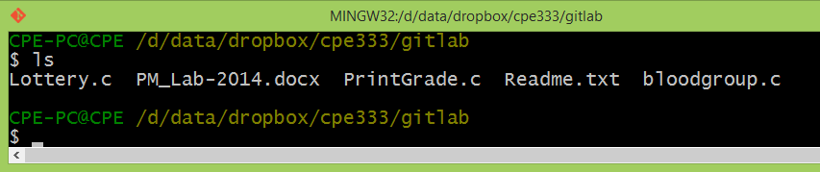

* Make this a .git repository using **git init**. This example sets the user name and email for this repository to “drsuthep” and [“sut](mailto:suthepmail@gmail.com)h[epmail@gmail.com](mailto:suthepmail@gmail.com)”

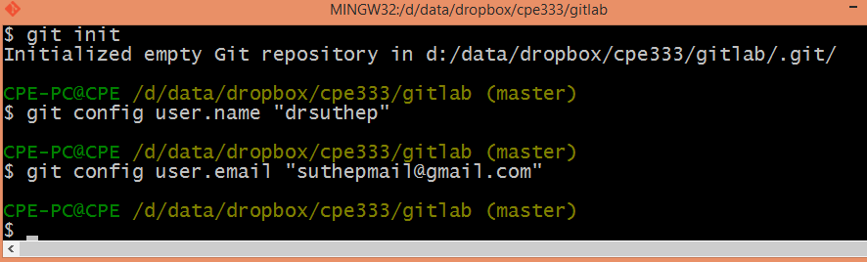

* Add all files to the git repository using the **add** command. Then use the **commit** command to finalize the files to the local repository. 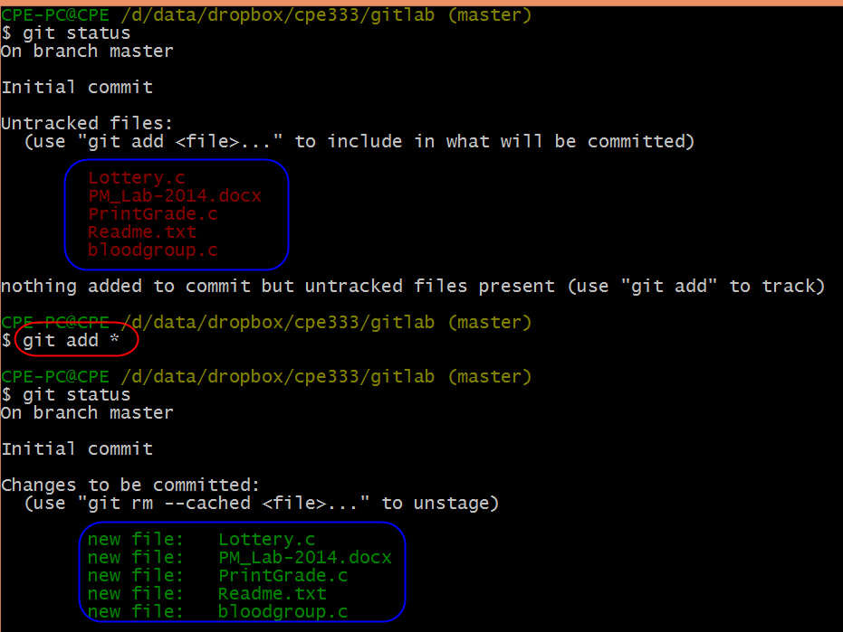
* “Staged” means ready to be committed. Now we **commit** these changes with a comment as “First copy of 5 files”

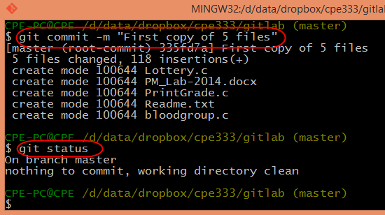

* Log in to your GitHub account and create an online repository location for your repository.
* 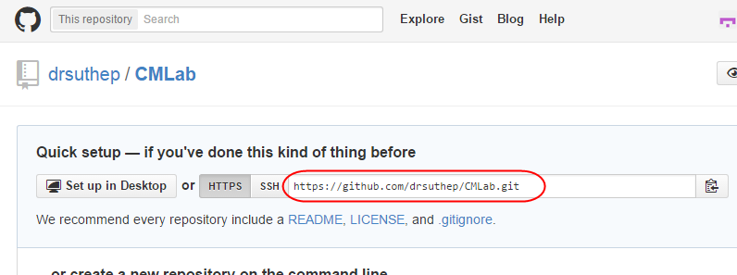
* Add a collaborator. If you are working in a pair, this will be your partner’s username. Otherwise, use the username for the second GitHub account you created. We will call this collaborator “User B”.
* 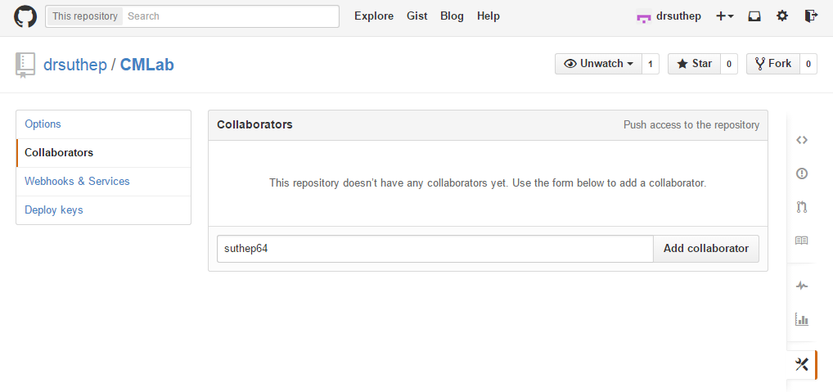
* Now link the remote repository to your local repository.

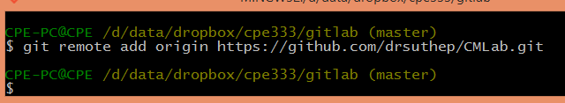

* Next, push the local folder (called ***origin master***) to the GitHub repository using the **push** command.
* 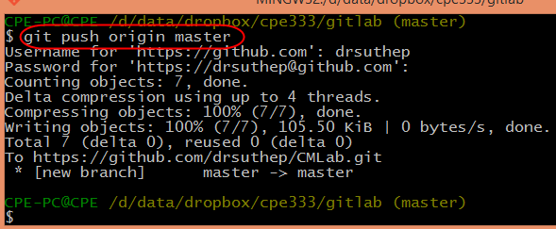

1. Now we will look at collaboration. User B will creates a copy of the online repository locally in another folder of his/her own computer, then print local status Users B.

* Let’s assume on user B’s computer it is in folder d:/data/dropbox/cpe333/gitlab-userB:

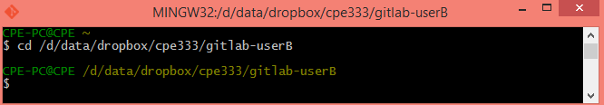

* In this example, the second user or user B is “suthep64” (You need 2 email accounts to simulate 2 users if you are doing the lab alone). This account has email of “[suthep@kmutt.ac.th](mailto:suthep@kmutt.ac.th)”.

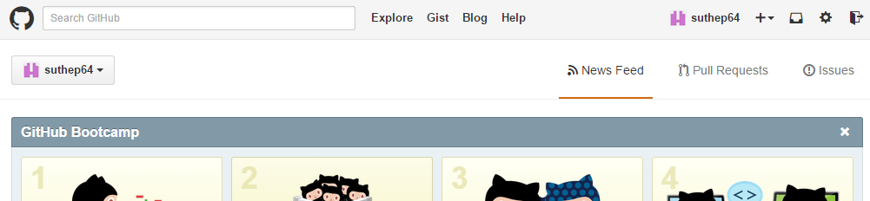

* Initialize the local repository at the current folder to create a .git repository and then set the user name and configurations for this repository:

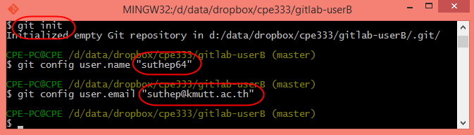

* Next, inform the local directory where the GitHub is located, and then pull the code into that directory using the ***pull*** command.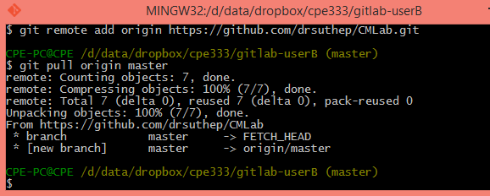

1. Go back to user A’s directory. Change the code function in one source files. Print the local status of User A.

* Before changing file “bloodgroup.c”:

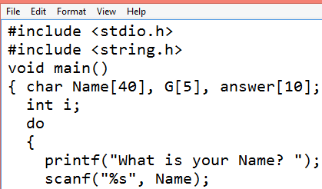

* After changing file “bloodgroup.c”:

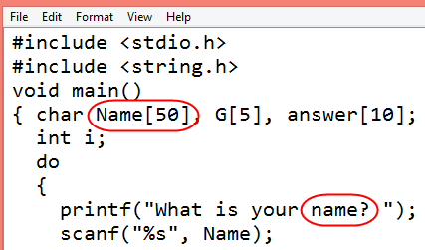

* Print User A’s status.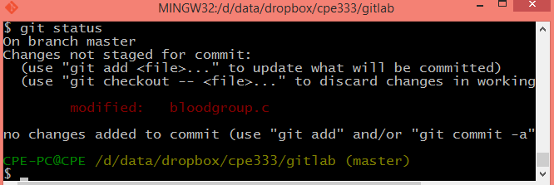
* Print User B’s status. Of course there’s no record of what User A has done.

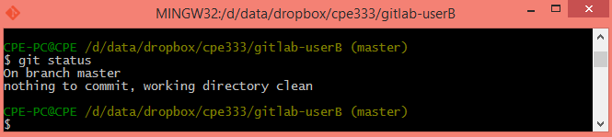

1. Now, as User B, change a function in another source file, then print local status for User B.

* Before change to “PrintGrade.c”

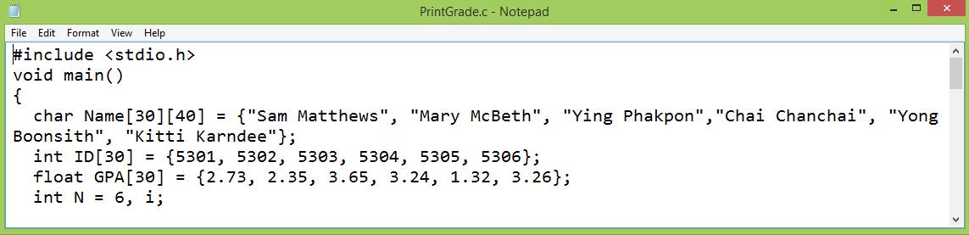

* User B makes change to “PrintGrade.c”:

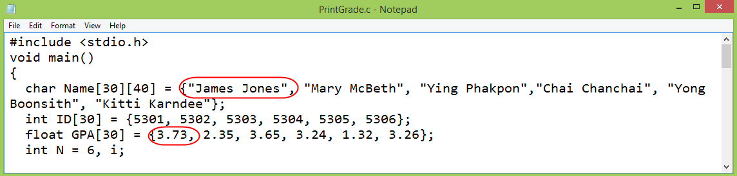

* Print User B status: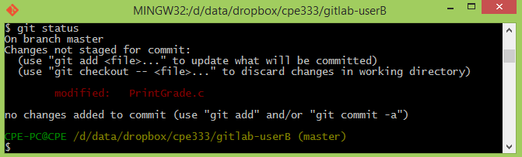

1. Go back to User A’s directory. Create a new C program called TimeGreeting.c. (If you are following htis workflow, you can copy this from the *NEW* subdirectory created when you unzip the lab files.) Do not put into Git yet. Print local status User A.

* A new file “TimeGreeting.c” was added to user A’s folder.

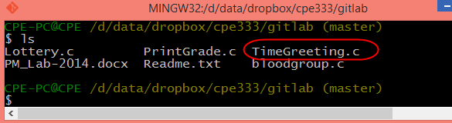

* The new status. Git knows there is a file that is not yet being managed by the SCM.

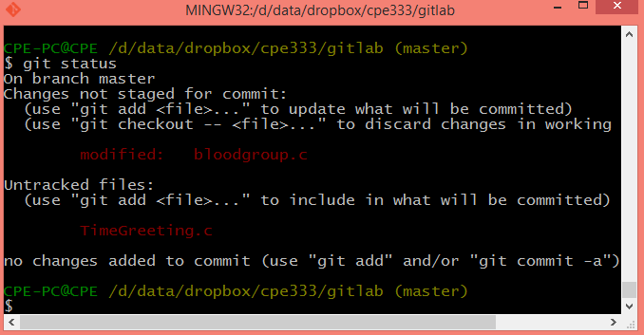

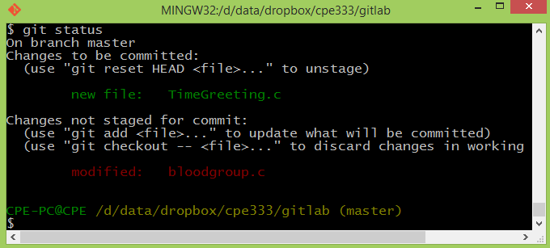

1. User A puts TimeGreeting.c under Git control using **git add**. Then User A commits changes (note that changed files are bloodgroup.c and TimeGreeting.c). Print local status for User A.

* Usesr A commits with the comment “Add 1 file. Change 1 file”

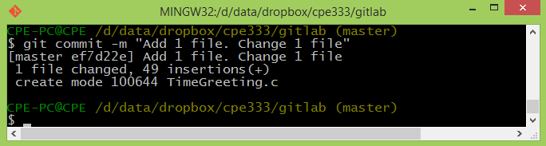

* The git status shows only one file changed. This is because User A forgot to add bloodgroup.c. You can add and commit at once by using “git commit –a” or otherwise you do in two steps: 1) git add bloodgroup.c; 2) git commit –m “Modified bloodgroup.c”.

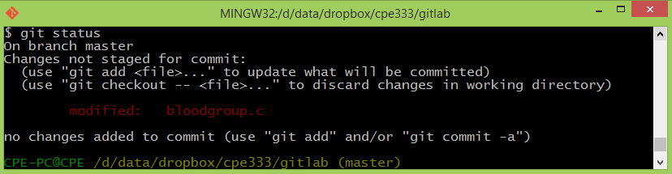

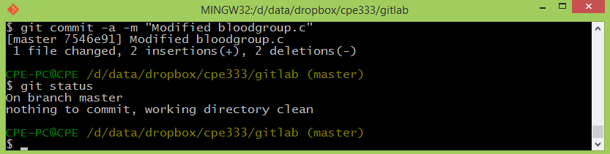

1. Having committed changes to the local repository, User A pushes changes to the GitHub repository, then prints User A’s status.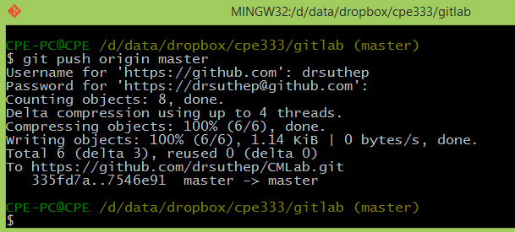
2. Going back to User B’s environment, this user adds the changes to PrintGrade.c and commits in a single step, then prints local status; note that the changes have not yet been pushed to the central repository.

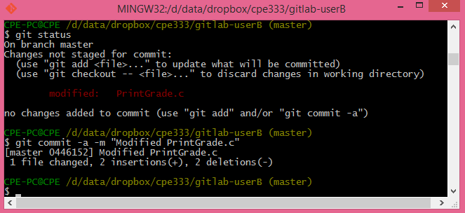

1. User B wonders what other collaborators have been doing. To get an up-to-date version of all code, User B pulls repository from GitHub.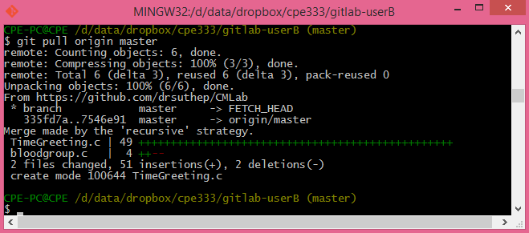
2. Now User B’s local copy includes other people’s changes. So User B pushes her changes to GitHub repository, then prints the status.

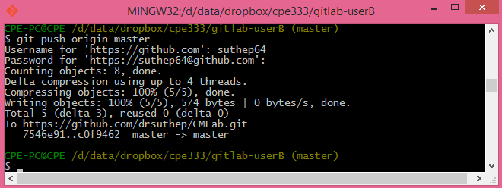

1. User A wonders what collaborators have been doing, so pulls repository from GitHub.

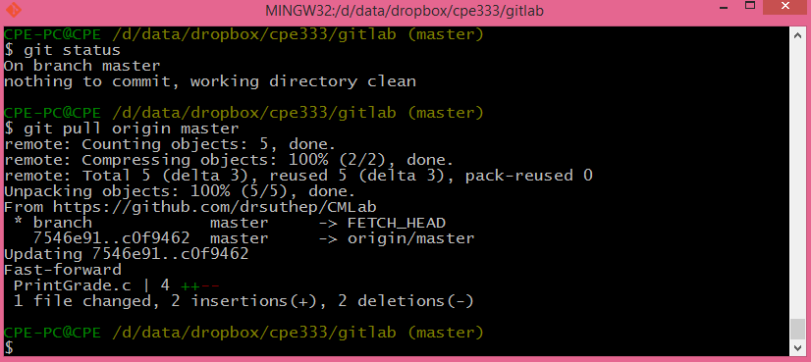

* **All 3 repositories have same copy now.**

1. However, we have not yet looked at the common situation where two users make changes to the same source file. Suppose User A changes Lottery.c and User B also changes the same lines in Lottery.c, but with different content. Both add and commit changes in one statement. Print status of User A and User B.

Original Lottery.c file:

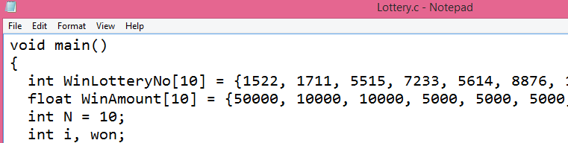

* Change by User A:

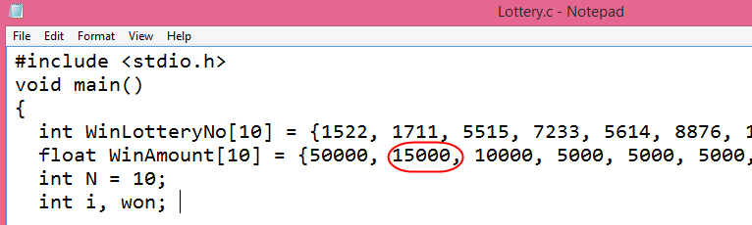

* Change by User B:

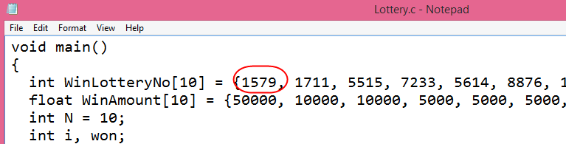

* Commit by User A:

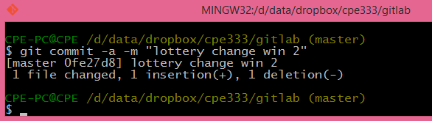

* Commit by User B:

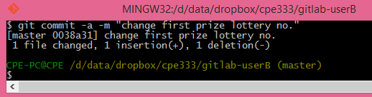

1. They both push changes to GitHub Repository.

* User A:

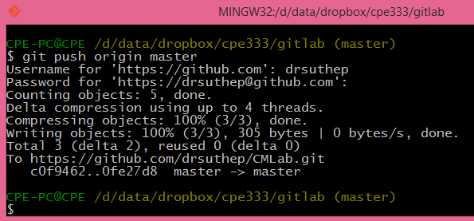

* User B cannot push because some changes exist in the master copy that are not in User B’s local copy. Hence User B must pull first. It’s always a good idea to pull and then push.

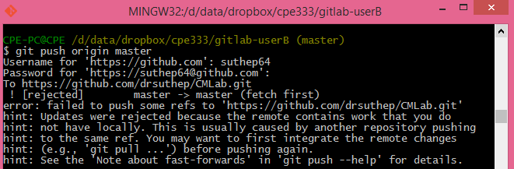

* When the pull executes, **git** discovers there is a conflict, that is, incompatible changes by two users in the same area of the same file. 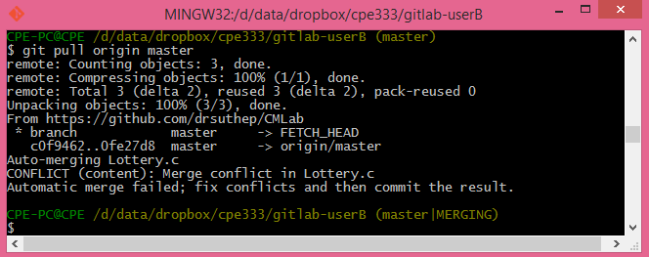
* The two sets of changes in Lottery.c must be resolved manually:

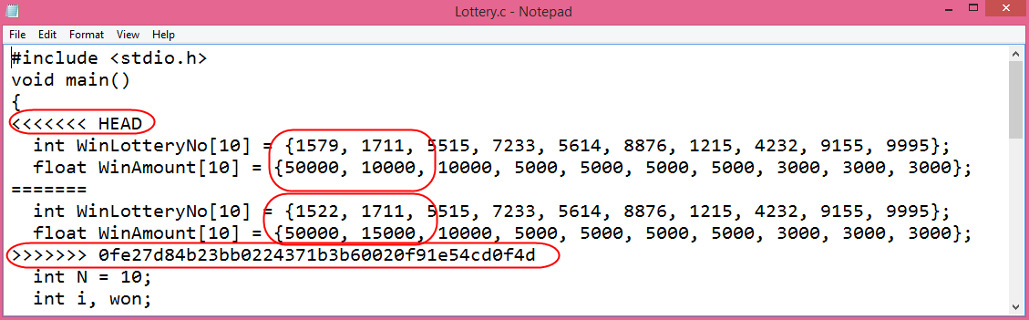

* User B fixes the conflict as follows and then saves the file.

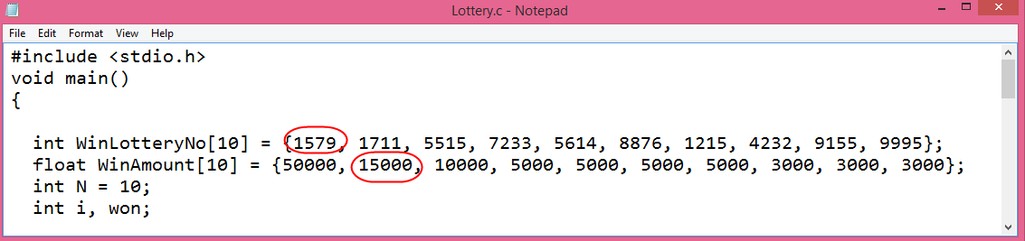

* User B then commits the change:

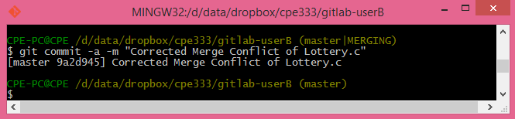

* And pushes the changes to the GitHub repository: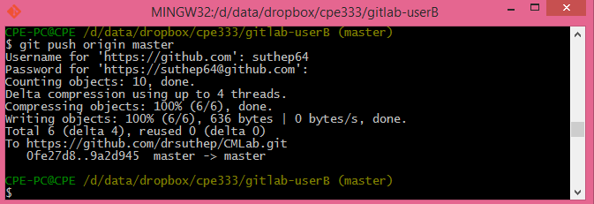

1. Then User A pulls the changes.

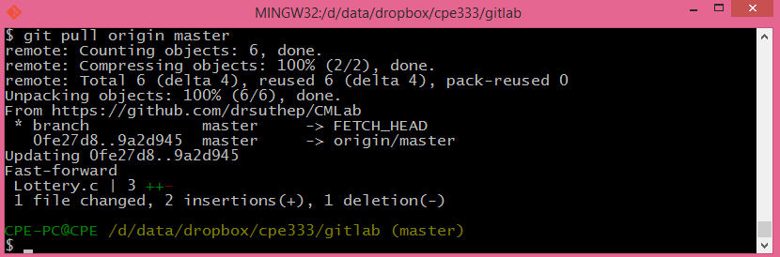

* Now user A has the same copy of the file Lottery.c with conflict resolved as User B:

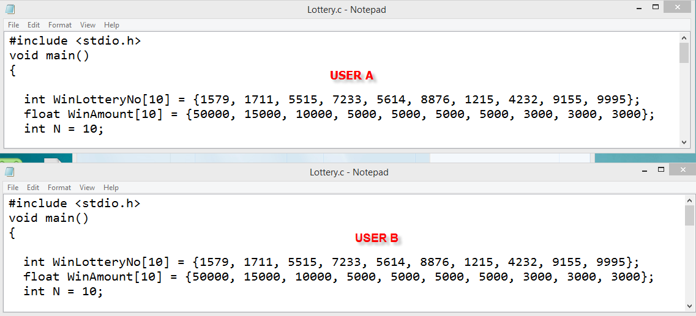

Laboratory Exercise

Run the following and submit a PDF dump similar to my above workflow dump for the following commands:

1. Unzip the lab zip file. The original source files can be found under *src*. The new file *TimeGreeting.c* is located in *NEW*.
2. Create a blank repository in GitHub under User A’s account called “GITLAB” with 1 Readme file. Print hub status. Both users A and B will use this repository. Add User B as collaborator to this repository.
3. In some path create a folder called “CPE327-A” for User A. Make this a git repository and pull data from GitHub. Show status.
4. In some path create a folder called “CPE327-B” for User B. Make this a git repository and pull data from GitHub. Show status.
5. User A. Use file manager to put two C programs (*bloodgroup.c* and *PrintGrade.c*), and one MS Word document into CPE327-A.
6. User A. Add all files to git. Then commit. Show Status.
7. User A. Push your local repository to the GitHub repository. (You should always pull before you push). Show screen.
8. User B pulls data from GitHub. Show status.
9. User B change 1 function in *PrintGrade.c.* Print local status User B.
10. User B create a new C program *TimeGreeting.c*. Do not put into Git yet. Print local status User B.
11. User B adds *TimeGreeting.c* to Git control (git add). Print local status User B.
12. User B commits changes. Print local status User B.
13. User B pushes changes to the GitHub repository. (You should always pull before you push). Print hub status. Print User B status.
14. User A change something in *bloodgroup.c*. Print local status User A.
15. User A adds its changes and commits at once. Print local status User A.
16. User A pulls repository from GitHub.
17. User A pushes changes to GitHub repository. Print status User A.
18. User B pulls repository from GitHub.

* All 3 repositories have same copy now.

1. Then User A changes *bloodgroup.c* at two places and User B changes same *bloodgroup.c* at two places (make sure they change same general area of the code or in the next step there may be no merge conflict visible ☺) . Both add and commit changes. Print status of User A and User B.
2. User A pulls from GitHub and then pushes to GitHub. User B then pulls and pushes to GitHub, but there’s conflict. (There will be a conflict if user A and B both change *bloodgroup.c* at about the same lines). Resolve this merge conflict for User B and commit change. Show each step.
3. Then User A pulls the changes. Display the contents of *bloodgroup.c* for both users to demonstrate that they are now the same.

If two users make *compatible changes* to the same file, then **git** may be able to resolve conflicts automatically. For instance, if User A added a line *#include <time.h>* at the top of the file, and User B included a brand new function at the end of the same source file, these two changes could be automatically combined. However, **git** would still inform you of the differing contents. You should always check the results of automatic merges, to be sure they make sense from a programming perspective. SCM systems, including **git**, don’t know anything about program meaning; they can only detect conflicts or multiple changes based on the text content of the source files.

Note that this exercise does not provide any practice using branches. In fact, in many real world projects that use GitHub, developers do not make changes to the origin master directly. Instead they create a branch using the clone command, do their work, then merge changes back into the main line of development.

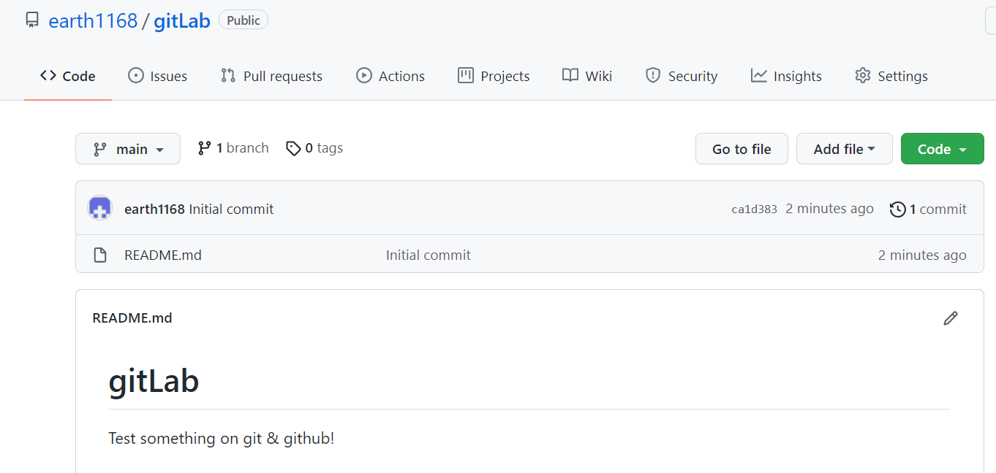1.) Create blank repository

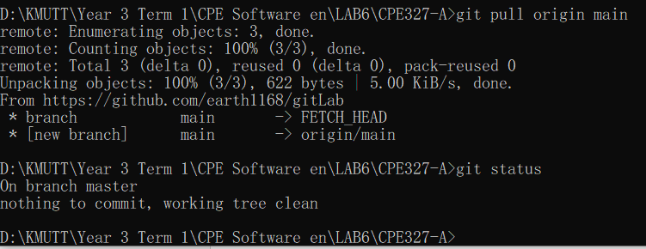2.) Pull and show status of user A

3.) Pull and show status of user B

