Right click on ROOT ->Properties. Change Context path from “/ROOT” to “/”

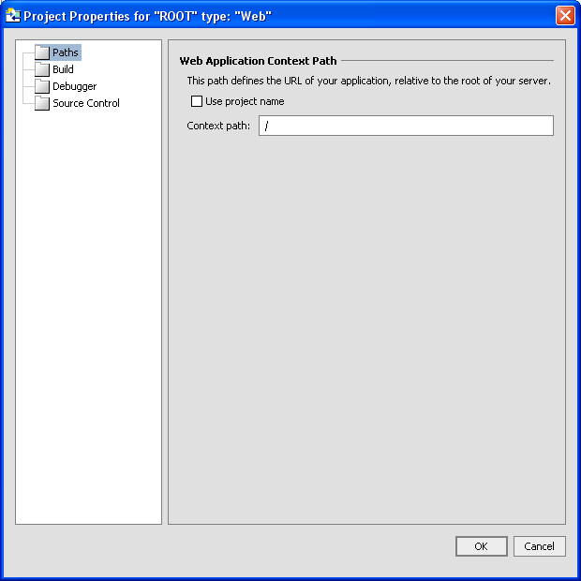

In Project Properties dialog – switch to Build View.

With “Use IDE build” radio checked, click the Export to Ant File button. This will put a file called exported_build.xml into the project. Open the file and towards to the bottom look for this element:

<webappbuild appdir="${app.local.directory}"
appname="${appname}"
servername="${servername}"
domainroot="${domainroot}"
verbose="false"
nowarn="false"
noerr="false"
debug="${debug.info}"
serverbuild="true"
precompilejsp="false"
useincrementalbuild="${use.incremental.build}">
<Webapp name="${webappname}" contextroot="${webappcontextroot}" uri="${webappuri}"
classpath="${class.path}"/>
</webappbuild>

Make sure the precompilejsp attribute is set to false. Save the file and go back to the Project Properties Build view. Make the selections shown below: Check “Use Ant Build” and select the exported_build.xml as the Ant file.

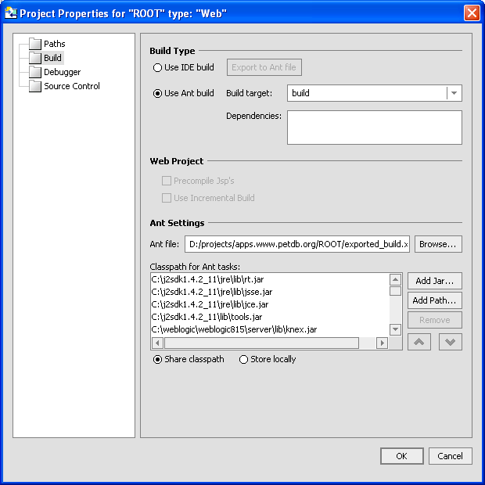

Build the EAR file from the Build menu.

Open the Built EAR in WinRAR and get application.xml from the META_INF folder to your local disk and open it

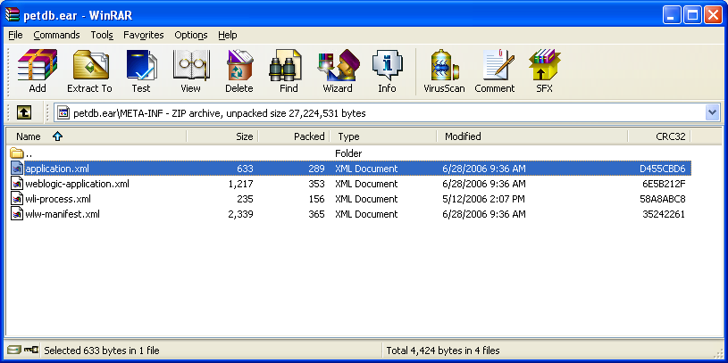

Add a slash into the context-root element.

<module>
<web>
<web-uri>ROOT</web-uri>
<context-root>/</context-root>
</web>
</module>

Save application.xml and drag it back into the META_INF folder of the EAR file in WinRAR.

The EAR file is ready for deployment. Stop the PetDB application from the Weblogic console before overwriting the existing EAR file in the various environments (dev, alpha, etc…)

