SpectralBridge: An Auditable Software Workflow for Reflectance Comparisons Across NEON, Drones, and Landsat
Ty Tuff¹, Aashish Mukund¹, Nayani T. Ilangakoon², Erick Verleye², Megan E. Cattau⁴, Janushi Shastri^{2,3}, Pavan Appanna^{2,3}, Tyler L. McIntosh², Matthew E. Bitters², Carol A. Wessman⁵, Jennifer K. Balch^{1,6}, Cibele Amaral¹
- Earth Lab and the Environmental Data Science Innovation & Impact Lab (ESIIL), Cooperative Institute for Research in Environmental Sciences (CIRES), University of Colorado Boulder, Boulder, Colorado, USA
- Earth Lab, Cooperative Institute for Research in Environmental Sciences (CIRES), University of Colorado Boulder, Boulder, Colorado, USA
- Department of Computer Science, University of Colorado Boulder, Boulder, Colorado, USA
- Human-Environment Systems, School of the Environment, Boise State University, Boise, Idaho, USA
- Department of Ecology and Evolutionary Biology, University of Colorado Boulder, Boulder, Colorado, USA
- Department of Geography, University of Colorado Boulder, Boulder, Colorado, USA
ORCID identifiers: Ty Tuff 0000-0001-5249-5197; Nayani T. Ilangakoon 0000-0002-6607-0605; Erick Verleye 0009-0009-8854-0127; Megan E. Cattau 0000-0003-2164-3809; Tyler L. McIntosh 0000-0002-6383-1755; Carol A. Wessman 0000-0002-7325-0153; Jennifer K. Balch 0000-0002-3983-7970; Cibele Amaral 0000-0001-7597-2427
Corresponding author: ty.tuff@colorado.edu
Revised 12 October 2026

Summary
Reflectance describes how a surface reflects light at different wavelengths. SpectralBridge is Python research software that helps teams prepare and check reflectance products from NEON airborne sensors, drones, and Landsat. It retains named intermediate rasters, extracted values, quality checks, and provenance so users can inspect how each product was made. Separate routes preserve sensor-specific operations, while collection tools summarize selected flightlines and sites. The package organizes established corrections rather than proposing a new algorithm. Tests and team research examples demonstrate software contracts and limitations, not agreement among sensors.

Statement of need
Band names invite direct comparison, but spectral response, footprint, viewing direction, and illumination help define the reflectance recorded by each instrument. A drone may isolate sunlit foliage; NEON records a dense spectrum; Landsat mixes canopy, gaps, soil, and shadow across broader pixels (Kampe et al. 2010; National Ecological Observatory Network 2026; Woodcock and Strahler 1987). Matching labels therefore do not make measurements equivalent, and these differences can change an ecological interpretation (Nicodemus et al. 1977; Schaepman-Strub et al. 2006; Teillet 1997; Roy et al. 2016; Huang et al. 2002). The intended users are remote-sensing researchers and developers who need to construct sensor-oriented products, inspect intermediate states, verify outputs, or summarize flightlines. They remain responsible for temporal matching, co-registration, and common spatial support. Independent validation also requires characterized reference measurements and uncertainty analysis; process completion alone cannot establish it (Origo et al. 2020). SpectralBridge preserves the sequence from source through configured transformations to extracted values, helping users locate where an unexpected pattern first appears. It does not diagnose discrepancies or choose a valid spatial/temporal design. Figure 1 illustrates the separate roles of spatial support and spectral response.
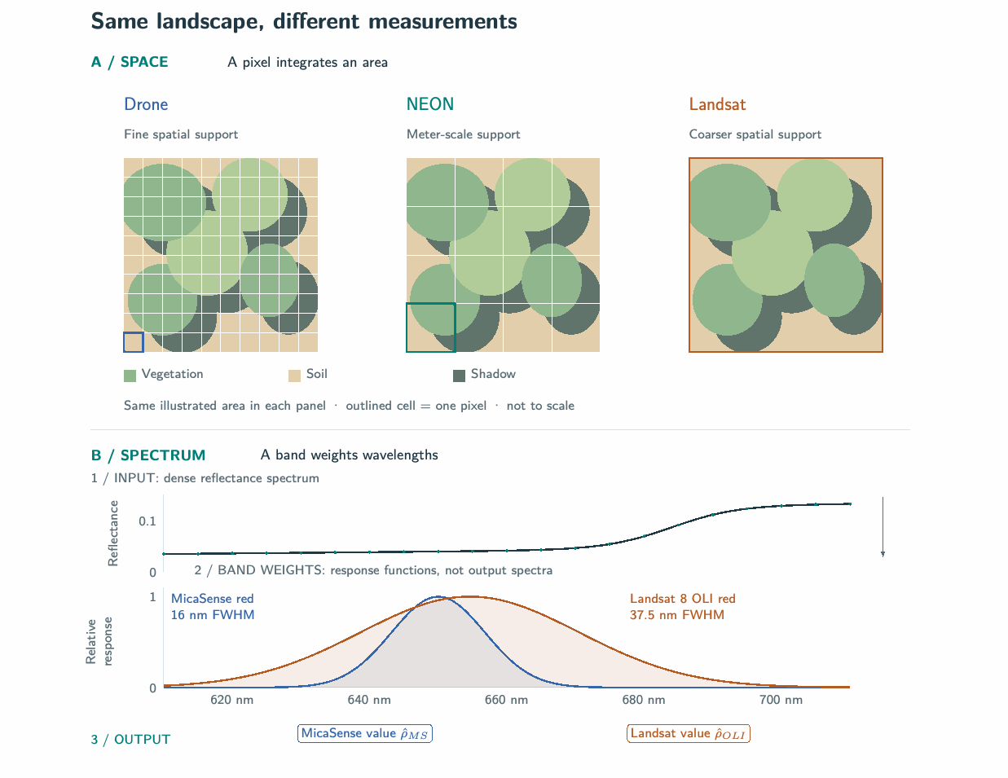
Figure 1. Two independent sources of measurement mismatch. (A) The same illustrated vegetation, soil, and shadow are integrated over different pixel footprints; grids are schematic and not to scale. (B) Read from top to bottom: the upper curve is the input reflectance spectrum; the lower curves show how strongly each target band weights each wavelength. They are response functions, not output spectra. Applying a response curve to the input produces one weighted reflectance value, shown schematically by the matching colored output label and defined in Equation 1. The Gaussian profiles use packaged Landsat 8 OLI and MicaSense centers and full widths at half maximum (FWHM), not official measured response curves (Earth Lab 2026k); the spectrum is illustrative.

State of the field
HyTools is SpectralBridge’s closest methodological relative and part of its NEON lineage. HLS and Sen2Like harmonize satellite products; FORCE processes satellite archives; Snakemake and Nextflow orchestrate general pipelines (Chlus et al. 2025; Claverie et al. 2018; Ju et al. 2025; Saunier et al. 2022; Frantz 2019; Köster and Rahmann 2012; Di Tommaso et al. 2017). In the systems compared here, none combines the separate NEON and drone routes with collection-level artifact and QA contracts (Earth Lab 2026x, 2026j). SpectralBridge’s contribution is this sensor-aware integration, restart checks, and grouped summaries - not a new correction method or harmonization product.

Software design
The workflow addresses geometry normalization and target-band weighting, while preserving geospatial products for downstream spatial reconciliation. It does not create a common spatial support; nominally matching bands may also require bandpass adjustment (Chander et al. 2013; Roy et al. 2016; Earth Lab 2026z, 2026m). NEON provides the dense spectrum from which configured MicaSense- and Landsat-like products are constructed. Independently acquired drone data follow a separate preparation path (National Ecological Observatory Network 2026; Earth Lab 2026z, 2026h). Thus, Drone → NEON → Landsat describes a comparison design, not a physical conversion chain. A named target product reflects configured weighting and any recorded adjustment, while retaining NEON’s original spatial support.

Geometry and terrain
For NEON, the workflow estimates bandwise SCS+C topographic terms, then applies RossThick and LiDenseR BRDF terms using available solar and view geometry (Queally et al. 2022; Earth Lab 2026r, 2026ab). These are established methods, with code lineage to HyTools acknowledged in the implementation (Ross 1981; Roujean, Leroy, and Deschamps 1992; Li and Strahler 1992; Soenen, Peddle, and Coburn 2005; Wanner, Li, and Strahler 1995; Schaaf et al. 2002; Chlus et al. 2025). Invalid geometry ratios receive neutral factors, which QA should report. Both corrections share one output cube, so their separate effects cannot be isolated from that artifact.

Spectral response
Different instruments weight different parts of the spectrum, so matching band names do not guarantee matching measurements (Chander et al. 2013; Roy et al. 2016). Given source reflectance samples $ρ_{i}$ and target-band weights $s_{b,i}$ sampled on the same source-band grid, SpectralBridge computes
ρb=i​ρisb,ii​sb,i. (1)
The implementation normalizes supplied response weights by their discrete sum; it does not perform wavelength-interval quadrature. Weights must therefore match the source grid and intended spectral support. Actual Landsat weighting requires measured relative spectral responses, not band centers and widths alone (Barsi et al. 2014). A deterministic fixture checks this arithmetic to an absolute tolerance of $2×{10}^{−7}$ (Earth Lab 2026s, 2026ae). Source atmospheric correction is inherited from NEON; some configured Landsat-like products also receive a separate empirical brightness adjustment (National Ecological Observatory Network 2026; Earth Lab 2026l). These configured representations are not proof of physical agreement with another sensor (Claverie 2023; Ju et al. 2025).

Spatial support
Matching band spaces does not make a crown-scale spectrum and a Landsat pixel the same spatial mixture (Teillet 1997; Woodcock and Strahler 1987; Huang et al. 2002). SpectralBridge preserves georeferenced rasters and polygon extractions but leaves grid alignment, overlap, and aggregation to the user, because these choices determine which observations contribute (Dungan et al. 2002; Earth Lab 2026m, 2026h).

Architecture and data flow
Figure 2 aligns the two observation routes and the shared collection-analysis path. NEON and drone processing share most stages; their main differences are at the edges: drone processing adds local-image staging and may use an affine mapping, while NEON’s dense spectrum supports target-band convolution. Each route writes named artifacts for distinct measurement states, linking the source to corrected and target-band products (Earth Lab 2026e, 2026m).
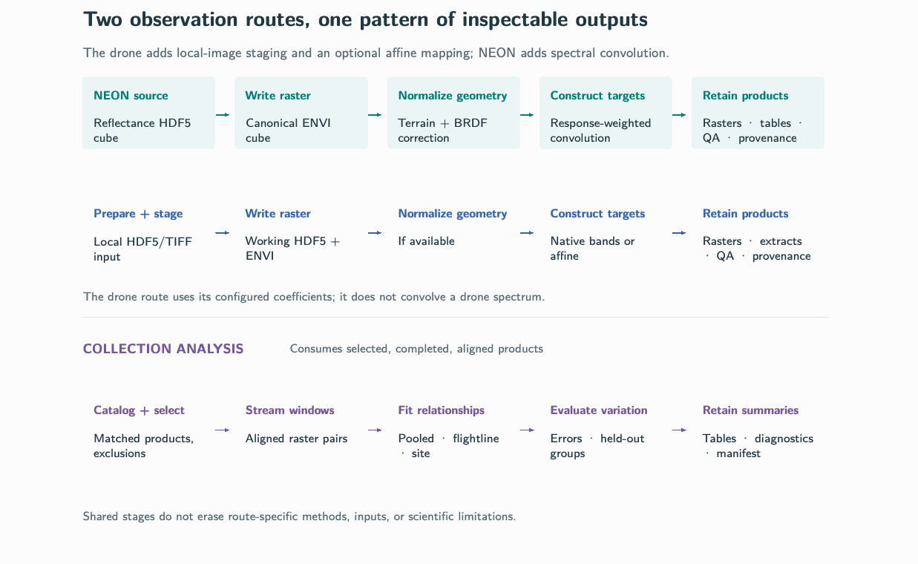
Figure 2. The NEON and drone routes share most stages and retain similar rasters, tables, and QA/provenance. Drone processing adds local input staging and may apply a configured affine mapping; NEON processing convolves its dense spectrum with target-band responses. The shared collection path streams selected, aligned products into grouped fits and diagnostics. The diagram shows intended workflow structure, not one campaign’s results (Earth Lab 2026j, 2026m, 2026h, 2026x, 2026a).
The architecture evolved from a HyTools-based workflow; HyTools is no longer a runtime dependency, but lineage remains in NEON access, ENVI writing, and correction components (Chlus et al. 2025; Earth Lab 2025a, 2025b, 2026i, 2026t, 2026r). The NEON route applies configured geometry corrections and spectral weighting to its source cube. The drone route retains native bands and may apply reviewed affine coefficients, without runtime coefficient fitting or spectral convolution (Earth Lab 2026e, 2026m, 2026h, 2026c). Collection analysis streams aligned ENVI windows into pooled, flightline-, and site-level fits. It accumulates compact statistics but still reads source rasters; no performance advantage is claimed without a matched benchmark (Earth Lab 2026a, 2026aa, 2026b). Named files serve as stage interfaces, not disposable cache. This design lets users inspect intermediate states, check stage-specific QA, and reuse valid products after interruption; it costs storage and I/O, and does not serialize every realized parameter. Restart therefore supports recovery, not guaranteed exact replay. Completion is request-specific: every configured output must exist and be readable (Earth Lab 2026j, 2026d, 2026ad, 2026u).
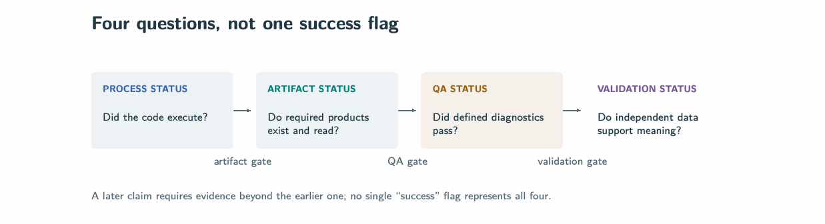
Figure 3. Four questions govern a multi-stage scientific workflow. Normal process termination does not establish production of the requested scientific state; artifact existence does not establish QA; and QA does not establish agreement with independent observations. Remote-sensing validation frameworks likewise treat validation as staged evidence rather than a binary declaration (Morisette et al. 2006; Origo et al. 2020). The examples in the Research impact statement illustrate these separate checks (SpectralBridge project team 2026; Earth Lab 2026p).
The package is OS-independent, requires Python 3.10 or newer, and is distributed under the GNU General Public License version 3 (GPLv3); installation and usage are documented in its README (Earth Lab 2026v, 2026x). The evidence spans version 2.2.0 at f7e7ddd for the historical NEON route and c86da6a for later bulk work and 2.3.0rc1 preparation, but supplied run records do not link every result to an exact revision (Earth Lab 2026y, 2026g). The public release page listed v1.0.0 at commit 9d1de28 as latest on 12 October 2026; the cited Zenodo DOI is a pre-rename archive, not a record for these results (Earth Lab 2026w, 2026f). The supplementary material distinguishes these historical source and execution records.

Reuse potential
Reuse is most direct for NEON products and drone observations that match the supported input schemas. Users can configure target-band responses or reviewed affine registries, while preserving exact wavelength definitions and coefficient provenance; adding spatial aggregation or a new sensor remains a study-specific extension. The ENVI, Parquet, and JSON products can then be inspected or consumed by downstream analysis tools (Earth Lab 2026m, 2026h, 2026x).

Research impact statement
The examples below come from the authors’ ongoing research workflow for comparing NEON, drone, and Landsat reflectance; they are developer-team applications, not evidence of external adoption. Deterministic fixtures cover convolution, correction, extraction, QA, restart, and collection-analysis contracts (Kanewala and Bieman 2014; Earth Lab 2026ac, 2026n). In the R10C NEON example, the declared route produced 18 readable Parquet outputs, while QA retained warnings, including 68 poor-quality wavelength bands that were reported but not masked. This demonstrates artifact completion and warning preservation, not correction efficacy or agreement with Landsat (Earth Lab 2026p, 2026q). A separate 43-flight drone attempt exposes the value of explicit completion checks: orchestration labeled all flights processed, but required ENVI and Parquet outputs were absent (SpectralBridge project team 2026). A supplied bulk analysis summarizes 122 flightlines, but its executed software revision and run manifest were not provided (SpectralBridge bulk evidence bundle 2026; Earth Lab 2026o). Together, these cases show how the workflow can expose incomplete production, preserve warnings, and summarize collections while making the limits of the evidence visible. They do not establish independent cross-sensor accuracy, a performance advantage, improved ecological inference, or adoption beyond the developer team.

AI usage disclosure
The authors report beginning with GPT-3.5 for early consultation and subsequently using all later models available in their workflow. This early history predates the repository's partial prompt log, which records OpenAI Codex and Cursor Agent. Recorded model labels for Codex include GPT-5, GPT-5 family (exact deployment identifier not exposed), and GPT-6. Cursor entries and most historical Codex entries do not identify a model; unrecorded model versions are not inferred (Earth Lab, 2026, AI Transparency Statement).
Logged requests cover software implementation and refactoring, regression and contract tests, pipeline debugging, source and licensing audits, documentation and release preparation, QA visualization, analysis-table checks, and manuscript conversion and citation checks. Requested verification includes automated tests, linting, documentation checks, installed-artifact smoke tests, and inspection of numerical and rendered outputs. The log begins on 21 March 2026, after development was underway, and records user requests rather than accepted outputs or proof that every requested check was completed.
Human team members reviewed proposed software changes, citations, and calculations. AI output was not treated as scientific evidence; the authors retain responsibility for the software, scientific interpretation, and manuscript. [AUTHOR INPUT REQUIRED: confirm that human authors reviewed, edited and validated all AI-assisted outputs and made the core design decisions.]

Acknowledgements
[AUTHOR INPUT REQUIRED: list financial support and award numbers, describe sponsor involvement, or confirm no financial support.]
Conflicts of interest: [AUTHOR INPUT REQUIRED: provide the authors’ disclosure or confirm that there are no relevant conflicts.]

References
Barsi, Julia, Kenton Lee, Geir Kvaran, Brian Markham, and Jeffrey Pedelty. 2014. “The Spectral Response of the Landsat-8 Operational Land Imager.” Remote Sensing 6 (10): 10232–51. https://doi.org/10.3390/rs61010232.
Chander, Gyanesh, Nischal Mishra, Dennis L. Helder, David B. Aaron, Amit Angal, Taeyoung Choi, Xiaoxiong Xiong, and David R. Doelling. 2013. “Applications of Spectral Band Adjustment Factors (SBAF) for Cross-Calibration.” IEEE Transactions on Geoscience and Remote Sensing 51 (3): 1267–81. https://doi.org/10.1109/TGRS.2012.2228007.
Chlus, Adam, Zhiwei Ye, Ting Zheng, Natalie Queally, Evan Greenberg, and Philip A. Townsend. 2025. “HyTools: Hyperspectral image processing library.” https://doi.org/10.5281/zenodo.16900026.
Claverie, Martin. 2023. “Evaluation of surface reflectance bandpass adjustment techniques.” ISPRS Journal of Photogrammetry and Remote Sensing 198: 210–22. https://doi.org/10.1016/j.isprsjprs.2023.03.011.
Claverie, Martin, Junchang Ju, Jeffrey G. Masek, Jennifer L. Dungan, Eric F. Vermote, Jean-Claude Roger, Sergii V. Skakun, and Christopher Justice. 2018. “The Harmonized Landsat and Sentinel-2 surface reflectance data set.” Remote Sensing of Environment 219: 145–61. https://doi.org/10.1016/j.rse.2018.09.002.
Di Tommaso, Paolo, Maria Chatzou, Evan W Floden, Pablo Prieto Barja, Emilio Palumbo, and Cedric Notredame. 2017. “Nextflow enables reproducible computational workflows.” Nature Biotechnology 35 (4): 316–19. https://doi.org/10.1038/nbt.3820.
Dungan, J. L., J. N. Perry, M. R. T. Dale, P. Legendre, S. Citron‐Pousty, M.‐J. Fortin, A. Jakomulska, M. Miriti, and M. S. Rosenberg. 2002. “A balanced view of scale in spatial statistical analysis.” Ecography 25 (5): 626–40. https://doi.org/10.1034/j.1600-0587.2002.250510.x.
Earth Lab. 2026. “SpectralBridge AI Transparency Statement.” https://github.com/earthlab/spectralbridge/blob/main/docs/ai-transparency.md.
Earth Lab. 2025a. “SpectralBridge history: HyTools compatibility and dependency work, 8–23 October 2025.” https://github.com/earthlab/spectralbridge/commits/main/?since=2025-10-08&until=2025-10-23.
———. 2025b. “SpectralBridge history: transition to internal NEON processing components, 27–28 October 2025.” https://github.com/earthlab/spectralbridge/commits/main/?since=2025-10-27&until=2025-10-28.
———. 2026a. “Build a bulk cross-run analysis.” https://github.com/earthlab/spectralbridge/blob/c86da6a642a8a0bef37108df31af1fed1a882bd2/docs/vignettes/bulk-analysis.md.
———. 2026b. “Bulk pipeline implementation: September snapshot.” https://github.com/earthlab/spectralbridge/blob/c86da6a642a8a0bef37108df31af1fed1a882bd2/src/spectralbridge/pipelines/bulk.py.
———. 2026c. “Bulk population-analysis pipeline source.” https://github.com/earthlab/spectralbridge/blob/f7e7ddd2e01ee5f7cd74688eb479fd12fbc0b705/src/spectralbridge/pipelines/bulk.py.
———. 2026d. “Carry On My Wayward Son: resume a run.” https://github.com/earthlab/spectralbridge/blob/f7e7ddd2e01ee5f7cd74688eb479fd12fbc0b705/docs/vignettes/carry-on-wayward-son.md.
———. 2026e. “Core NEON pipeline source.” https://github.com/earthlab/spectralbridge/blob/f7e7ddd2e01ee5f7cd74688eb479fd12fbc0b705/src/spectralbridge/pipelines/pipeline.py.
———. 2026f. “DOI and Zenodo status.” https://github.com/earthlab/spectralbridge/blob/f7e7ddd2e01ee5f7cd74688eb479fd12fbc0b705/docs/dev/doi-zenodo.md.
———. 2026g. “Finalize SpectralBridge 2.3.0rc1 preparation.” https://github.com/earthlab/spectralbridge/commit/c86da6a642a8a0bef37108df31af1fed1a882bd2.
———. 2026h. “Module vignette 6: process drone imagery.” https://github.com/earthlab/spectralbridge/blob/f7e7ddd2e01ee5f7cd74688eb479fd12fbc0b705/docs/vignettes/drone-processing.md.
———. 2026i. “NeonCube and NEON ancillary-data implementation.” https://github.com/earthlab/spectralbridge/blob/f7e7ddd2e01ee5f7cd74688eb479fd12fbc0b705/src/spectralbridge/neon_cube.py.
———. 2026j. “Package architecture.” https://github.com/earthlab/spectralbridge/blob/f7e7ddd2e01ee5f7cd74688eb479fd12fbc0b705/docs/dev/architecture.md.
———. 2026k. “Packaged Landsat and MicaSense band definitions.” https://github.com/earthlab/spectralbridge/blob/f7e7ddd2e01ee5f7cd74688eb479fd12fbc0b705/src/spectralbridge/data/landsat_band_parameters.json.
———. 2026l. “Packaged Landsat brightness adjustments derived from Table Moun- tain HLS medians.” https://github.com/earthlab/spectralbridge/tree/f7e7ddd2e01ee5f7cd74688eb479fd12fbc0b705/src/spectralbridge/data/brightness.
———. 2026m. “Pipeline outputs and file structure.” https://github.com/earthlab/spectralbridge/blob/f7e7ddd2e01ee5f7cd74688eb479fd12fbc0b705/docs/pipeline/outputs.md.
———. 2026n. “Production validation record.” https://github.com/earthlab/spectralbridge/blob/f7e7ddd2e01ee5f7cd74688eb479fd12fbc0b705/docs/dev/production-validation-record.md.
———. 2026o. “Production validation record: September snapshot.” https://github.com/earthlab/spectralbridge/blob/c86da6a642a8a0bef37108df31af1fed1a882bd2/docs/dev/production-validation-record.md.
———. 2026p. “R10C combined QA record.” https://github.com/earthlab/spectralbridge/blob/f7e7ddd2e01ee5f7cd74688eb479fd12fbc0b705/docs/validation/artifacts/r10c-l002-20210915/qa/combined/combined_qa.json.
———. 2026q. “Real flightline QA walkthrough: R10C, D10, L002, 2021-09-15.” https://github.com/earthlab/spectralbridge/blob/f7e7ddd2e01ee5f7cd74688eb479fd12fbc0b705/docs/validation/real-data-example.md.
———. 2026r. “SCS+C and kernel-driven BRDF correction implementation.” https://github.com/earthlab/spectralbridge/blob/f7e7ddd2e01ee5f7cd74688eb479fd12fbc0b705/src/spectralbridge/corrections.py.
———. 2026s. “Spectral resampling source.” https://github.com/earthlab/spectralbridge/blob/f7e7ddd2e01ee5f7cd74688eb479fd12fbc0b705/src/spectralbridge/resample.py.
———. 2026t. “SpectralBridge ENVI header and writer implementation.” https://github.com/earthlab/spectralbridge/blob/f7e7ddd2e01ee5f7cd74688eb479fd12fbc0b705/src/spectralbridge/envi_writer.py.
———. 2026u. “SpectralBridge outputs and file structure.” https://earthlab.github.io/spectralbridge/pipeline/outputs/.
———. 2026v. “SpectralBridge package metadata.” https://github.com/earthlab/spectralbridge/blob/f7e7ddd2e01ee5f7cd74688eb479fd12fbc0b705/pyproject.toml.
———. 2026w. “SpectralBridge public GitHub releases.” https://github.com/earthlab/spectralbridge/releases.
———. 2026x. “SpectralBridge repository README: September release-candidate snapshot.” https://github.com/earthlab/spectralbridge/blob/c86da6a642a8a0bef37108df31af1fed1a882bd2/README.md.
———. 2026y. “SpectralBridge source repository, commit f7e7ddd2e01ee5f7cd74688eb479fd12fbc0b705.” https://github.com/earthlab/spectralbridge/tree/f7e7ddd2e01ee5f7cd74688eb479fd12fbc0b705.
———. 2026z. “SpectralBridge: Start Here.” https://github.com/earthlab/spectralbridge/blob/f7e7ddd2e01ee5f7cd74688eb479fd12fbc0b705/START_HERE.md.
———. 2026aa. “Streaming bulk statistics implementation.” https://github.com/earthlab/spectralbridge/blob/c86da6a642a8a0bef37108df31af1fed1a882bd2/src/spectralbridge/bulk/streaming.py.
———. 2026ab. “Topographic and BRDF implementation.” https://github.com/earthlab/spectralbridge/blob/f7e7ddd2e01ee5f7cd74688eb479fd12fbc0b705/src/spectralbridge/brdf_topo.py.
———. 2026ac. “Validation evidence index.” https://github.com/earthlab/spectralbridge/blob/f7e7ddd2e01ee5f7cd74688eb479fd12fbc0b705/docs/validation/index.md.
———. 2026ad. “Validation—save and restart behavior.” https://github.com/earthlab/spectralbridge/blob/f7e7ddd2e01ee5f7cd74688eb479fd12fbc0b705/docs/validation/save_restart.md.
———. 2026ae. “Validation—sensor convolution.” https://github.com/earthlab/spectralbridge/blob/f7e7ddd2e01ee5f7cd74688eb479fd12fbc0b705/docs/validation/sensor_convolution.md.
Frantz, David. 2019. “FORCE—Landsat + Sentinel-2 Analysis Ready Data and Beyond.” Remote Sensing 11 (9): 1124. https://doi.org/10.3390/rs11091124.
Huang, Chengquan, John R. G. Townshend, Shunlin Liang, Satya N. V. Kalluri, and Ruth S. DeFries. 2002. “Impact of sensor’s point spread function on land cover characterization: assessment and deconvolution.” Remote Sensing of Environment 80 (2): 203–12. https://doi.org/10.1016/S0034-4257(01)00298-X.
Ju, Junchang, Qiang Zhou, Brian Freitag, David P. Roy, Hankui K. Zhang, Madhu Sridhar, John Mandel, et al. 2025. “The Harmonized Landsat and Sentinel-2 version 2.0 surface reflectance dataset.” Remote Sensing of Environment 324: 114723. https://doi.org/10.1016/j.rse.2025.114723.
Kampe, Thomas U., Brian R. Johnson, Michele A. Kuester, and Michael Keller. 2010. “NEON: the first continental-scale ecological observatory with airborne remote sensing of vegetation canopy biochemistry and structure.” Journal of Applied Remote Sensing 4 (01): 1–24. https://doi.org/10.1117/1.3361375.
Kanewala, Upulee, and James M. Bieman. 2014. “Testing scientific software: A systematic literature review.” Information and Software Technology 56 (10): 1219–32. https://doi.org/10.1016/j.infsof.2014.05.006.
Köster, Johannes, and Sven Rahmann. 2012. “Snakemake—a scalable bioinformatics workflow engine.” Bioinformatics 28 (19): 2520–22. https://doi.org/10.1093/bioinformatics/bts480.
Li, X., and A. H. Strahler. 1992. “Geometric-optical bidirectional reflectance modeling of the discrete crown vegetation canopy: effect of crown shape and mutual shadowing.” IEEE Transactions on Geoscience and Remote Sensing 30 (2): 276–92. https://doi.org/10.1109/36.134078.
Morisette, J. T., F. Baret, J. L. Privette, R. B. Myneni, J. E. Nickeson, S. Garrigues, N. V. Shabanov, et al. 2006. “Validation of global moderate-resolution LAI products: a framework proposed within the CEOS land product validation subgroup.” IEEE Transactions on Geoscience and Remote Sensing 44 (7): 1804–17. https://doi.org/10.1109/TGRS.2006.872529.
National Ecological Observatory Network. 2026. “Spectrometer orthorectified surface directional reflectance - flightline (DP1.30006.001).” National Ecological Observatory Network (NEON). https://doi.org/10.48443/jhbd-n155.
Nicodemus, F E, J C Richmond, J J Hsia, I W Ginsberg, and T Limperis. 1977. “Geometrical considerations and nomenclature for reflectance.” NBS Monograph 160. National Bureau of Standards; National Bureau of Standards. https://doi.org/10.6028/NBS.MONO.160.
Origo, Niall, Javier Gorroño, James Ryder, Joanne Nightingale, and Agnieszka Bialek. 2020. “Fiducial Reference Measurements for validation of Sentinel-2 and Proba-V surface reflectance products.” Remote Sensing of Environment 241: 111690. https://doi.org/10.1016/j.rse.2020.111690.
Queally, Natalie, Zhiwei Ye, Ting Zheng, Adam Chlus, Fabian Schneider, Ryan P. Pavlick, and Philip A. Townsend. 2022. “FlexBRDF: A Flexible BRDF Correction for Grouped Processing of Airborne Imaging Spectroscopy Flightlines.” Journal of Geophysical Research: Biogeosciences 127 (1): e2021JG006622. https://doi.org/10.1029/2021JG006622.
Ross, Juhan. 1981. The radiation regime and architecture of plant stands. Springer Netherlands. https://doi.org/10.1007/978-94-009-8647-3.
Roujean, Jean‐Louis, Marc Leroy, and Pierre‐Yves Deschamps. 1992. “A bidirectional reflectance model of the Earth’s surface for the correction of remote sensing data.” Journal of Geophysical Research: Atmospheres 97 (D18): 20455–68. https://doi.org/10.1029/92JD01411.
Roy, D. P., V. Kovalskyy, H. K. Zhang, E. F. Vermote, L. Yan, S. S. Kumar, and A. Egorov. 2016. “Characterization of Landsat-7 to Landsat-8 reflective wavelength and normalized difference vegetation index continuity.” Remote Sensing of Environment 185: 57–70. https://doi.org/10.1016/j.rse.2015.12.024.
Saunier, Sébastien, Bringfried Pflug, Italo Lobos, Belen Franch, Jérôme Louis, Raquel De Los Reyes, Vincent Debaecker, et al. 2022. “Sen2Like: Paving the Way towards Harmonization and Fusion of Optical Data.” Remote Sensing 14 (16): 3855. https://doi.org/10.3390/rs14163855.
Schaaf, Crystal B, Feng Gao, Alan H Strahler, Wolfgang Lucht, Xiaowen Li, Trevor Tsang, Nicholas C Strugnell, et al. 2002. “First operational BRDF, albedo nadir reflectance products from MODIS.” Remote Sensing of Environment 83 (1-2): 135–48. https://doi.org/10.1016/S0034-4257(02)00091-3.
Schaepman-Strub, G., M. E. Schaepman, T. H. Painter, S. Dangel, and J. V. Martonchik. 2006. “Reflectance quantities in optical remote sensing—definitions and case studies.” Remote Sensing of Environment 103 (1): 27–42. https://doi.org/10.1016/j.rse.2006.03.002.
Soenen, S. A., D. R. Peddle, and C. A. Coburn. 2005. “SCS+C: a modified Sun-canopy-sensor topographic correction in forested terrain.” IEEE Transactions on Geoscience and Remote Sensing 43 (9): 2148–59. https://doi.org/10.1109/TGRS.2005.852480.
SpectralBridge bulk evidence bundle. 2026. “SpectralBridge bulk results visual report and numerical exports.”
SpectralBridge project team. 2026. “2023–2024 drone campaign production inventory.”
Teillet, P. 1997. “Effects of spectral, spatial, and radiometric characteristics on remote sensing vegetation indices of forested regions.” Remote Sensing of Environment 61 (1): 139–49. https://doi.org/10.1016/S0034-4257(96)00248-9.
Wanner, W., X. Li, and A. H. Strahler. 1995. “On the derivation of kernels for kernel‐driven models of bidirectional reflectance.” Journal of Geophysical Research: Atmospheres 100 (D10): 21077–89. https://doi.org/10.1029/95JD02371.
Woodcock, Curtis E., and Alan H. Strahler. 1987. “The factor of scale in remote sensing.” Remote Sensing of Environment 21 (3): 311–32. https://doi.org/10.1016/0034-4257(87)90015-0.

