The Grandfather Paradox: revisted by KEVIN YUAN-KUNG HUANG 11/24/2023
+1 647 712 1984 (whatsapp)
general8dstar@gmail.com or quantumbiotch@gmail.com

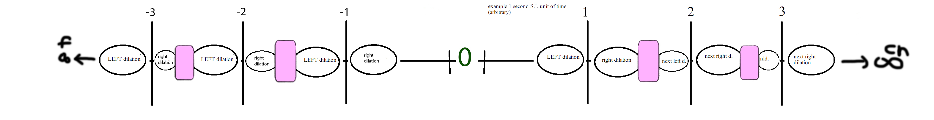

What I hope to discuss here is the Grandfather Paradox and Time-Quantum Wormholes and Time itself.
I believe Time and all of the local reality (our local universe) is just a wave of time in 1 dimension that vibrates. Otherwise no vibration of the 1D line of time would mean zero time or no time.

Conservation of time vs moment
A moment is perceived by consciousnesses (organic) and stored as fractal action-reaction in the brain field that is made up of tubulars of synaspses that communicate quickly in a fractally activated, grown pattern.
But elementally, time is everything and an instant
I believe time balances out at “regular” standard international units or standard uninversal units so that paradoxes are avoided at this specific YING-YANG balance points.

EISTEIN RELATIVITY
Was the math/science relative to 0 time? Because we know scientists assume 0 time as a relative point, this could be understood as the pinnacle arc of a object thrown in presence of gravity.
Perhaps a new theory could better use the phrases RECURSIVE FRACTAL PARAODIXCAL or RFP

+1 0 -1

If you can plan recursively in the future but also affect the past paradoxically (if you don't use perfect math and/or have evil intentions or from natural affect) then the space inbetween 1 time unit and the next time unit is another zone. This zone is a conservation of time. Where natural or non natural (consciouness effected time waves) seem to constrctively/de-constructively just balance out like ripples in a pond.

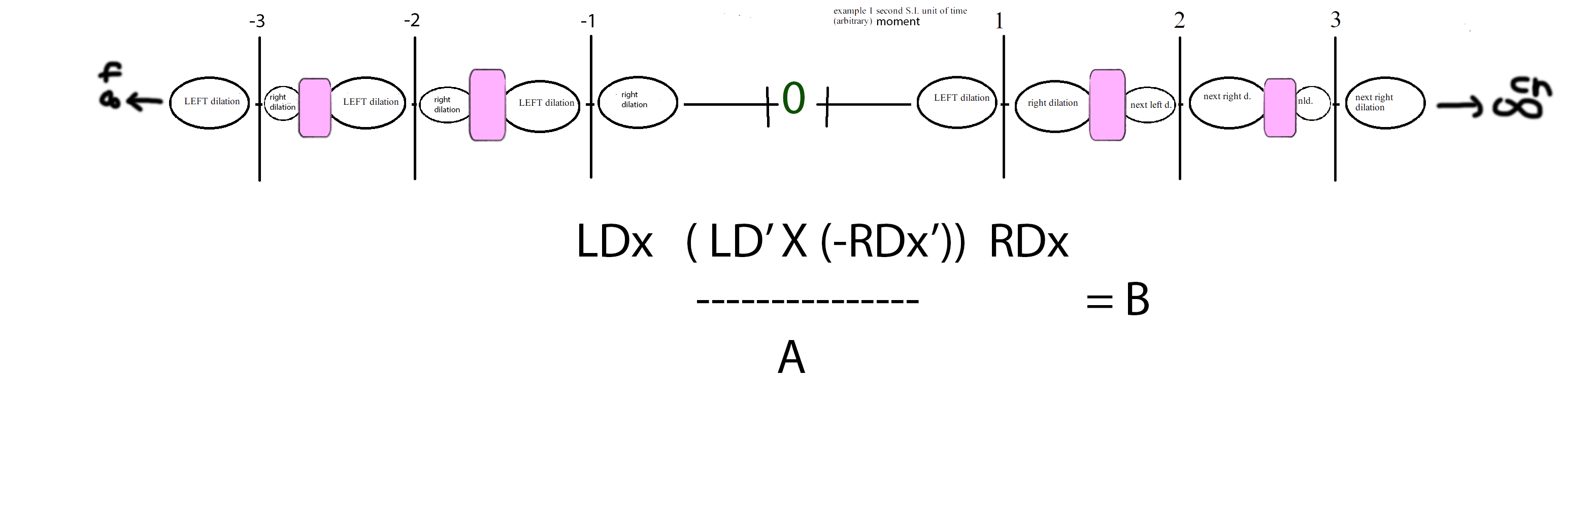

Definitions:
LDx' Using negtiave energy to affect the past with time crystals you can use calculus
-RDx' Use recursive thinking or actions to affect the future, the negative sign is to signal things can move forward and back easily with negativity in formulas and understandings of reality. It's really a trick to make you think but also a forward calculus derivation should really have a negative sign infront of it.


LDx or RDx
Is the natural balance of time between moments of time or it could be seen as an instant time example. Since there is a possibility of time travel a possible paradoxical event will affect the time wave instantly through out “history to the present or the future”. Thus both represent paraoxidical and recursive actions naturally balance out, but paradoxical could be natural like strong Gravity waves from a black whole or through tampering by consciousnesses.
I call this area Conservation of time waves
1D Is a line that actually is a wave as a straight line would be 0 time.
2D A matrix which could be seen as a table of multiplication or Fractal or digital video fractally represented.
3D A field of space where matter exists in a realm of perception by biological life and just matter.
F infinity A fractal big bang that really is just part of a fractal possible multi universe or next level or plane of existence backwards not forwards fractally.
CN Recursively forward until the end of the universe but if we can turn back time we can turn back space-time and paradoxically safely move all planets back closer to each other to an earlier universe.
And if we find a way to turn the wasted energy from stars back into matter, there could be a great aritifical or consciousness made contraction of the universe.
Think linear accelerators and bose-eistein condenstates – Turning energy back into matter.
X Is multiplication but really it's a metaphorical relationship between paradoxes, recursive forward actions in fluctuations in time which is a vibrating line.

A The relationship that is close beweteen paradoxical present (moment since we as beings perceive instant or moments in spans of time since time is infinitely small in s.i. Units) and recursive future products due to action re-action.
B Symoblizes Time, something very simple but very complex.
Do not get confused with Alice and Bob with wormholes via Leonard Susskind.

Fractal Means an Algorithm or Steps and Knowledge or Logic and Science or Logic/Steps and Philosophy.

Wormholes

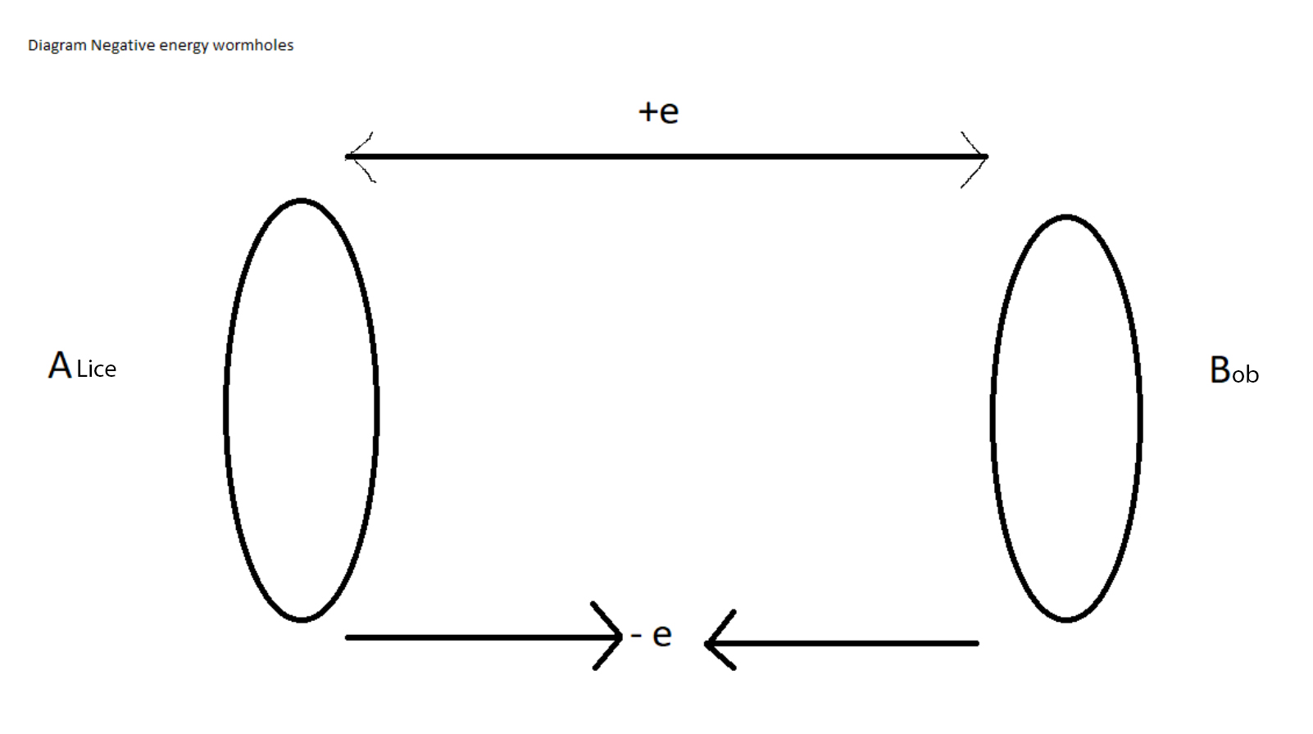

Some more Definitions in a contextual all perspective way:

Algorithm Logical and philsophy or Steps and Understandings

Coherence vs Decoherence Kind of reversed maybe?

The wiggle of everthing is often thought of as decoherence. But in fact, we are all in coherence with each other, the whole universe moves forward in time safely because if not we are not safe. If not all are safe, no one is safe. So wiggles that are thought of as a challenge is actually what we have to reverse calculate with algorithms of fractals to get past singularity and have negative energy to be used to make wormholes, food making machines (think Star Trek) and other quantum technological solutions like UFO/UAP spacecraft.

If done unsafely, Alice and Bob could individually be lost to the other in space and time because the were displaced with a paradox or or not able to mathematically return to same relative "time zone".
This is what can be learned from the newer discovery of Time Crystals.

Wormholes >|<

Leonard Susskind in a youtube video has described the wormhole as in a sense a traversable door to another door. The problems to make the doors close enough (superposition?) to open and walk through. For some reason space and/time is expanding so any existing door or possible future doors will drift apart preventing the “contraction or superposition” of the doors to make it “open-able” or traversible.

So to pull the space and time together to make sort 1 door. You'll need an energy that's sort of "opposite" = negative energy.

Negative Energy and Crystals (Time Crystals?)

Watch style piezoelectric cystals create spark or static or energy when compressed. But what if negative pressure is forced or vacuumed?

If a time crystal is more stable in time in that it vibrates or moves less at time segments than let's say a human does, that could mean something about the wobble or coherence is diffferent with other types of matter arrangements? Could a time crystal be more stable in a way it more easy to caculate with calculus or fractals the "proper" or "right amount so that negative energy is generated?
High frequency NEMS/MEMS (nano/micro electronic mechanical systems) could be arranged in and/or around time crystals (or an array of them) with piezo electric like non-symmetry as to push and pull on the atomic arrangements so that the system in whole has possitive and negative forces/pressures to create positive and negative energy in much a similar way to piezoelectric crystals.

So to create or generate or harness or transmt or transform (the descriptive word to be used has yet to be picked) negative energy, fractals must be used to reverse or forward calculate a fractal algorithm with an ending or singularity that must be surpassed.
The "point" to surpass is a singularity. But time could be many singularities with dialiations that must cohere or mix in a regular way, not time itself or the markeable segments we use to measure and use.

Fields and ways to use or generate them?

A time crystal then could be thought as a time-matter field

A time-space field should then exist by definition of the above?
The universe has pointed me now to the idea a STARGATE (the technology from StarGate the movie and T.V. franchise) could be possible through fields quantum entangled with itself and streteched over a distance by traditional kinematic locomotion. See the next chapter for Stargate workings.
A time-field would then must exist and be used as a confinement "area":

Let's make two categories of ramifications:
A. Quantum entanglment of space which would mean traverseable wormholes

B. Ethical and safefood quantum replicators that are sort of like Star Trek/science fiction food replicators but not the moving live or any matter site to site transporters. Just make dead food layer by layer by “teleporting” or with the proper term, through time-quantum-wormholes with dead on accuracy.

StarGates/Wormholes
A Man made wormhole would be something as simple as following the metaphors in the franchise, Stargate.
In Stargate, the liquid that we see appears to be a metaphor for a singularity.
In fact, following that train of thought put forth here in this paper, we actually do need a substance like liquid made of normal to meta-normal atoms.
Since we need a field to exist and to entangle and stretch or carry information and/or matter to another point in space, we could easily use something that already has fields. Atoms have orbital fields.
We need to pick an element from table of elements that is liquid at room temperature (so our bodies can handle the thermal variations) as well, we need a element that is not too dense so we can easily walk through the liquid with ease. Perhaps molecules work as well such as H2O/water but perhaps we can do better.
What if we used a meta-atom, a Man made atom with electron orbitals numerous in levels that perhaps had the largest or suitable largest we need orbital field.
Then, we need to quantum entangle all the atoms, separate them via a safe distance (see last chapter), and we would then have a traversible wormhole when we needed it.
This meta-atom could be made by quantum entangling atoms and learning particle orbital mechanics and then at the right 'time' adjust or had orbital levels through quantum wormholes themselves. Whoops!
Likely we will have to have a supply of negative energy to keep the doors in superposition to make it actually traversible by matter. Then again, perhaps, information can be sent with the most minimal ammount of negative energy. Since information is energy or wave, it is much smaller relatively to the size of a human body.
Time, again

If a time crystal wobbles or is a little "less" wobbly than regular matter in other arrangements, then zero time could be thought as a singularity in a hypothetical fractal? Sort of!

But what are in between the singularities of time? What is in between the tick tocks or Standard International units of time-moments?

Well since now we can control or move time relativeness, we must find a way to deal with the spots inbetween time segments. But either side of singularity has a fractal animation or maybe dilations to confine the time segment. THEN! what are the spots between the dilations that is on one "side" of a time segment? Could it be a time field that must be calculated? If dilations are thought as waves like SINE then some simple way to think about it would be interference that keeps time sane!
Negative energy storage possibility, a wild guess
How do we store negative energy, from the High Frequency actuated time crystal negative energy generator device?
Well as the time crystal is pulled a part with a negative force (much like a vacuum), when the negative energy is harnessed from the local universe, there must be a way to store the energy.
When we discover or if we discover negative matter, we could make negative energy batteries or capacitors/super-capacitors (solid state negative energy fields) to store for later use.
Alternatively, I wonder if we could use negative matter magnetism in such a way to accelerate negative energy in a linear accelerator to produce negative bose-eistein condenstates.
That is turn energy into matter, or in our case negative energy in to negative matter for later use.
Remember, energy is neither created nor destroyed.

Now my philosophical/religious beliefs and why it matters:
What I think our duty the universe is or our duty to time is, is to do something like the following:
Find the dead with quantum wormhole carrying advanced space ships and maping as many stars as possible as safe as possible to humanity and of course the other beings in the universe and while keeping Time/Universe Safe (don't paradox).
This idea could be seen as Grey Goo (wikipedia) or self-replication often seen in Science Fiction such as in Star Trek where the actor character's 'Rom' and 'Nog' protect the local quadrant of the galaxy with self-replicating time mines placed next to a Relgious Wormhole to prevent invasion by an alien force made up of shape shifting creatures and soldiers genetically engineered and created to fight hand to hand combat. As well in StarGate, there were swarms or small robotic nano-bots that were in fact rat size that would self-replicate and eat any biological beings it was instructed to terminate.
What we need to do is send out probes that carry quantum wormholes with enough of the orbital field generating liquid/atoms where the probes also self-replicate at desitinations with sub light speeds at less than 1 light year distances or through advanced mathmatics of warp drives that also prevent paradoxical effects. The probes would reach a destination, setup a wormhole if instructed, but also map the stars from that relative location.
I believe we will find our lost dead people and ancestors.
Why are the dead alive? The first alien species to discover this science, as we are not the center of the solar system nor the universe, will spread like this and with in a short very short amount of time, they will have control of the local Universe.
LOCAL is the key. That is this universe could be of many, and then what's above or bellow our universe? Bellow is matrixes or time shift univeres (BAD) or we can make universes.
The scary part is that the local universe could already be controlled, owned and quantum entangled by beings from another fractal universe or from meta fractal universes (higher planes of existence).
Finally, If the aliens or alien KING is like god and is kind, he would let us evolve to be beings who on their own harnsessed science to save ourselves from eternal damnation; such as, hunger, poverty, natural aging, death from natural local planetary and space dangers such as asteroids, blackholes, or events in space that could wipe out biological life that has no defenses, such as solar storms or pulsars/magnetars (or worse).
Addendum:
To safely travel in space without the possibility for paradoxes
1. Either travel less than 1 light year at a time to avoid paradoxical affects on nature/beings or effects that could disrupt the universe.
or
2. Travel more than a light year but in a pattern that negates possibility of paradoxical reprocussions.
Remember, there is an s.i. .unit maybe for distances where fluctuations in time regardless if paradoxical or not will indeed balance out. So we must take this into consideration when we go faster than the speed of light. Perhaps the speed no velocity must be at such a scale that there is time for paradoxical events to balance out in time waves before reaching the next time wave balancing s.i. Unit.

