Project Working Title

Concept #1

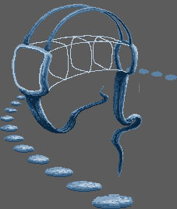

Initial meeting 01/11/16 – Starbucks

“Life is either a daring adventure or nothing at all.”
― Helen Keller, The Open Door

Preliminary ideas/intentions discussed, following format outlined:

- HD resolution, scalable, responsive
- 3D game assets, point and click style, mouse/touch interaction
- Exploration puzzle genre, integral sonic gameplay element
- Unity3D game engine, fixed camera angle (indicated by Concept #1)

Pending tasks:

- Adam is refreshing his knowledge of Blender in order to produce a basic low-poly mesh interpretation of Concept #1
- Sean, let me know what you're thinking/looking into

