# **Tutorial: Create your first Universal Windows Platform application in Visual Studio with XAML and C#**

In this introduction to the Visual Studio integrated development environment (IDE), you'll create a "Hello World" app that runs on any Windows 10 or later device. To do so, you'll use a Universal Windows Platform (UWP) project template, Extensible Application Markup Language (XAML), and the C# programming language.

If you haven't already installed Visual Studio, go to the [Visual Studio downloads](https://visualstudio.microsoft.com/downloads) page to install it for free.

## **Create a project**

First, create a Universal Windows Platform project. The project type comes with all the template files you need, before you've even added anything!

1. Open Visual Studio, and on the start window, choose Create a new project.
2. On the Create a new project screen, enter *Universal Windows* in the search box, choose the C# template for Blank App (Universal Windows), and then choose Next.  
   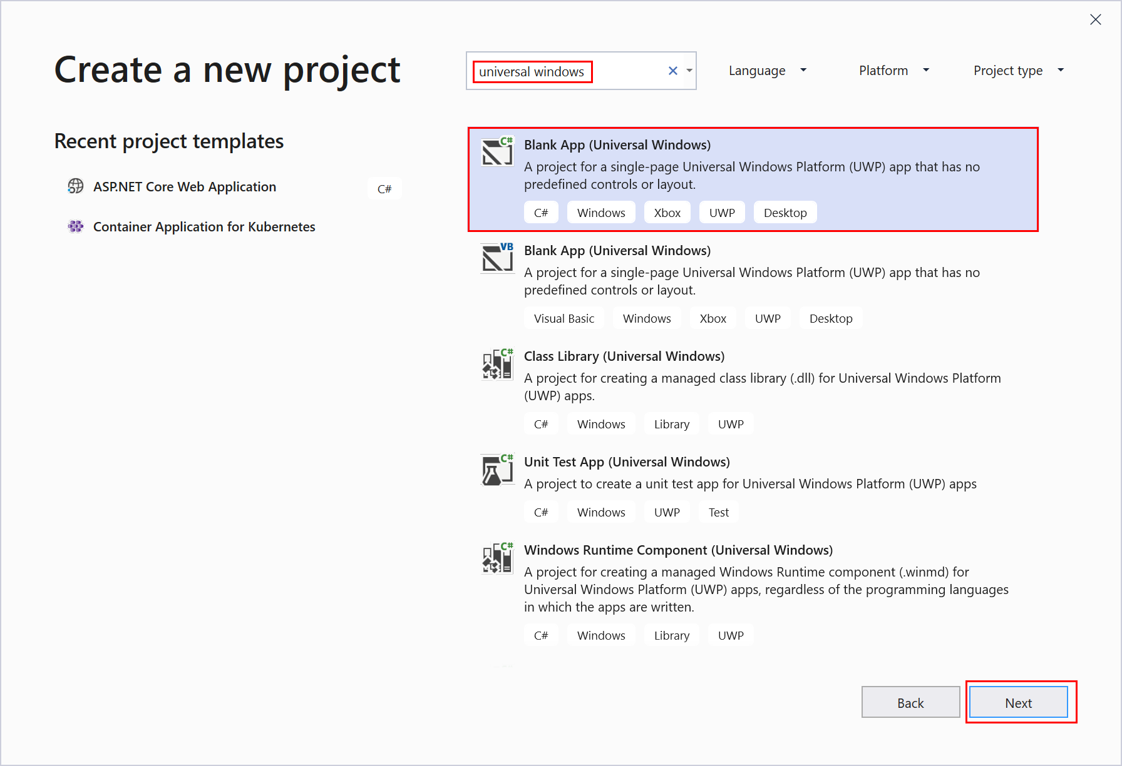  
    Note  
   If you don't see the Blank App (Universal Windows) project template, click the Install more tools and features link.  
     
   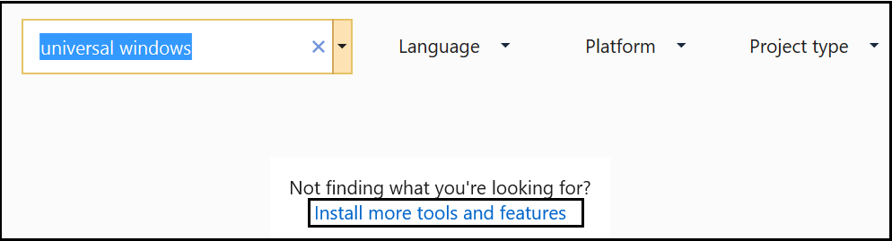  
     
   The Visual Studio Installer launches. Choose the Universal Windows Platform development workload, and then choose Modify.  
     
   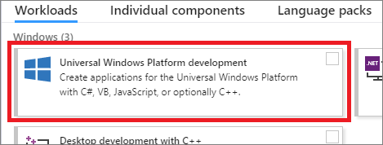
3. Give the project a name, *HelloWorld*, and choose Create.  
   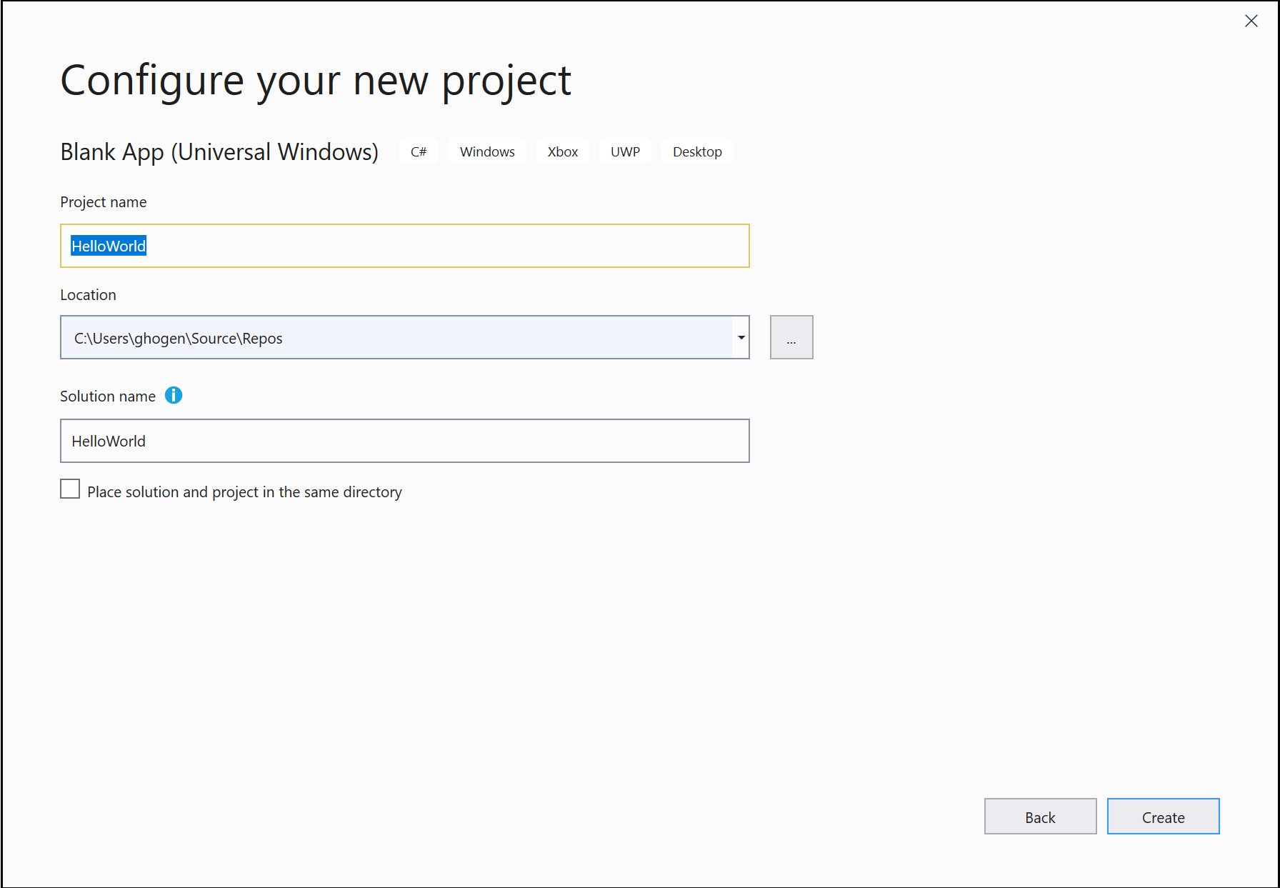
4. Accept the default Target version and Minimum version settings in the New Universal Windows Platform Project dialog box.  
   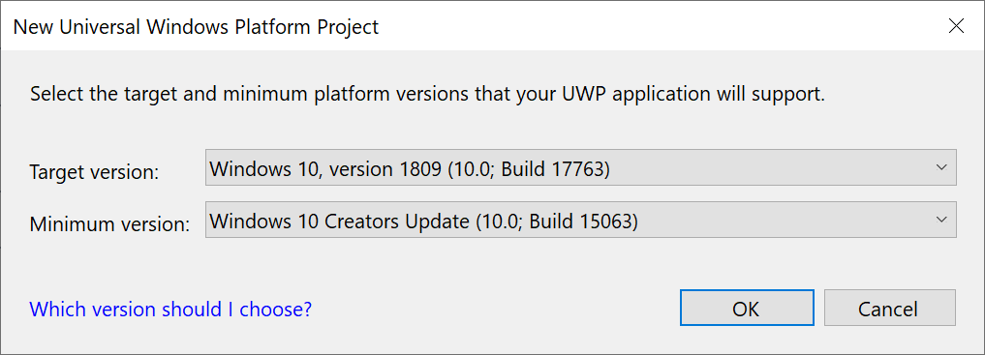

Note

If this is the first time you have used Visual Studio to create a UWP app, a Settings dialog box might appear. Choose Developer mode, and then choose Yes.

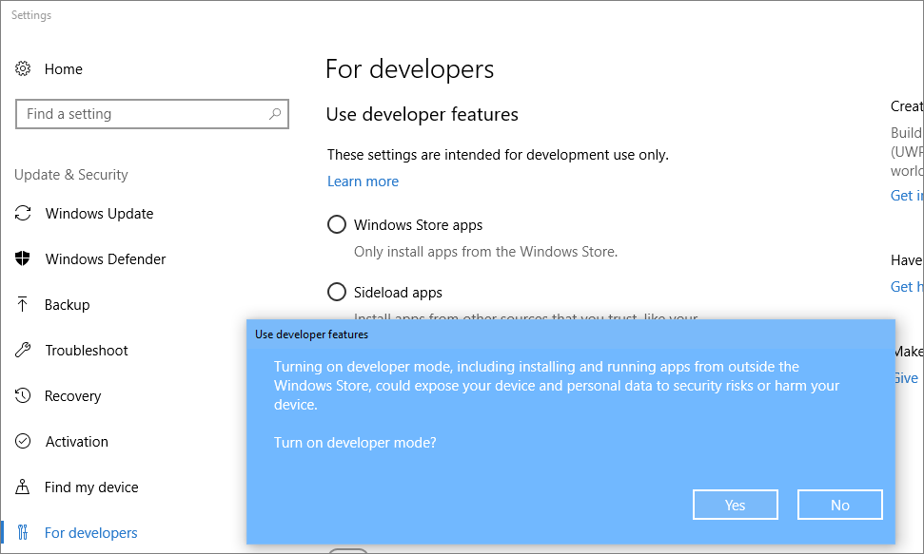

Visual Studio installs an additional Developer Mode package for you. When the package installation is complete, close the Settings dialog box.

## **Create the application**

It's time to start developing. You'll add a button control, add an action to the button, and then start the "Hello World" app to see what it looks like.

### **Add a button to the Design canvas**

1. In the Solution Explorer, double-click *MainPage.xaml* to open a split view.  
   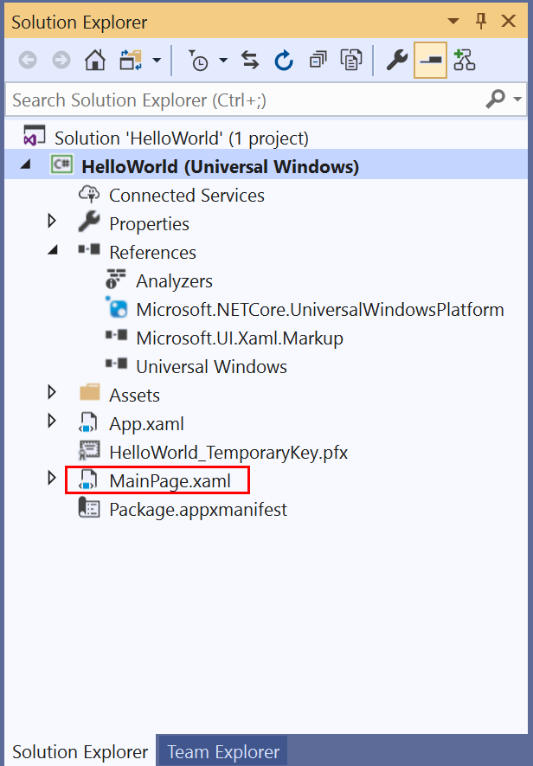  
   There are two panes: The XAML Designer, which includes a design canvas, and the XAML Editor, where you can add or change code.  
   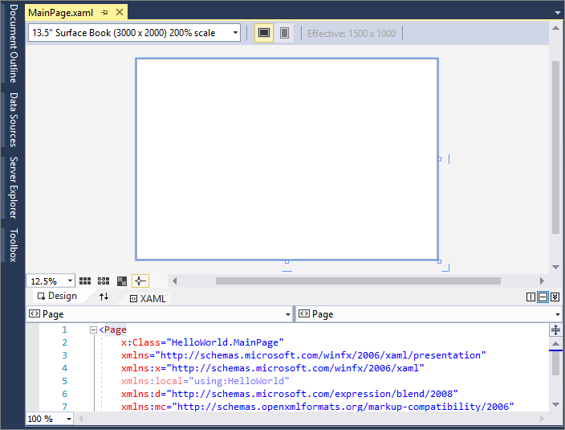
2. Choose Toolbox to open the Toolbox fly-out window.  
   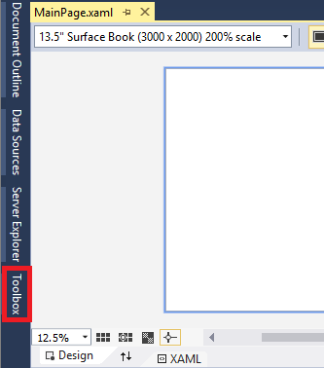  
   (If you don't see the Toolbox option, you can open it from the menu bar. To do so, choose View > Toolbar. Or, press Ctrl+Alt+X.)
3. Click the Pin icon to dock the Toolbox window.  
   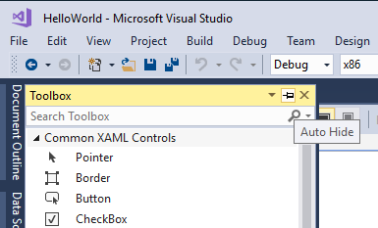
4. Click the Button control and then drag it onto the design canvas.  
   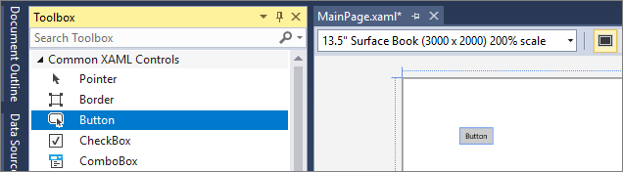  
   If you look at the code in the XAML Editor, you'll see that the Button has been added there, too:  
   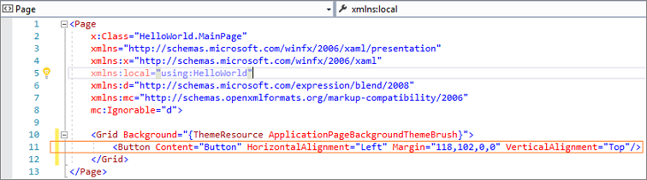

### **Add a label to the button**

1. In the XAML Editor, change Button Content value from "Button" to "Hello World!".  
   Screenshot showing the XAML code for the Button in the XAML editor. The value of the Content property has been changed to 'Hello World!'.
2. Notice that the button in the XAML Designer changes, too.  
   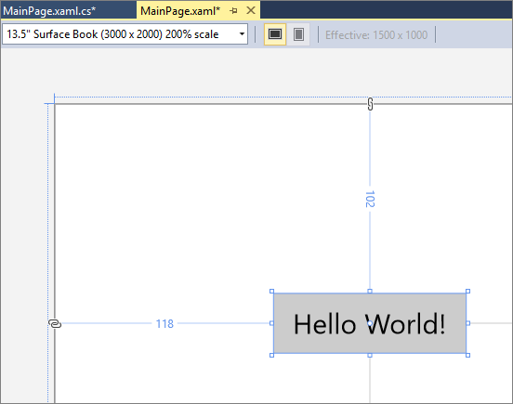

### **Add an event handler**

An "event handler" sounds complicated, but it's just another name for code that is called when an event happens. In this case, it adds an action to the "Hello World!" button.

1. Double-click the button control on the design canvas.
2. Edit the event handler code in *MainPage.xaml.cs*, the code-behind page.  
   Here is where things get interesting. The default event handler looks like this:  
   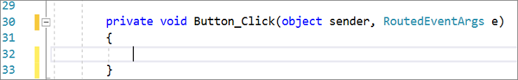  
   Let's change it, so it looks like this:  
   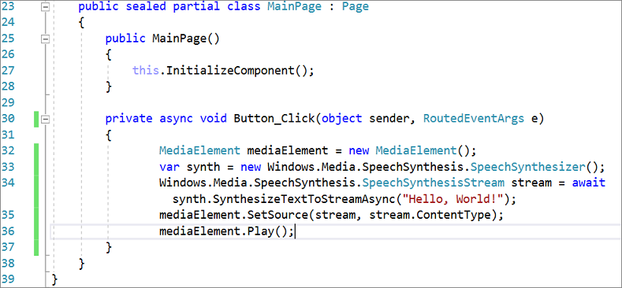  
   Here's the code to copy and paste:
3. C#
4. Copy

private async void Button_Click(object sender, RoutedEventArgs e)

{

MediaElement mediaElement = new MediaElement();

var synth = new Windows.Media.SpeechSynthesis.SpeechSynthesizer();

Windows.Media.SpeechSynthesis.SpeechSynthesisStream stream = await synth.SynthesizeTextToStreamAsync("Hello, World!");

mediaElement.SetSource(stream, stream.ContentType);

mediaElement.Play();

}

#### **What did we just do?**

The code uses some Windows APIs to create a speech synthesis object and then gives it some text to say. (For more information on using SpeechSynthesis, see [System.Speech.Synthesis](https://docs.microsoft.com/en-us/dotnet/api/system.speech.synthesis).)

## **Run the application**

It's time to build, deploy, and launch the "Hello World" UWP app to see what it looks and sounds like. Here's how.

1. Use the Play button (it has the text Local Machine) to start the application on the local machine.  
   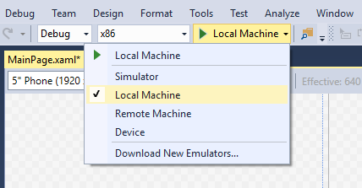  
   (Alternatively, you can choose Debug > Start Debugging from the menu bar or press F5 to start your app.)
2. View your app, which appears soon after a splash screen disappears. The app should look similar to this:  
   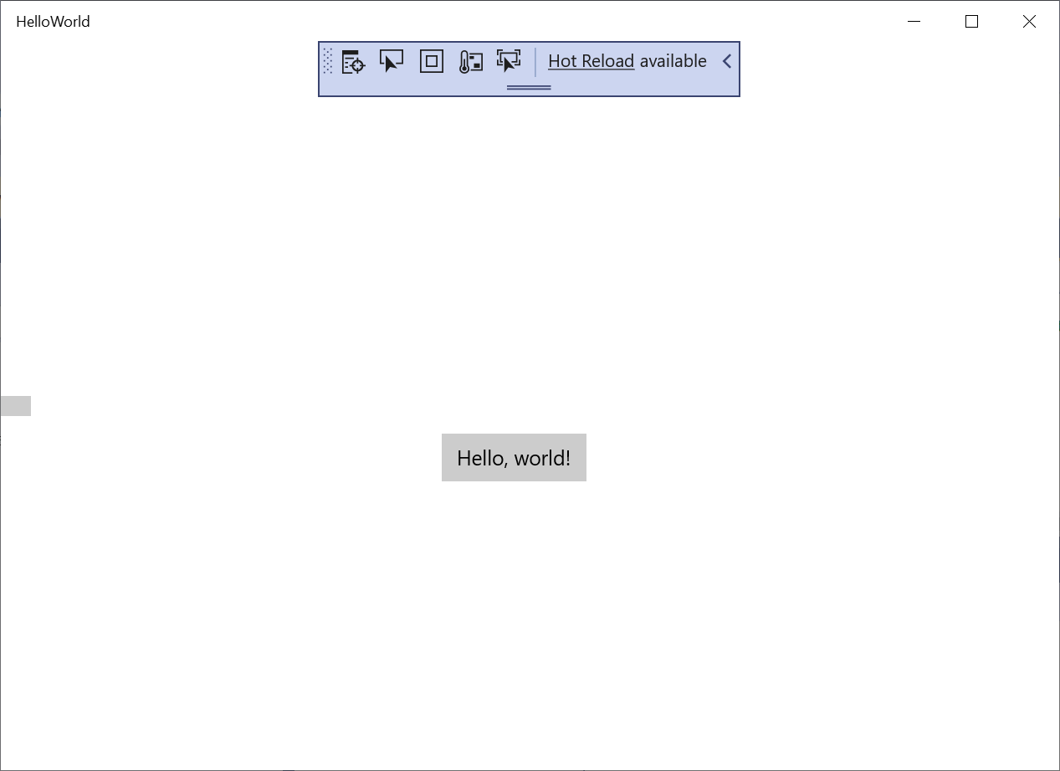
3. Click the Hello World button.  
   Your Windows 10 or later device will literally say, "Hello, World!"
4. To close the app, click the Stop Debugging button in the toolbar. (Alternatively, choose Debug > Stop debugging from the menu bar, or press Shift+F5.)