# **Tutorial: Get started with C# and ASP.NET Core in Visual Studio**

In this tutorial for C# development with ASP.NET Core using Visual Studio, you'll create a C# ASP.NET Core web app, make changes to it, explore some features of the IDE, and then run the app.

## **Prerequisites**

1. Install Visual Studio  
   If you haven't already installed Visual Studio, go to the [Visual Studio downloads](https://visualstudio.microsoft.com/downloads) page to install it for free.
2. Update Visual Studio - If you've already installed Visual Studio, make sure that you're running the most recent release. For more information about how to update your installation, see the [Update Visual Studio to the most recent release](https://docs.microsoft.com/en-us/visualstudio/install/update-visual-studio?view=vs-2019) page.
3. Choose your theme (optional) - This tutorial includes screenshots that use the dark theme. You can [Personalize the Visual Studio IDE and Editor](https://docs.microsoft.com/en-us/visualstudio/ide/quickstart-personalize-the-ide?view=vs-2019) page to learn how.

## **Create a project**

First, you'll create a ASP.NET Core project. The project type comes with all the template files you'll need for a fully functional website, before you've even added anything!

1. In the start window, choose Create a new project.  
   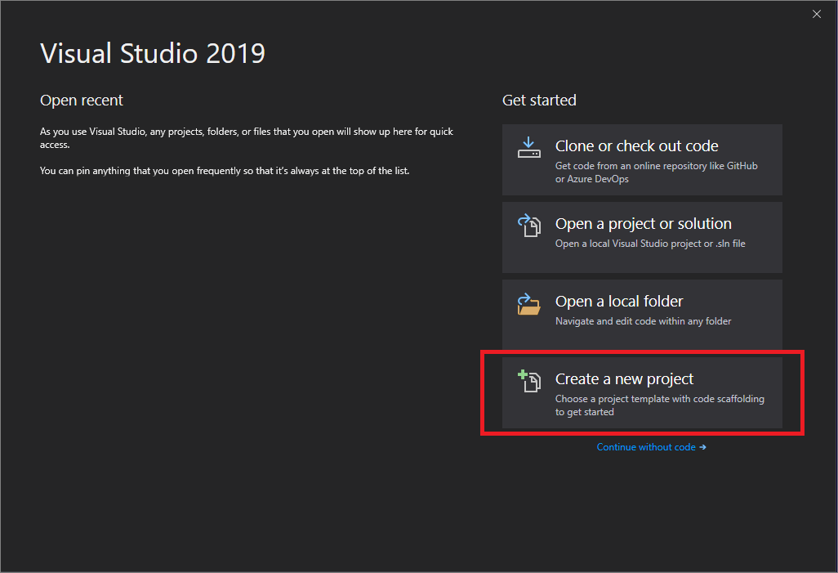
2. In the Create a new project window, choose C# from the Language list. Next, choose Windows from the Platform list, and Web from the project types list.  
   After you apply the language, platform, and project type filters, choose the ASP.NET Core Web App template, and then choose Next.  
   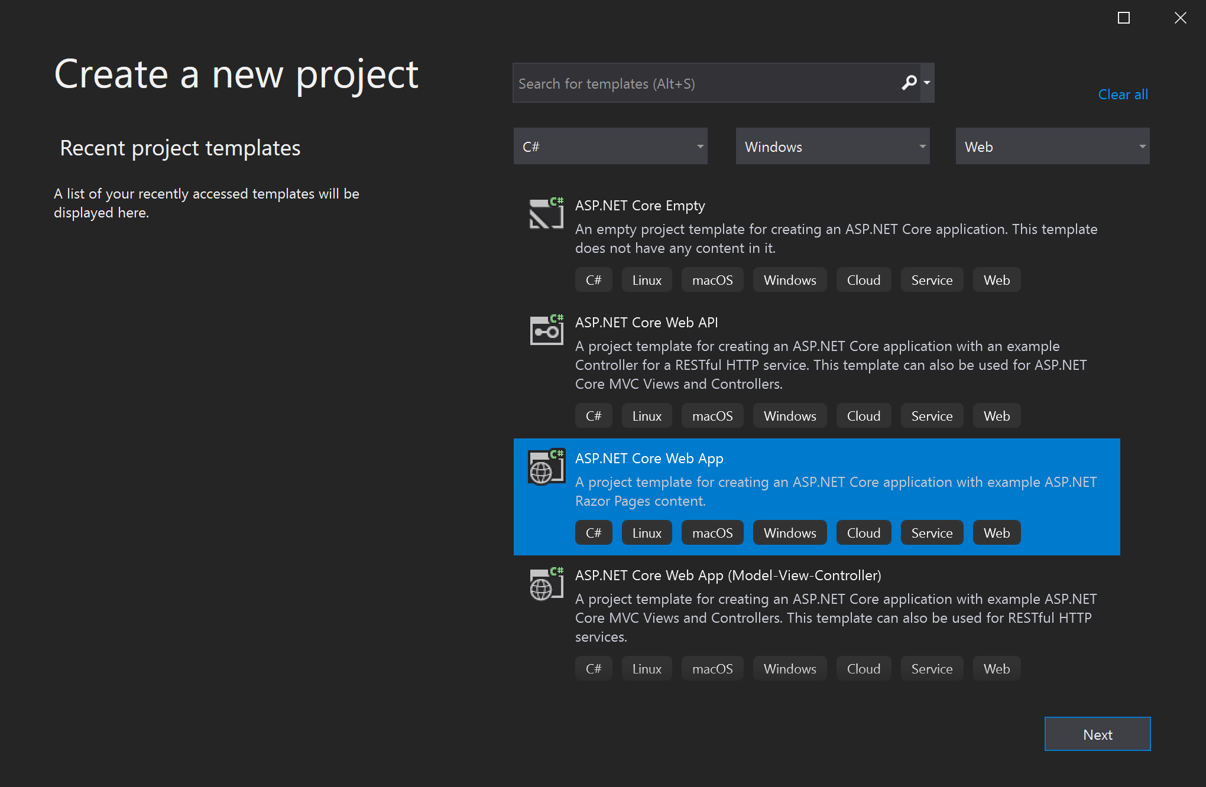  
    Note  
   If you don't see the ASP.NET Core Web App template, you can install it from the Create a new project window. In the Not finding what you're looking for? message, choose the Install more tools and features link.  
   Screenshot showing the 'Install more tools and features' link that is part of the 'Not finding what you're looking for' message.  
   Then, in the Visual Studio Installer, choose the ASP.NET and web development workload.  
   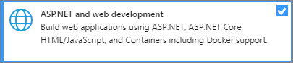  
   After that, choose the Modify button in the Visual Studio Installer. If you're prompted to save your work, do so. Next, choose Continue to install the workload. Then, return to step 2 in this "[Create a project](https://docs.microsoft.com/en-us/visualstudio/get-started/csharp/tutorial-aspnet-core?view=vs-2019#create-a-project)" procedure.
3. In the Configure your new project window, type or enter *MyCoreApp* in the Project name box. Then, choose Next.  
   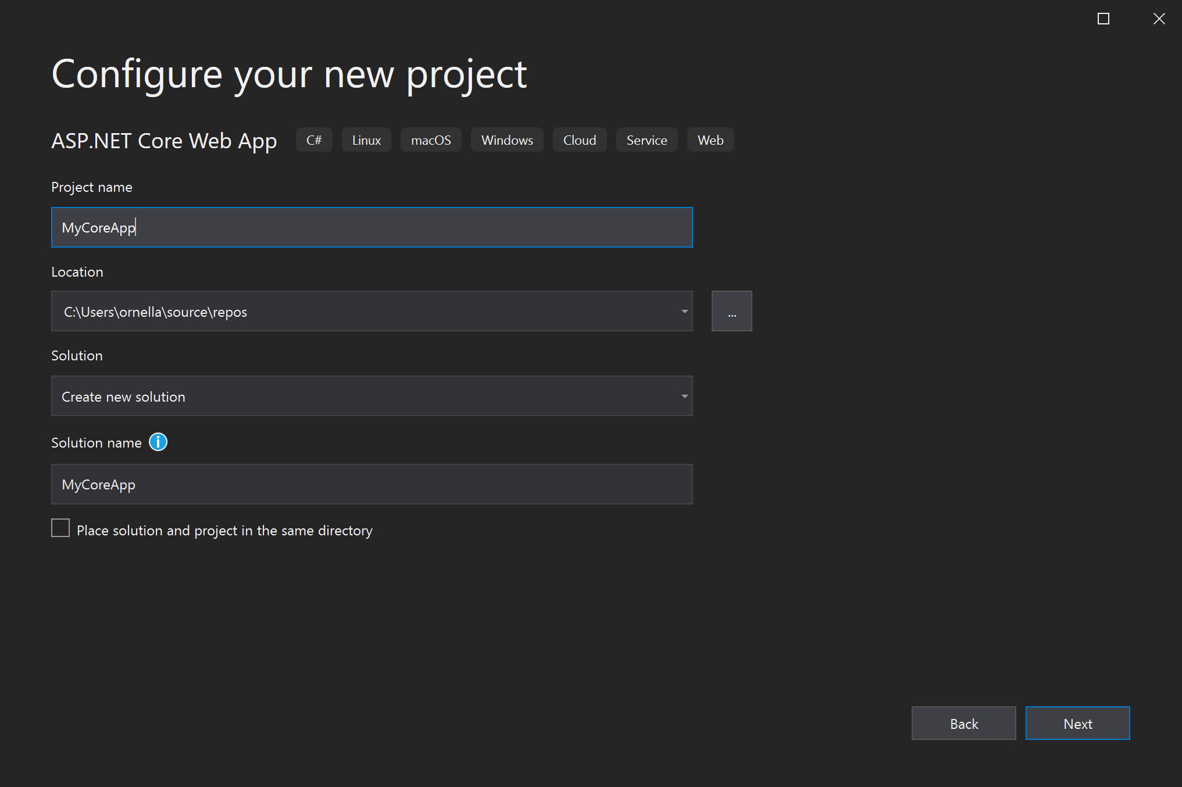
4. In the Additional information window, verify that .NET Core 3.1 appears in the top drop-down menu. Note that you can choose to enable Docker support by checking the box. You can also add authentication support by clicking the change Authentication button. From there you can choose from:
   * None: no authentication.
   * Individual accounts: these are stored in a local or Azure-based database.
   * Microsoft identity platform: this option uses Active Directory, Azure AD, or Microsoft 365 for authentication.
   * Windows: suitable for intranet applications.
5. Leave the Enable Docker box unchecked, and select None for Authentication Type. Then, select Create.  
   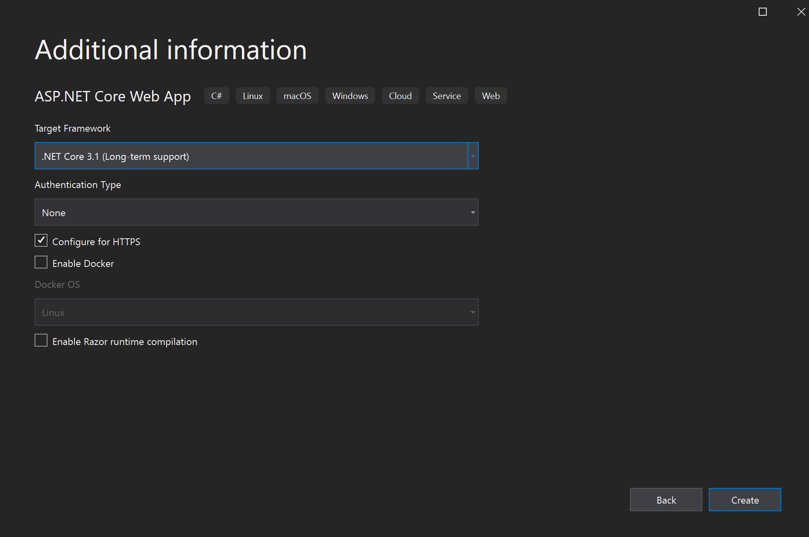  
   Visual Studio will open up your new project.

### **About your solution**

This solution follows the Razor Page design pattern. It's different than the [Model-View-Controller (MVC)](https://docs.microsoft.com/en-us/aspnet/core/tutorials/first-mvc-app/start-mvc?view=aspnetcore-2.1&tabs=aspnetcore2x&preserve-view=true) design pattern in that it's streamlined to include the model and controller code within the Razor Page itself.

## **Tour your solution**

1. The project template creates a solution with a single ASP.NET Core project that is named *MyCoreApp*. Choose the Solution Explorer tab to view its contents.  
   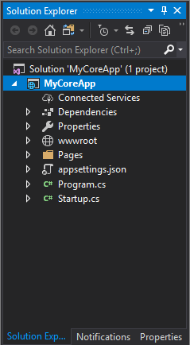
2. Expand the Pages folder.  
   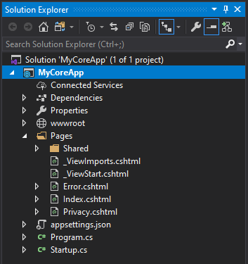
3. View the Index.cshtml file in the code editor.  
   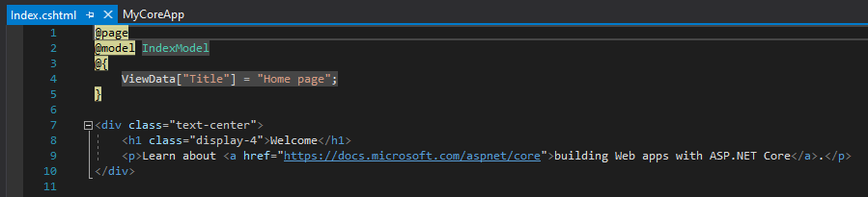
4. Each .cshtml file has an associated code file. To open the code file in the editor, expand the Index.cshtml node in Solution Explorer, and choose the Index.cshtml.cs file.  
   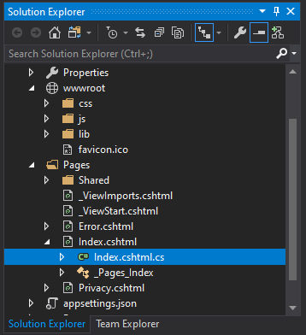
5. View the Index.cshtml.cs file in the code editor.  
   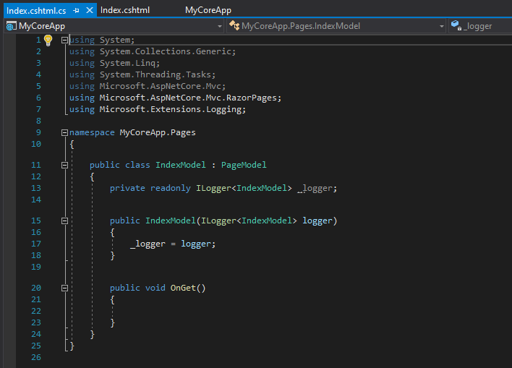
6. The project contains a wwwroot folder that is the root for your website. Expand the folder to view its contents.  
   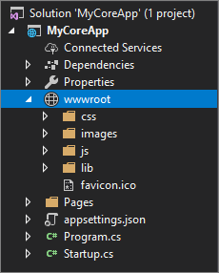  
   You can put static site content—such as CSS, images, and JavaScript libraries—directly in the paths where you want them.
7. The project also contains configuration files that manage the web app at run time. The default application [configuration](https://docs.microsoft.com/en-us/aspnet/core/fundamentals/configuration) is stored in *appsettings.json*. However, you can override these settings by using *appsettings.Development.json*. Expand the appsettings.json file to view the appsettings.Development.json file.  
   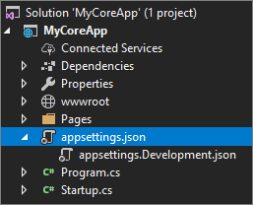

## **Run, debug, and make changes**

1. Choose the IIS Express button in the IDE to build and run the app in Debug mode. (Alternatively, press F5, or choose Debug > Start Debugging from the menu bar.)  
   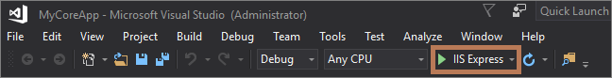  
    Note  
   If you get an error message that says Unable to connect to web server 'IIS Express', close Visual Studio and then open it by using the Run as administrator option from the right-click or context menu. Then, run the application again.  
   You might also get a message that asks if you want to accept an IIS SSL Express certificate. To view the code in a web browser, choose Yes, and then choose Yes if you receive a follow-up security warning message.
2. Visual Studio launches a browser window. You should then see Home, and Privacy pages in the menu bar.
3. Choose Privacy from the menu bar.  
   The Privacy page in the browser renders the text that is set in the *Privacy.cshtml* file.  
   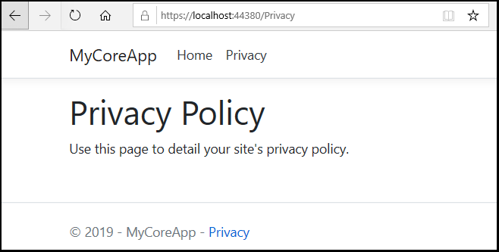
4. Return to Visual Studio, and then press Shift+F5 to stop Debug mode. This also closes the project in the browser window.
5. In Visual Studio, open Privacy.cshtml for editing. Then, delete the words *Use this page to detail your site's privacy policy* and in its place, add the words *This page is under construction as of @ViewData["TimeStamp"]*.  
   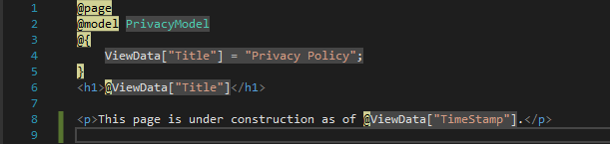
6. Now, let's make a code change. Choose Privacy.cshtml.cs. Then, clean up the using directives at the top of the file by using the following shortcut:  
   Choose any of the grayed-out using directives and a [Quick Actions](https://docs.microsoft.com/en-us/visualstudio/ide/quick-actions?view=vs-2019) light bulb will appear just below the caret or in the left margin. Choose the light bulb, and then hover over Remove unnecessary usings.  
   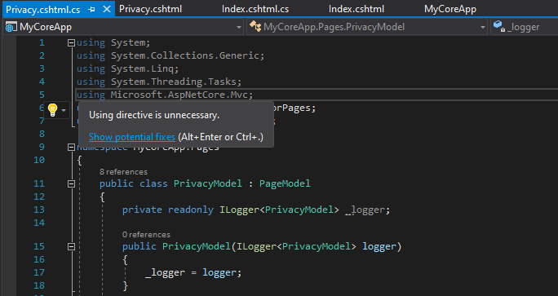  
   Now choose Preview changes to see what will change.  
   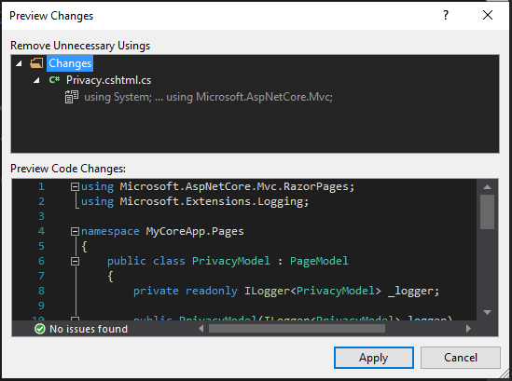  
   Choose Apply. Visual Studio deletes the unnecessary using directives from the file.
7. Next, in the OnGet() method, change the body to the following code:
8. C#
9. Copy

public void OnGet()

{

string dateTime = DateTime.Now.ToShortDateString();

ViewData["TimeStamp"] = dateTime;

}

1. Notice that two wavy underlines appear under DateTime. The wavy underlines appear because this type isn't in scope.  
   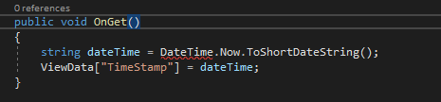  
   Open the Error List toolbar to see the same errors listed there. (If you don't see the Error List toolbar, choose View > Error List from the top menu bar.)  
   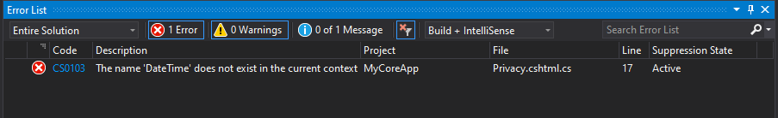
2. Let's fix this. In the code editor, place your cursor on either line that contains the error, and then choose the Quick Actions light bulb in the left margin. Then, from the drop-down menu, choose using System; to add this directive to the top of your file and resolve the errors.  
   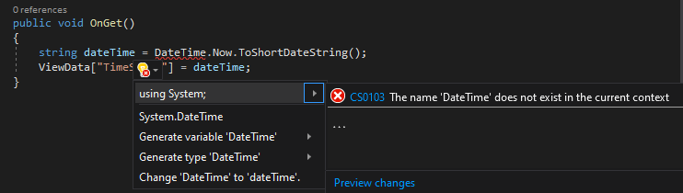
3. Press F5 to open your project in the web browser.
4. At the top of the web site, choose Privacy to view your changes.  
   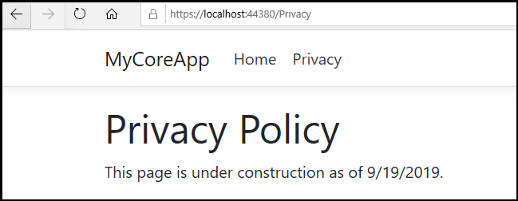
5. Close the web browser, press Shift+F5 to stop Debug mode, and then close Visual Studio.