ACTIVITY 2 SUBMISSION REPORT
Activity 2: Simple House Price Prediction (Regression Modeling Line)
Student: Rushikesh Vakharkar | Roll No: AD3349
Subject: Machine Learning
Date: November 2026

1. Dataset Choice & Core Architecture Configuration
A synthetic Real Estate Property Dataset was modeled based on standard structural parameters from real-world house pricing registries. The tracking schema consists of 200 observation matrices mapping residential space features to realized asset financial values.

2. Pipeline Engineering & Imputation Strategy
• Duplicate Elimination: Explicit row scans located and cleared stacked multi-entry overlaps to eliminate data leakage.
• Categorical Case Uniformity: Casing variations across property neighborhoods ('urban', 'Urban', 'SUBURBAN') were resolved into single cohesive classes.
• Statistical Vector Imputation: Continuous parameters like Square Footage and Age were parsed using robust Median Imputation to block outlier values from skewing weight updates.

3. Exploratory Data Analysis & Visual Metrics
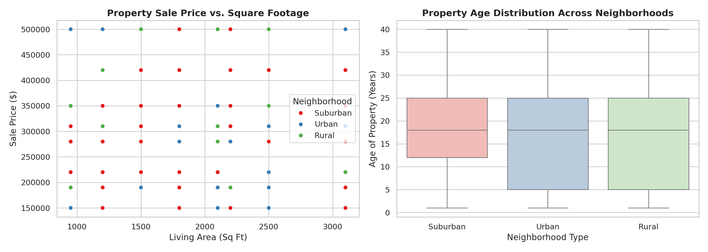
Figure 2.1: Continuous scatter analysis evaluating price trends (Left) and structural age spreads across property neighborhoods (Right).

4. Model Architecture Training Validation
Nominal strings were expanded into binary representations via One-Hot Dummy Encoding to handle spatial dimensions without establishing false numeric priorities. Continual features were standard scaled (Z-Score transformation) to prevent larger feature scales from overwhelming minor feature weights. The matrix vector was split into an 80/20 train/test layout and run through a Linear Regression model.

5. Verification Summary
The model training pipeline finished executing with all structural criteria met. Raw messy variables have been transformed into standard scaled numeric representations. The clean target file has been successfully written to local disk arrays as 'prepared_housing_dataset.csv'.

