Group 10

Author: 卞一涵

Software Requirements

Elevator System

Table of Contents

System Objective 2

Domain Analysis 2

System Architecture 4

Use Cases 5

Software Requirements 5

## System Objective

we need to develop a software that can control the elevator and its surrounding environment in order to let the elevator run correctly without safety error. By providing interconnected interfaces on both floor and in elevator, user can go to the floor by just pressing the button. We also need to let the two elevator coordinate to reduce the unnecessary moving.

## Domain Analysis

Here is how different part of the elevator system runs.

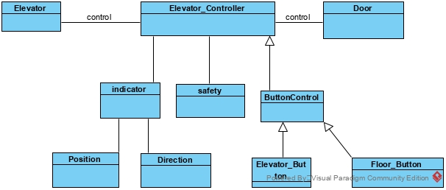Here is the relationship between parts:

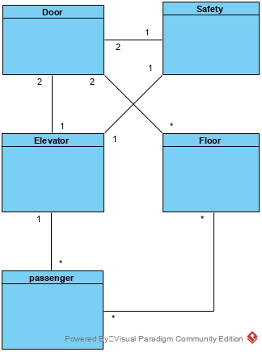

Here is the sequence of passenger calling at floor

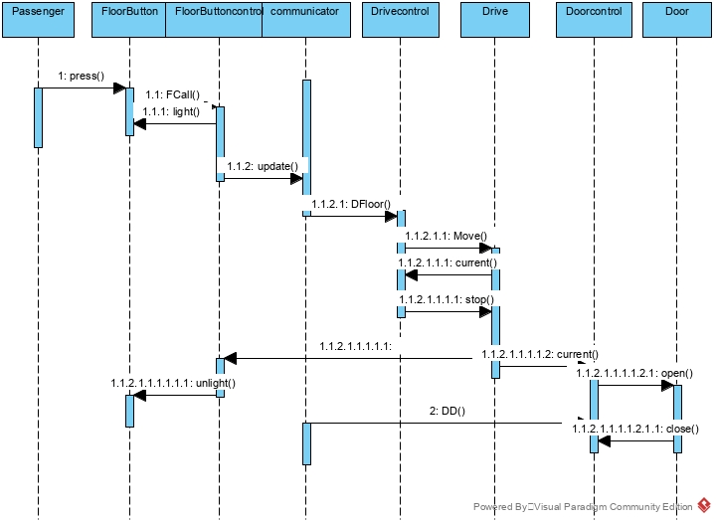

Here is the sequence of passenger operate in the elevator:

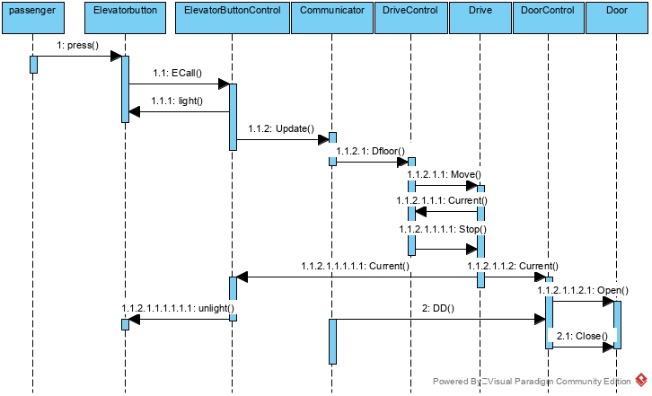

The sequence of Move the Elevator: the elevator is asked to move from stop status. And it should move from slow speed to fast speed.

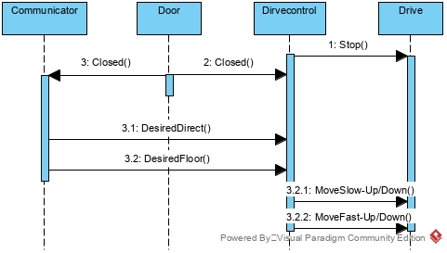

Stop the car: when the elevator is approaching the floor, it should slow down and finally stop;

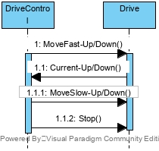

The Emergency happen when the car is moving but door opens:

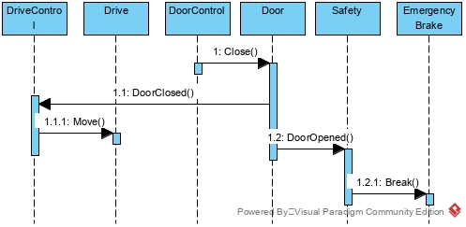

Other emergency situation ……

## System Architecture

From the information above, we will design a system that allows the passenger call elevator both in the elevator and on the floor. The system architecture is shown below:



## Use Cases

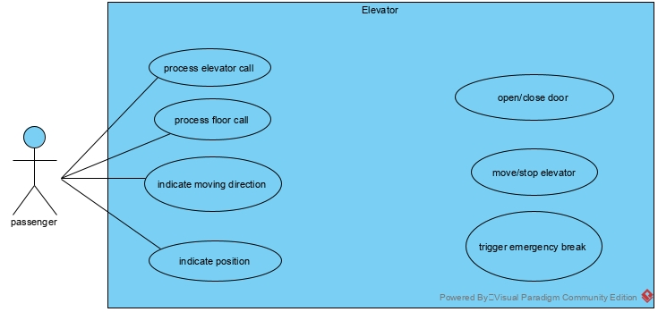

## Software Requirements

### R1: Floor

* R1.1: Should indicate the position of Elevator
* R1.2: should have the Button to call the Elevator
* R1.3: should indicate the moving direction of the Elevator

### R2: Elevator

* R2.1: Should have the floors button
* R2.2: should have the button to open and close door
* R2.3: should indicate the current floor

### R3: Coordinate

* R3.1: should command the elevator nearest the passenger to move
* R3.2: should keep the elevator moving in the same direction until there is no request on that direction
* R3.3: should stay on the 1st floor after a limit time without passenger call

### R4: Safety

* R4.1: should break and send signal when any emergency mentioned above happened