Group 10

Author: Lu WeiChen

Software Specifications

Elevator

Table of Contents

System Architecture 2

Software Specifications 2

S1: FigureUI implementation 2

## System Architecture

The system architecture is shown below:

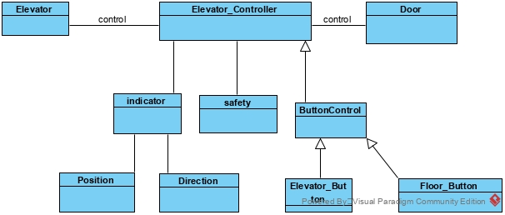

## Software Specifications

### S1: FigureUI implementation

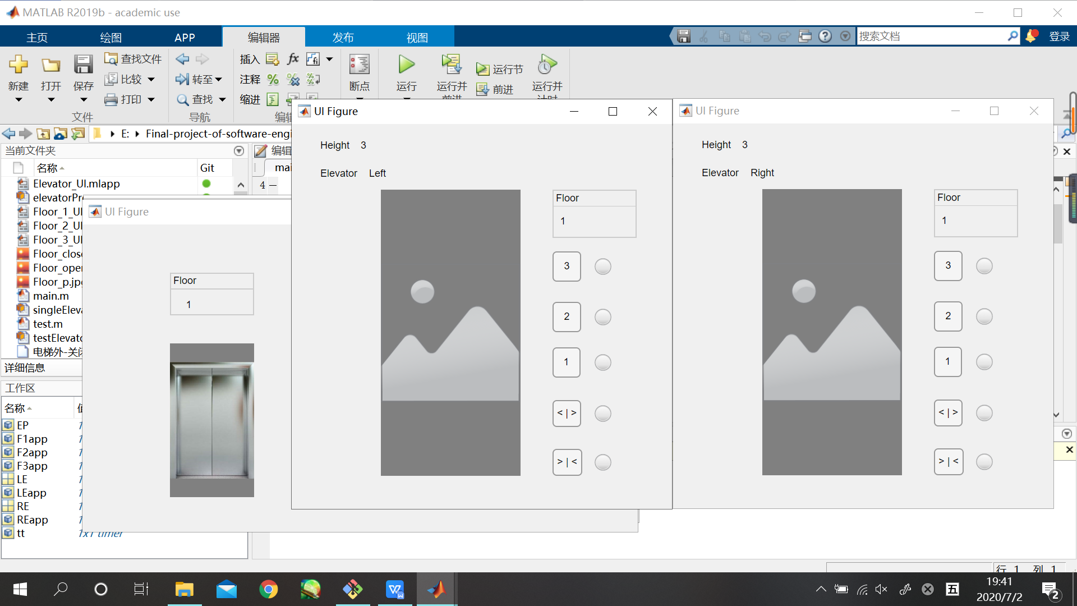

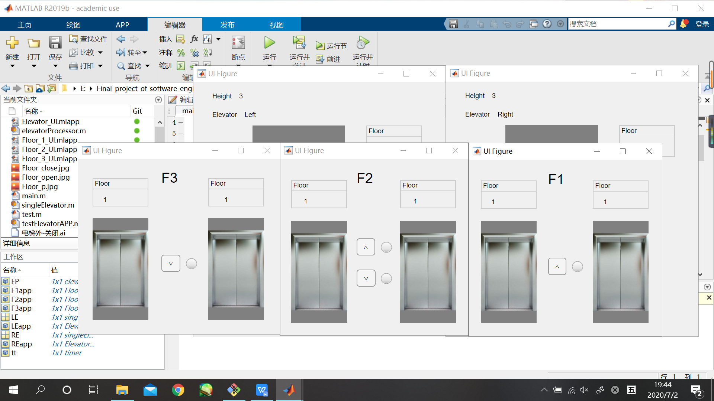

#### S1.1: Call a elevator

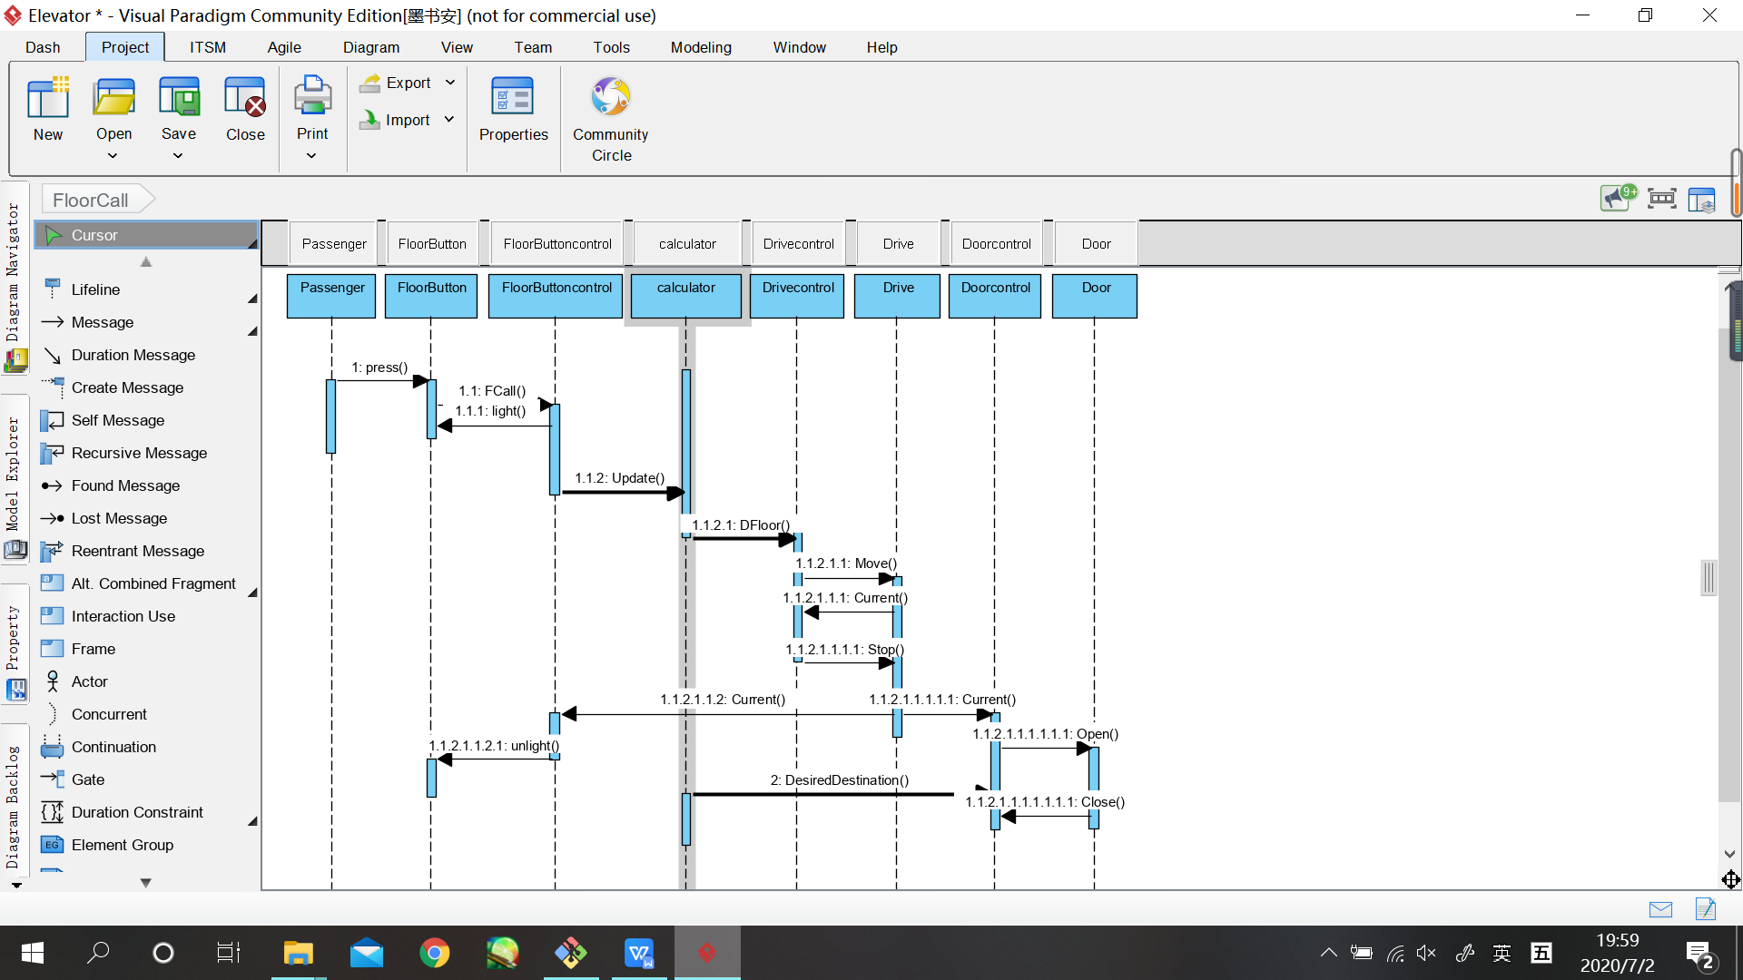

* S1.1.1: call an elevator outside

1. Floor button clicked
   1. If there’s an elevator is at that floor, open it
   2. If there’s no elevator is there, move the elevator(move one)
   3. Update the data in calculator
   4. If the elevator is moved, light the lamp of it

#### S2.1: Elevator Call

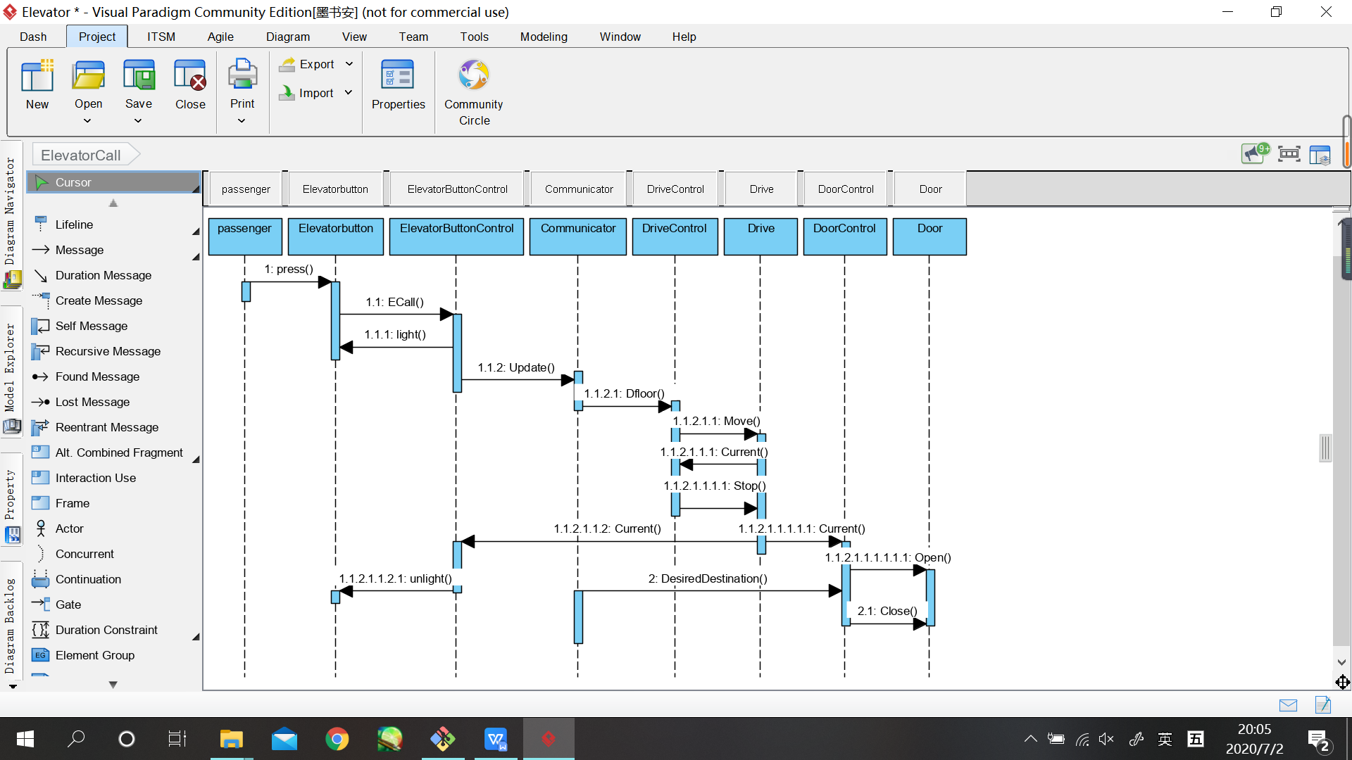

* S2.1.1: call an elevator outside

1. One floor clicked

a. If the elevator is moving, turn on the light. If it stops, turn off the light.

#### S2.1: Move and stop

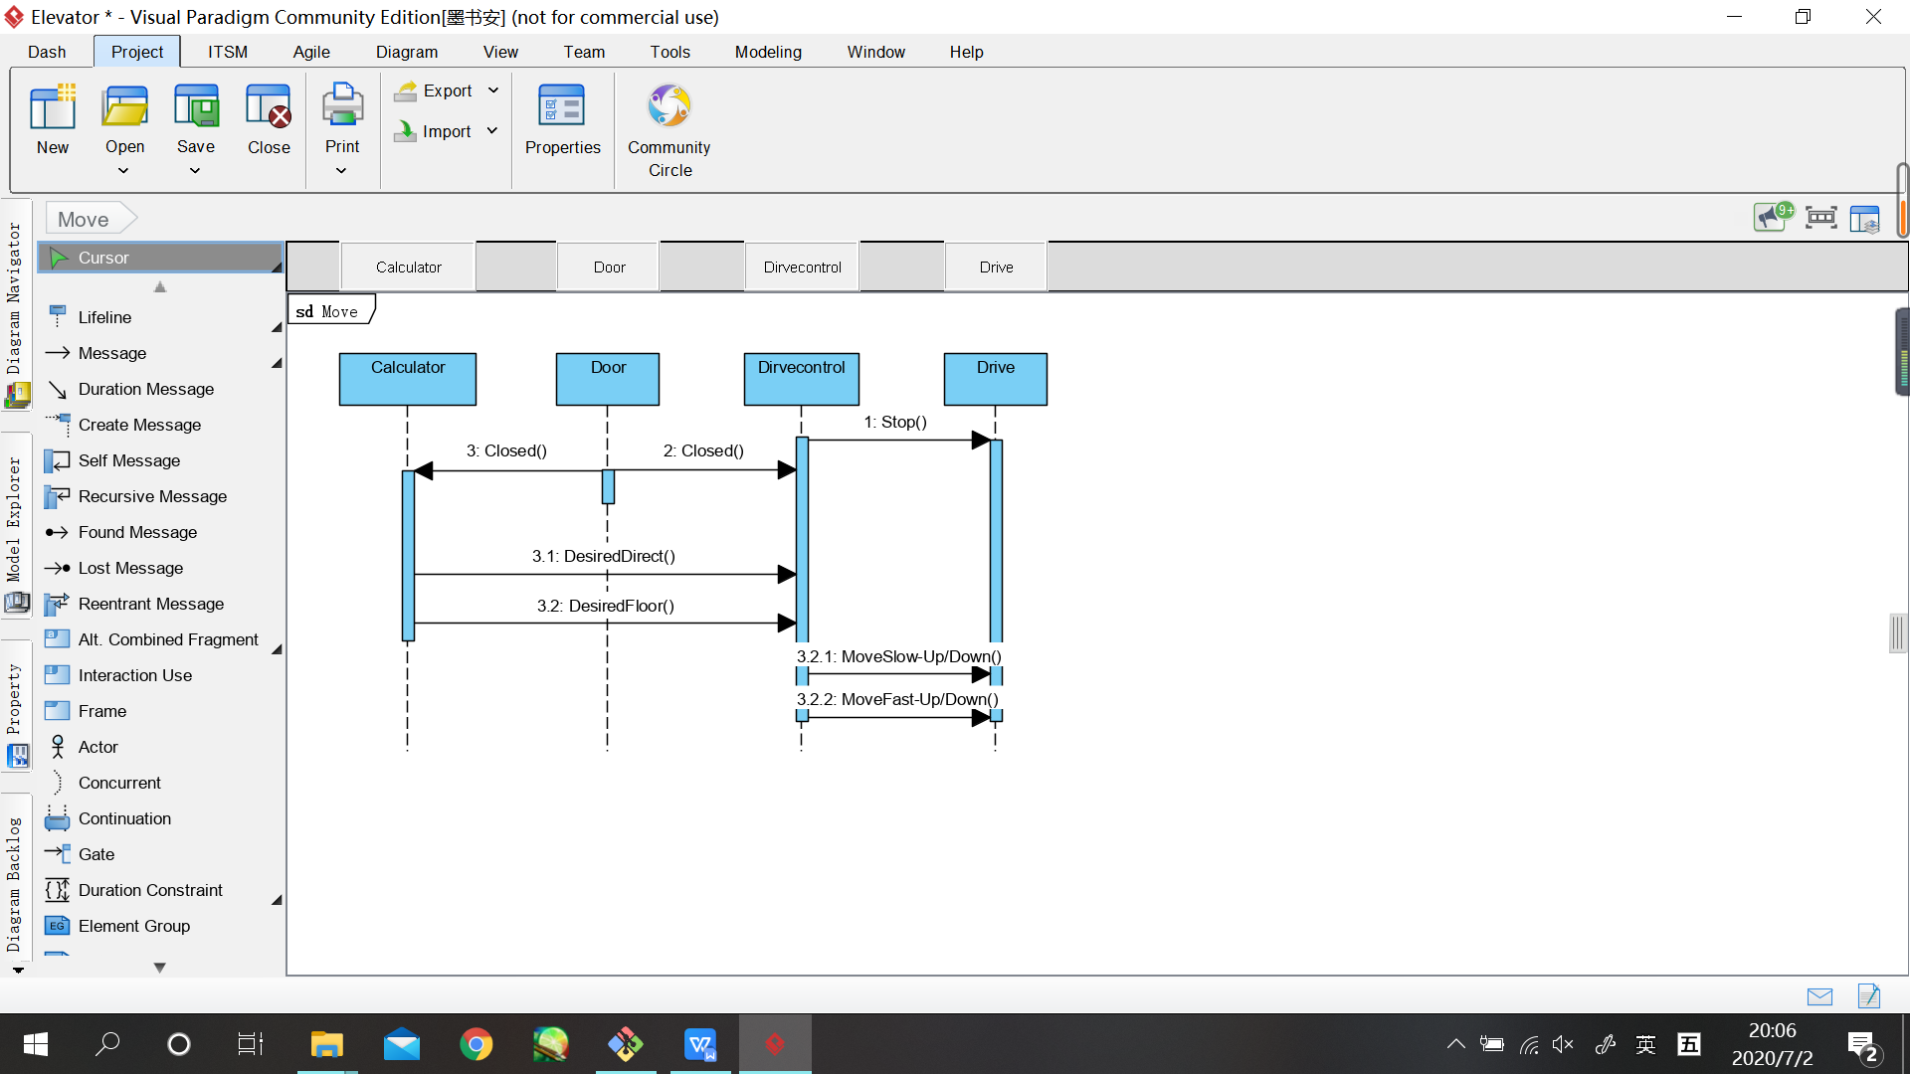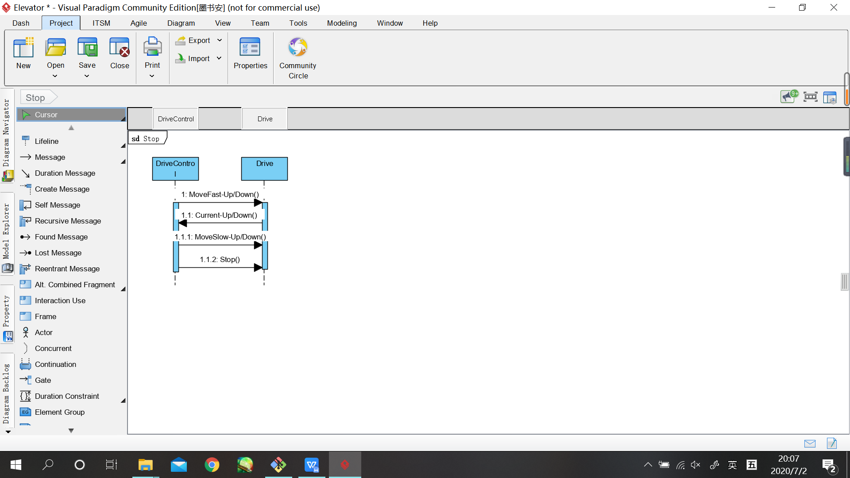

* S3.1.1: Move

a. if the door isn’t closed, it can’t move

b. The elevator should first move fast, then move constantly and finally move slow.

* S3.1.2: Stop