Group 10

Author: 卞一涵

User Manual

Elevator

Table of Contents

System Architecture 2

ElevatorCaller Manual 2

FloorCaller Manual 3

## System Architecture

The system architecture is shown below:

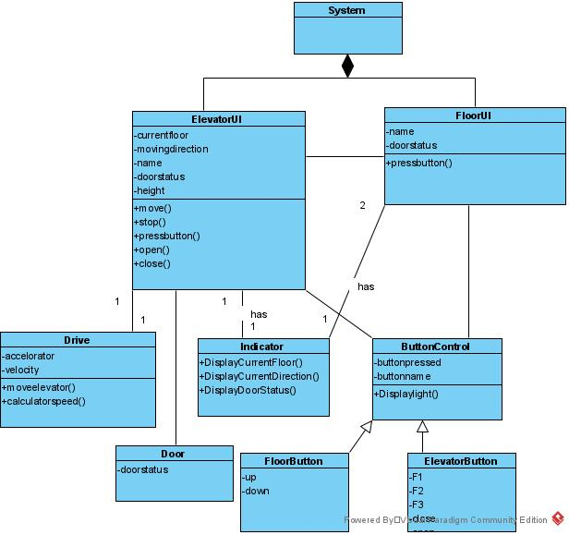

## ElevatorCaller Manual

The server has a UI which is shown below:

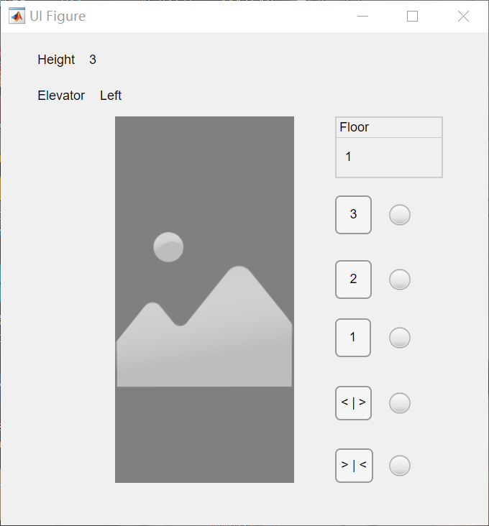

#### Close the door

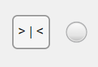

Press this button will close the door and the light will flash to show the Elevator receive this call. YOU CAN NOT ClOSE THE DOOR IMEDIATELY under the situations below:

1. when the door was just opened
2. when the Open The Door button was just pressed

When door is closed it’s shown like this:



#### Open the door

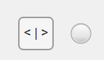

Press this button will open the door and the light will flash to show the Elevator receive this call. YOU CAN NOT OPEN THE DOOR IMEDIATELY under the situations below:

1. when the Elevator is moving
2. when the Open The Door button was just pressed

When door is closed it’s shown like this:



#### Show the current floor and direction

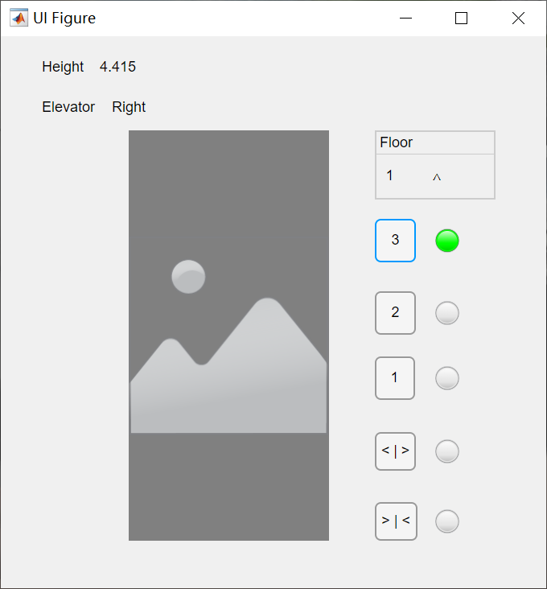

A

A: the number show the current floor the elevator stay; the arrow show the direction of the moving elevator

#### Process a call in Elevator



B

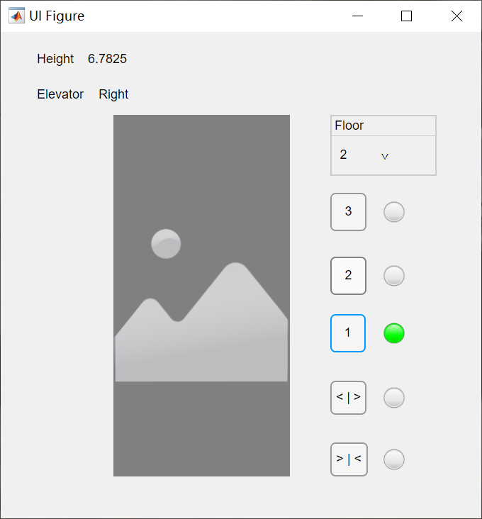

B

B: the three button indicates the floor elevator can approach, press any button among these three the green light on the right will on, which indicates the destination. The green light will off when the Elevator arrive the required floor.

## FloorCaller Manual

The FloorCaller has a UI which is shown below:

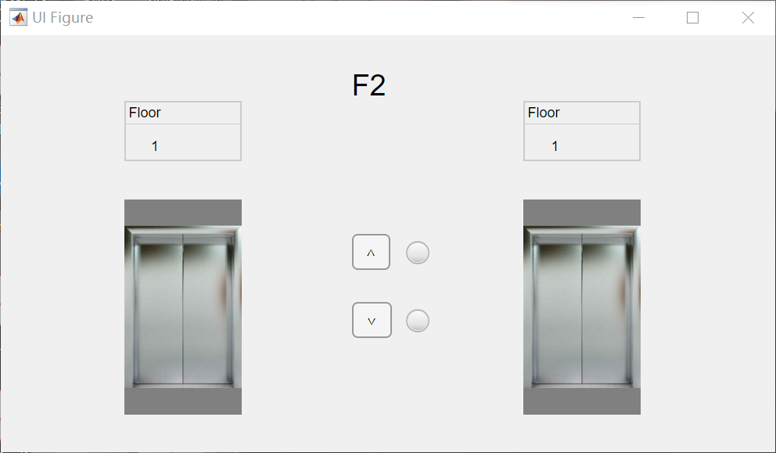

#### Close the door

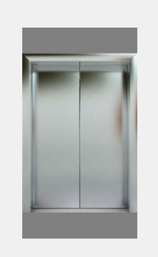

This picture shows the door is closed

#### Open the door

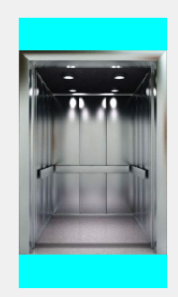

this picture shows the door is opened

#### Show the current floor and direction

A

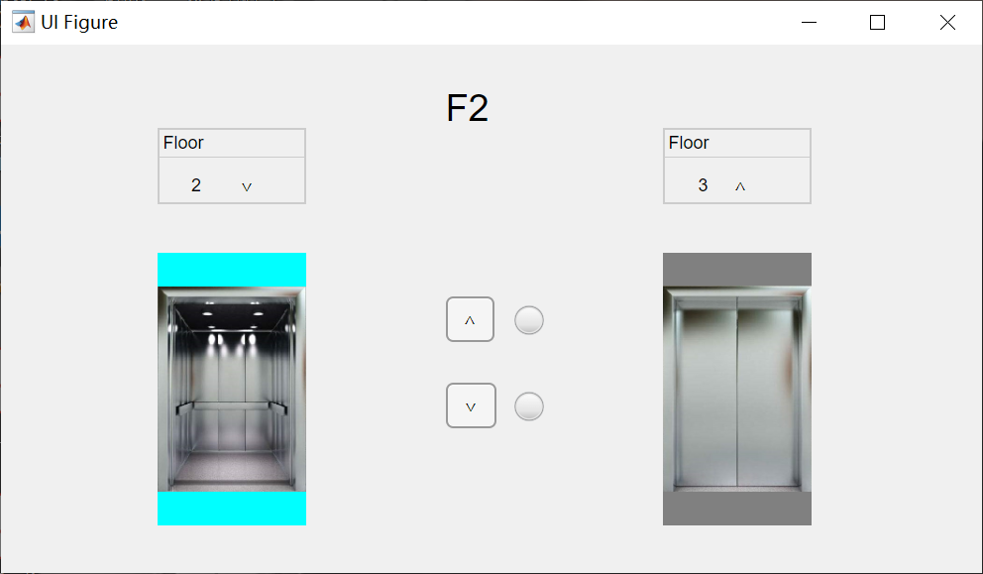

A: the number show the current floor the elevator stay; the arrow show the direction of the moving elevator

#### Process a call on the floor

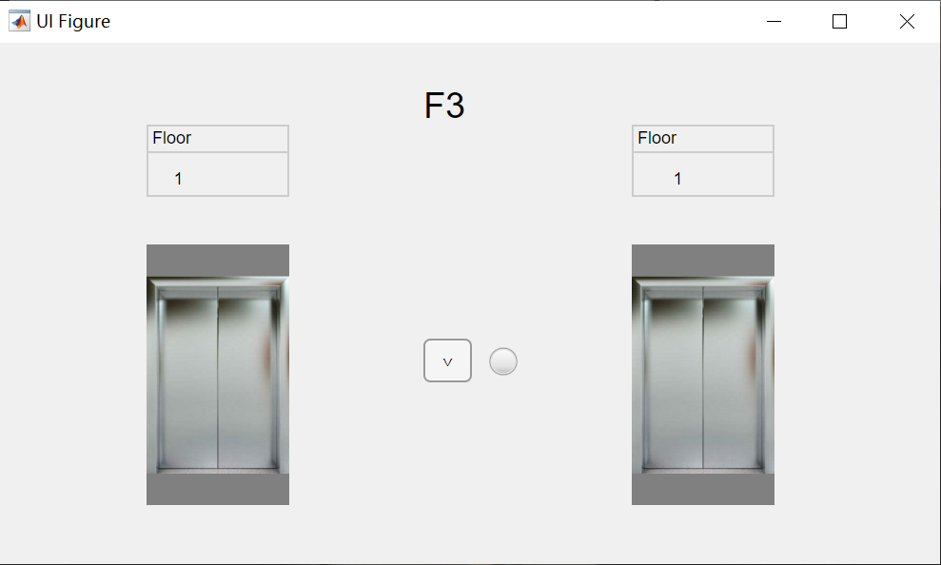

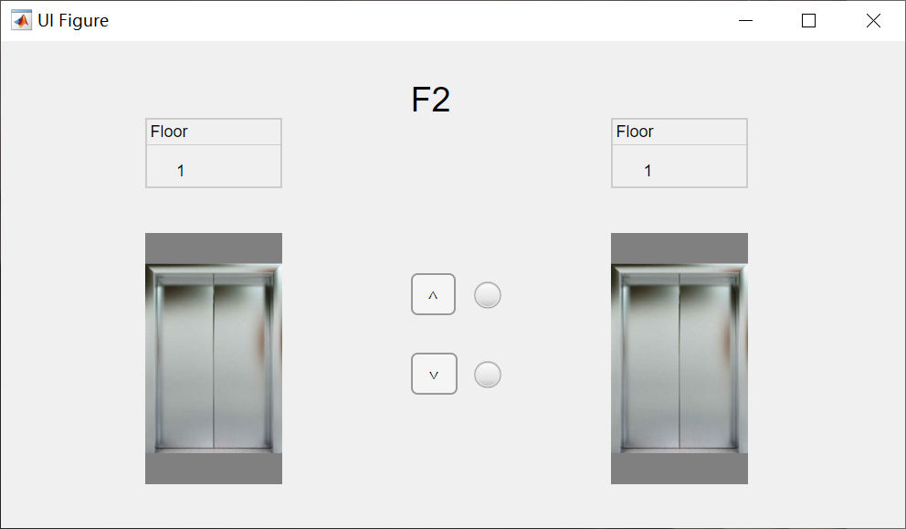

B2

B1

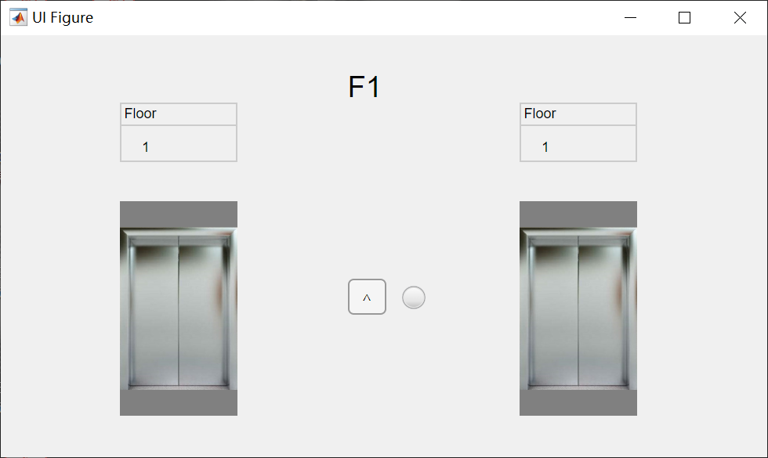

Floor 1 only has one button to call the elevator; Floor 2 has two; Floor 3 has one.

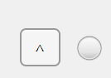

B1:call a Elevator to go up; the light on the left shows that the Elevator is processing this call and it will off when elevator arrive

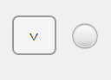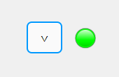

B2:call a Elevator to go down; the light on the left shows that the Elevator is processing this call and it will off when elevator arrive

## Chef Manual

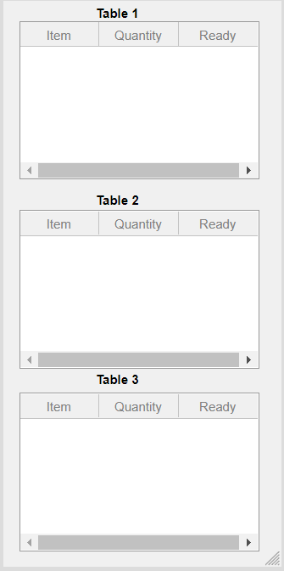

#### When an item is ready