Group 10

Author: ShenYuan

Software Requirements

HuaRongDao

Table of Contents

System Objective 2

Domain Analysis 2

System Architecture 5

Use Cases 5

Software Requirements 6

R1: StartUI 6

R2: GameUI 6

## System Objective

In this project, we are developing a game. There are 10 items in the fixed area(5x4) -- 5 long items(1x2), 4 small square items(1x1) and one big squire item(2x2). The biggest item is “Cao Cao” and is placed at the middle of the top. Players would help it to move to the middle of the bottom by moving the items to the empty area. Besides, player can’t take out the items or change its direction.

## Domain Analysis

The relationship in the game is shown as follows:

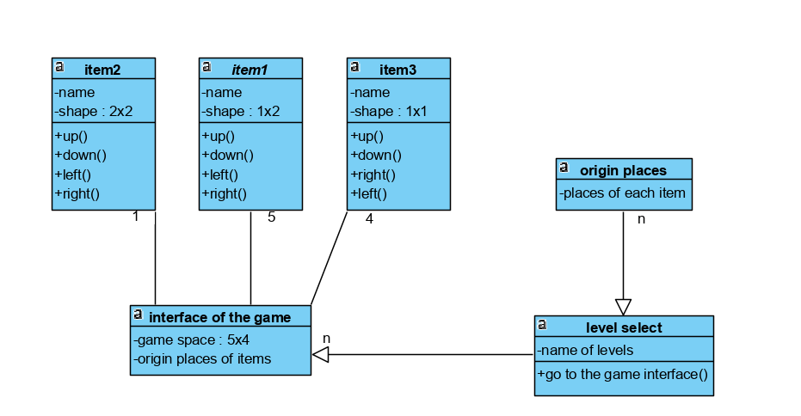

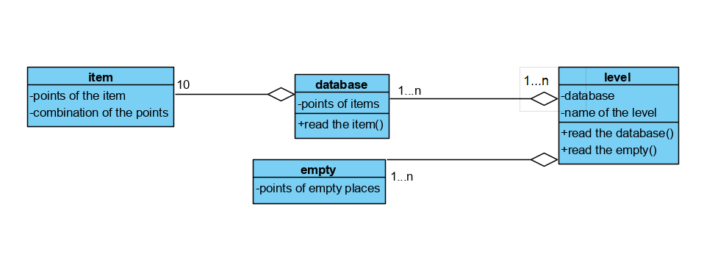

And there’s a special function called customization:

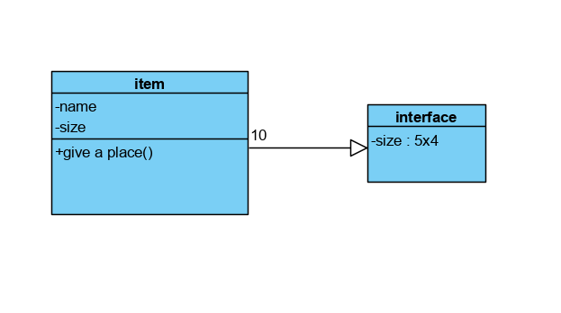

Here is the sequence of starting a game:

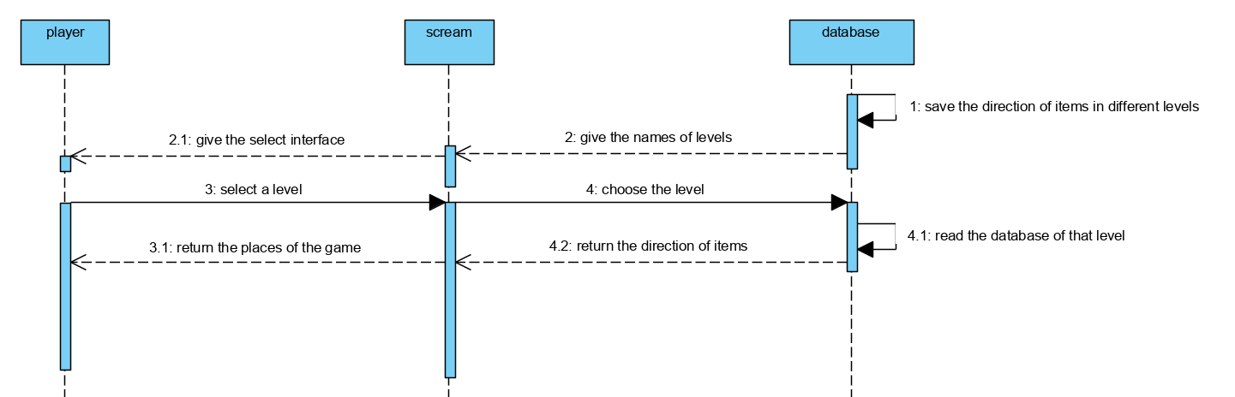

Here is the sequence of moving the items:

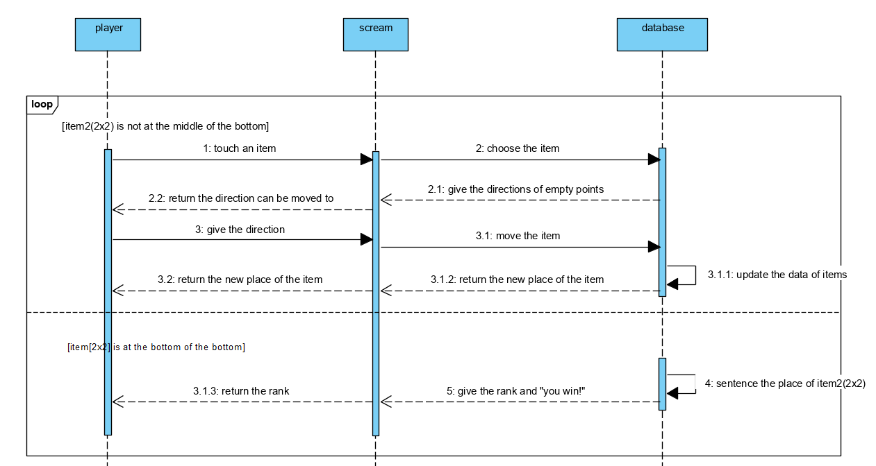

Here is the sequence of the customization:

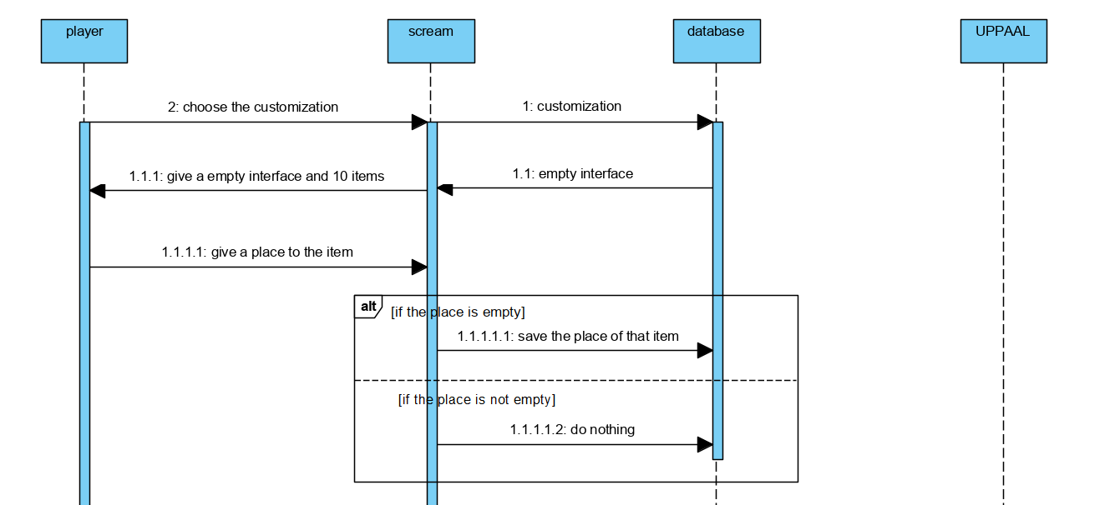

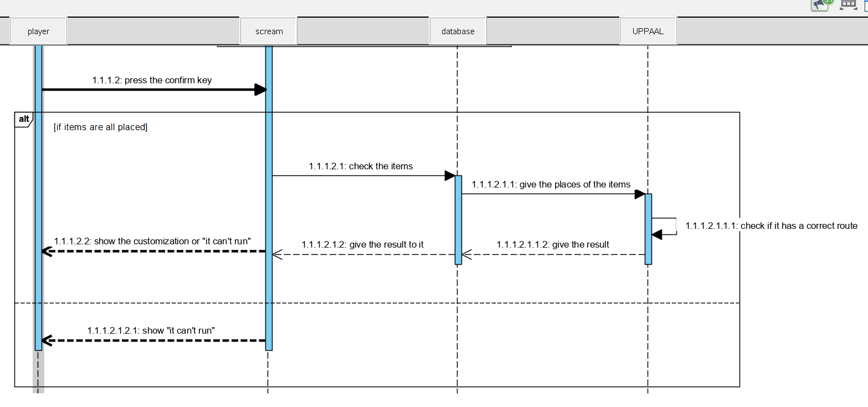

## System Architecture

From the information above, we will design a software system that allows the player to choose items and give direction to it. The game would sentence if the item can be moved and move the items. The system architecture is shown below:

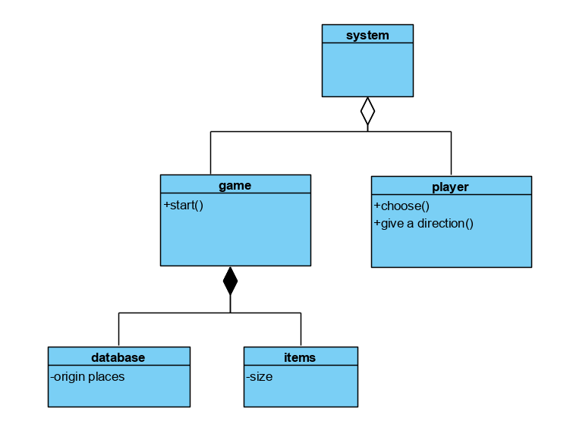

## Use Cases

The system can achieve the following use cases from the players’ perspectives:

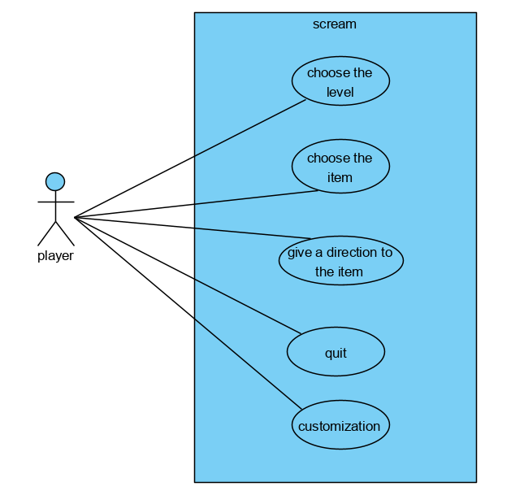

## Software Requirements

### R1: StartUI

* R1.1: The server should be able to place all the levels on his UI
* R1.2: The server should have a start bottom

### R2:GameUI

* R2.1:it should have a 5x4 game interface
  + R2.1.1: it should have 10 items and 2 empty points
  + R2.1.2:the size of the items are : 2x2(1), 1x2(5), 1x1(4)
* R2.2:items can’t be moved out of the interface
* R2.3:items can’t cover each other

### R3:WinUI

* R3.1:show the win to the player