Group 10

Author: 卞一涵

Software Specifications

HuaRong Path

Table of Contents

System Architecture 2

Software Specifications 2

S1: ServerUI implementation 2

S2: ChefUI Implementation 4

## System Architecture

The system architecture is shown below:

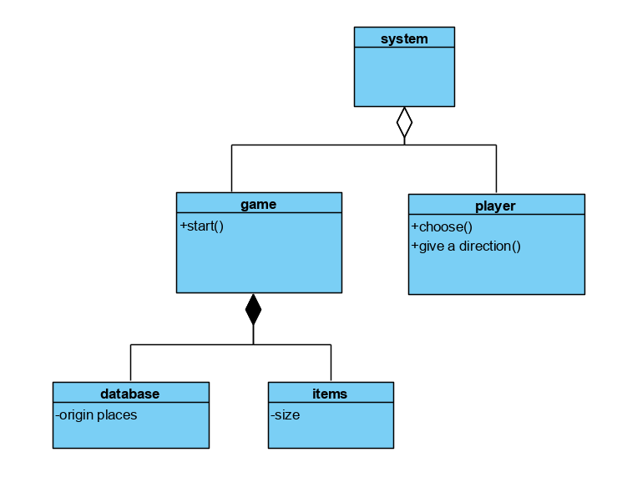

## Software Specifications

### S1: StarterUI implementation

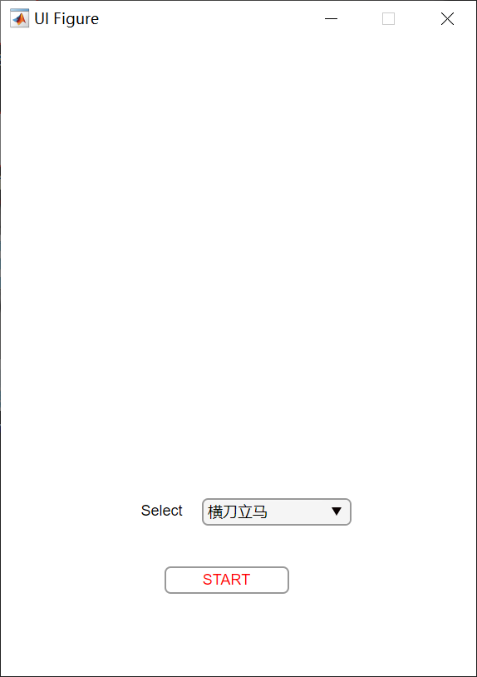

#### S1.1:Select level

* S1.1.1: Select level

1. Drop down clicked
2. For any level selected
3. Compare the value with existing level
   1. If it exits, show start button and generate the chessboard
      1. Start button clicked, initialize a new board with generated chessboard
      2. Show chessboardUI
   2. If not, nothing will happen

### S2: BoardUI Implementation

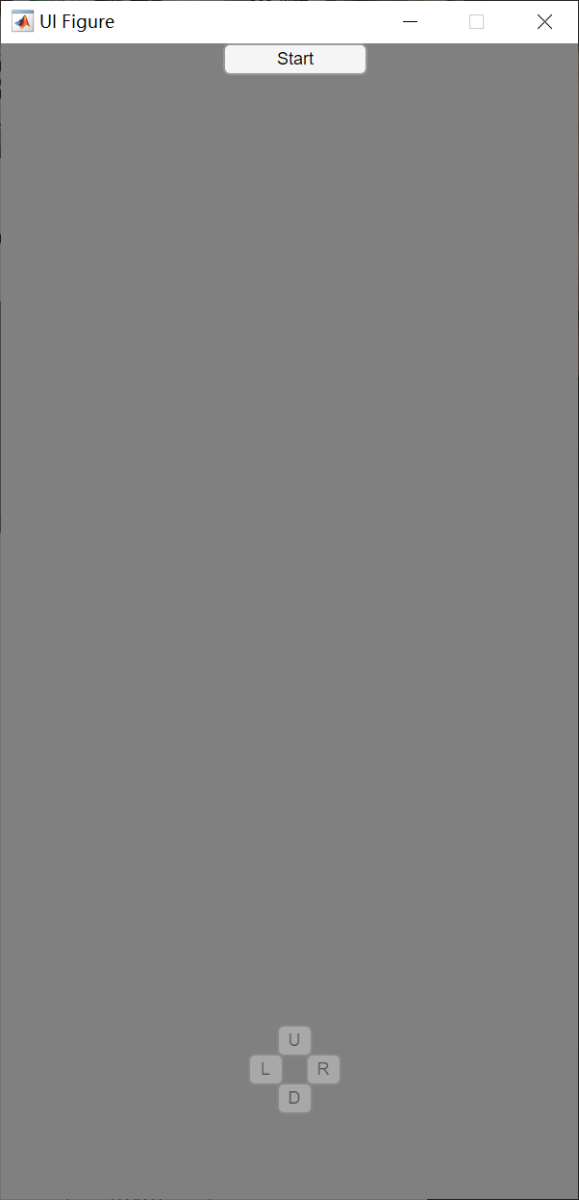

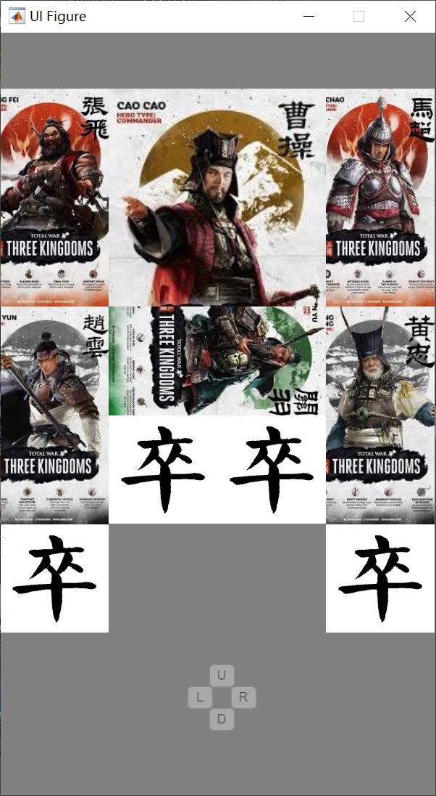

#### S2.1: Play game

* S2.2.1: start game
  + Start button pressed
  + Show all the chess according to the selected level
* S2.2.2: Select character

1. Picture chess clicked
2. Change the value of the selected chess attribute
3. Send the value to the mirror digital matrix chessboard
4. Calculate the possible moving direction
5. Show the direction button of the possible moving direction
6. Direction button clicked once
7. Change the value in the digital matrix chessboard
8. Recalculate the picture position

* S2.2.3: game over

1. If Caocao is on the specific position, show the Win UI

### S3: WinUI Implementation

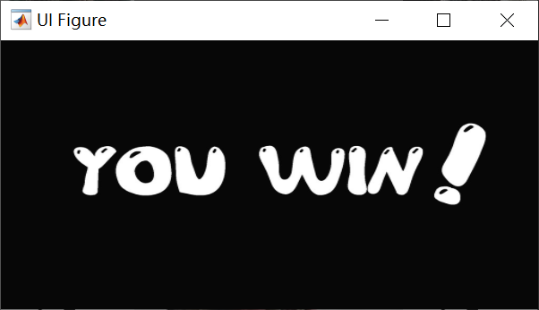

#### S3.1: Player win

1. Show the win picture