Group 10

Author: ShenYuan

Traceability Report

HuaRong Path

Table of Contents

System Architecture 2

Software Traceability 2

## System Architecture

The system architecture is shown below:

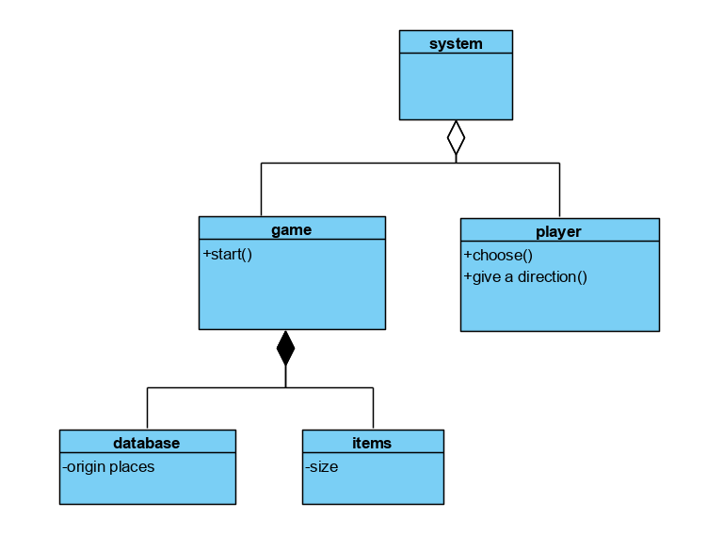

## Software Traceability

|  |  |  |
| --- | --- | --- |
|  | Is implemented by | Is validated by |
| R1 | S1 |  |
| R1.1 | S1.1.1 |  |
| R1.2 | S1.1.1 |  |
| R2 | S2 |  |
| R2.1.1 | S2 |  |
| R2.1.2 | S2 |  |
| R2.2 | S2.2.2 |  |
| R2.3 | S2.2.2 |  |
| R3 | S3 |  |
| R3.1 | S3.1 |  |