Group 10

Author: ShenYuan

User Manual

Hua Rong Dao

Table of Contents

[System Architecture 2](#_Toc10414792)

[Start Manual 2](#_Toc10414793)

[Game Manual 3](#_Toc10414794)

## System Architecture

The system architecture is shown below:

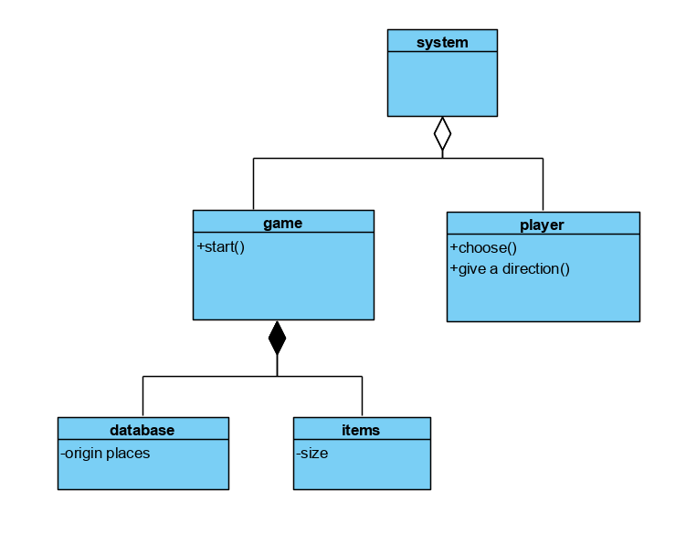

## start Manual

The start has a UI which is shown below:

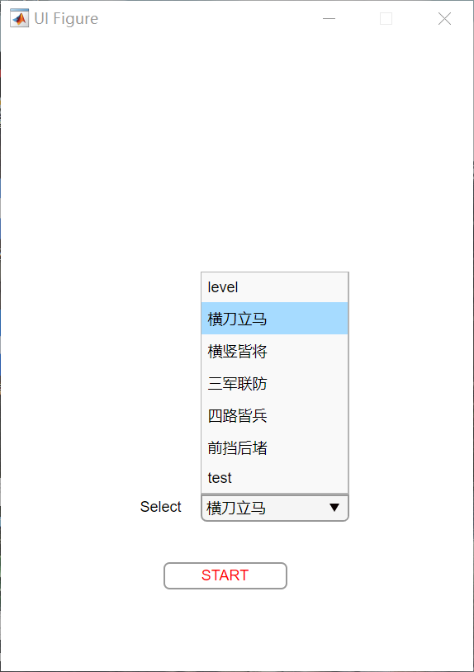

Choose a level/ customization

Press the start button

## Game Manual

IMG_256

Press the start button

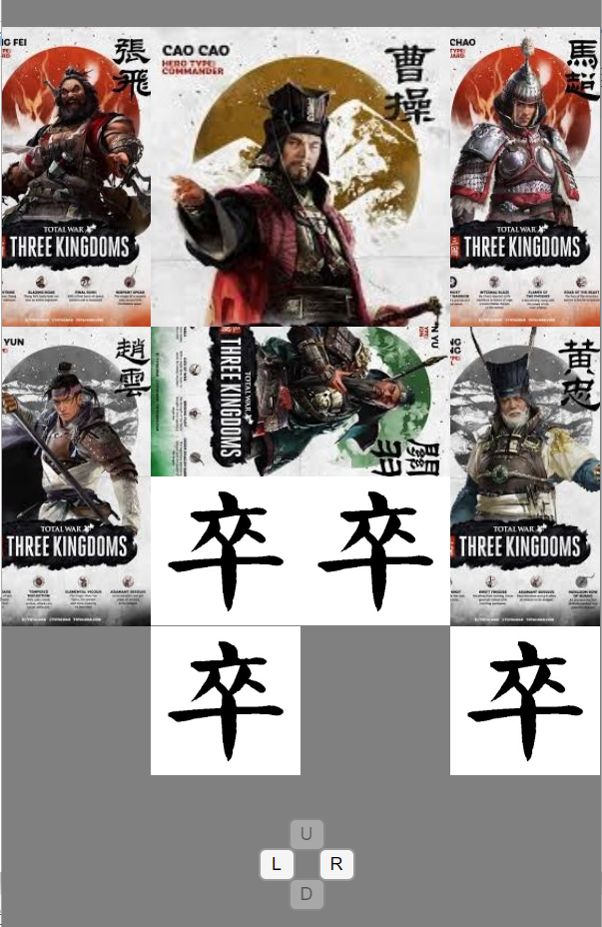

Choose a item

Choose a direction