Group 10

Author: WeihenLu

Software Specifications

HuaRong Path

Table of Contents

System Architecture 2

T1: Unit Test 2

T1.1: OrderDB Unit Test 2

T2: Integration Test 3

T3: Functional Test 3

## System Architecture

The system architecture is shown below:

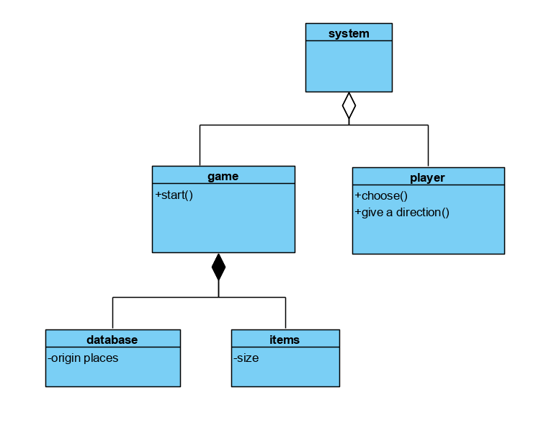

## T1: Unit Test

### T1.1: Starter Unit Test

T1.1.1: Test SelectValueChanged()

function SelectValueChanged(app, event)

value = app.Select.Value;

app.STARTButton.Visible = 'on';

if(value == char("横刀立马"))

app.level = 1;

elseif(value == char("横竖皆将"))

app.level = 2;

elseif(value == char("三军联防"))

app.level = 3;

elseif(value == char("四路皆兵"))

app.level = 4;

elseif(value == char("test")) Tcover 1.1.1.1

app.level = 5;

elseif(value == char("前挡后堵"))

app.level = 6;

end

end

* Coverage Criteria: Statement coverage
* Test case

|  |  |
| --- | --- |
|  | Test Case T1.1.1.1 |
| Coverage Item | Tcover1.1.1.1 |
| Input | testCase.App = Starter;  testCase.choose(testCase.App.Select,"test"); |
| State | testCase.App = Starter; |
| Expected Output | testCase.App.STARTButton.Visible=='on'  testCase.App.level==5 |

* Test coverage: 1/1=100%
* Test result: 1 passed

T1.1.2: Test STARTButtonPushed()

function STARTButtonPushed(app, event)

app.pressed = true; Tcover 1.1.2.1

if( app.level == 1&&app.pressed == true)

b = board;

b.level = 1;

elseif(app.level == 2&&app.pressed == true)

b = board;

b.level = 2;

elseif(app.level == 3&&app.pressed == true)

b = board;

b.level = 3;

elseif(app.level == 4&&app.pressed == true)

b = board;

b.level = 4;

elseif(app.level == 5&&app.pressed == true)

b = board;

b.level = 5;

elseif(app.level == 6&&app.pressed == true)

b = board;

b.level = 6;

end

end

* Coverage Criteria: Statement coverage
* Test case

|  |  |
| --- | --- |
|  | Testcase T1.1.2.1 |
| Coverage Item | Tcover 1.1.2.1 |
| Input | testCase.press(testCase.App.STARTButton); |
| State | testCase.App = Starter;  testCase.choose(testCase.App.Select,"test"); |
| Expect output | testCase.App.pressed==true  A game board appears(validated by people) |

* Test coverage: 1/1=100%
* Test result: 1 passed

### T1.2: Board Unit Test

T1.2.1: Test fivepredict() and ZhangfeiClicked()

function fivepredict(app,x,y,h)

if(h==0)

if(app.Mirror.mirror(x,y-2) == 0)

app.UButton.Enable = 'on';

end

if(app.Mirror.mirror(x,y+1) == 0)

app.DButton.Enable = 'on';

end

if(app.Mirror.mirror(x-1,y) == 0&&app.Mirror.mirror(x-1,y-1) == 0)

app.LButton.Enable = 'on';

end

if(app.Mirror.mirror(x+1,y) == 0&&app.Mirror.mirror(x+1,y-1) == 0)

app.RButton.Enable = 'on';

end

elseif(h==1)

if(app.Mirror.mirror(x,y-1) == 0&&app.Mirror.mirror(x+1,y-1) == 0) Tcover1.2.1.1

app.UButton.Enable = 'on';

end

if(app.Mirror.mirror(x,y+1) == 0&&app.Mirror.mirror(x+1,y+1) == 0) Tcover1.2.1.2

app.DButton.Enable = 'on';

end

if(app.Mirror.mirror(x-1,y) == 0) Tcover1.2.1.3

app.LButton.Enable = 'on';

end

if(app.Mirror.mirror(x+2,y) == 0) Tcover1.2.1.4

app.RButton.Enable = 'on';

end

end

end

* Coverage Criteria: Statement coverage
* Test case

|  |  |
| --- | --- |
|  | Testcase T1.2.1.1, |
| Coverage Item | Tcover 1.2.1.1 Tcover 1.2.1.2 Tcover 1.2.1.3 Tcover 1.2.1.4 |
| Input | B = board;  B.level = 5;  testCase.press(B.StartButton);  testCase.press(B.Zhangfei); |
| State | B = board;  B.level = 5;  testCase.press(B.StartButton); |
| Expect output | B.UButton.Enable== 'off'  B.DButton.Enable== 'off'  B.LButton.Enable== 'off'  B.RButton.Enable== 'off' |

* Test coverage: 4/4=100%
* Test result: 4 passed

T1.2.2: Test caocaopredict() and CaocaoClicked() and DButtonPushed()

function caocaopredict(app,x,y)

if(app.Mirror.mirror(x,y-2) == 0&&app.Mirror.mirror(x+1,y-2) == 0) Tcover 1.2.2.1

app.UButton.Enable = 'on';

end

if(app.Mirror.mirror(x,y+1) == 0&&app.Mirror.mirror(x+1,y+1) == 0) Tcover 1.2.2.2

app.DButton.Enable = 'on';

end

if(app.Mirror.mirror(x-1,y) == 0&&app.Mirror.mirror(x-1,y-1) == 0) Tcover 1.2.2.3

app.LButton.Enable = 'on';

end

if(app.Mirror.mirror(x+2,y) == 0&&app.Mirror.mirror(x+2,y-1) == 0) Tcover 1.2.2.4

app.RButton.Enable = 'on';

end

end

function DButtonPushed(app, event)

app.Status.positionlist(app.Selected,2) = app.Status.positionlist(app.Selected,2) - 1;

app.plist = ChessPosition(app.Status);

app.Mirror = boardmirror(app.Status);

deleteimage(app);

createchess(app);

reset(app);

end

* Coverage Criteria: Statement coverage
* Test case

|  |  |
| --- | --- |
|  | Testcase T1.2.2.1, |
| Coverage Item | Tcover 1.2.2.1 Tcover 1.2.2.2 Tcover 1.2.2.3 Tcover 1.2.2.4 |
| Input | B = board;  B.level = 5;  testCase.press(B.StartButton);  testCase.press(B.Caocao); |
| State | B = board;  B.level = 5;  testCase.press(B.StartButton); |
| Expect output | B.UButton.Enable== 'off'  B.DButton.Enable== 'on'  B.LButton.Enable== 'off'  B.RButton.Enable== 'off'  Caocao moves down, win figure appears(validated by people) |

* Test coverage: 4/4=100%
* Test result: 4 passed

## T2: Integration Test

T2.1: Starter + Board integration

## T3: Functional Test