Group 10

Author: YuanShen

Software Specifications

Painkiller Injection System

Table of Contents

System Architecture 2

Software Specifications 3

S1: Physician UI implementation 3

S2: Patient UI implementation 6

S3: Injection processor implementation 8

## System Architecture

The system architecture is shown below:

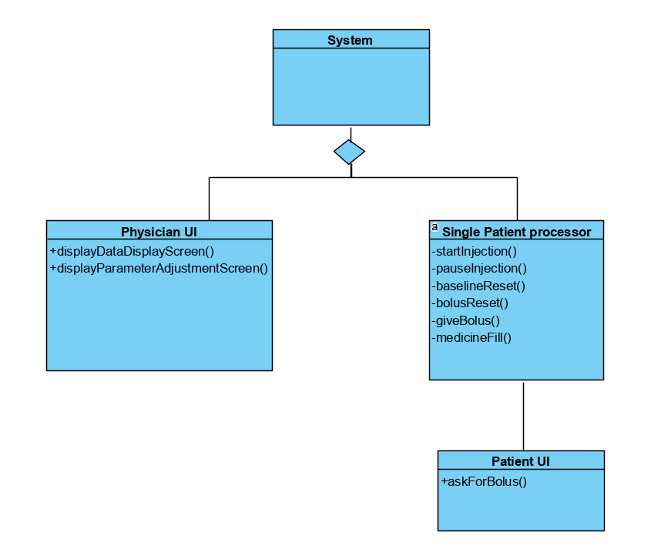

## Software Specifications

### S1: Physician UI implementation

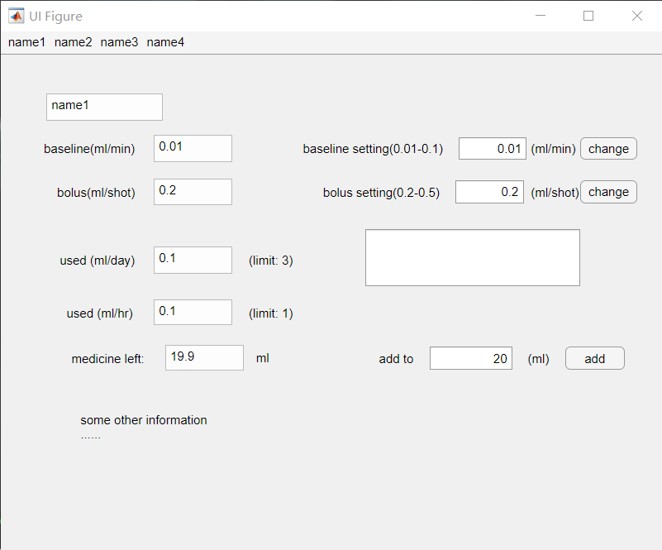

#### S1.1: Adjust baseline

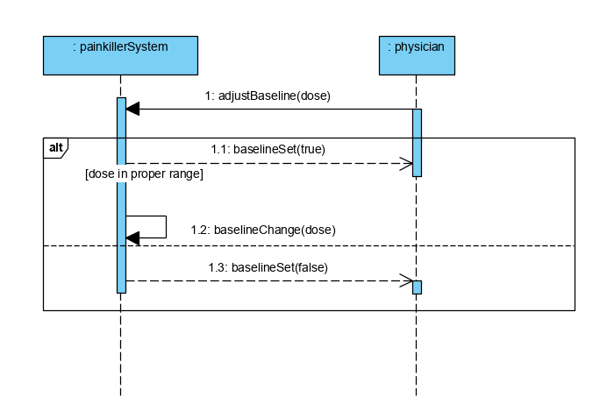

* S1.1: Adjust baseline

1. Change button clicked
2. For input dose
   1. If dose is in [0.01,0.1], change the baseline of the chosen patient in the system
   2. If dose is not in [0.01,0.1], show failure message and don’t change anything

#### S1.2: Adjust bolus

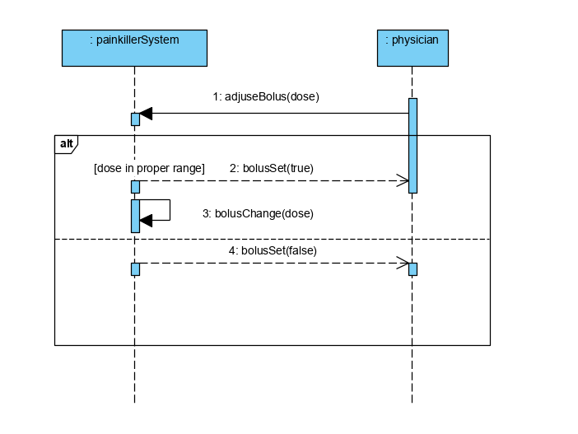

* S1.2: Adjust bolus

1. Change button clicked
2. For input dose
3. If dose is in [0.2,0.5], change the bolus of the chosen patient in the system
4. If dose is not in [0.2,0.5], show failure message and don’t change anything

#### S1.3: Fill in painkiller

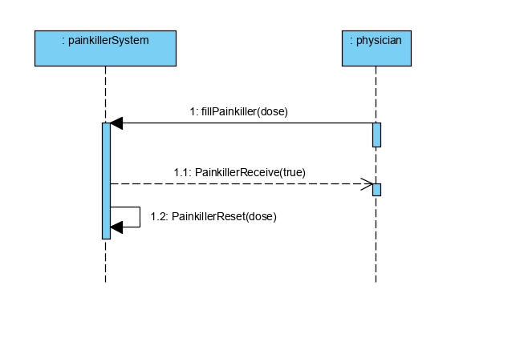

* S1.3: Fill in painkiller

1. Add button clicked
2. For input dose, change the medicine left to it.

### S2: Patient UI implementation

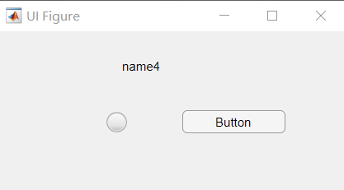

#### S2.1: Apply for bolus

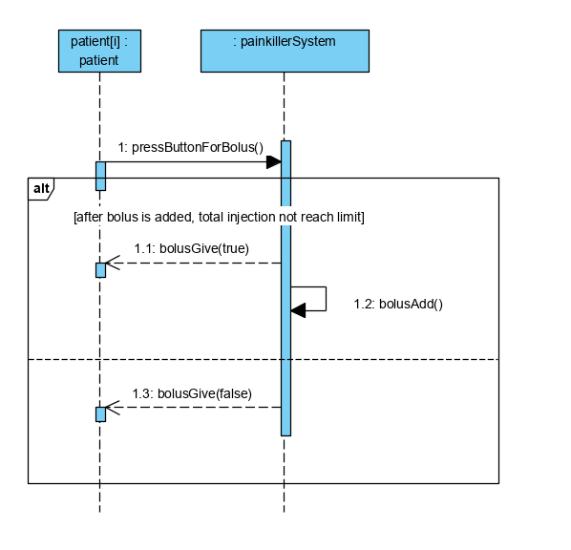

* S2.1: Apply for bolus

1. Button clicked
2. For the patient’s injection condition:
3. If patient’s hour injection plus bolus is not greater than hour limit, and patient’s day injection plus bolus is not greater than day limit, give bolus.
4. If any limit is reached, don’t give bolus.

### S3: Injection processor implementation

#### S3.1: Judge injection

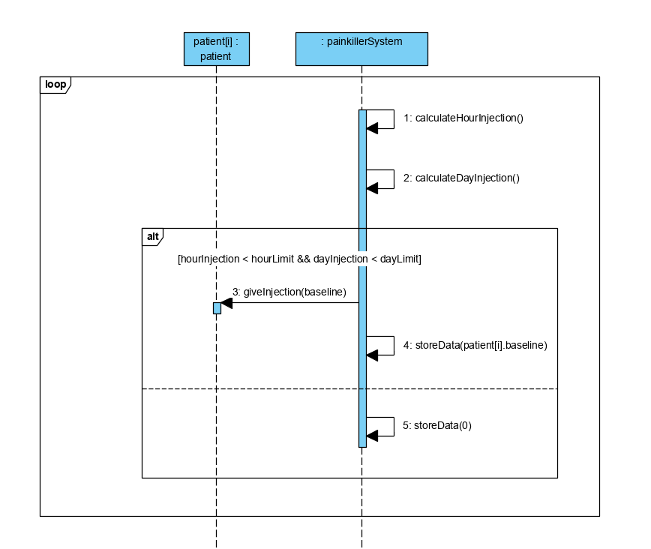

* S3.1: Judge Injection

1. Calculate total amount of injected painkiller in the last 59min and last 23h59min
2. If last 59min’s injection + baseline < hour limit && last 23h59min’s injection + baseline < day limit, give baseline injection. Store this injection dose in the system.
3. If any limit is reached, just store the injection dose( which is zero) in the system.