Group 10

Author: WeichenLu

User Manual

Painkiller Injection System

Table of Contents

System Architecture 2

Physician Manual 2

Patient Manual 5

## System Architecture

The system architecture is shown below:

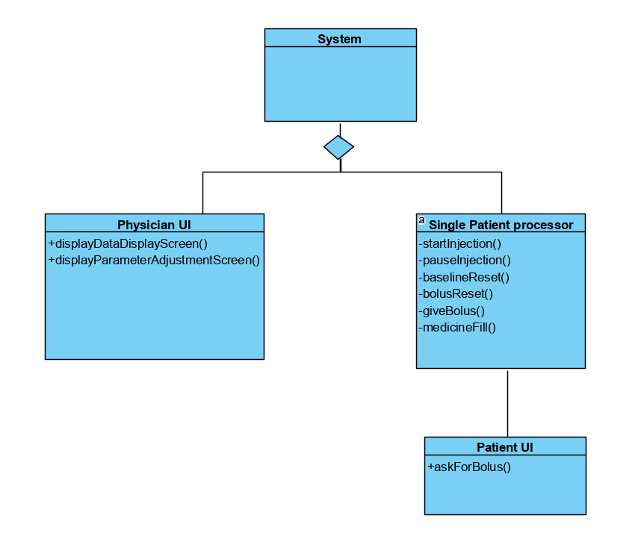

## Physician Manual

The physician has a UI which is shown below:

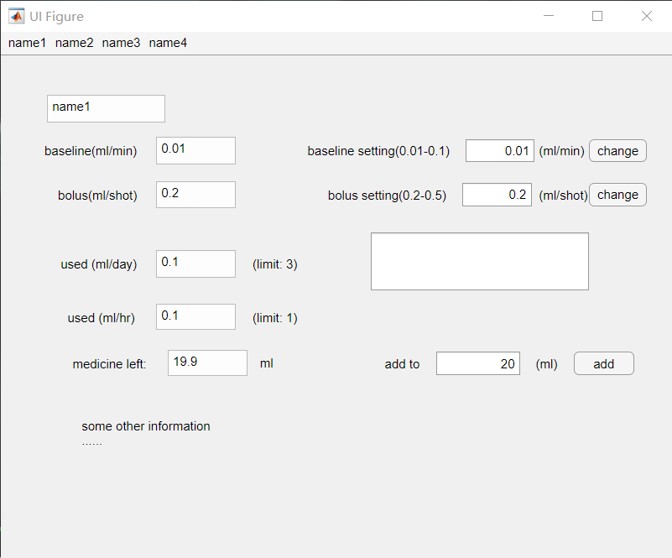

The system can manage four patients at the same time.

On the top of the UI, physician can choose which patient they would like to check.

The left part shows the information of the injection of the patient, which contains the patient’s name, baseline, bolus, used amount in single day and single hour, and the left medicine in the device.

The right part is for physician to set the parameters of the injection.

#### Change the baseline



Physician can change the baseline of the injection of any patient .

In the circled place, input the wanted baseline in the text box, then press “change” button. The range of valid baseline is 0.01 to 0.1 milliliter per minute(mL/min). If the input data is not in this range, the system won’t accept it, and the rejection message will appear in the pointed text box. If the input data is valid, the system will refresh the data.

#### Change the bolus



Physician can change the bolus of the injection of any patient .

In the circled place, input the wanted bolus in the text box, then press “change” button. The range of valid bolus is 0.2 to 0.5 milliliter per shot(mL/shot). If the input data is not in this range, the system won’t accept it, and the rejection message will appear in the pointed text box. If the input data is valid, the system will refresh the data.

#### Fill the painkiller



Physician can fill painkiller in the device.

In the circled place, input the amount of medicine this addition will reach, and press add button. The system will refresh the data.

## Patient Manual

Each patient has a UI which is shown below:

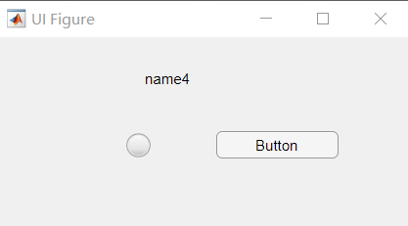

It shows the patient’s name. It also contains a lamp and a button.

#### Ask for a bolus

When patient feels painful, they could ask for a bolus by pressing the button. If the injection condition allows this bolus, the lamp will become green for one second, and the system will inject the bolus at the same time. If it is not allowed, the lamp will become red for one second, and the system will not give the bolus to the patient.