REPORT 1
INTRODUCTION
This report presents the analysis of digital addiction and screen time behavior using Power BI. It provides a clear and interactive view of how different factors such as gender, age group, stress level and academic work impact the screen time and digital habits of users.
The report helps in understanding the patterns and trends in smartphone usage, identifying high-risk groups and providing useful insights for better digital well-being.
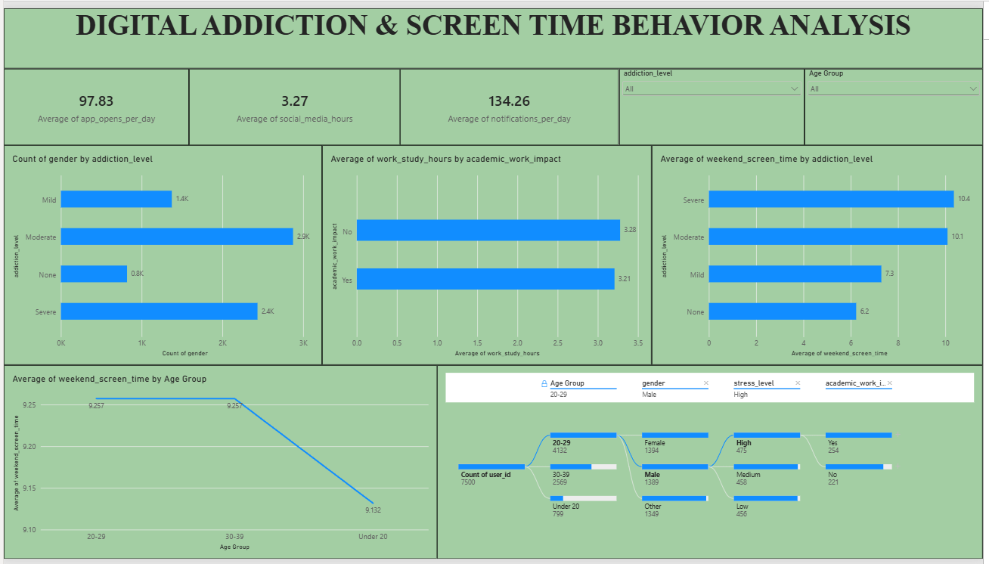
Key Findings:
1. Screen Time and App Usage
- Average of app opens per day is 97.83 and average of social media hours is 3.27.
- Average of notifications per day is 134.26.
2. Addiction Level Analysis
- Moderate addiction level has the highest count (2.9K), followed by Severe (2.4K), Mild (1.4K) and None (0.8K).
3. Gender Analysis
- Females have the highest addiction level (1.4K), followed by Males (1.2K) and Other (0.8K).
4. Work and Study Impact
- Users with “No” academic/work impact have slightly higher work/study hours (3.28) than “Yes” (3.21).
5. Weekend Screen Time by Addiction Level
- Severe addiction level has the highest weekend screen time (10.4 hours), followed by Moderate (10.1), Mild (7.3) and None (6.2).
6. Age Group Analysis
- Age group 20-29 has the highest weekend screen time (9.27), followed by 30-39 (9.26) and Under 20 (9.13).
7. Detailed View by Filters
- The bottom section shows how users are distributed across age group, gender, stress level and academic work impact.

REPORT 2
INTRODUCTION
This report presents the analysis of smartphone usage and digital well-being using Power BI. It provides a clear and interactive view of how different factors such as gender, age group, screen time, gaming hours, social media usage, sleep hours, notifications and other digital habits impact the well-being of users. The report helps in identifying key patterns and trends in smartphone usage and provides useful insights for better digital well-being.
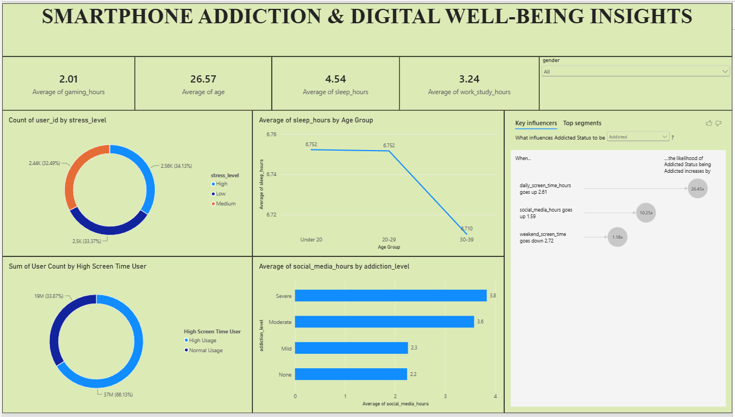
Key Findings:
1. Gaming and Work/Study hours
- Average gaming hours are 2.01 hours.
- Average work/study hours are 3.24 hours.
2. Average Age
- The average age of users is 26.57 years.
3. Stress Level
- The donut chart shows the distribution of users across High, Low and Medium stress levels.
4. Sleep Hours by Age Group
- The line chart compares average sleep hours across 20-29, Under 20 and 30-39 age groups.
5. High Screen Time Users
- The donut chart compares users classified as High Usage and Normal Usage.
6. Social Media and Addiction Level
- The bar chart compares average social media hours across None, Mild, Moderate and Severe addiction levels.
7. Key Influencers
- The key influencers visual identifies factors associated with Addicted status, such as daily screen time, social media hours and weekend screen time.
8. Interactive Filtering
- The dashboard includes a gender slicer allowing the report to be filtered by gender.

