Automated Deployment of WordPress Website on Nginx using GitHub Actions on AWS Cloud

This documentation outlines the steps to set up an automated deployment process for a WordPress website using Nginx as the web server, LEMP (Linux, Nginx, MySQL, PHP) stack, and GitHub Actions as the CI/CD automation tool. The deployment process follows security best practices and ensures optimal performance of the website.

Website URL – https://wordpress.binbash.website/
Github Repo URL - https://github.com/eashan98/wordpress

## Table of Contents
- Server Provisioning
- Package Installtion
- Website Configuration
- GitHub Repository Setup

1- Ubuntu Server Provisioning
• I have choosed a cloud provider of AWS and provision an EC2 Server of Ubuntu Linux 22.04
• Set the firewall rules as stated below
◦ Open the port of 33000 only on my IP for secure connection of SSH
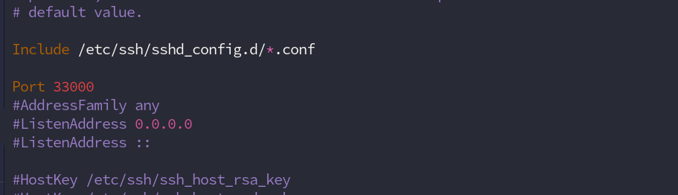
◦ Open the port 80 & 443 for the https traffic
• Setup SSH service for only key-based authentication and disable root login for secure remote access
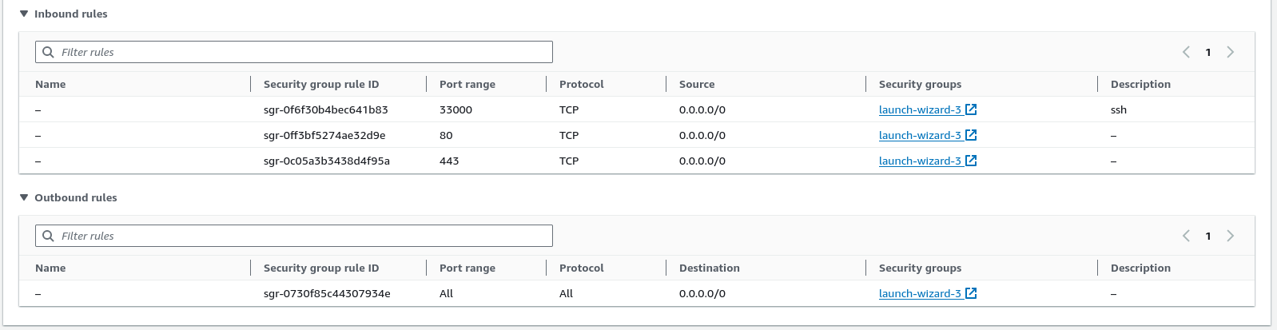

2. Packages Installation
• Install Nginx as the web server.
◦ Created Nginx config file for the configuration
▪ URL – https://github.com/eashan98/wordpress/blob/main/nginx.conf
◦ setup the project directory at /var/www/html/wordpress
◦ change the owner ship of the /var/www/html/wordpress dir so that nginx can access this directory
• Install MySQL as the database.
◦ Mysql version – 5.7
• Install PHP for processing dynamic content.
◦ Php version – 7.4

3. Website Configuration
• Set up WordPress
◦ Install and configure WordPress in VPS
◦ Setup WordPress with strong password
◦ Change the Setting to lock after 3 login attempts
◦ Add Wordpress plugin to protect from XSS & Brute Force Attack
• Implemented SSL Certificate with LetsEncrypt for Secure HTTPS connection and setup LetsEncrypt for auto-renewal of certificate. (here is a report from www.ssllabs.com)
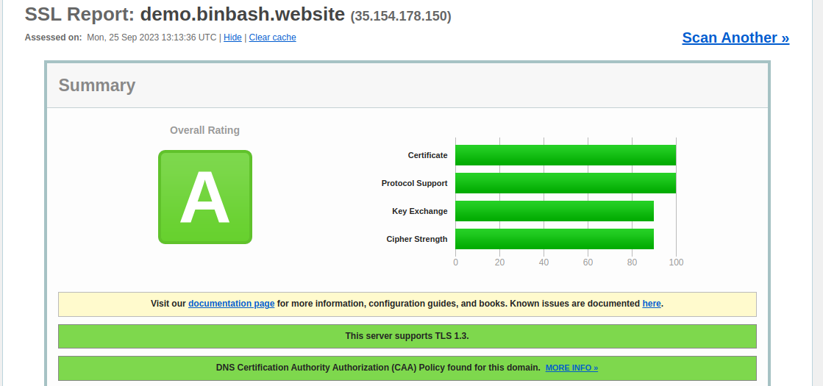

• Optimized Nginx Configuration
◦ Optimized the Nginx server configuration to enhance website performance using caching, gzip compression, and added Security Headers to increase security.
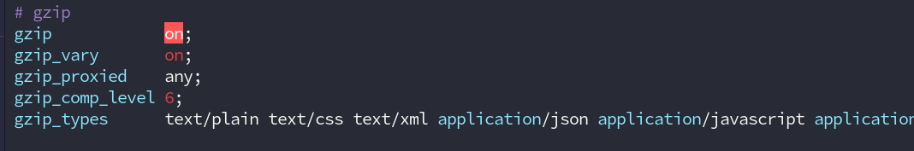
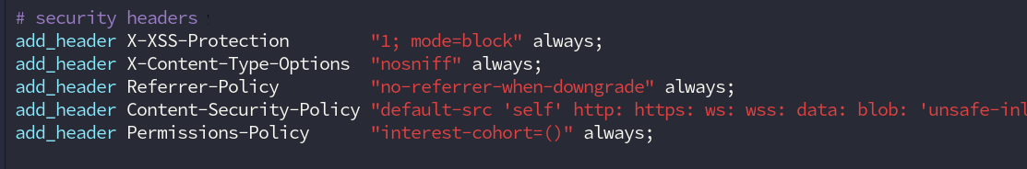

4. GitHub Repository Setup
• Created a GitHub Repository to save the WordPress project.
• Create the GitHub Actions yaml for the automated deployment of project and securely transfer project files to the VPS also install dependency (if required)
◦ ci-yaml - https://github.com/eashan98/wordpress/blob/main/.github/workflows/main.yml
• Here you can find the instruction to setup this enviroment locally
◦ README.md – https://github.com/eashan98/wordpress/blob/main/README.md

