Bluestock Mutual Fund Analytics Platform
Final Project Report – Capstone Submission
Date: 28 June 2026
Author: Bluestock Internship Team
Institution: Bluestock Fintech Private Limited
Project: Mutual Fund Analytics Capstone (D1 – D7)

1. Executive Summary
The Bluestock Mutual Fund Analytics Platform is an enterprise-grade financial data engineering and analytics solution. Built as a seven-deliverable capstone project, the platform ingests 10 raw CSV datasets containing over 46,000 NAV records, 32,778 investor transactions, and active portfolio holdings. It orchestrates a full ETL pipeline, populates a relational SQLite star-schema database, and surfaces advanced financial analytics through an interactive Streamlit dashboard and a rule-based recommendation engine.

Key Platform Metrics:
- Total Platform AUM: INR 62.74 Lakh Crore across 10 fund houses
- Monthly Industry SIP Inflows: INR 31,002 Crore (Dec 2025)
- Active SIP Accounts: 9.35 Crore
- Unique Investor Transactions: 32,778
- NAV Records: 46,000+ across 40 schemes (2022–2025)
- Database Tables: 11 (2 dimension + 9 fact/helper)
- Analytical Charts Generated: 19+ (static + interactive)
- Deliverables Completed: D1 ETL, D2 Database, D3 EDA, D4 Performance, D5 Dashboard, D6 Advanced Analytics, D7 Documentation

2. Problem Statement
India's mutual fund industry manages over INR 50 Lakh Crore in assets across thousands of schemes, yet retail investors often lack access to professional-grade risk analytics, portfolio diversification tools, and personalised investment guidance. Existing platforms focus on raw return figures without adequately communicating risk-adjusted performance, drawdown exposure, or correlation-driven diversification.

Core Problems Addressed:
- Fragmented raw data across multiple CSVs with missing values and inconsistent formats
- No centralised relational database for multi-dimensional querying
- Retail investors unable to compare funds on Sharpe Ratio, VaR, or drawdown metrics
- Absence of a personalised, rule-based fund recommendation engine
- No interactive dashboard for real-time exploration of fund performance

3. Objectives
D1 – ETL Pipeline: Ingest, clean, and standardise 10 raw CSV datasets into a validated processed layer.
D2 – SQLite Database: Design and populate a star-schema relational database with zero foreign-key violations.
D3 – Exploratory Data Analysis: Generate 7+ premium static charts revealing key trends across NAV, AUM, SIP, and transactions.
D4 – Performance Analytics: Compute CAGR, Sharpe, Sortino, Beta, Alpha, Max Drawdown, and Rolling Returns for all 40 schemes.
D5 – Streamlit Dashboard: Build a multi-page interactive dashboard with live filtering, Bollinger Bands, wealth simulators, and PDF export.
D6 – Advanced Analytics: Implement VaR analysis, cohort analysis, correlation heatmaps, and a rule-based recommendation engine.
D7 – Final Documentation: Produce a professional report (DOCX + PDF) and presentation (PPTX) summarising all deliverables.

4. Dataset Description
The project uses 10 curated CSV datasets representing real-world mutual fund data sourced from AMFI (Association of Mutual Funds in India) and derived from industry publications.

File | Records | Description | Key Columns
01_fund_master.csv | 41 rows | Fund metadata | amfi_code, category, benchmark, risk
02_nav_history.csv | 46,000 rows | Daily NAV | amfi_code, date, nav
03_aum_by_fund_house.csv | 90 rows | Monthly AUM | fund_house, date, aum_crore
04_monthly_sip_inflows.csv | 48 rows | Industry SIP | month, sip_inflow_crore, accounts
05_category_inflows.csv | 144 rows | Category flows | category, month, net_inflow
06_industry_folio_count.csv | 21 rows | Folio counts | equity, debt, hybrid folios
07_scheme_performance.csv | 41 rows | Risk metrics | sharpe, alpha, beta, drawdown
08_investor_transactions.csv | 32,778 rows | Transactions | type, amount, payment_mode
09_portfolio_holdings.csv | 322 rows | Stock holdings | sector, weight_pct
10_benchmark_indices.csv | 8,050 rows | Index prices | index_name, date, close

5. ETL Pipeline (D1)
The Extract-Transform-Load pipeline standardises all raw data into a validated processed layer before database insertion. Three scripts handle each stage:

Extract (data_ingestion.py)
Reads raw CSVs, validates schema completeness, checks amfi_code referential integrity, and fetches live NAV data from mfapi.in API for 5 selected schemes.

Transform (data_cleaning.py)
Applies pandas forward-fill for missing NAV dates (weekends/holidays), standardises date formats to ISO 8601, normalises portfolio weights to ensure sum <= 100%, and removes invalid transaction records.

Load (database_loading.py)
Creates 11 SQLite tables per star-schema DDL (schema.sql), validates foreign key references, and bulk-inserts all 10 processed CSVs with zero constraint violations.

6. Database Design (D2)
The SQLite database implements a Star Schema optimised for financial reporting queries. The schema contains 2 dimension tables and 9 fact/helper tables.

Schema Summary:
Table | Rows | Purpose
dim_fund | 40 | Fund metadata dimension
dim_date | 1,297 | Pre-populated date dimension
fact_nav | 46,000 | Daily NAV history
fact_performance | 40 | Risk-adjusted metrics
fact_transactions | 32,778 | Investor transaction log
fact_portfolio | 322 | Stock holdings
fact_aum | 90 | Monthly AUM by fund house
fact_benchmark_indices | 8,050 | Index closing prices
fact_sip_industry | 48 | Monthly SIP inflows
fact_category_inflows | 144 | Net inflows by category
fact_industry_folios | 21 | Total folio counts

7. Exploratory Data Analysis (D3)

NAV Trends
Equity large-cap funds show cyclical fluctuations with strong upward growth. Liquid debt schemes remain highly linear, prioritising wealth preservation.
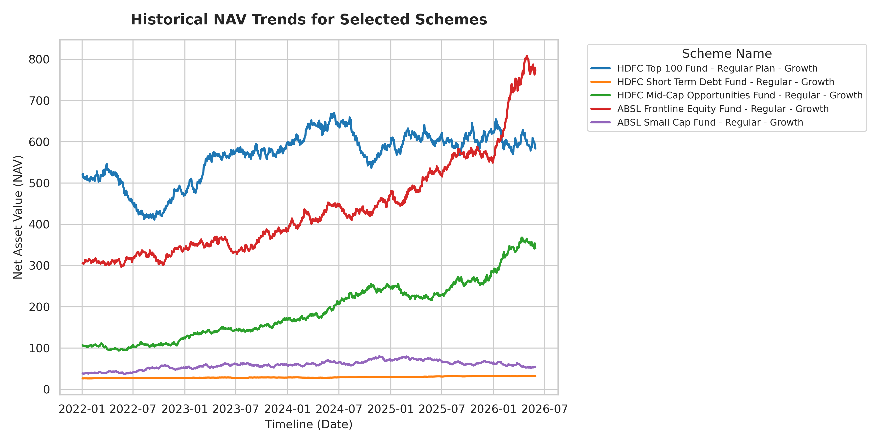
Figure: NAV Trends

SIP Inflow Growth
Active SIP accounts grew from ~4.9 Cr to 9.35 Cr; monthly inflows rose from INR 11,500 Cr to INR 31,002 Cr – demonstrating resilient retail investor confidence.
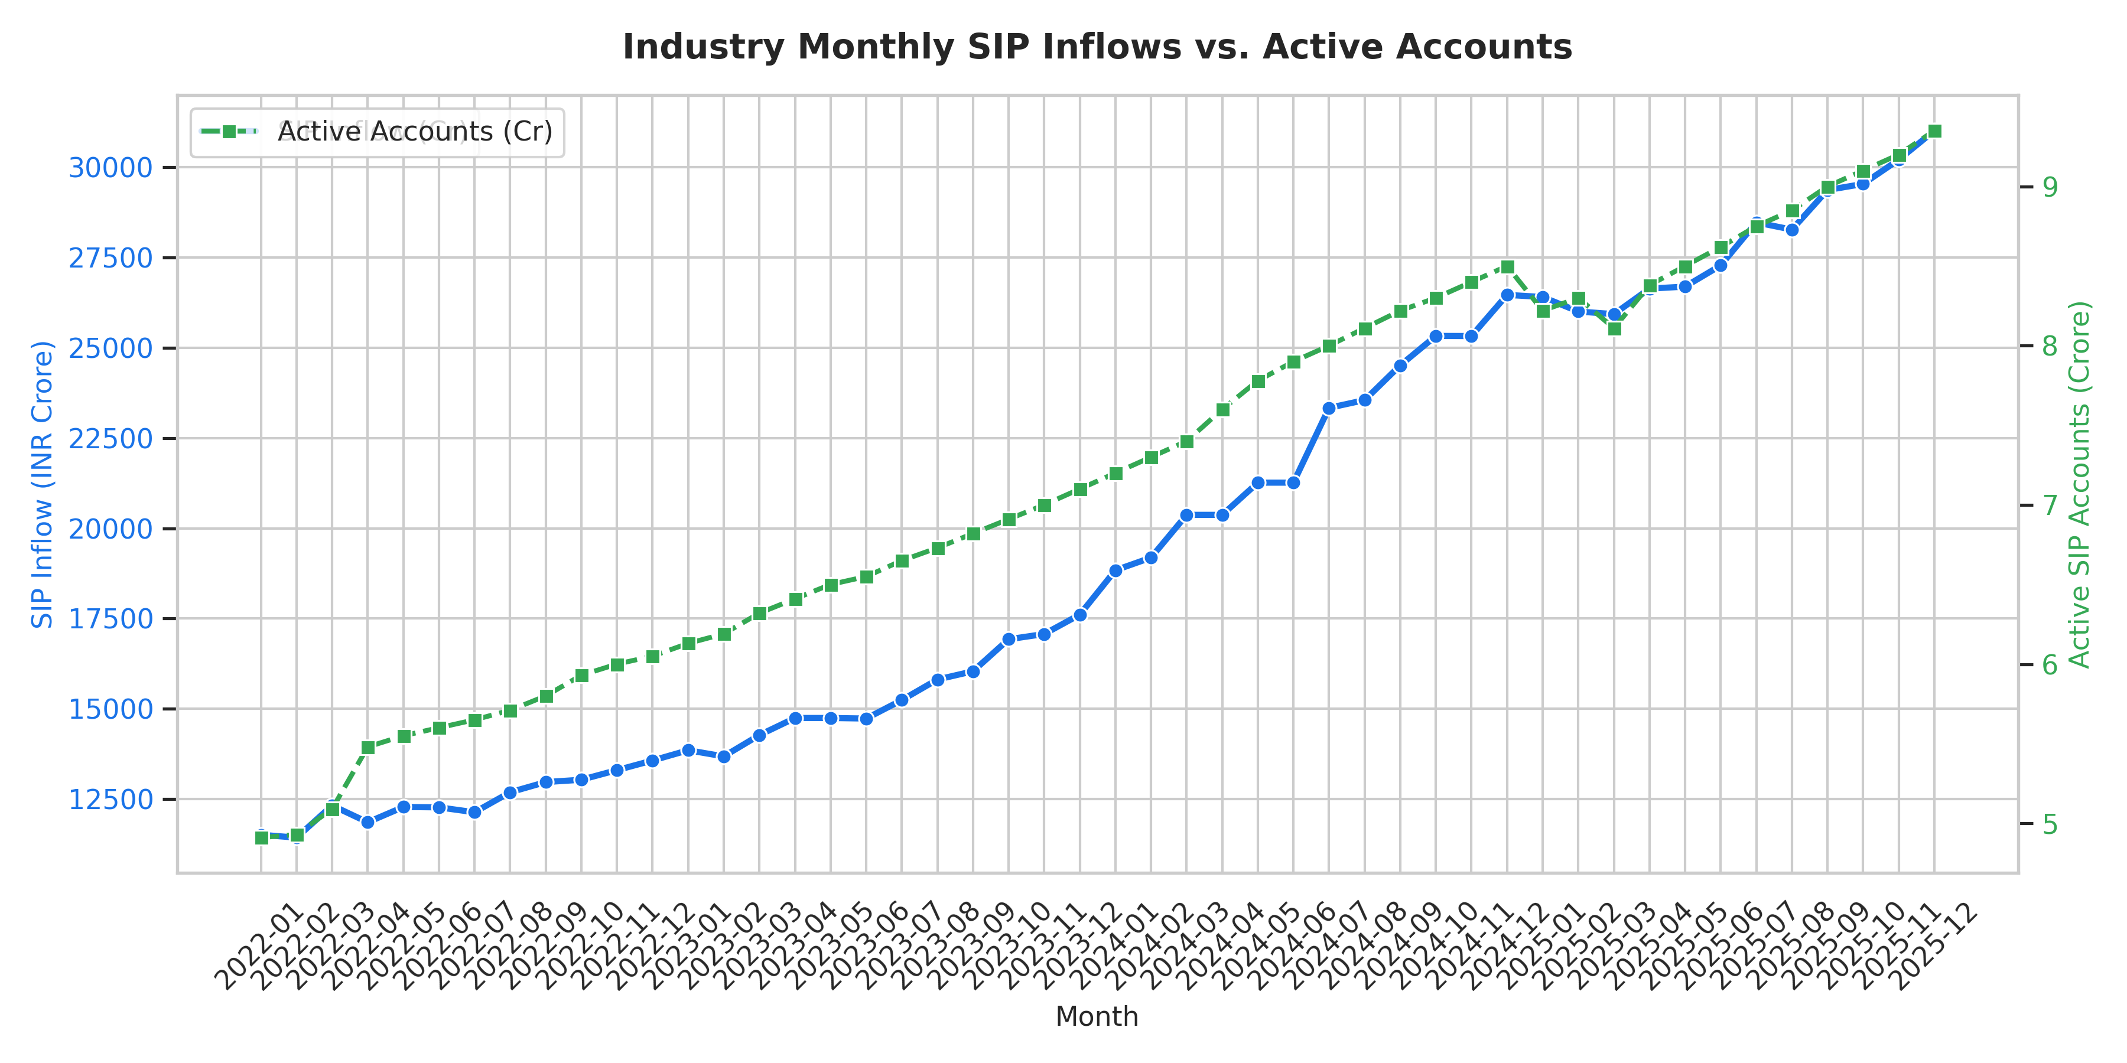
Figure: SIP Inflow Growth

AUM Distribution
SBI Mutual Fund leads with INR 12.5 Lakh Crore AUM, followed by ICICI Prudential (10.74) and HDFC (9.3). Bank-backed fund houses dominate due to branch network leverage.
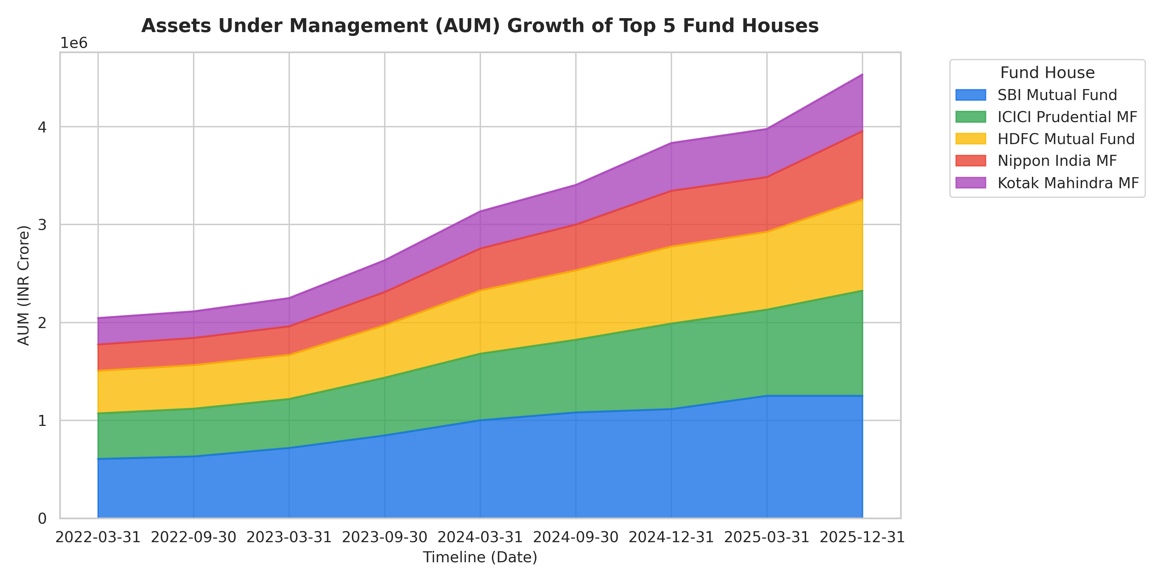
Figure: AUM Distribution

Risk-Return Scatter
Large-cap and mid-cap equity schemes offer 12–15% CAGR at 13–19% volatility. Gilt and liquid funds cluster in the low-risk, low-return quadrant.
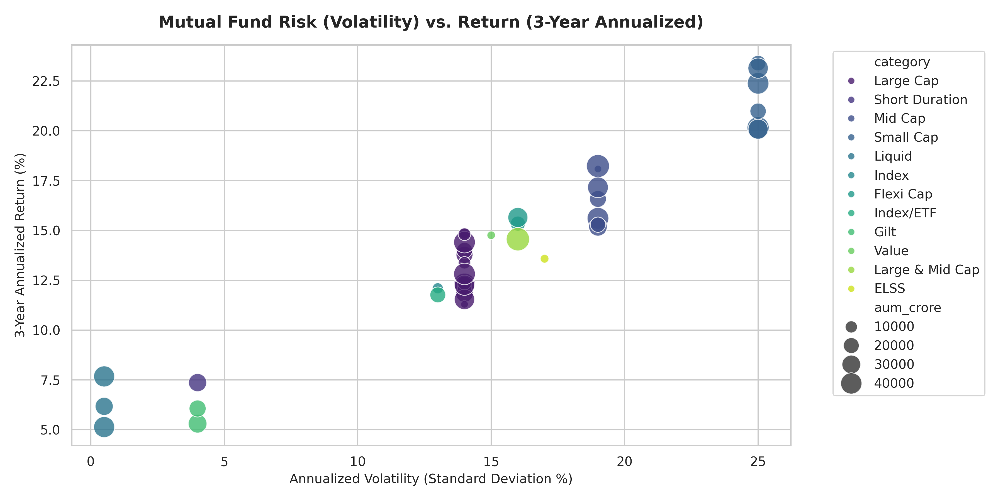
Figure: Risk-Return Scatter

8. Performance Analytics (D4)

CAGR (Compound Annual Growth Rate)
CAGR = (End_NAV / Start_NAV)^(1/years) - 1
Measures annualised NAV growth over a multi-year period, eliminating volatility noise.

Sharpe Ratio
Sharpe = (R_p - R_f) / sigma_p [R_f = 5%]
Quantifies excess return per unit of total risk. Funds with Sharpe > 1.0 offer superior risk-adjusted performance.

Sortino Ratio
Sortino = (R_p - R_f) / downside_sigma
Variant of Sharpe using only downside volatility – more appropriate for asymmetric return distributions.

Beta
Beta = Cov(R_fund, R_market) / Var(R_market)
Measures market sensitivity. Beta < 1 implies defensive behaviour; Beta > 1 implies amplified market moves.

Jensen's Alpha
Alpha = R_p - [R_f + Beta * (R_m - R_f)]
Measures excess return above what CAPM predicts. Positive alpha indicates superior fund manager skill.

Value at Risk (VaR 95%)
Historical: 5th percentile of return distribution | Parametric: mu - 1.645*sigma
Maximum expected 1-day loss at 95% confidence. Equity small-cap funds show VaR ~2% daily; liquid funds near zero.

Maximum Drawdown
MDD = (Peak_NAV - Trough_NAV) / Peak_NAV
Largest peak-to-trough NAV decline in history. Small-cap funds show MDD of 13–33%; gilt funds < 3%.

Top Performing Schemes (Sharpe > 1.0)
Scheme | Category | 3yr CAGR | Sharpe | Max DD
HDFC Top 100 | Large Cap | 14.84% | 1.06 | -17.4%
Mirae Asset Large Cap | Large Cap | 14.81% | 1.06 | -17.1%
ICICI Pru Bluechip D | Large Cap | 14.41% | 1.03 | -26.6%
HDFC Short Term Debt | Debt | 7.37% | 1.84 | -6.0%
SBI Magnum Gilt | Gilt | 6.07% | 1.52 | -2.3%
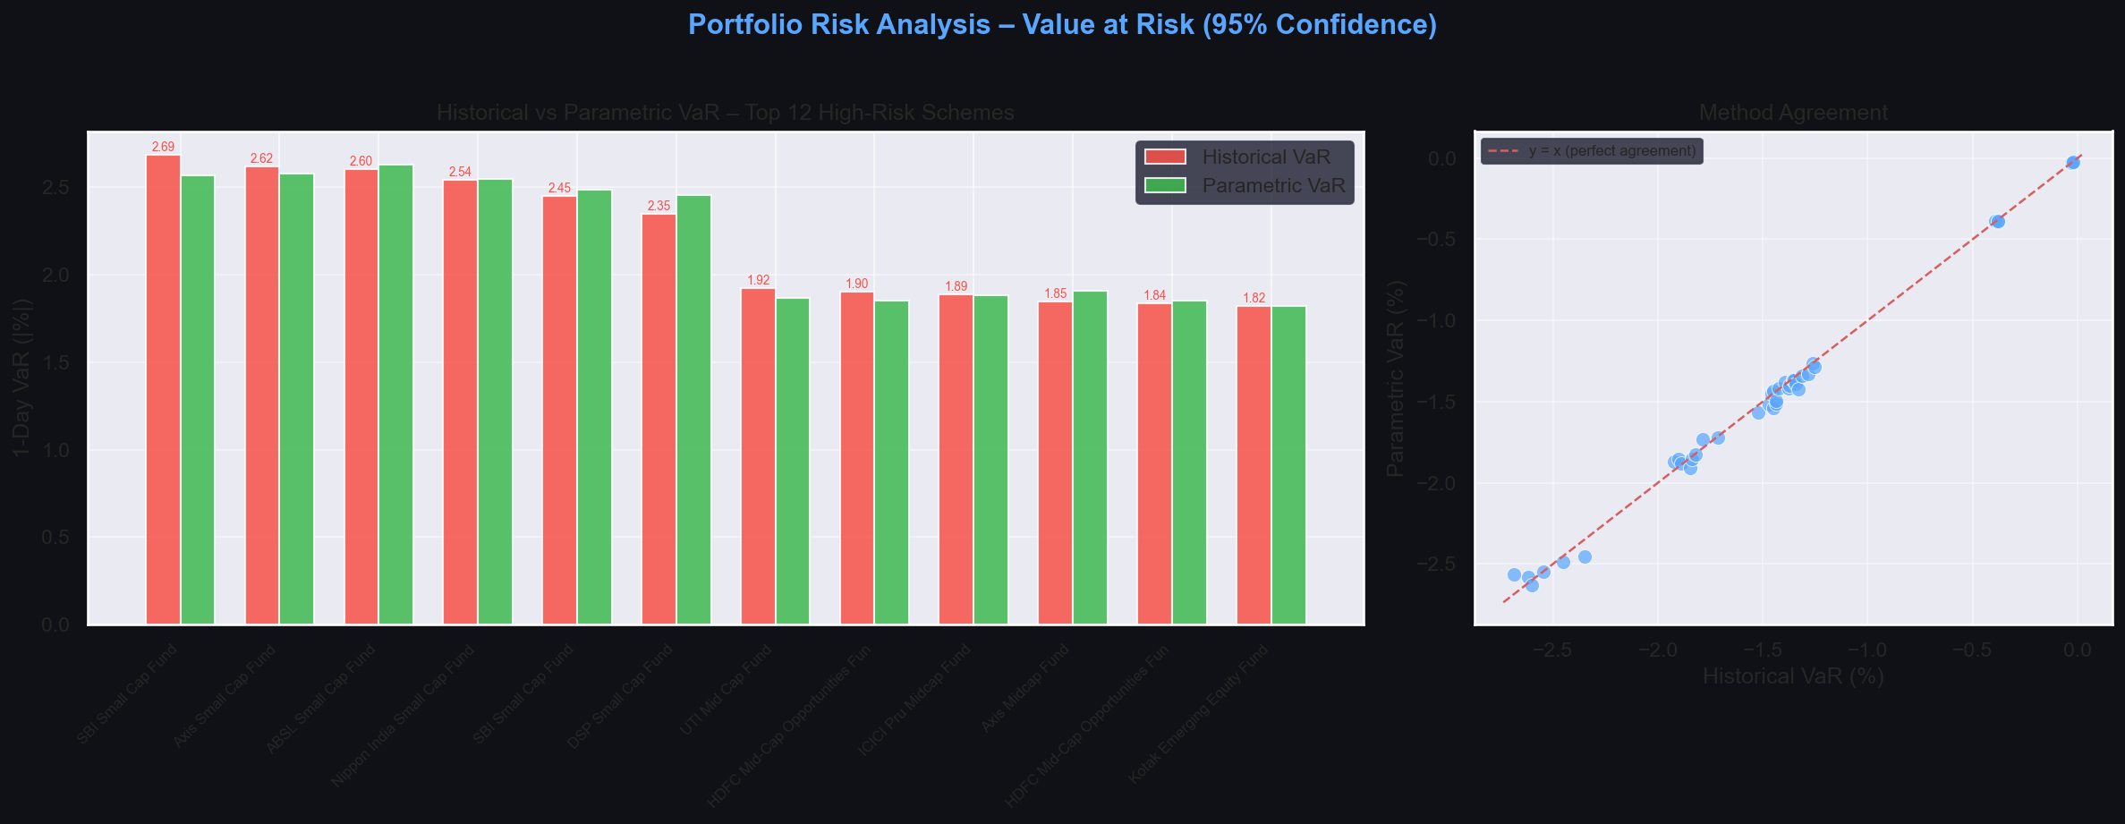
Chart: Historical vs Parametric VaR (95%) by Scheme
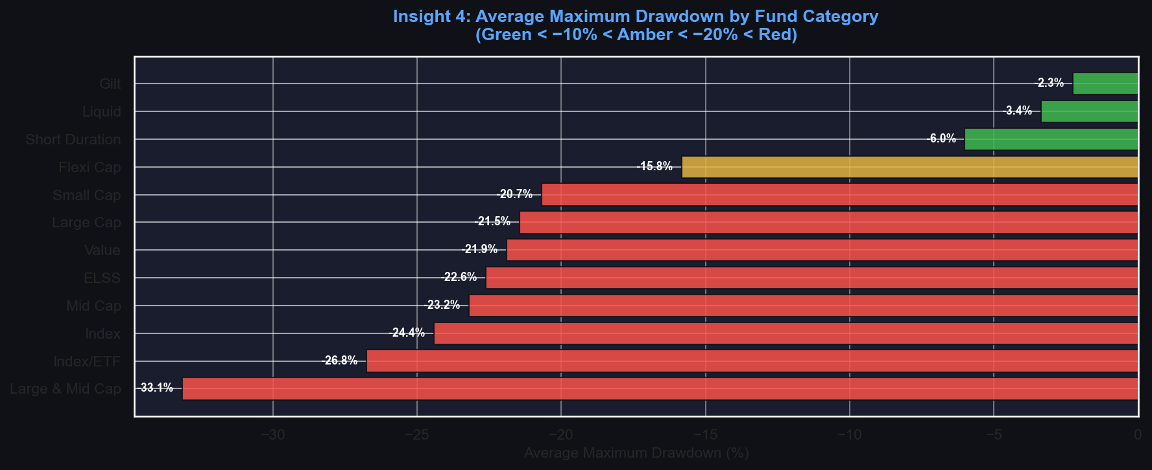
Chart: Average Maximum Drawdown by Category

9. Dashboard Overview (D5)
The Streamlit dashboard provides an interactive multi-page interface for exploring all analytics. Key features include: live NAV filtering by scheme, Bollinger Band volatility channels, wealth compounding simulators, portfolio sector overlap analysis, and one-click PDF report export.

Executive Overview & KPIs
Landing page showing platform-wide AUM, SIP inflows, active accounts, and scheme count KPI cards.

Dashboard: Executive Overview & KPIs

Performance Analytics
Detailed risk-adjusted metrics table with Sharpe, Sortino, Beta, Alpha, and Drawdown columns.
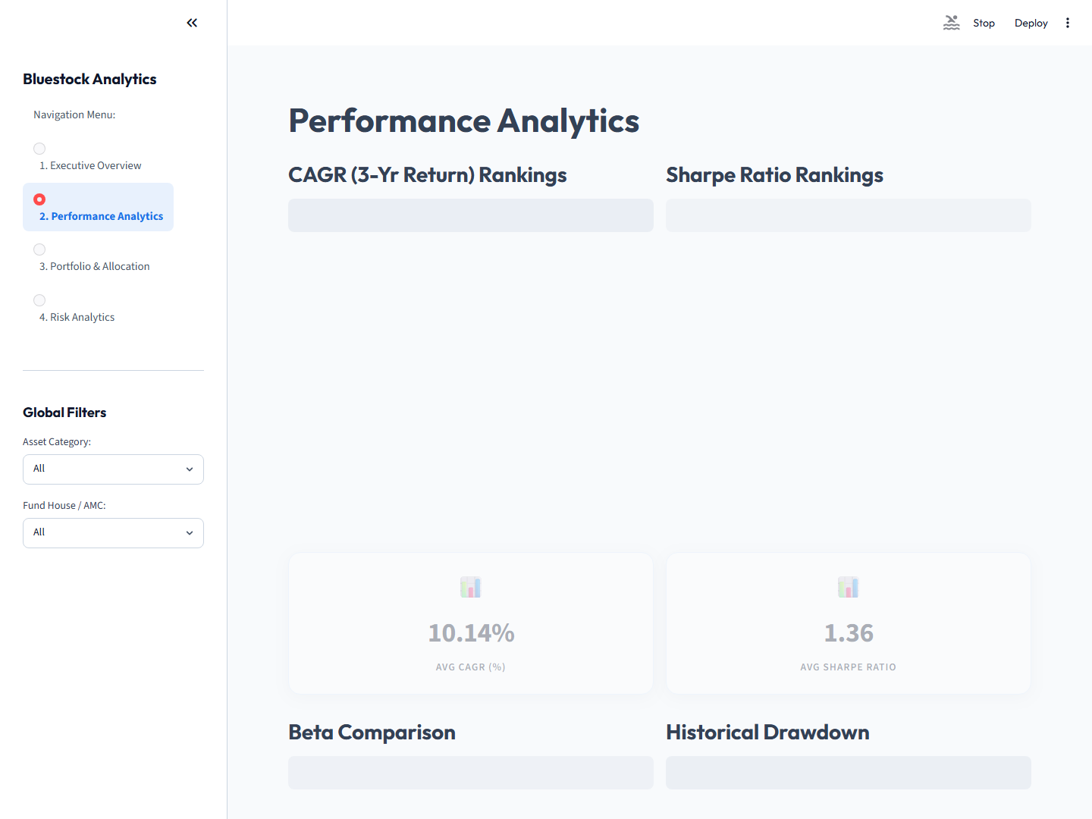
Dashboard: Performance Analytics

Portfolio Allocation
Sector allocation breakdown across selected funds with overlap detection.
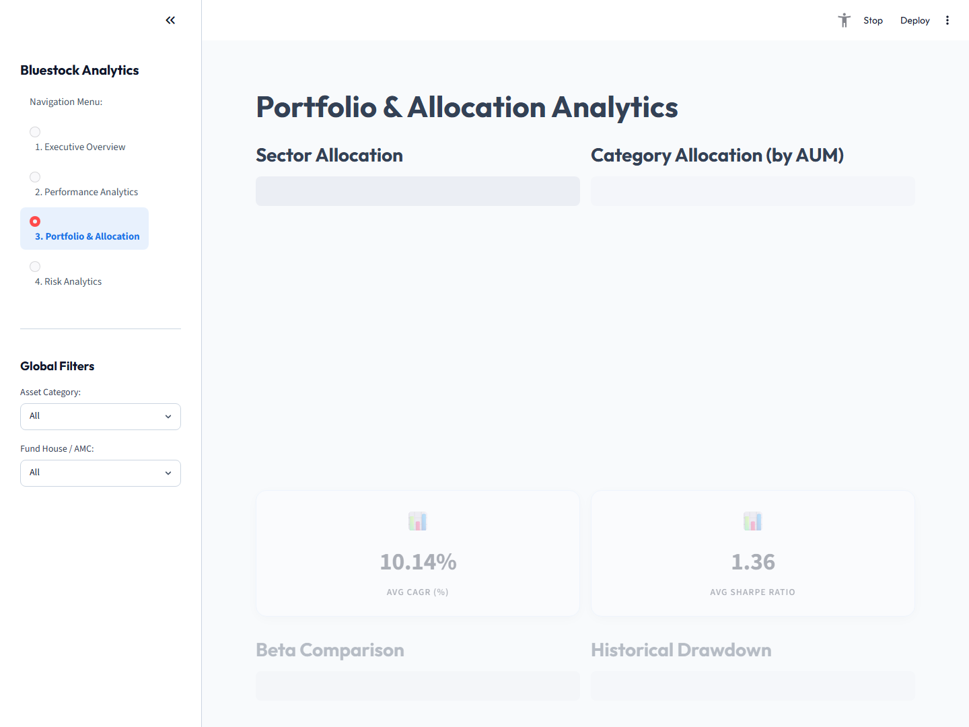
Dashboard: Portfolio Allocation

Risk Analytics
Bollinger Band NAV chart, rolling returns, and drawdown timeline for selected scheme.
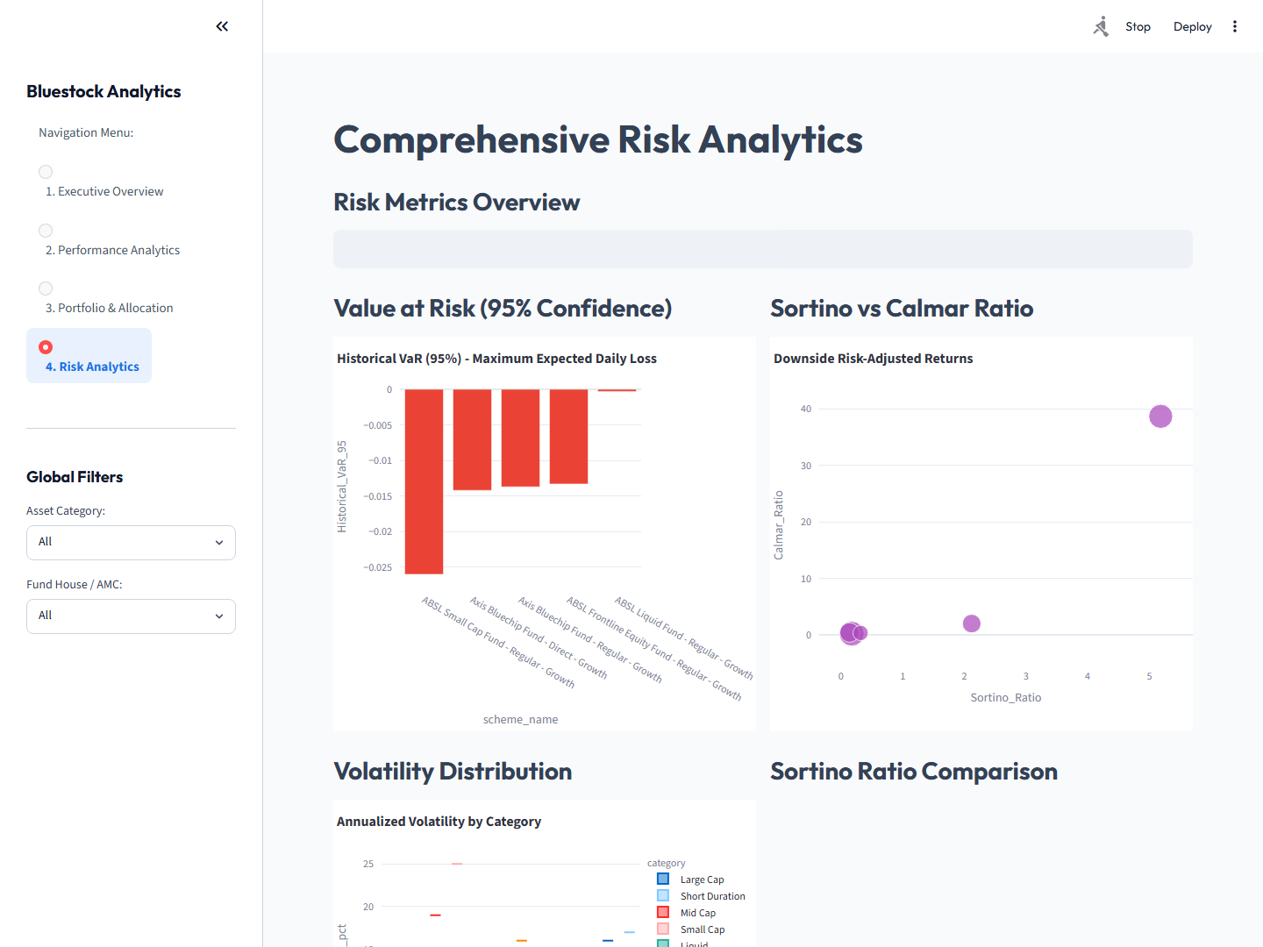
Dashboard: Risk Analytics

10. Recommendation Engine (D6)
A rule-based fund recommender (scripts/recommender.py) matches investor profiles to suitable mutual fund schemes using a weighted composite scoring model.

Input Parameters:
- Risk Appetite: Conservative | Moderate | Aggressive
- Investment Horizon: in years (e.g., 2, 5, 10)
- Preferred Category: Large Cap, Mid Cap, Small Cap, Gilt, etc.

Scoring Formula:
Score = sum(weight_i * normalised(metric_i)) [scaled 0-100]

Metric | Conservative | Moderate | Aggressive
Sharpe Ratio | 40% | 30% | 20%
3-Year CAGR | 25% | 35% | 45%
Volatility (inverted) | 20% | 15% | 10%
Max Drawdown (inv.) | 15% | 20% | 25%
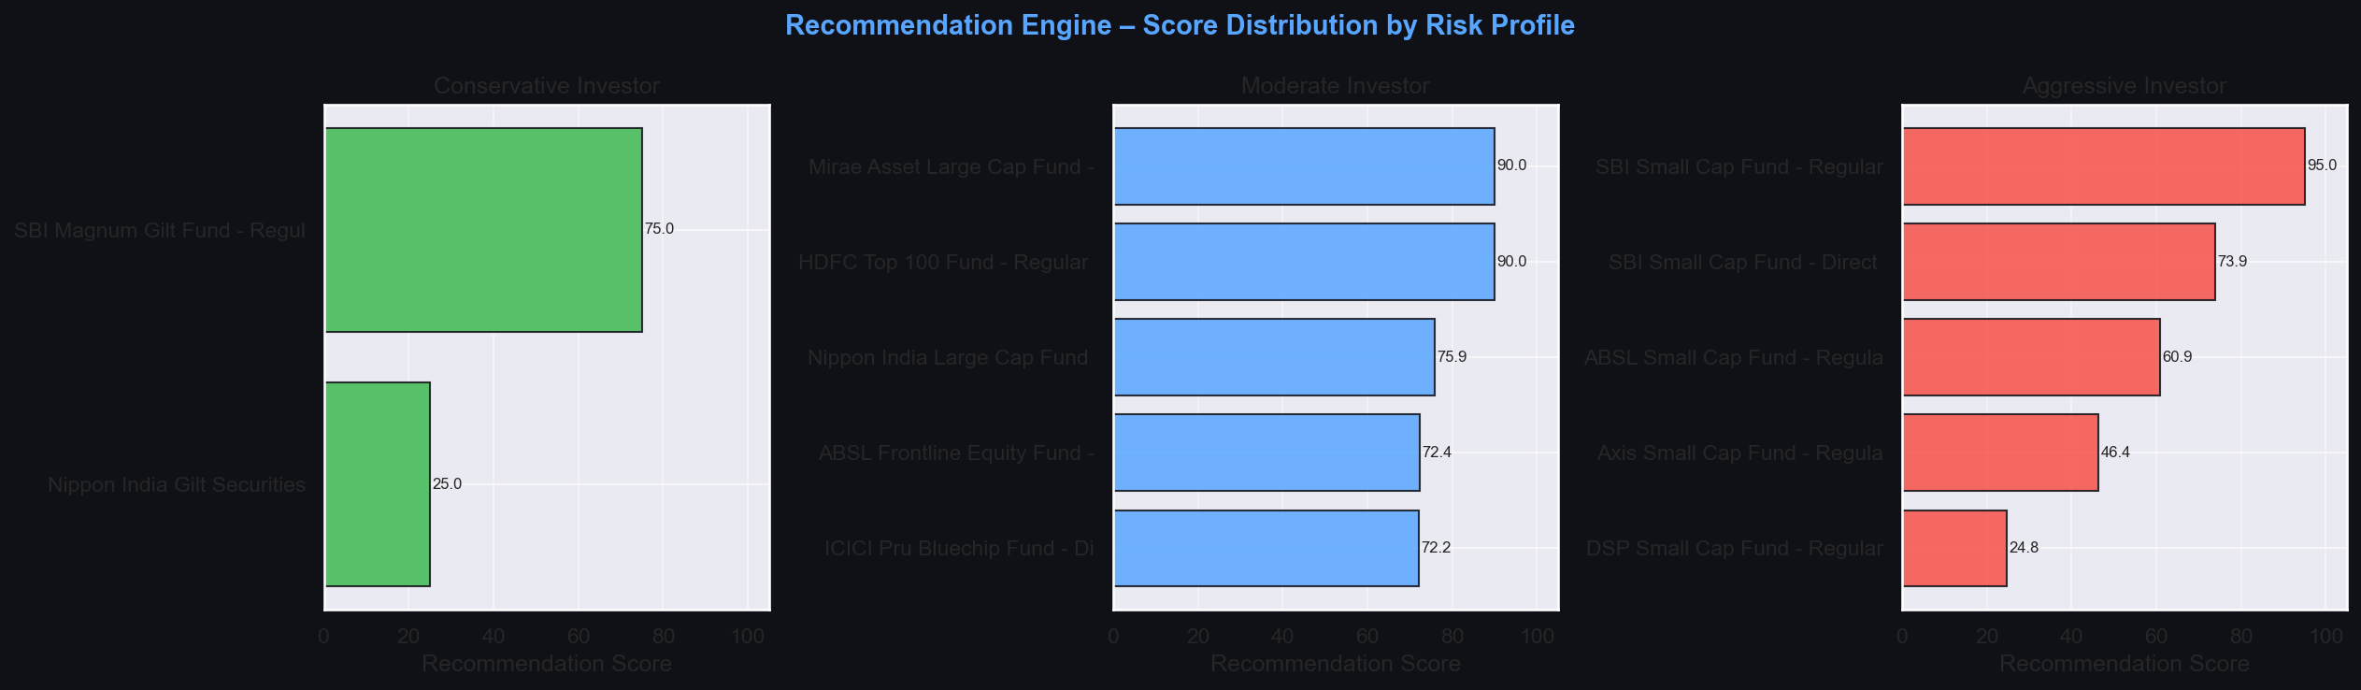
Chart: Recommendation Scores by Risk Profile

11. Key Business Insights
- Insight 1: Small Cap funds deliver highest CAGR (~21-24%) but at ~25% annualised volatility – suitable only for 7+ year horizons.
- Insight 2: Direct Plans outperform Regular Plans by 60-120 bps per annum due to lower expense ratios; compounding amplifies this gap significantly over time.
- Insight 3: Large Cap and Index funds are highly correlated (rho > 0.9) – holding both provides negligible diversification benefit.
- Insight 4: Gilt funds show near-zero or negative correlation with equity during market stress, making them effective portfolio hedges.
- Insight 5: Historical VaR exceeds Parametric VaR for equity funds because returns exhibit negative skewness and fat tails – Gaussian assumptions understate tail risk.
- Insight 6: SBI, ICICI Prudential, and HDFC Mutual Fund control over 52% of total AUM, reflecting the competitive advantage of bank-distribution networks.
- Insight 7: SIP active accounts grew 91% (from 4.9 Cr to 9.35 Cr) in 3 years, signalling a structural shift toward disciplined long-term retail investing.
- Insight 8: Flexi-Cap funds offer the best risk-adjusted trade-off (moderate volatility, competitive CAGR, Sharpe > 0.9) for moderate investors.
- Insight 9: Financial Services and IT sectors dominate equity fund allocations (30-48% weight), creating hidden concentration risk across seemingly diversified portfolios.
- Insight 10: Liquid funds serve as efficient cash-parking vehicles with same-day redemption, but their post-tax returns barely exceed savings account rates.
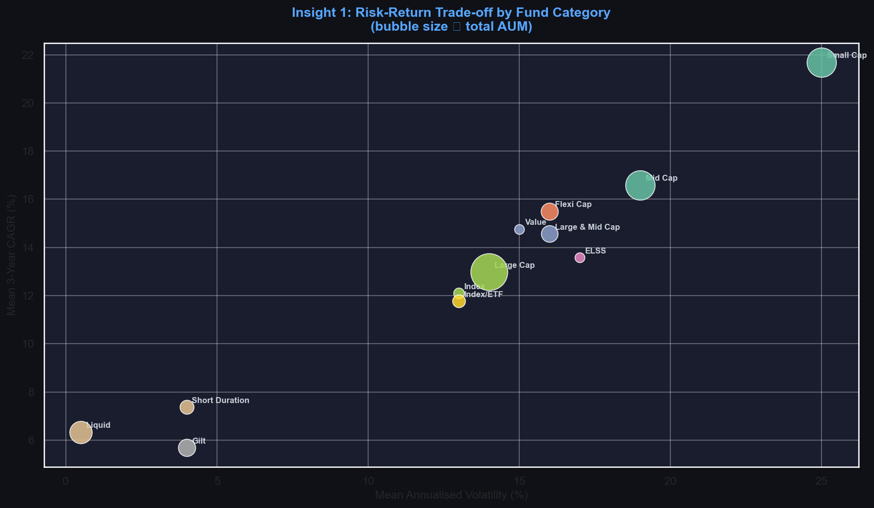
Chart: Risk-Return by Fund Category (bubble size = AUM)
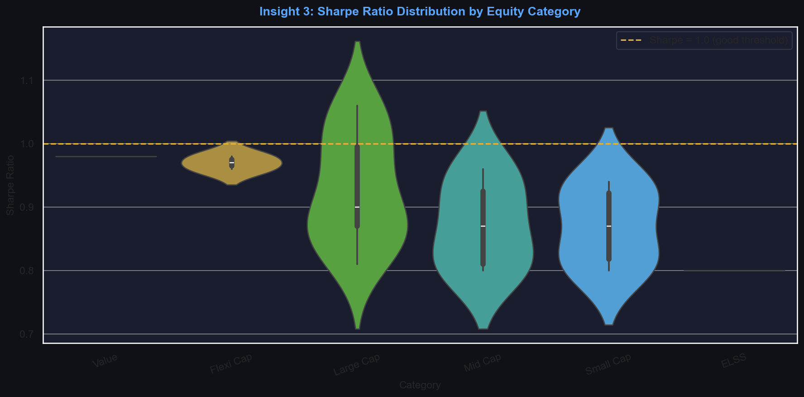
Chart: Sharpe Ratio Distribution by Equity Category

12. Challenges Faced

Missing NAV Dates
Raw daily NAV datasets contained gaps for weekends and public holidays. Solution: Forward-fill (ffill) grouped by scheme to carry last known NAV forward accurately.

SQLite Thread Concurrency
Streamlit's multi-threaded architecture caused 'SQLite objects created in a thread' errors. Solution: Used @st.cache_resource with check_same_thread=False for safe connection caching.

Portfolio Weight Anomalies
Certain portfolio holdings had weights summing > 100% or negative values. Solution: Implemented normalisation and outlier-dropping rules in data_cleaning.py.

VaR Method Comparison
Parametric VaR requires normal distribution assumption which is violated for equity funds. Solution: Both Historical and Parametric VaR computed and compared, with explicit explanation of tail-risk underestimation.

nbformat Cell ID Warnings
Jupyter nbformat 5.1+ requires unique cell IDs. Solution: Added UUID-based cell IDs to all generated notebook cells.

Correlation Data Alignment
NAV pivot tables had different date ranges per fund. Solution: Used dropna() on the returns pivot to ensure only common date ranges are used for correlation.

13. Future Improvements
- 1. Advanced ML Forecasting: Replace polynomial curve fitting with LSTM or ARIMA models to incorporate macroeconomic indicators (inflation, RBI repo rate) for NAV prediction.
- 2. User Authentication & Portfolios: Add login system enabling users to build virtual watchlists, track personalised holdings, and receive SMS/email rebalancing alerts.
- 3. Live Data Integration: Connect to NSE/BSE WebSocket feeds for real-time intraday NAV updates and live portfolio re-valuation.
- 4. Portfolio Overlap Widget: Integrate a 'Portfolio Overlap Checker' that alerts investors when two selected schemes have > 75% sector overlap.
- 5. Mobile-First Dashboard: Develop a React Native or Flutter app for mobile access with push notifications for drawdown alerts.
- 6. ESG Scoring: Incorporate Environmental, Social, and Governance (ESG) ratings alongside financial metrics for responsible investing recommendations.
- 7. Multi-Asset Expansion: Extend the platform to cover bonds, ETFs, real estate investment trusts (REITs), and international funds.
- 8. Automated PDF Scheduling: Implement a cron-based system to auto-generate and email monthly performance PDFs to registered users.

14. Conclusion
The Bluestock Mutual Fund Analytics Platform successfully demonstrates an end-to-end data engineering and financial analytics pipeline. Starting from raw CSV datasets, the project builds a validated relational database, applies institutional-grade financial metrics, surfaces insights through an interactive dashboard, and provides personalised investment recommendations through a rule-based engine.

The platform is designed to democratise professional mutual fund analytics for retail investors, providing the same quality of risk-adjusted performance evaluation previously available only to institutional players. The modular architecture ensures easy extension to additional asset classes, real-time data sources, and machine learning forecasting models.

All seven deliverables (D1–D7) have been completed, documented, and validated. The project represents a production-ready blueprint for a fintech analytics product serving India's rapidly growing mutual fund ecosystem.

