REUSABLE MARKET SPECIFICATION
LLC Portfolio Identification
and Mailing Research
Process requirements, decision rules, data model, and operating diagrams

Chicago / Cook County implementation baseline
Version 1.0 | 28 August 2026
Core rule
Group different LLC owners by the same normalized owner tax mailing address — never by the property address.

1. Purpose and intended use
This specification defines a repeatable process for discovering probable real-estate portfolios held through multiple differently named limited liability companies. It is designed to be reused market by market, beginning with Chicago and Cook County, and to produce a defensible mailing shortlist backed by parcel-level evidence.

The business question
Which owner tax mailing addresses receive records for two or more distinct LLC owners that collectively hold two or more distinct parcels, and what public entity evidence supports the conclusion that those LLCs may share a common controller or operating portfolio?

Required interpretation
- The result is a probable common-controller or common-portfolio signal, not proof of beneficial ownership.
- A manager, registered agent, organizer, attorney, tax processor, or property manager is not automatically the beneficial owner.
- Every mailed candidate must remain traceable to the public source records and the transformations that created the cluster.

Out of scope
- Filtering to multifamily, 2+ unit, commercial, or any other property class before the LLC-owner test.
- Grouping LLCs by the property or situs address.
- Treating a shared registered-agent address as conclusive proof of shared ownership.
- Naming a person as recipient without credible cross-entity support.

2. Executive requirements
ID | Requirement | Mandatory rule
R-01 | Universe | Begin with every parcel in the selected geography.
R-02 | LLC test | Keep records whose normalized legal owner name ends with LLC.
R-03 | Key | Use normalized owner tax mailing address as the candidate-cluster key.
R-04 | Threshold | Require 2+ distinct normalized LLC names and 2+ distinct parcels.
R-05 | Evidence | Retain property address as inventory evidence only.
R-06 | Review | Flag intermediaries and mass-service addresses; never silently remove them.
R-07 | Enrichment | Use Secretary of State records after clustering to corroborate entities.
R-08 | Outputs | Produce both cluster-level decisions and parcel-level audit evidence.

3. End-to-end workflow
The process separates discovery, qualification, corroboration, and mailing preparation. This prevents entity-enrichment data from biasing the initial portfolio signal.
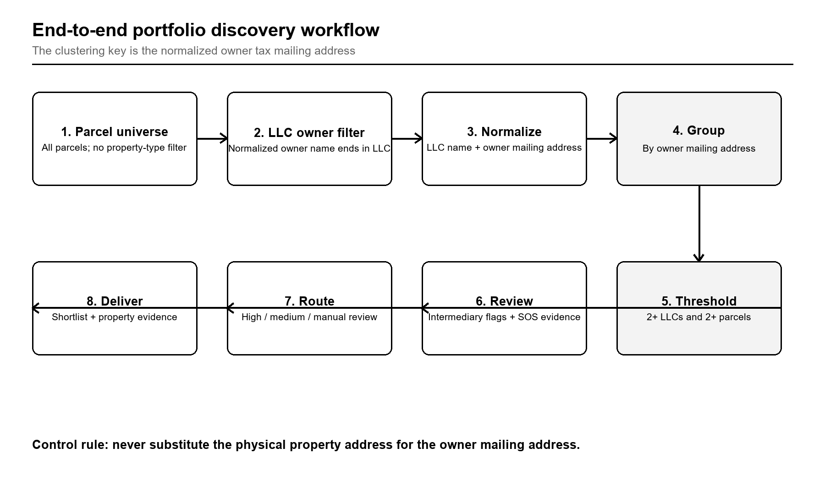
Figure 1. End-to-end portfolio discovery workflow
The owner mailing address is normalized before grouping; Secretary of State evidence enters only after the threshold test.

4. Source data requirements

Minimum parcel-record fields
Field | Meaning | Use | Status
Parcel identifier | Stable parcel/PIN key | Deduplication, evidence, joins | Required
Legal owner name | Tax-roll or assessment owner | LLC suffix filter; entity identity | Required
Owner mailing name | Addressee on tax record | Recipient candidate; QA | Preferred
Owner mailing address | Street, unit, city, state, ZIP | Primary clustering key | Required
Property/situs address | Location of owned parcel | Inventory and evidence only | Required
Source date/version | Assessment roll vintage | Reproducibility | Required

Chicago / Cook County baseline mapping
Cook County field | Role | Processing rule
owner_address_name | Legal owner name | Normalize; test suffix LLC
mail_address_full | Owner tax mailing street/unit | Normalize; cluster key
mail_address_city_name | Mailing city | Cluster-key component
mail_address_state | Mailing state | Cluster-key component
mail_address_zipcode_1 | Mailing ZIP | Cluster-key component
prop_address_full | Physical property address | Output/evidence only
pin | Parcel identifier | Distinct parcel count and audit key

5. LLC owner selection
The LLC test applies to the normalized legal owner name. It is intentionally broad and does not depend on property type, unit count, assessed use, or building class.

Required owner-name normalization
- Convert to uppercase and trim leading/trailing whitespace.
- Collapse repeated internal whitespace.
- Standardize terminal variants such as L.L.C., L L C, and punctuation-separated forms to LLC.
- Preserve the original source owner name alongside the normalized value.
- Pass only when the normalized owner name ends with the standalone suffix LLC.

Examples
Source owner name | Normalized owner name | Keep?
Lake View Owner, L.L.C. | LAKE VIEW OWNER LLC | Yes
West Loop Holdings LLC | WEST LOOP HOLDINGS LLC | Yes
LLC Management Services Inc. | LLC MANAGEMENT SERVICES INC | No — does not end in LLC
John and Mary Smith | JOHN AND MARY SMITH | No

6. Correct clustering logic
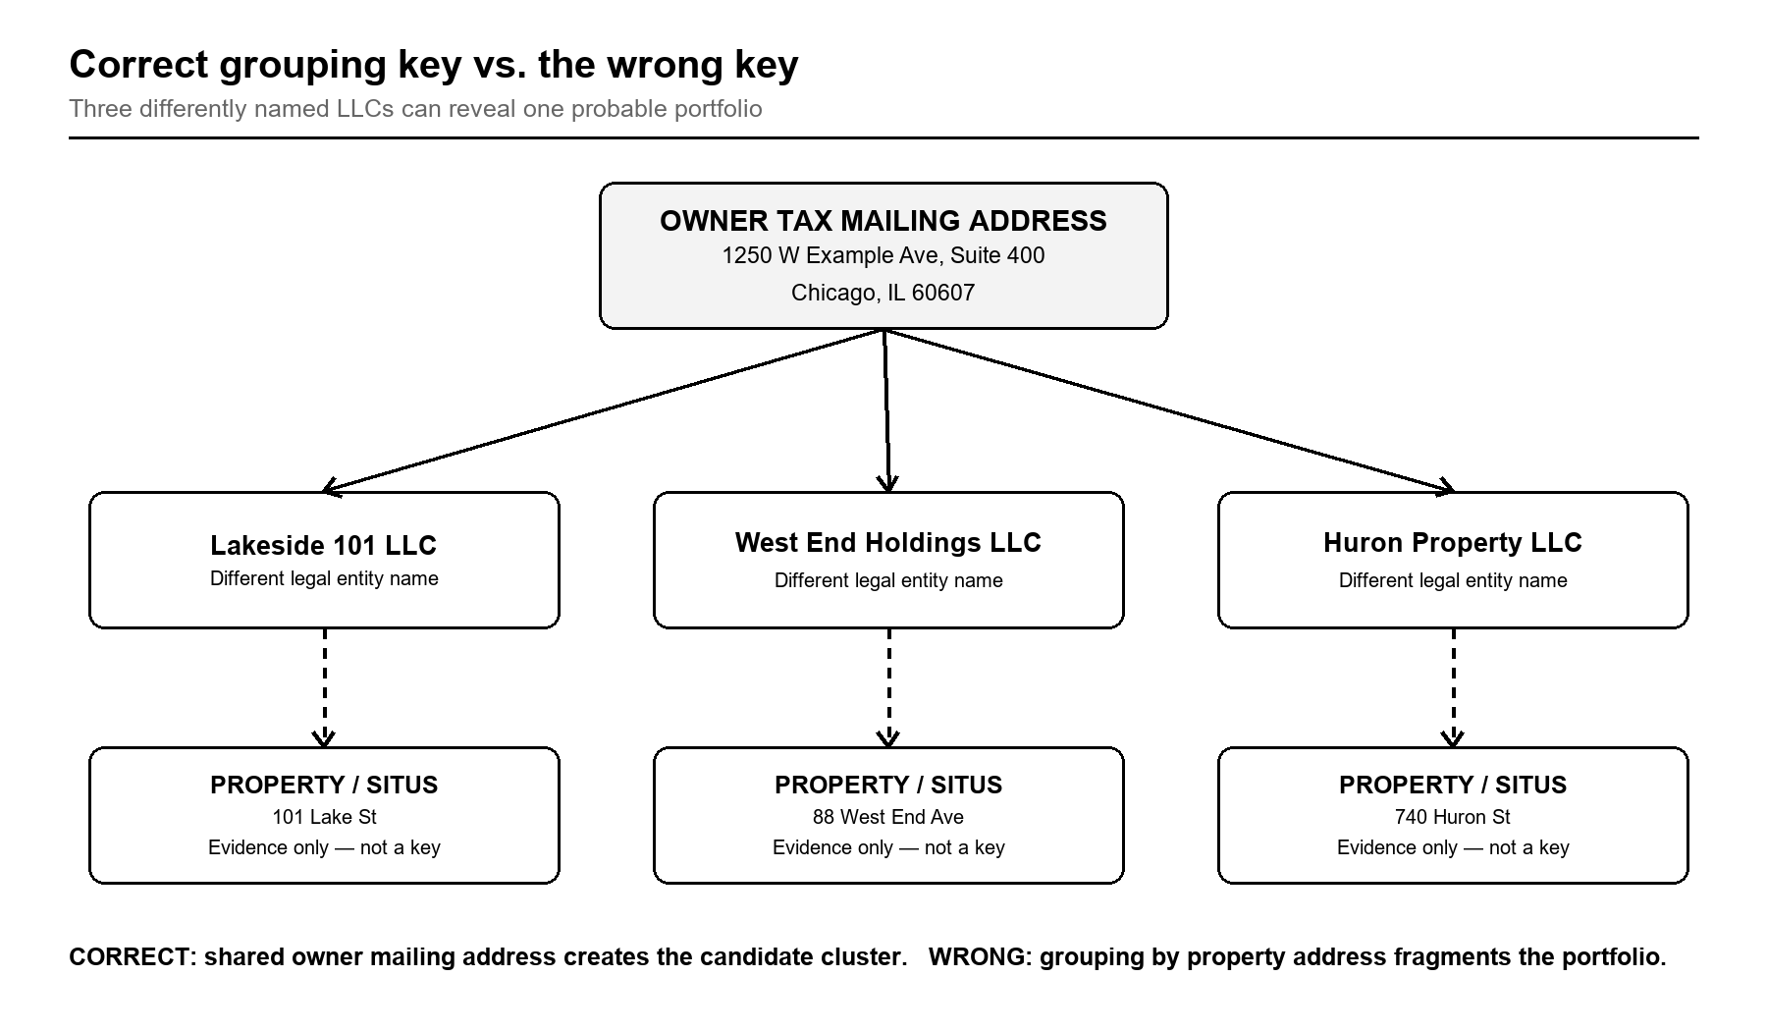
Figure 2. Correct grouping key versus the wrong key
Different property addresses are expected. Their shared owner mailing address is the candidate portfolio signal.

Non-negotiable rule
The physical property address must never be used as the initial grouping key. It identifies the asset, not the place where the owner receives tax mail.

7. Mailing-address normalization
Normalization must improve match consistency without erasing meaningful unit, suite, or postal information. Store both the source value and each normalized component.
Component | Rule
Case and whitespace | Uppercase; trim; collapse repeated spaces
Punctuation | Remove non-semantic punctuation; preserve unit meaning
Street suffixes | Standardize common equivalents, e.g., STREET→ST, AVENUE→AVE
Directionals | Standardize NORTH→N, SOUTH→S, EAST→E, WEST→W when unambiguous
Units | Standardize SUITE/STE and APARTMENT/APT; do not drop the unit
City/state | Normalize spelling and two-letter state abbreviation
ZIP | Use five-digit ZIP as the default; preserve ZIP+4 separately
PO boxes | Standardize PO BOX; retain as a valid mailing address
Missing/invalid | Do not cluster; route to QA/exclusion log

Recommended cluster key
normalized_street_line_1 + normalized_street_line_2 + normalized_city + normalized_state + normalized_zip5
Exact normalized matching is the production baseline. Fuzzy or probabilistic address matching, if later introduced, must be a separate review layer with an explainable score and no silent merges.

8. Data relationship model
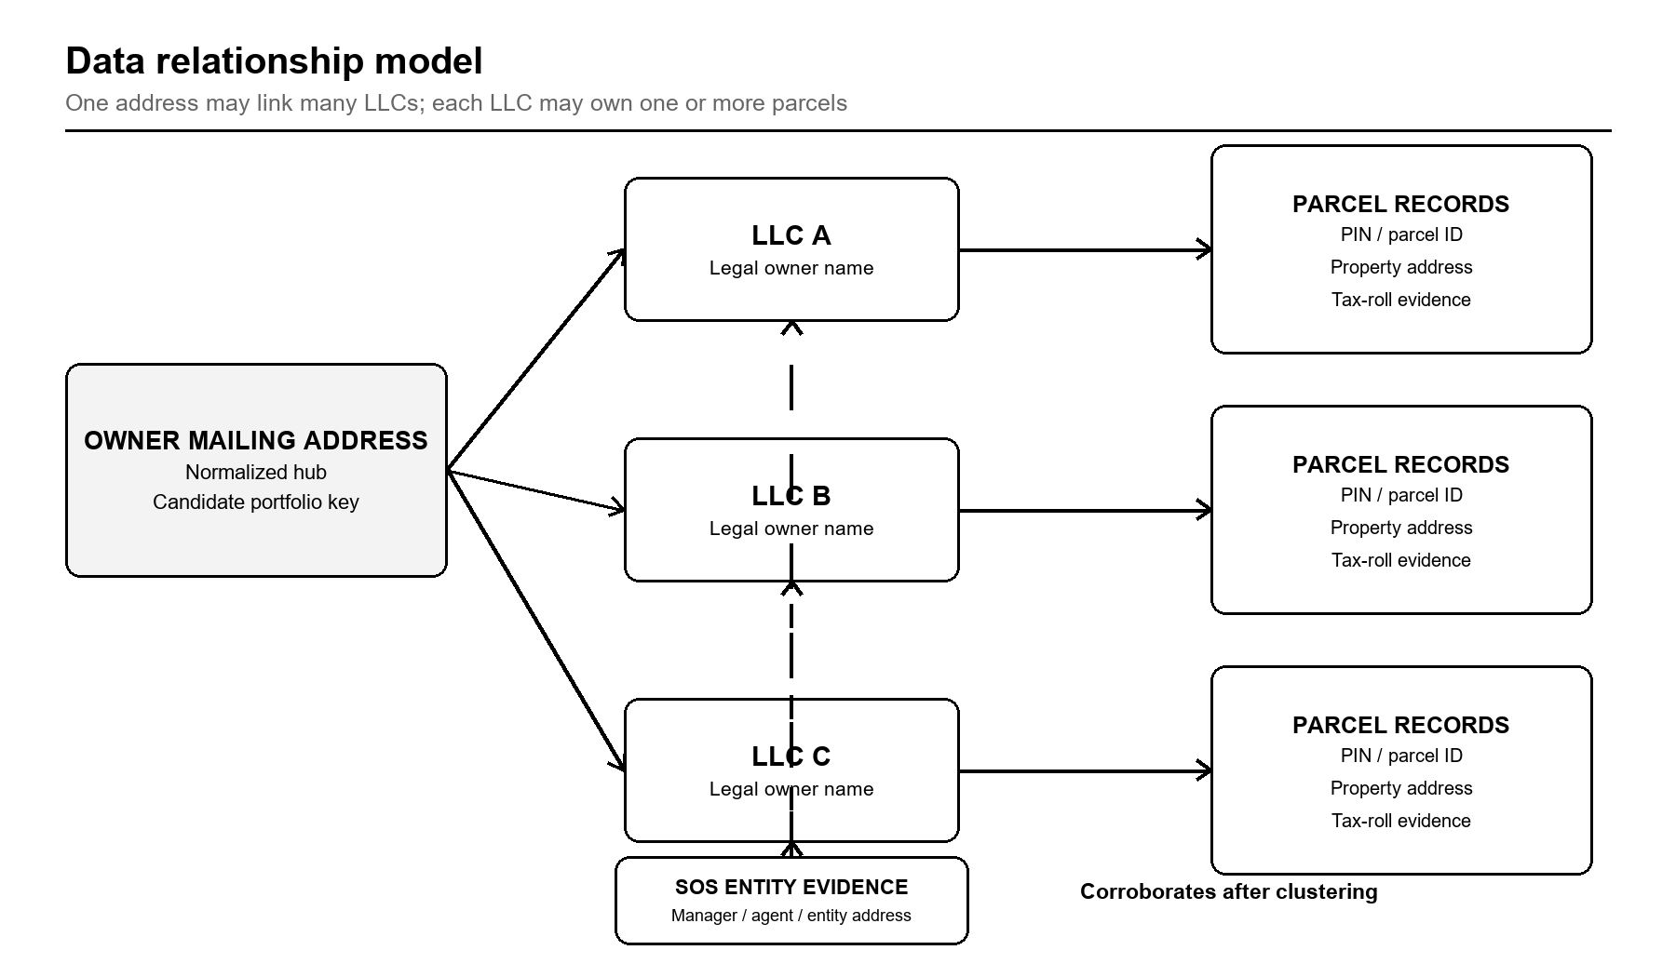
Figure 3. Data relationship model
The address hub creates a candidate cluster; parcel records prove holdings; entity records corroborate after discovery.

9. Cluster construction and qualification

Algorithm
- Load the complete parcel universe for the target geography and source vintage.
- Normalize the legal owner name and retain rows where it ends with LLC.
- Normalize the owner tax mailing address and quarantine missing or invalid values.
- Group records by the exact normalized owner mailing address.
- Within each address group, count distinct normalized LLC names and distinct parcel identifiers.
- Qualify groups with at least two distinct LLC names and at least two distinct parcels.
- Apply intermediary and mass-service-address flags without deleting the group.
- Enrich each distinct LLC with Secretary of State evidence and assign confidence.
- Create the cluster summary, property evidence, mailing shortlist, and QA logs.

Formal acceptance expression
normalized_owner_mailing_address → 2+ distinct normalized LLC names → 2+ distinct parcels

Distinctness and deduplication
- A parcel is distinct by stable parcel/PIN identifier, not by formatted property address.
- An LLC is distinct by normalized legal name within the parcel source; entity identifiers may later refine this.
- Duplicate source rows must not inflate parcel or LLC counts.
- One LLC owning several parcels does not satisfy the multi-LLC requirement by itself.

10. Qualification and routing
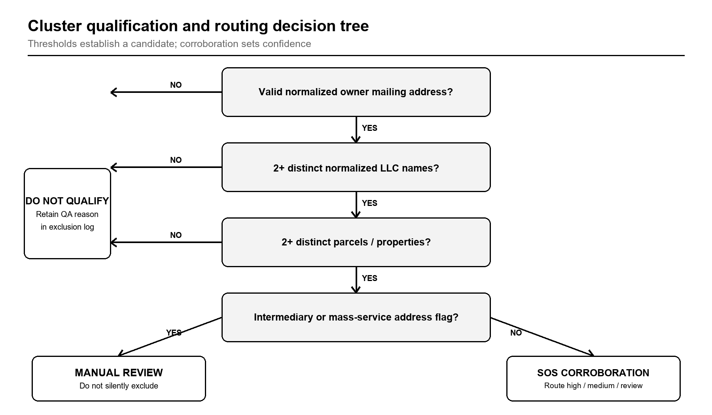
Figure 4. Cluster qualification and routing decision tree
A service-address flag changes the review route; it does not erase the candidate.

11. Intermediary and false-positive controls
Shared addresses may represent a common controller, but they may also belong to professional intermediaries. These cases must be visible, explainable, and reviewable.
Pattern | Observable signal | Required treatment
Registered agent | Address reused across unrelated entities; agent name present | Flag; compare managers/principals and address scale
Law firm | Firm name, attorney suite, many unrelated clients | Flag for manual review
Tax processor/accountant | Tax-service addressee or very high entity volume | Flag; seek corroborating manager evidence
Property manager | Management company receives bills for many owners | Flag; compare owner/entity records
Mass service/virtual office | Address links unusually many LLCs across broad industries | Flag; lower confidence absent corroboration
Property address reused as mail | Mailing address equals one situs address | Flag; do not assume owner residence or control

Scale-based review
The project should calculate the number of distinct LLCs, parcels, owner names, and industry/entity patterns per mailing address. High-volume addresses are not automatically invalid, but require stronger corroboration and often manual review.

12. Secretary of State corroboration
Illinois Secretary of State data is used after parcel clustering. It should validate entity identity and reveal repeated managers, principals, registered agents, or entity addresses across the LLCs in a candidate cluster.

Recommended entity fields
- Entity file number, exact legal name, status, formation date, jurisdiction, and entity address.
- Registered-agent name and address.
- Manager/member or principal names and addresses where publicly available.
- Annual-report or series-LLC relationships where applicable.

Match hierarchy
- Exact normalized legal name plus jurisdiction/status.
- Exact legal name plus corroborating address or file number.
- Fuzzy name candidates only as manual-review leads; never as silent matches.

Interpretation guardrails
- Manager does not necessarily mean beneficial owner.
- Registered-agent matches alone are weak control evidence.
- Repeated credible manager/principal names or addresses across multiple LLCs materially strengthen the portfolio hypothesis.

13. Confidence framework
Level | Evidence pattern | Routing
High | Shared owner mailing address; repeated credible manager/principal or entity-address support across LLCs; no strong intermediary flag | Eligible for mailing shortlist after final QA
Medium | Shared owner mailing address; active entity matches; limited direct manager proof; no strong contradiction | Eligible with conservative recipient naming
Low / review | Agent, law firm, tax processor, property manager, mass-mailing address, situs reuse, ambiguous entity match, or conflicting evidence | Manual review before any mailing

Recipient naming
- Use a person’s name only when the same credible person is supported across multiple LLCs in the cluster.
- Otherwise use the tax-roll mailing name when suitable.
- If no defensible recipient name exists, use “Property Owner” rather than inventing a person.
- Retain the LLC names and property list in the evidence file even when the outbound card uses a generalized addressee.

14. Required output package
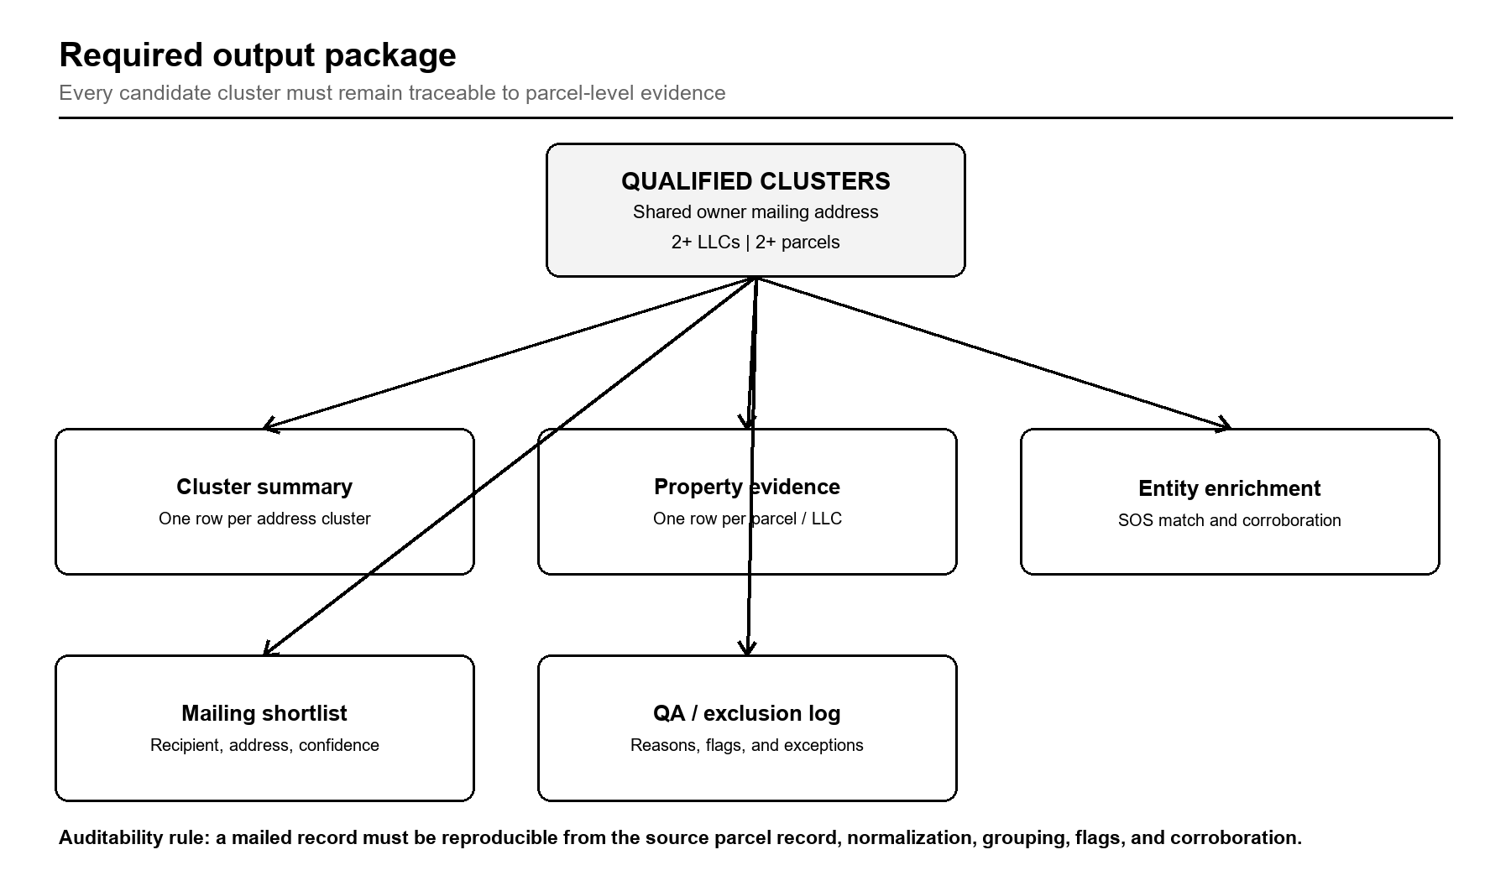
Figure 5. Required output package
The mailing shortlist is a downstream view, not a substitute for cluster and parcel evidence.

15. Output schemas

A. Cluster summary — one row per normalized owner mailing address
Field | Definition
cluster_id | Stable project-generated identifier
normalized_owner_mailing_address | Exact grouping key
source_owner_mailing_addresses | Observed source variants
distinct_llc_count | Count of normalized LLC names
distinct_parcel_count | Count of parcel/PIN values
llc_names | All source and normalized LLC names
property_geography | Cities/neighborhoods/ZIPs represented
intermediary_flags | All triggered review flags
confidence_level | High, medium, or low/review
decision_reason | Human-readable rationale

B. Property evidence — one row per parcel-owner record
Field | Definition
cluster_id | Foreign key to cluster summary
parcel_id / PIN | Stable parcel identifier
source_owner_name | Owner text as published
normalized_llc_name | Normalized distinct-LLC key
property_address | Situs/inventory address; never clustering key
owner_mailing_name | Tax-roll addressee
source_owner_mailing_address | Published mailing address
normalized_owner_mailing_address | Cluster key
source_version | Dataset vintage and retrieval date

C. Entity enrichment and mailing shortlist
Artifact | Minimum fields
Entity enrichment | cluster_id, LLC name, entity/file ID, status, entity address, agent, managers/principals, match method, source date
Mailing shortlist | cluster_id, recipient, deliverable mailing address, LLC count, parcel count, confidence, review status, rationale
QA/exclusion log | record/cluster ID, rule triggered, reason, source values, reviewer, disposition, timestamp

16. Quality assurance and acceptance tests

Record-level tests
- Every included owner name passes the normalized terminal LLC test.
- Every included parcel has a stable parcel/PIN key.
- Every clustered record has a nonblank normalized owner mailing address.
- Every property address is stored separately from the owner mailing address.

Cluster-level tests
- Every qualified cluster contains 2+ distinct normalized LLC names.
- Every qualified cluster contains 2+ distinct parcel identifiers.
- No duplicate source row inflates either count.
- All intermediary flags are retained with the cluster.
- Confidence and recipient decisions have a written rationale.

Auditability tests
- A reviewer can reproduce the group from the normalized address and property evidence file.
- Original source fields are retained beside normalized fields.
- Dataset vintage, retrieval date, and processing version are recorded.
- Manual overrides identify reviewer, timestamp, prior value, new value, and reason.

Acceptance rule
The process is accepted only when 100% of qualified clusters satisfy the two-LLC/two-parcel threshold, 100% of mailed records link to parcel-level evidence, and no property/situs address is used as a clustering key.

17. Market adaptation checklist
- Define the target geography and obtain the complete parcel universe.
- Confirm which source fields contain legal owner name, owner mailing name/address, property address, and parcel ID.
- Document access method, terms, refresh cadence, and dataset vintage.
- Map local LLC suffix variants and address conventions into the normalization rules.
- Locate the relevant Secretary of State entity and manager/agent records.
- Profile high-volume mailing addresses and build local intermediary indicators.
- Run threshold and QA tests before entity enrichment or mailing selection.
- Perform a documented sample review across high-, medium-, and review-routed clusters.
- Freeze the output schema, processing version, and source snapshot for reproducibility.

Market configuration record
Configuration item | Required entry
Market / MSA | Name and geographic boundaries
Parcel authority | Agency, dataset, access method, refresh date
Entity authority | Secretary of State source and refresh date
Field mapping | Local field → canonical field
Normalization version | Named ruleset/version
Thresholds | Default: 2+ LLCs and 2+ parcels
Known intermediaries | Local firms, agents, processors, virtual offices
QA owner | Reviewer and approval date

18. Mailing preparation and operating safeguards
Mailing preparation begins only after cluster qualification, entity review, and recipient routing. The research dataset and the outbound mailing list should remain separate artifacts so later suppression or compliance decisions do not alter the underlying evidence.
- Validate address deliverability and standardization through an authorized postal process before printing.
- Maintain suppression lists for returned mail, opt-outs, do-not-contact decisions, and duplicate households/addresses.
- Do not include sensitive personal information on the card or in exposed tracking parameters.
- Use public-record information only for the documented business purpose and review applicable federal, state, and local solicitation rules before launch.
- Retain the research basis, mailing version, and campaign date so each card can be traced to an approved shortlist record.

Pre-mail release gate
Gate | Required approval
Data | Cluster and parcel evidence passed all acceptance tests
Identity | Recipient name and confidence treatment follow this specification
Address | Deliverability check completed; suppressions applied
Content | Card copy approved; no unsupported ownership claims
Compliance | Campaign reviewed for applicable solicitation/privacy requirements
Archive | Source snapshot, shortlist version, and approval log retained

19. Chicago / Cook County implementation baseline
Chicago is the first implementation market under this reusable specification. Cook County parcel/assessment records provide the owner, mailing, situs, and PIN elements needed for discovery. Illinois Secretary of State entity records provide the post-cluster corroboration layer.

Implementation sequence
- Acquire and version the countywide parcel source.
- Apply the LLC suffix test to the legal owner field.
- Normalize mail_address_full plus city, state, and ZIP into the owner mailing key.
- Group countywide by that owner mailing key and apply the two-LLC/two-parcel threshold.
- Profile and flag likely intermediaries and service addresses.
- Match qualifying LLCs to Illinois entity, agent, annual-report, manager, and series records where available.
- Review confidence, assign recipient treatment, and publish the five-output package.

Success measure
The Chicago research phase is ready to trigger when the source snapshot, field mapping, normalization rules, intermediary review method, entity-source access, output locations, and QA reviewer are documented and testable against this specification.

20. Definitions and version control
Term | Definition
Owner mailing address | Address where the parcel authority sends owner/tax correspondence; the clustering key
Property/situs address | Physical location of the parcel; inventory evidence only
Candidate cluster | Records sharing one normalized owner mailing address before final confidence review
Qualified cluster | Candidate meeting 2+ LLC and 2+ parcel thresholds
Intermediary flag | Signal that the address may belong to a professional service provider
Corroboration | Independent entity evidence supporting a common-control hypothesis
Probable portfolio | Qualified and reviewed cluster; not a legal conclusion of beneficial ownership

Document control
Version | Date | Status | Change
1.0 | 28 Aug 2026 | Baseline | Initial reusable specification; Chicago/Cook County implementation mapping

Future changes should preserve the core grouping rule unless a formally approved version explicitly replaces it: group different LLC owners by normalized owner tax mailing address, not by property address.

