# ****Student and course****

## ODL

My consideration

interface Student (key S#)

{

attribute string S#;

attribute string name;

attribute string gender;

attribute string birthdate;

attribute string tel;

attribute string QQ;

relationship Set<Course> choose

inverse Course::chosedBy;

relationship List<Exam> attend

inverse Exam::attendedBy;

}

interface Course (key C#)

{

attribute string C#;

attribute string name;

attribute string department;

attribute float hours;

attribute float credits;

relationship Set<Student> chosedBy

inverse Student::choose;

relationship List<Exam> hold

inverse Exam heldBy

}

interface Exam

{

attribute string date;

attribute float result;

relationship Course heldBy

inverse Course::hold;

relationship Set<Student>::attendedBy

inverse Student::attend;

}

Entity-Relation Diagram

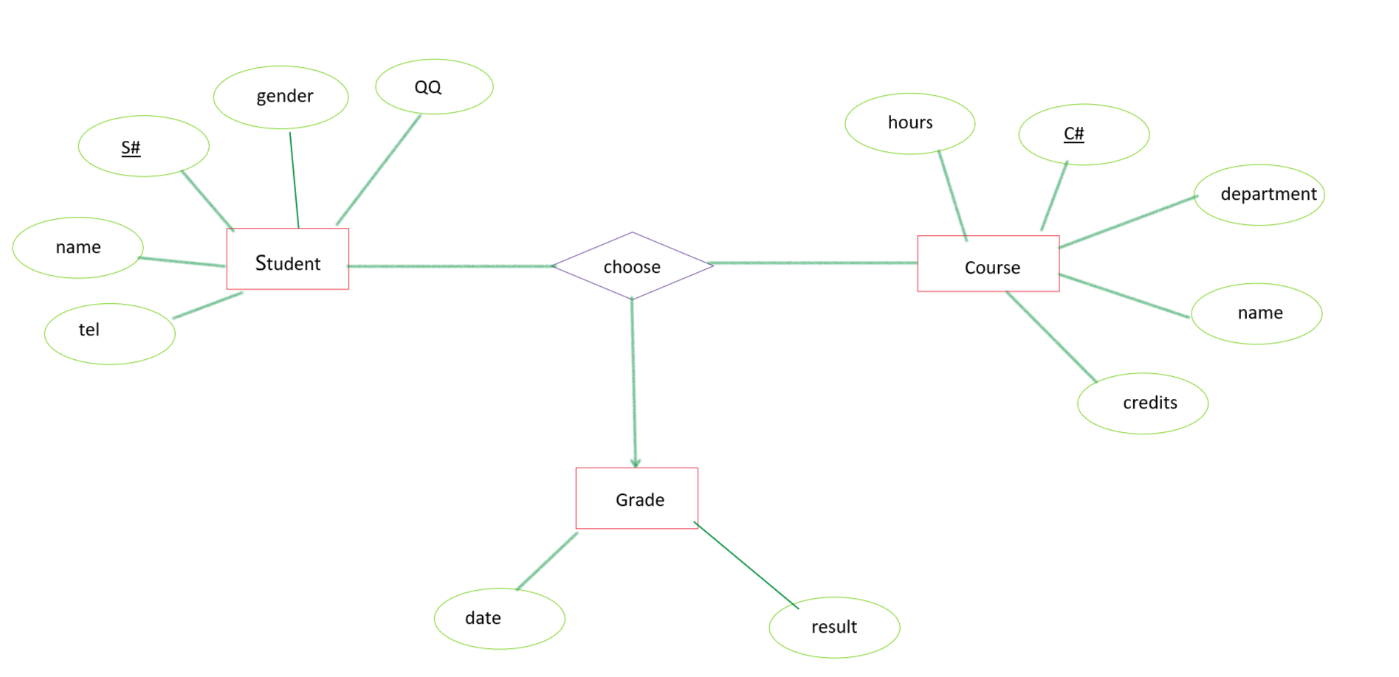

**figure 1 Mutiway relationship**

Use weak entity sets to eliminate multiway relationship:

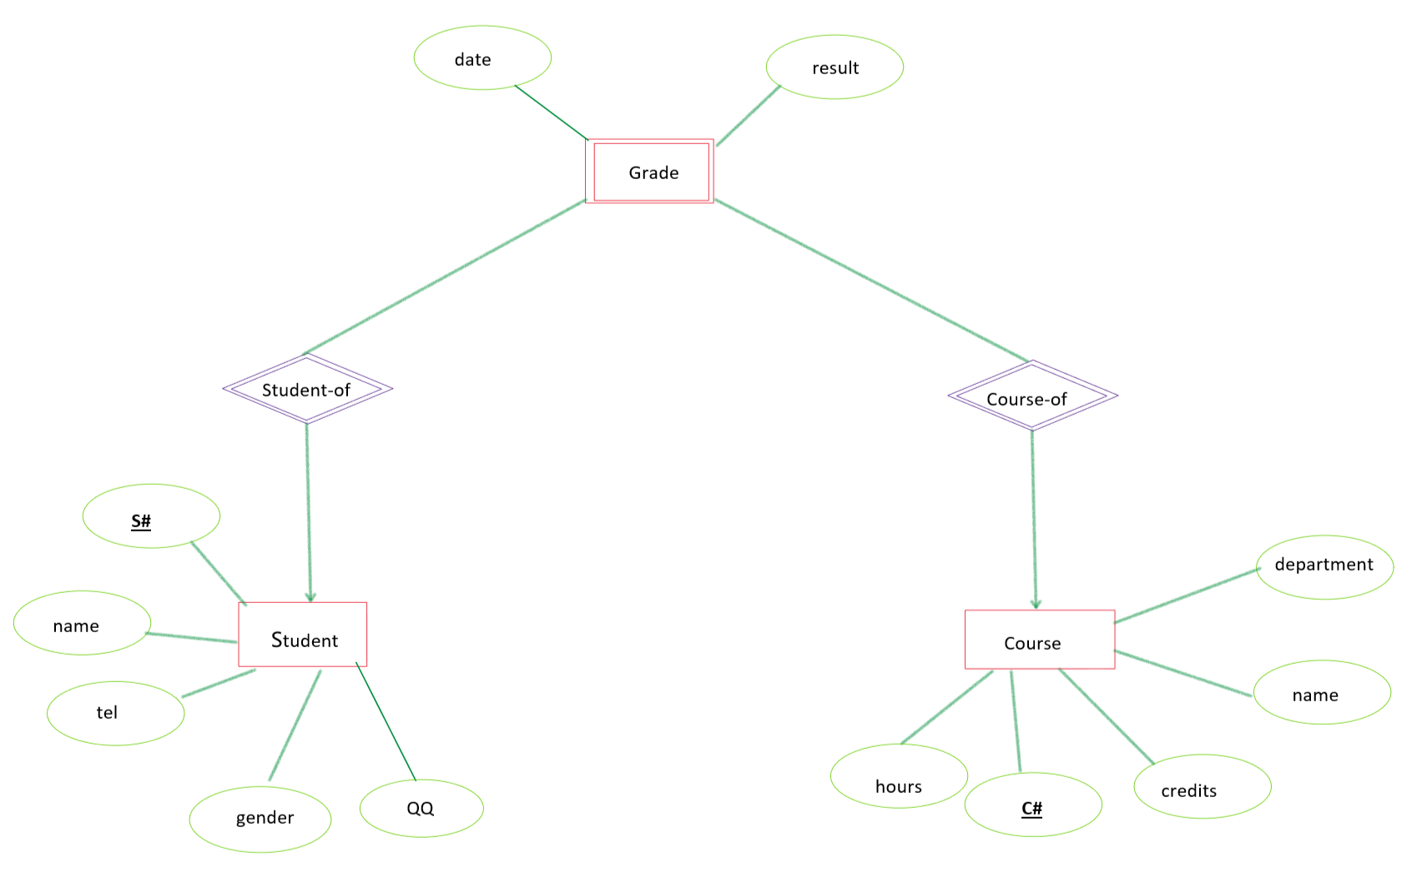

**figure 2 Weak entity sets**

Relation Schema

Student(S#, name, gender, birthdate, tel, QQ);

Course(C#, name, department, hours, credits);

Grade(S#, C#, name, date, result);