准备
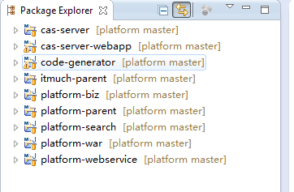

导入MySQL脚本
脚本在sql目录下, 如果有多个, 导入时间戳最晚的那个即可.

修改配置文件
/cas-server-webapp/src/main/webapp/WEB-INF/deployerConfigContext.xml
修改其中的数据源配置

安装cas-server

在cas-server上右击 - Run As - Maven build
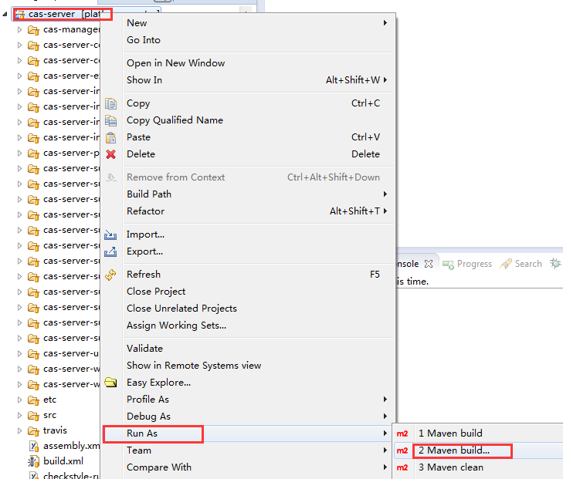

输入clean install

同理安装cas-server-webapp

由于CAS默认是HTTPS的, 需要证书, 为了方便, 我们自签名即可

证书我已经生成好
/cas-server-webapp/localhost.cer
/cas-server-webapp/localhost.keystore

将localhost.cer放到D:\

执行以下命令, 将证书导入到jdk
cd C:\Program Files\Java\jdk1.7.0_55\jre\lib\security ===> 具体视自己的jdk版本为准
keytool -import -alias localhost -file D:\localhost.cer -noprompt -trustcacerts -storetype jks -keystore cacerts -storepass changeit

启动cas

在cas-server-webapp上右击 - Run As - Maven build

输入tomcat7:run

输入:https://localhost:8443/cas 即可访问
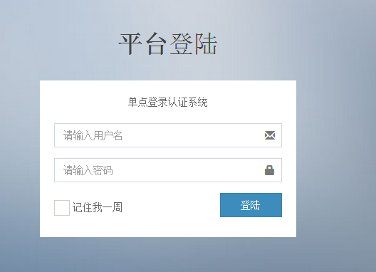

如果不想用https, 可以参考cas取消https

修改cas配置:
详见: http://blog.csdn.net/yangsen251024/article/details/7357762

修改/cas-server-webapp/pom.xml
找到
<plugin>
<groupId>org.apache.tomcat.maven</groupId>
<artifactId>tomcat7-maven-plugin</artifactId>
<configuration>
<uriEncoding>UTF-8</uriEncoding>
<path>/cas</path>
<port>8888</port>

<httpsPort>8443</httpsPort>
<keystoreFile>${project.basedir}/localhost.keystore</keystoreFile>
<keystorePass>123456</keystorePass>
</configuration>
</plugin>
改成:
<plugin>
<groupId>org.apache.tomcat.maven</groupId>
<artifactId>tomcat7-maven-plugin</artifactId>
<configuration>
<uriEncoding>UTF-8</uriEncoding>
<path>/cas</path>
<port>8888</port>
</configuration>
</plugin>

修改/platform-war/pom.xml
找到
<plugin>
<groupId>org.apache.tomcat.maven</groupId>
<artifactId>tomcat7-maven-plugin</artifactId>
<configuration>
<uriEncoding>UTF-8</uriEncoding>
<path>/platform</path>
<port>7777</port>

<httpsPort>9443</httpsPort>
<keystoreFile>${project.basedir}/localhost.keystore</keystoreFile>
<keystorePass>123456</keystorePass>
</configuration>
</plugin>
改成
<plugin>
<groupId>org.apache.tomcat.maven</groupId>
<artifactId>tomcat7-maven-plugin</artifactId>
<configuration>
<uriEncoding>UTF-8</uriEncoding>
<path>/platform</path>
<port>7777</port>
</configuration>
</plugin>

