CIS 663 Biometrics

Assignment 2

**This assignment is due by the week 5 live session. If you make any** **assumptions, clearly state them in your answer.**

1. The following represents a 10 x 10-pixel grayscale. 0 represents black and 255 represents white.

0 0 0 0 0 0 0 1 1 1

0 0 3 3 3 3 3 2 1 1

0 0 3 3 4 4 4 4 4 4

0 0 3 3 3 3 4 4 4 4

0 0 0 1 1 3 4 4 4 4

0 0 0 0 0 4 4 4 1 0

5 5 0 0 0 4 4 4 0 0

5 5 0 0 0 4 4 4 0 0

5 5 0 0 0 0 5 5 0 0

5 5 0 0 0 0 5 5 0 0

a. Convert the image to an integral image. (10pt)

b. Using the integral image, compute the sum of area from (2,2) to (5,7), shaded red above. Show your steps. (10pt) 2. Using the grayscale image from Question 1, apply the following Haar

filter to all positions that are feasible. (20pts)

3. In Viola-Jones face detection algorithm, explain what cascading is and

why it is important. (20pt) 4. (20pts) Consider the following labeled data (x, y) ∈ R2 (i is the example index):

i x y Label

1 11 3 -

2 10 1 -

3 4 4 -

4 12 10 +

5 2 4 -

6 10 5 +

7 8 8 -

8 6 5 +

9 7 7 +

10 7 8 +

In this problem, you will use Adaboost to learn a hidden function from this set of training examples. We will use two rounds of AdaBoost to learn a hypothesis for this data set. In round number t, AdaBoost chooses a weak learner that minimizes the weighted error(t). As weak learners, you will use axis parallel lines of the form (a) Label + if x > a, else - or (b) Label + if y > b, else -, for some integers a, b (either one of the two forms, not a disjunction of the two).

a) The first step of AdaBoost is to create an initial data training data weight distribution D1. What are the initial weights given to data points with index 4 and 7 by the AdaBoost algorithm, respectively?

b) Which is the hypothesis h1 that minimizes the weighted error in the first round of AdaBoost, using the distribution D1 computed in the above question?

c) What is the weighted error of h1 computed above?

d) After computing h1 in the previous questions, we proceed to round 2 of AdaBoost. We begin by recomputing data weights depending on the error of h1 and whether a point was (mis)classified by h1. What are the weights given to data points with index 4 and 7 according to the distribution after round 1, D2, respectively? e) Which is the hypothesis h2 that minimizes the weighted error in the second round of AdaBoost, using the distribution D2 computed in the above question?

f) What is the weight assigned to the hypothesis of round 2, h2

g) Now that we have completed two rounds of AdaBoost, it is time to create the final output hypothesis. What is the final weighted hypothesis after two rounds of AdaBoost?

**Formulas:**

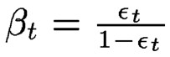

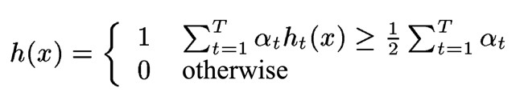

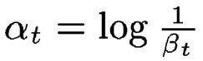

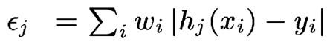

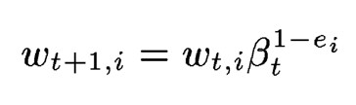

5. What is Principle Component Analysis and how does it relate to face recognition? (20pts)