Evan Smith

SoC Final Project

CSE-664

8-Bit Processor

Design Overview

* 8 Bit words
* 255-word instruction memory size
* Instructions:

|  |  |  |
| --- | --- | --- |
| **Code** | **Operation** | **Description** |
| 0000 | NOP | Do no operations, increment PC |
| 0001 | ADD | Add ACC to IMM Register |
| 0010 | SUB | Subtract ACC from IMM Register |
| 0011 | NOR | Perform NOR on ACC and IMM |
| 0100 | LRA | Load IMM Register to ACC |
| 0101 | LAC | Load ACC to IMM Register |
| 0110 | ZBR | Branch to instruction in IMM Register if ACC is zero |
| 0111 | ZBI | Branch to instruction in IMM if ACC is zero |
| 1000 | CBR | Branch to instruction in IMM Register if ACC is negative |
| 1001 | ------ | Not used |
| 1010 | CBI | Branch to instruction in IMM if ACC is negative |
| 1011 | SHL | Shift ACC left one bit (respecting sign) |
| 1100 | SHR | Shift ACC right one bit (respecting sign) |
| 1101 | LIA | Load IMM to ACC |
| 1110 | ------ | Not used |
| 1111 | HALT | Do no operations and do not increment PC or load instruction. EOF |

* 2 CPI
* Components: ALU, Accumulator, FSM Controller, Instruction Reg, Instruction Memory (disk-based), Register File.

Datapath is from spec, with the addition of an Instruction Memory component to read from disk rather than hard-coding the program in the testbench.

**Logic Overview**

My goal for this design was to focus on a behavior-modelling approach, since my previous experience was exclusively with structural models. To that end, I have combined the MUX units into the logical elements they support to make the datapath more concise. Additionally, this let me work on some of the more complex features of Verilog like file read/write to streamline the user experience.

The overall logical steps for this project are:

1. Reset
2. Load/Parse first instruction from memory
3. Determine command signals based on that instruction
4. Execute the command while parsing the next instruction
5. Repeat 3-4 until HALT operation is read.

This flow hinges on the fact that both the RegisterFile and InstructionMemory use constant assignment, so their output values update in phase with changes to their address inputs. This clock-independence allows the processor to be 2 CPI.

**Sample Code**

//Sample Program - a For-Loop!

11010011 //0- Load 8

01010001 //1- Store in Reg1

11010101 //2- Load 4

00100001 //3- Subtract Acc from Reg1

01010001 //4- Store in Reg1

01110110 //5- Z Jump to Instruction 8 (end)

11010000 //6- Load 0

01110110 //7- Z Jump to Instruction 2

11110000 //8- HALT

**Output**

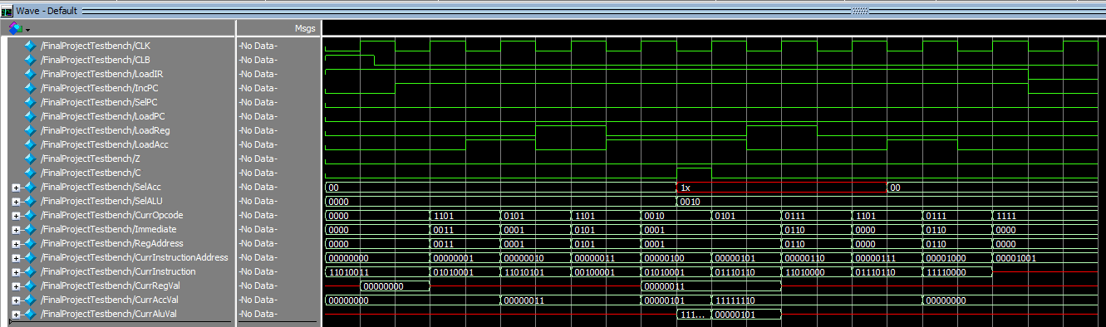

Waveform is hard to read, so I rigged up a write to file that helps show operation:

time = 10

OpCode = 0000

Immediate = 0000

Acc = 00000000

CurrRegValue = 00000000

time = 20

OpCode = 1101

Immediate = 0011

Acc = 00000000

CurrRegValue = xxxxxxxx

time = 30

OpCode = 0101

Immediate = 0001

Acc = 00000011

CurrRegValue = xxxxxxxx

time = 40

OpCode = 1101

Immediate = 0101

Acc = 00000011

CurrRegValue = xxxxxxxx

time = 50

OpCode = 0010

Immediate = 0001

Acc = 00000101

CurrRegValue = 00000011

time = 60

OpCode = 0101

Immediate = 0001

Acc = 11111110

CurrRegValue = 00000011

time = 70

OpCode = 0111

Immediate = 0110

Acc = 11111110

CurrRegValue = xxxxxxxx

time = 80

OpCode = 1101

Immediate = 0000

Acc = 11111110

CurrRegValue = xxxxxxxx

time = 90

OpCode = 0111

Immediate = 0110

Acc = 00000000

CurrRegValue = xxxxxxxx

time = 100

OpCode = 1111

Immediate = 0000

Acc = 00000000

CurrRegValue = xxxxxxxx

time = 110

OpCode = 1111

Immediate = 0000

Acc = 00000000

CurrRegValue = xxxxxxxx