**BCOMP3406 Logbook 1**

1. **Basic Information**

|  |  |
| --- | --- |
| 1.1 Student name | **LIM YIK SHEN** |
| 1.2 Who did you work with? Note that for logbook exercises you are allowed to work with one other person as long as you give their name and login id and both contribute to the work. Both students need to provide description of their contribution. | **Name:**  **Login id:** |
| 1.3 Which Exercise is this? Tick as appropriate. | Section 1 |
| 1.4 How well did you complete the exercise? Tick as appropriate. | * I tried but couldn't complete it * I did it but I feel I should have done better * I did everything that was asked ** * I did more than was asked for |
| 1.5 Briefly explain your answer to question 1.4 | **I’ve implement some custom css, and all required functionalities.** |

1. **Exercise answer**

**2.1 Screen shots demonstrating what you achieved**

**2.1.1 Home Screen**

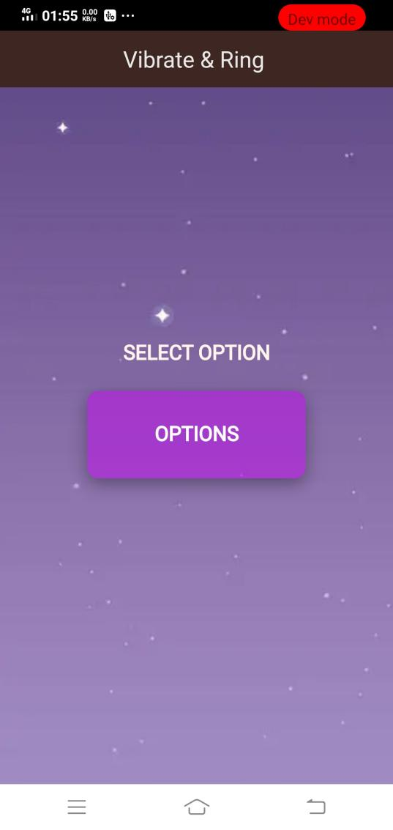

**Explanation**

This is a simple app to toggle phone’s notification vibration and message ringtone. User are allow to click on the **OPTIONS** button to show dialog.

**2.1.1 Home Screen - Dialog box**

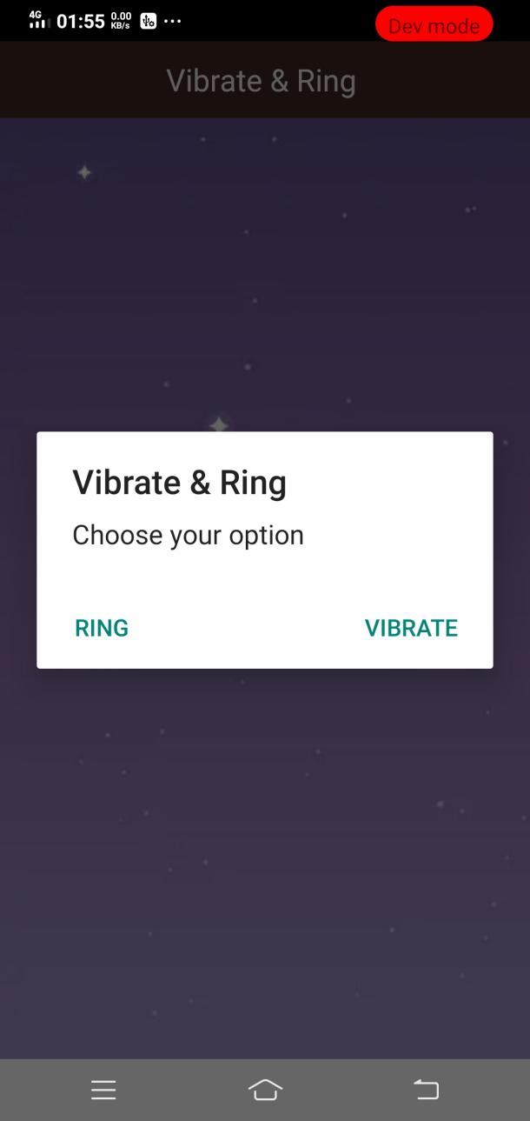

**Explanation**

This is the dialog after **OPTIONS** button was toggled. There are two notification options to select which are **RING** and **VIBRATE.**

**2.2 Codes**

**2.2.1 Index.html**

|  |
| --- |
| <div class="main-container">          <div class="header brown-900">              <h1 class="align-center">Vibrate & Ring</h1>          </div>          <div class="first-container">              <p class="main-text">SELECT OPTION</p>              <button id="openDialog" class="button-dialog">  OPTIONS  </button>          </div>  </div> |

There are 3 divisions where 2 of it wrap by a main division. Passing an

Id “openDialog” to point to specific function in index.js. The css class name

“header brown-900”, “align-center”, “button-dialog” are from MobileUI

Framework. The rest of the css for alignment and styling refer to section 2.2.2.

**2.2.2 index.css**

|  |
| --- |
| .main-container {      width: 100%;      height: 100%;      background-image: url('../img/backgroundImg.jpg')  }  .first-container {      display: flex;      flex-direction: column;      width: 100%;      height: 100vh;      align-items: center;      justify-content: center;  }  .main-text {      font-size: medium;      font-weight: bold;      color: seashell;  }  .button-dialog {      height: 80px;      width: 200px;      margin-top: 1rem;      border-radius: 10px;      background-color: rgba(190, 11, 235, 0.534);      font-weight: bold;      border: none;      color: white;      box-shadow: rgba(0, 0, 0, 0.35) 0px 5px 15px;  } |

**2.2.3 index.js**

|  |
| --- |
| function onDeviceReady() {      $('#openDialog').on('click', function(){          navigator.notification.confirm(              'Choose your option',              onToggled,              'Vibrate & Ring',              ['Vibrate', 'Ring']          );          function onToggled(index) {              if(index === 1){                  navigator.vibrate([3000]);              }              else if(index === 2) {                  navigator.notification.beep(5);              }          }      })  } |

The above function pointed to the button with id “openDialog”. navigator.notification.confirm is one of the cordova plugin to access customizable confirmation dialog box with supported dependencies such as message, confirmCallback, title, and buttonLabels.

The function onToggled callback when user toggled index of button, when index equals to 1 they will receive vibration notification where index 2 will receive notification beep(ring).