**Bayesian causal analysis of liver weight impacts in female *Peromyscus* exposed to PFHxS during sensitive life stages following the methods and general R code as Lazic et al. (YEAR#).**

Data for terminal body weight and liver weight for females were the only data analyzed in this method. The goal is to evaluate the contribution of direct changes in liver weight and indirect changes in liver weight (through changes in body weight) to better infer accounting for the causal relationship between liver and body weight. Additionally, this technique uses Bayesian techniques to the concentration where a greater than 20% change in direct liver weight is probabilistically identified. In these data, liver weight is clearly increasing, body weight is only elevated in the high treatment, and accordingly the liver to body weight ratio is increasing across concentrations (Figure S7 A, B, and C). Impactful to the analysis of liver weight is the correlation between liver weight and body weight (Figure S7 D), liver to body weight ratio (Figure S7 E), and an ANCOVA adjusted liver weight (body weight covariate) with bodyweight (Figure S7 F). Correlation exists in Fig S7 D and E but not F (see figure caption for Pearson correlation and hypothesis test results). The implication then is that the ratio data are biased by terminal body weight and may be inappropriately attributing some liver weight changes to indirect impacts of PFHxS on body weight.

The code supplied by Lazic et al was edited to decompose direct and indirect effects on liver weight (Figure S8). The first inference is that in all treatments, the effect on liver weight (each treatment individually compared against control) is minimally influenced by change in weight (Figure S8, left side). This is not surprising given Figure S7 A and B. The gray vertical dashed line in Figure S8 demarks a 20% increasing effect (mean control liver weight * 0.2) and above 3.5 mg/kg-d it is clear that liver weights are directly impacted in a >20% magnitude (Figure S8, right). At 1.6 mg/kg-d, the proportion of posterior distribution that is below is 0.56 which implies that an effect great or less than 20% are equivocal (Figure S8, top right). Accordingly, 1.6 mg/kg-d would not be considered an effect (NOAEL) but would also not likely be considered “safe” (44% chance impacts >20%) (Figure S8, top right). 3.5 mg/kg-d is clearly a LOAEL in the classic interpretation (Figure S8, right second from top).

The takeaway message from this analysis is that we are extremely confident that above 3.5 mg/kg-d PFHxS had a direct impact on increasing liver size above 20%. In contrast to the BMDL analysis of liver to body weight ratio presented in the main paper, this analysis improves the quality of interpretation but does not strictly provide a more protective point of departure. A BMDL could be produces from posterior probabilities of exceeding 20%, but as we did not have a treatment with less with less than 50% probability, the lower extremes of the model would be highly suspect.

See https://github.com/eastandrew/Peromyscus_PFHxS_causal_liver_weight_analysis for complete R and stan code modified from Lazic et al. (2020) Supplementary Info at https://doi.org/10.1038/s41598-020-63465-y (see also https://stanlazic.github.io).

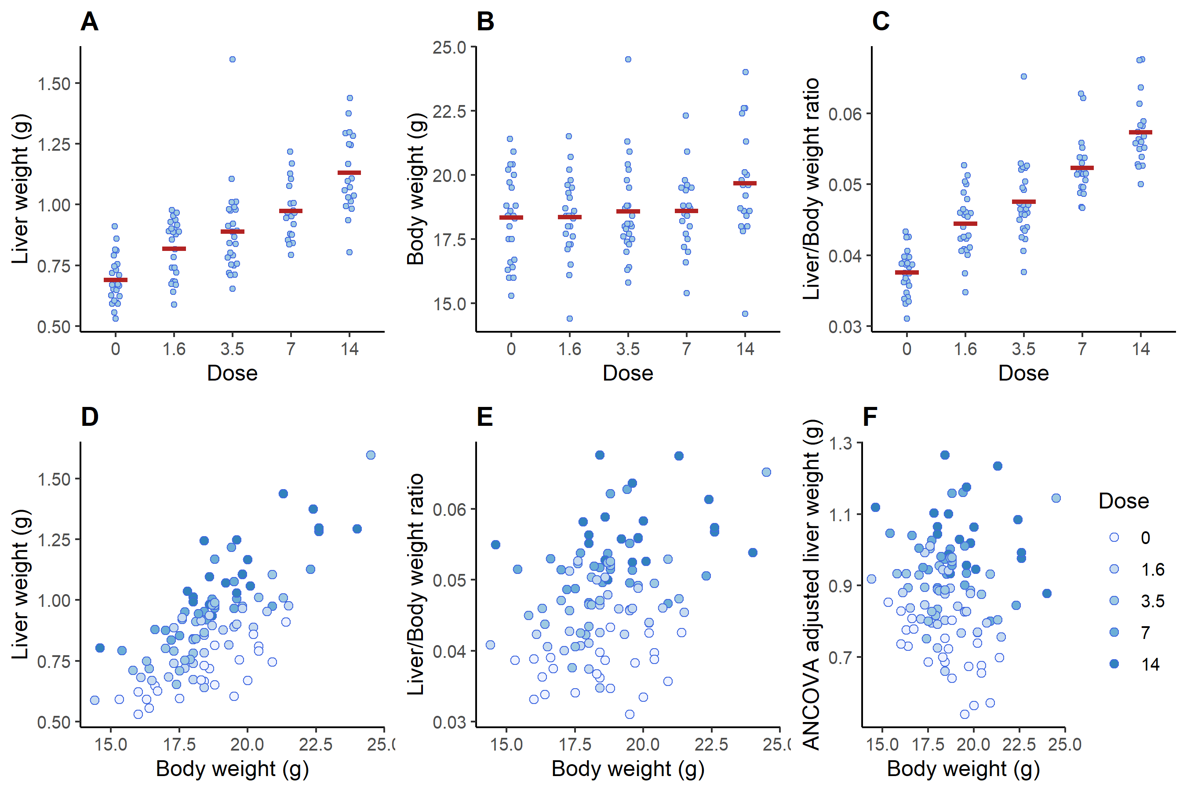

**Figure S7**: Relationships between liver and body weight (liver weight adjusted) and liver weight / body weight ratio by dose and with group means (red horizontal lines). As correlation between liver/body weight ratio and body weight is not zero (Pearson’s correlation = 0.34; p = 0.0002 with alternative that true correlation is not equal to 0) in E, this indicates that ratio alone is not highest quality quantitative representation of PFHxS direct effects on liver weight. Note clear treatment effect in D and E as well.

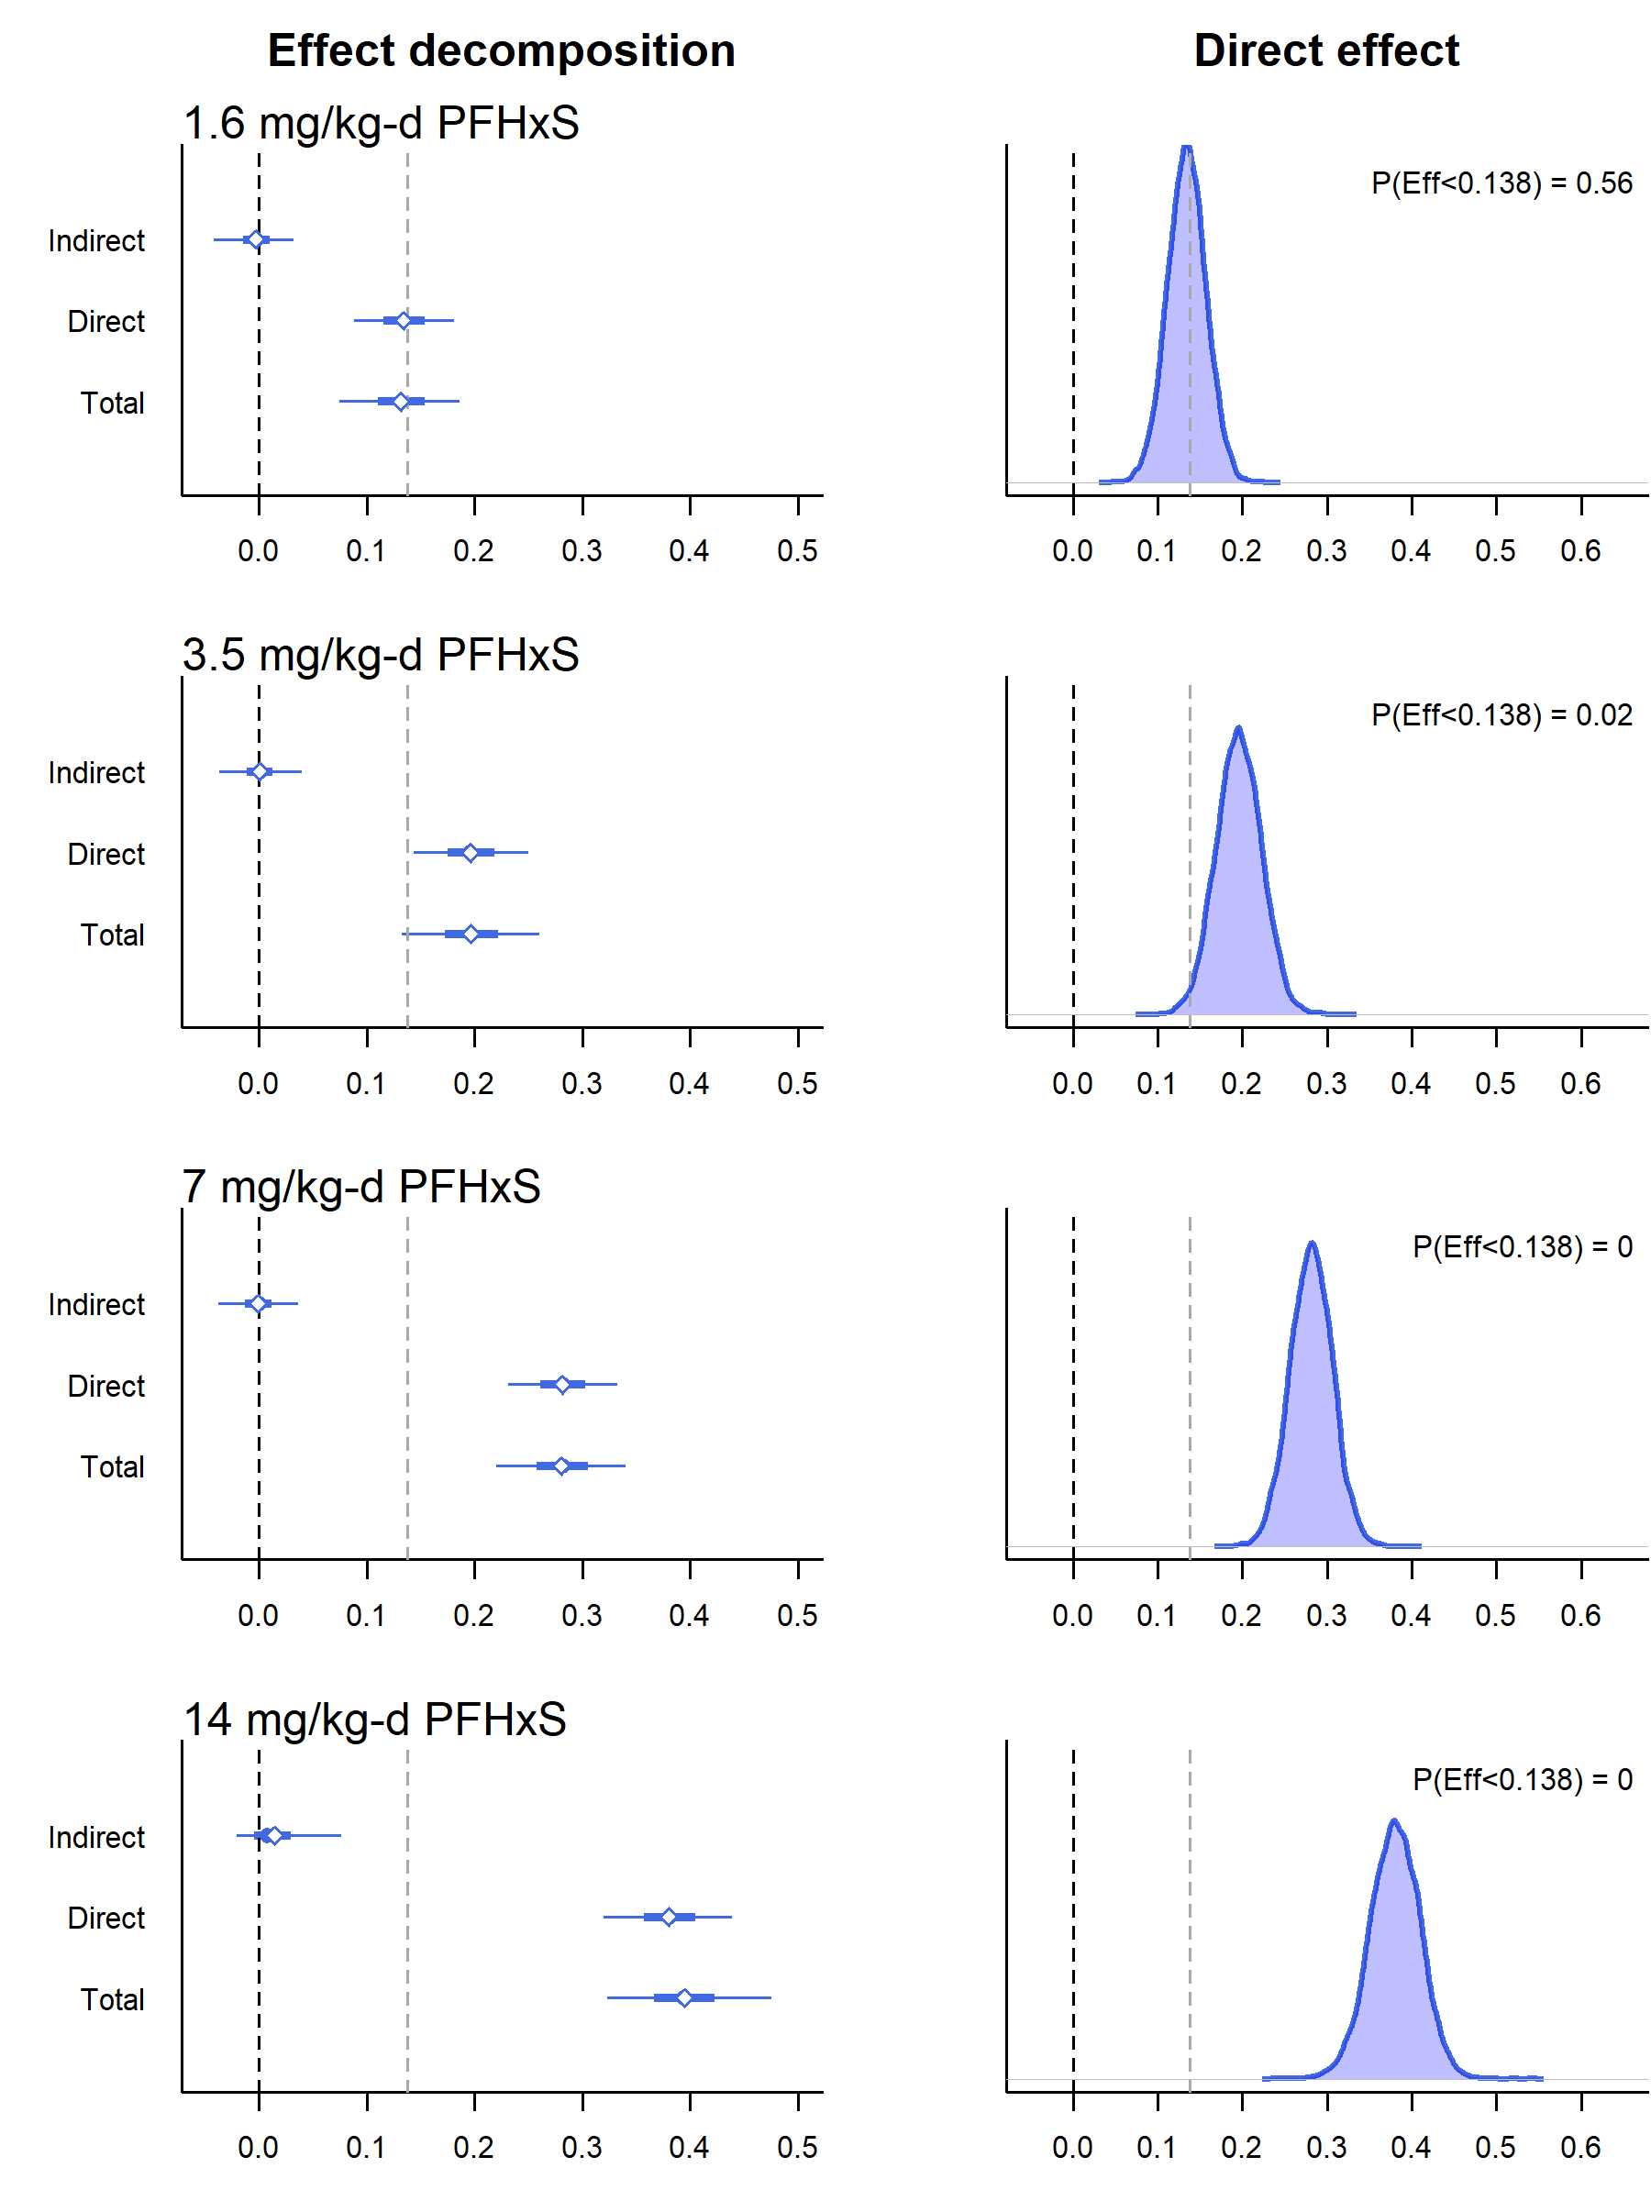

**Figure S8:** Signal of effects is direct impact on liver weight and 3.5 mg/kg-d PFHxS is likely best representative of LOAEL and 1.6 mg/kg-d is equivocal NOAEL (56% no effect, 44% effect). Decomposed effects of treatment doses (compared against control) on liver weight in context of body weight with posterior distributions of direct liver weight effects compared against a 20% increase (0.138 g effect on liver weight). Direct effect is direct impact on liver weight difference against control while indirect is liver weight changes through changes in body weight against control. X-axis here is g change against control and 0.138 g is 20% of mean control liver weight (0.69 g). Main takeaway is that PFHxS increased liver weights directly (not through indirect mechanisms) and when analyzed with body weight mediation, Bayesian analysis indicates that liver weight will increase above 20% of control at 3.5 mg/kg-d PFHxS with 98% probability.