Max Mixing Ratio Worksheet
 | 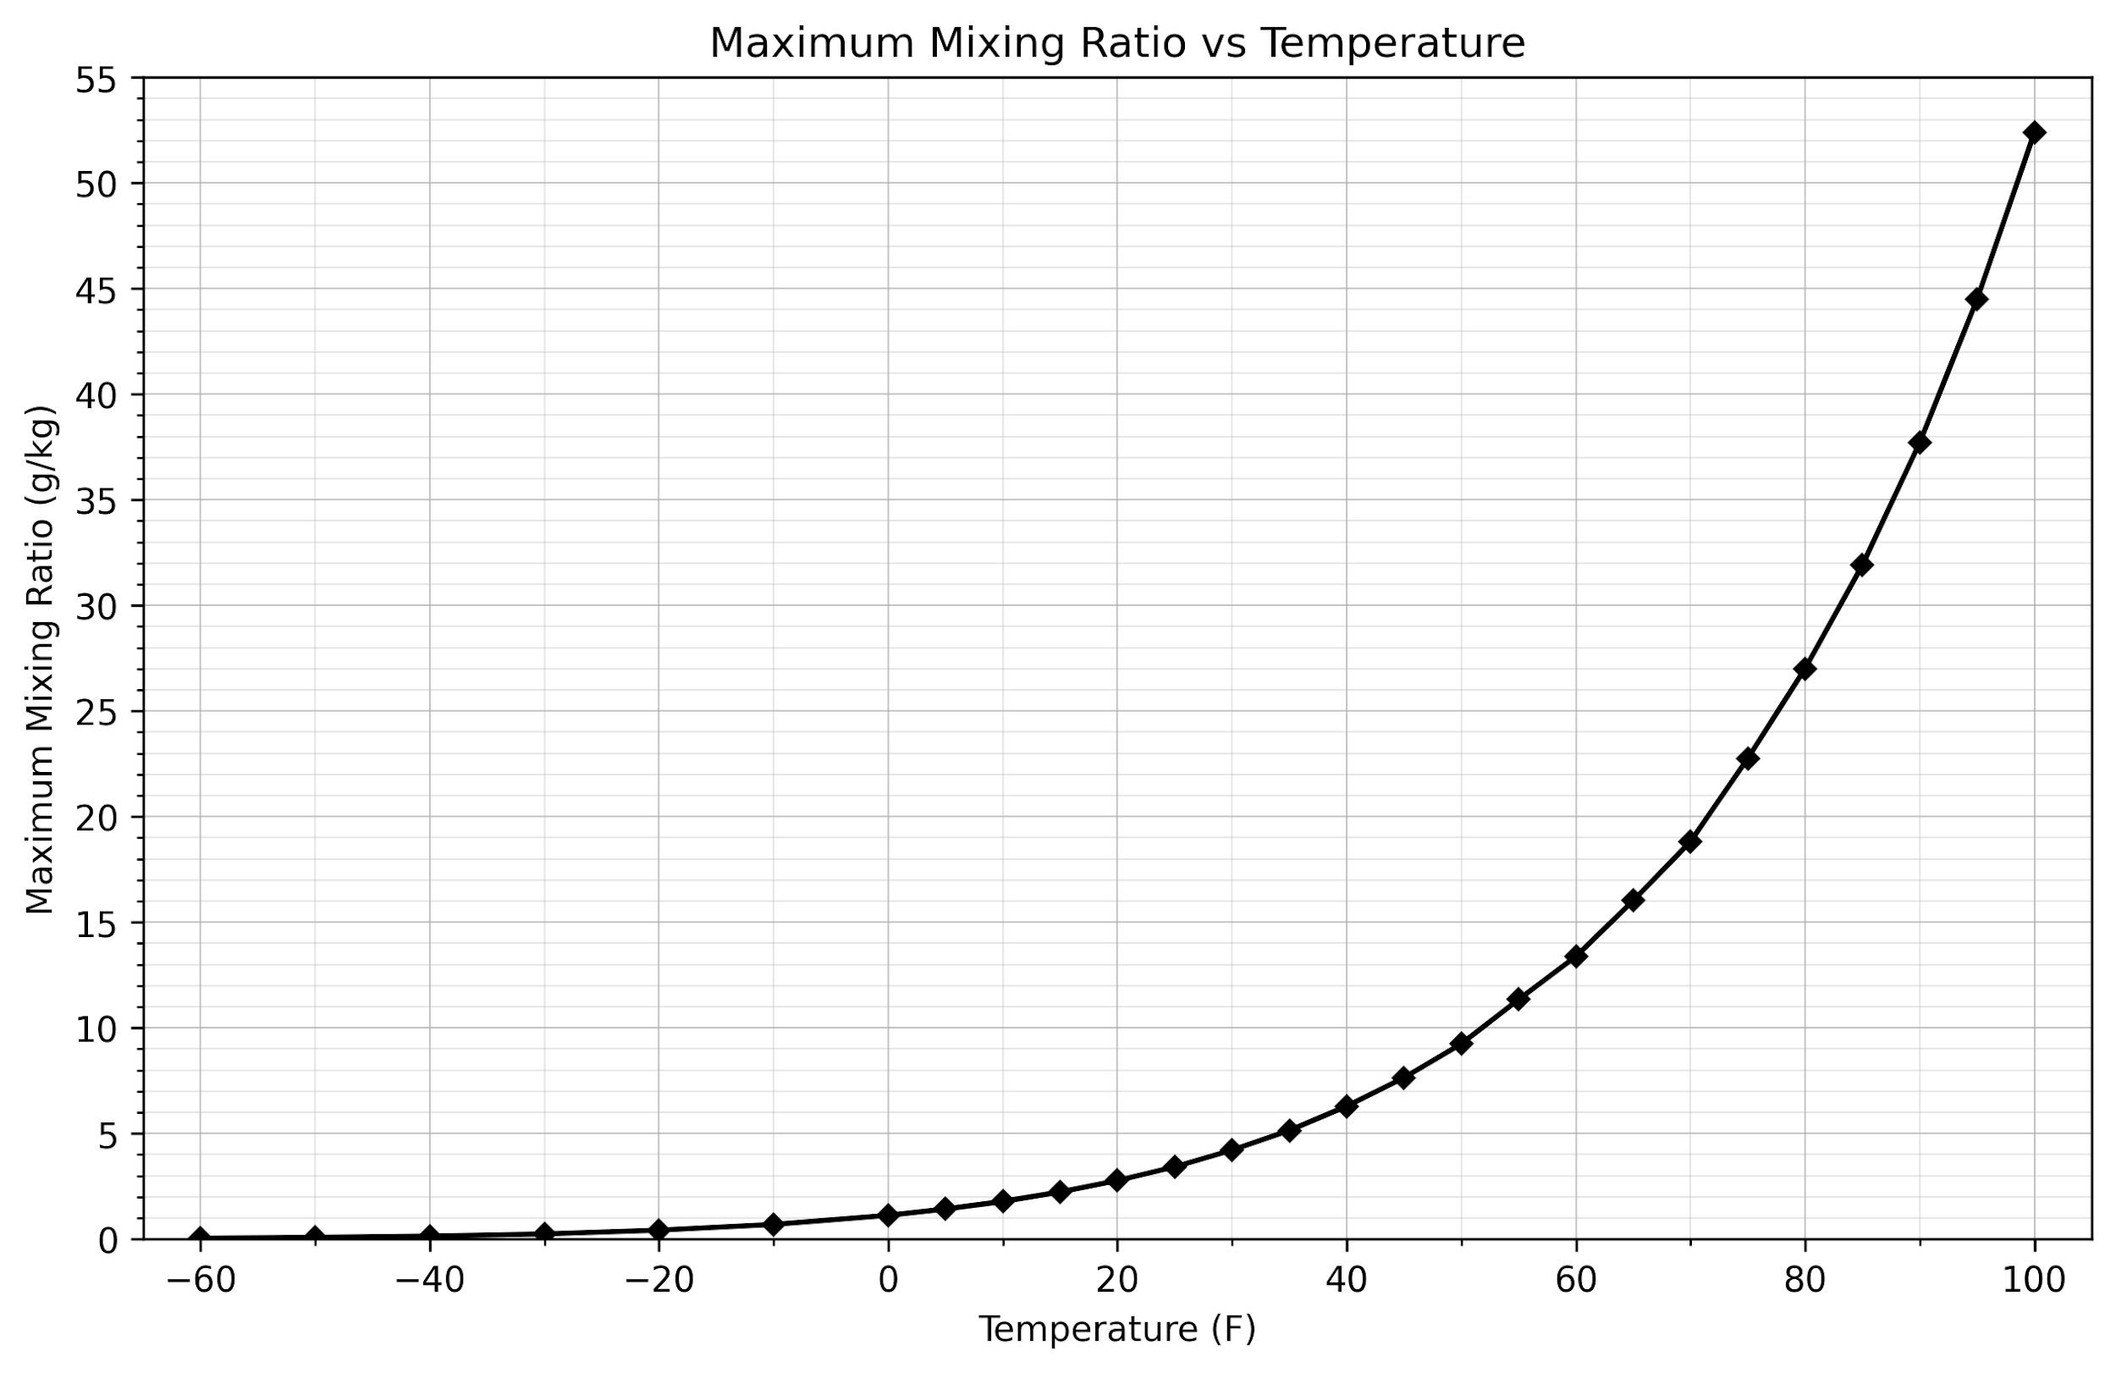
  Air Temp (F) | Max Ratio (g/kg)
  100 | 52.38
  95 | 44.48
  90 | 37.71
  85 | 31.91
  80 | 27.01
  75 | 22.76
  70 | 18.82
  65 | 16.02
  60 | 13.38
  55 | 11.34
  50 | 9.24
  45 | 7.64
  40 | 6.29
  35 | 5.14
  30 | 4.21
  25 | 3.42
  20 | 2.77
  15 | 2.23
  10 | 1.78
  5 | 1.42
  0 | 1.12
  -10 | 0.69
  -20 | 0.42
  -30 | 0.24
  -40 | 0.14
  -50 | 0.08
  -60 | 0.04

