Global measures
N : number of local communities sampled
n_{k} : number of individuals sampled in local community k
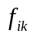 : observed relative abundance of species i in the local community k (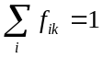)
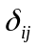 : phyletic or functional/trait distance between species i and j

Indices based on species abundances
Sample-based estimate of Rao’s entropy in local community k:
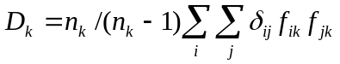
D_{k} is the mean phyletic or functional distance between two individuals.
Note that if n_{k} is unknown because species relative frequencies are given rather than absolute abundance (number of individuals), the estimation (uncorrected for sample size) becomes: 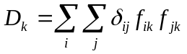
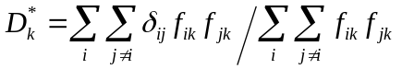
D_{k}* is the mean phyletic or functional distance between two individuals from local community k, excluding intra-species comparisons.
Estimate of Rao’s entropy within local communities:
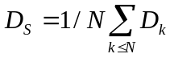
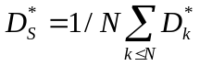
Estimate of Rao’s entropy over the whole community represented by the N sample of local communities:
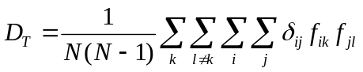
D_{T} is the mean phyletic or functional distance between two individuals from distinct local communities.
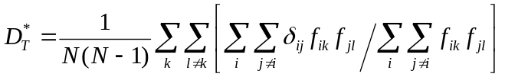
D_{T}* is the mean phyletic or functional distance between two individuals from distinct local communities, excluding intra-species comparisons.

Local phylogenetic similarity excess:
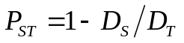
P_{ST} integrates both species turnover and phylogenetic turnover, weighting species according to local abundances.
T_{ST} is identical to P_{ST} but using functional/trait distances rather than phylogenetic distances.

Local species identity excess:
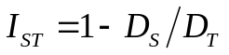 in the particular case where = 0 for i=j and =1 otherwise.
I_{ST} is a measure of species turnover accounting for local abundances, but with different properties than measures of species turnover based on species sharing (Réjou-Mechain & Hardy 2011). It is the analogue of G_{ST} in population genetics.

Local phylogenetic or functional similarity excess, excluding intra-species comparisons: 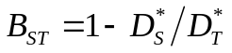
B_{ST} integrates only phylogenetic turnover, weighting species according to local abundances.
U_{ST} is identical to B_{ST} but using functional/trait distances rather than phylogenetic distances.

Indices based on species occurrences
Let 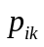= 1 if species i occurs in sample k ( > 0), otherwise = 0:
Local phylogenetic or functional distinctness:
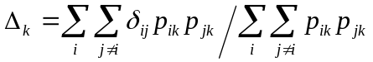
Δ_{k} is the mean distance between distinct species from local community k.

Mean distance between distinct species within local communities:
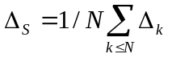

Mean distance between distinct species among local communities:
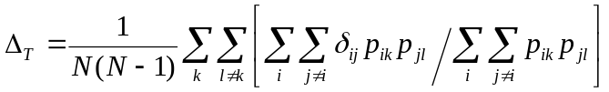
(this formulae corrects a typographic error in eq. 16 of Hardy and Senterre 2007 where the j≠i were missing)

Local phylogenetic or functional similarity excess:
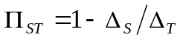
Π_{ST} expresses phylogenetic turnover without accounting for species local abundances (it is a presence/absence version of B_{ST}).
τ_{ST} is identical to Π_{ST} but using functional/trait distances rather than phylogenetic distances.

Notes:
1. These formulae estimate parameters of community structure using samples of local communities under the following assumptions:
- N is much smaller than the total number of local communities constituting the whole community of which the sampled local communities are representative (this justifies that D_{T} and Δ_{T} are estimated excluding pairs of species from the same local community)
- n_{k} is much smaller than the total number of individuals constituting local community k (this justifies the n_{k}/(n_{k}-1) correction factors)
2. Δ, Π and τ are written DELTA, PI and TAU, respectively, in the output of SPACoDi and spacodiR.

Simplified formulae for pairwise measures between local communities (k and l):

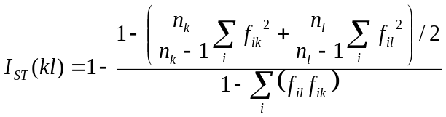
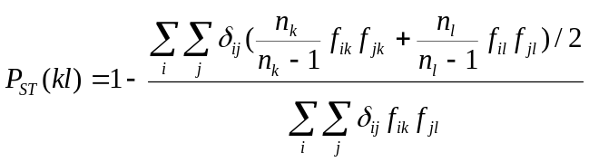
For I_{ST} and P_{ST}, the n_{k}/(n_{k}-1) and n_{l}/(n_{l}-1) factors drop if the total number of individuals per local community is undefined.

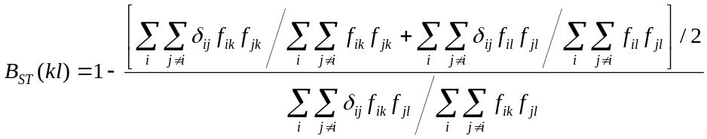
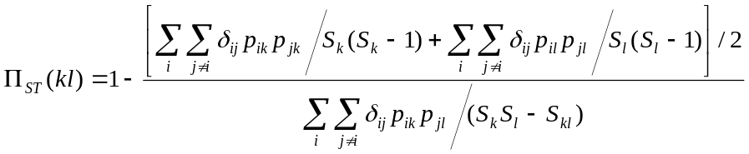
where S_{k} and S_{l} are the total number of species found in k and l, respectively, and S_{kl} is the number of shared species between k and l.

Note that for B_{ST} and Π_{ST}, each local community must contain at least two species.

