Closest Package Stop Algorithm

Algorithm Overview (B-1):
This algorithm aims to create routes that only add stops that have packages, skipping any (if any in this case) locations that don’t have any packages. It does this by:
- Taking the packages and stops that are inputed, add the packages to a hashmap and the stops to a graph
- Check the packages special notes and separate them based on those, leaving the remaining packages untouched
- Create initial routes based on each stop that can be reached from the hub
- Match a route with requirements from the special notes
- Remove overlapping packages and add unassigned packages to the route that it’ll depreciate the least
- Update the status of each package with the truck info
- Re-create the routes with the new packages to be sure it operates with the least miles
- Once a route is finished, check for undelivered packages and deploy any trucks that have returned with those packages
Below is an overview of my methods that control this algorithm:
Main
create our trucks and assign an empty truck object to them
import our excel sheets using pandas, separate the headers, clean up any new lines or double spaces in the data, remove empty cells and reattach the headers
take the packages data and import it into the hashmap function for the packages
insert the distance table headers into the graph, use the distance table to insert the graph location distances
create separate lists based on the project requirements for the packages and associate the packages to those lists
append each package to the graph points as a list
create a possible route from the hub with each headers as its first stop, each succeeding stop being the closest one to the previous, up to 16 total packages delivered per truck, and back to the hub
check to see if any routes contain 70% or more of the packages that we separated earlier
Take the routes with 70% or more and add the missing packages from the separated lists
Remove any overlapped packages so there aren’t doubles on separate routes
Check for packages that aren’t on any existing routes, test them on each route and add it to the most efficient
Change the delivery status of each package to indicate that it’s on a truck
start our simulation time on a separate thread
execute each route on their own trucks and on their own threads
check to see if any packages remain after the trucks have returned and rerun the threads with new routes with the remaining packages
mark execution as complete

The main function here executes with a worst time complexity of O(n^3). There are a few nested for loops throughout the function that tank the operating efficiency of this part of the algorithm. The packages below are used throughout main and sometimes referenced from within eachother

execute_route
import any necessary global variables and create those necessary for execution, the first stop in the route, distance traveled for the route, distance to the next stop, and average speed
check to see if any packages in the route have an incorrect address if so, get the package object from the hashmap based on the id provided
wait until the departure time of the truck is reached, this is by default 8 am but can be later depending if it has delayed packages from the airport
If packages that were delayed are on the route, change the status after their arrival time is reached
loop through each package, grab the next stop and determine the distance to that stop, loop and add to your distance traveled until it matches the distance necessary to that stop. Pull the packages from the point data on the graph and mark them as delivered with the time stamp of when they would have been delivered
if a package has the wrong address, check to see if it’s time to receive the updated address, call the function correct_address and create a new route with the corrected information. re-call execute_route with the new route
Once each package has been marked delivered, return to the hub. Total miles traveled is saved to a global variable for display later

Execute route suffers from the same curse as main since it has some embedded for loops. In some cases having a time complexity of O(n^3) and I believe O(n * log(n)) in other cases.

correct_address
retrieve the package id for the package with the wrong address
remove it from the list of affected packages
change the special note of the package to indicate that the address has been fixed
take the new address, break it down to zip code, city, and address
modify the package attributes that mate those that were previously extracted
loop through the points on the graph and remove it from the incorrect location and adding it to the correct one

Here we have the correct_address method. It has the best execution time so far of O(n) as it’s worst case. This is because we are referencing a hashmap which could have a best case of O(1) but we have a for loop in there that checks each of the graphs points and this leads to it being O(n). Implementing a hash function into the graphs class could decrease the best case of this function to O(1) and decrease the cases for other functions as well

create_route
set the default first stop as the hub, if a first stop was passed in on the method call, set that as the first stop as the route instead. The route is declared as a list
Check each of the packages that were passed in to see if there are in any of the filtered lists from the main function, add their labels to appropriate lists for filtering later
based on this prioritization, create the routes: time critical packages, standard packages, packages with the wrong address
for the packages in each of those groups, start with the last point in the route list, find the closest one based on the hashmap, add the closest location to the back of the route list
return the route

In create_route, we have loops that have a runtime of O(n * log(n)) as well as O(n^2). Since O(n^2) is the largest of the two, that is our final worst case runtime.

shortest_route
take a list of similar routes and loop through them
if shortest is empty, assign the first route to shortest
else calculate the total length in miles of shortest and the next route in the loop, if the next route is shorter, assign that to shortest
after each route is compared and shortest is decided, return shortest

Shortest route has a good case of O(n) since it’s only looping through it’s own list of routes. It can however have a runtime of O(1) if the list of routes passed through only has one route entry.

distance_calc
for I in our route
if previous is empty assign it to I
else get the weight of previous and I
add the weight to the total distance
return total distance

The last function we’ll talk about for the algorithm, distance calc has a runtime of O(n) with its for loop going through each stop in the given route. The remaining functions in main.py don’t affect the creation of the routes in this algorithm so they aren’t mentioned here, they are simply used to assist in the simulation of the routes. Execute route falls in between since it can modify routes based on wether or not they have a package with the wrong address and was treated as a part of the algorithm that determines the routes.

Development Environment (B-2):
This was developed on Mac OS in PyCharm with a python virtual environment specific to this project.

Time Complexity (B-3):
I use for loops a lot and have a few while loops. Depending on which function we are looking at, it ranges from O(n) to O(n^3). The main function of the algorithm is the worst offender at O(n^3), the hashmap class is the best at O(1) in it’s best case and O(n) in it’s worst. The next most influential function on the execution of the program will be the execute route function. It has a worst case of O(n^2) however this is simply for the simulation of the algorithm and doesn’t influence the create of the routes unless a package has it’s address updated prior to a truck returning to the hub. Finally, the graph algorithm. It has a time complexity of O(n) as it may need to search for the referenced object and stores everything in list’s.

Adaptability (B-4):
As of now, the creation of routes wouldn’t complete if additional packages were added since the code just isn’t there. The product is incomplete and only meet’s the needs of the current list. 48 packages would be the limit so that 16 packages are on each truck. However, the graph will support more locations without issue.

Efficiency and Maintainability (B-5):
Efficiency isn’t this programs strong suit as it can reach a time complexity of O(n^3) so optimizations or an algorithm reconsideration may be necessary. As far as maintainability, most of the crucial route creating components are their own methods so they can be called from other methods or parts of the code if necessary.

Strengths and Weaknesses (B-6):
The strength and goal of this algorithm is that the goal for the routes is to have them be as compressed as possible, with minimal space between each stop. The resulting weakness is that the hub can end up being farther away at the end of the route, having a long drive without any stops. The strength of using my graph is that it essentially digitizes the map. You can visualize this by picturing each stop as a point on a map with their distances being a line that connects them. A strength with this is that adding points, adding weights or distances, and retrieving the weights or distances between points are all best and worst case O(n), n being the total points you have on your graph. That is also the weakness that using a hashmap could have been better for as the best case would theoretically be O(1) and worst case O(n) where the graph is O(n) regardless of the case.

How the Graph Works (D):
The graph is fairly simple, it stores all of the points or in this case the stops in a one-dimensional list. Then the weights of the graph or distances between points are store in a two dimensional list with each index leading to the weight corresponds to the same index on the points list.

Two Strengths (I-1):
One of the strengths is that it isn’t limited on locations that can be inputed into the graph that the routes will be created from. Following that same track, it’ll ignore unnecessary stops, avoiding visits when there aren’t any packages available for a saved location. The amount of locations inputted won’t affect the time complexity of the graph that it’s using.

Other Algorithm’s (I-3):
Two other algorithms that come to mind that could work fairly well while still using the graph data structure are Dijkstra's Algorithm and possibly a Depth First Algorithm. With Dijkstra’s, the difference is that it would search for the quickest route from point A to point B regardless of wether a stop has a package that needs to be dropped off. It would also need to be run two or more times to accomplish a full route out from the hub and back. For a depth first algorithm, it would be something similar, you’d need to run it two or more times and it would initially find the farthest point out from our starting point, possibly leading to longer, less mile efficient routes.

What Would I do Differently? (J):
From the get-go, I would spend a lot more time on the planning phase of this program and writing psuedocode and spending time with a whiteboard. I often found myself rewriting code or writing horribly complicated code (some of which you can see is still there) and spending hours doing this. A lot of time was wasted this way and ultimately left me frustrated and sometimes confused by something I had written.

Data Structure Justification (K-1):
For the graph, adding packages and locations won’t change the amount of time used in the look-up function by much. Since it’s worst case is O(n), adding another location would make the time complexity O(n+1) for every location added. Since the packages are stored alongside the locations, if the location exists, adding a package won’t affect the time complexity at all. As for how the space will be affected, I’m don’t know how much would be added exactly. However, since the identifier that is used to pair the package and the location is the package id, it’ll be the amount of memory for the location string plus however many package integers are present in the list. The change in memory to the number of cities would be a bit larger since that is a new point in the points list in addition to whatever weights you add to that point and any other points with in the graph. So if we take our existing memory, we have our list of points or cities and that’ll be n. Then we have our data for the weights which is at a maximum 2n-1. Adding one city would guarantee n+1 in memory for the points and has the potential of 2(n+1)-1 for the weights of the graph. This would still result in lookups being O(n). The trucks are their own data structure however, I store them in yet another list so looking through each to find the truck we want would result in O(n) and if trucks are added, O(n + 1) for every truck added.

Other Data Structures (K-2):
One structure I considered was using a Pandas Data Frame. There are two problems with this, I didn’t create the algorithm for this data structure and was unsure if it’d be allowed and I wasn’t familiar enough with it at the time that I considered it to comfortably use it. I do use it to import the data and convert it to my graph however, if I were to interface with it directly, I believe it would have a similar time complexity as the graph. It imports the data in a way that it can be navigated in a similar way to a two dimensional list with headers. The headers likely could have been used for navigation instead which could make it more efficient than a graph but I don’t know the underlying algorithms for the pandas lookup functions. Another structure that could be used is a 2 dimensional hash map. It would be a similar concept to a two dimensional list but instead of using integer indexes it’ll use a hash for the location indexes that lead to the distance between the two locations. This has the potential to be more efficient with a best case time complexity of O(1) and a worst case of O(n) however, I think that I could implement hashes in my existing graph structure and achieve the same result.

Images:
8:51 AM:
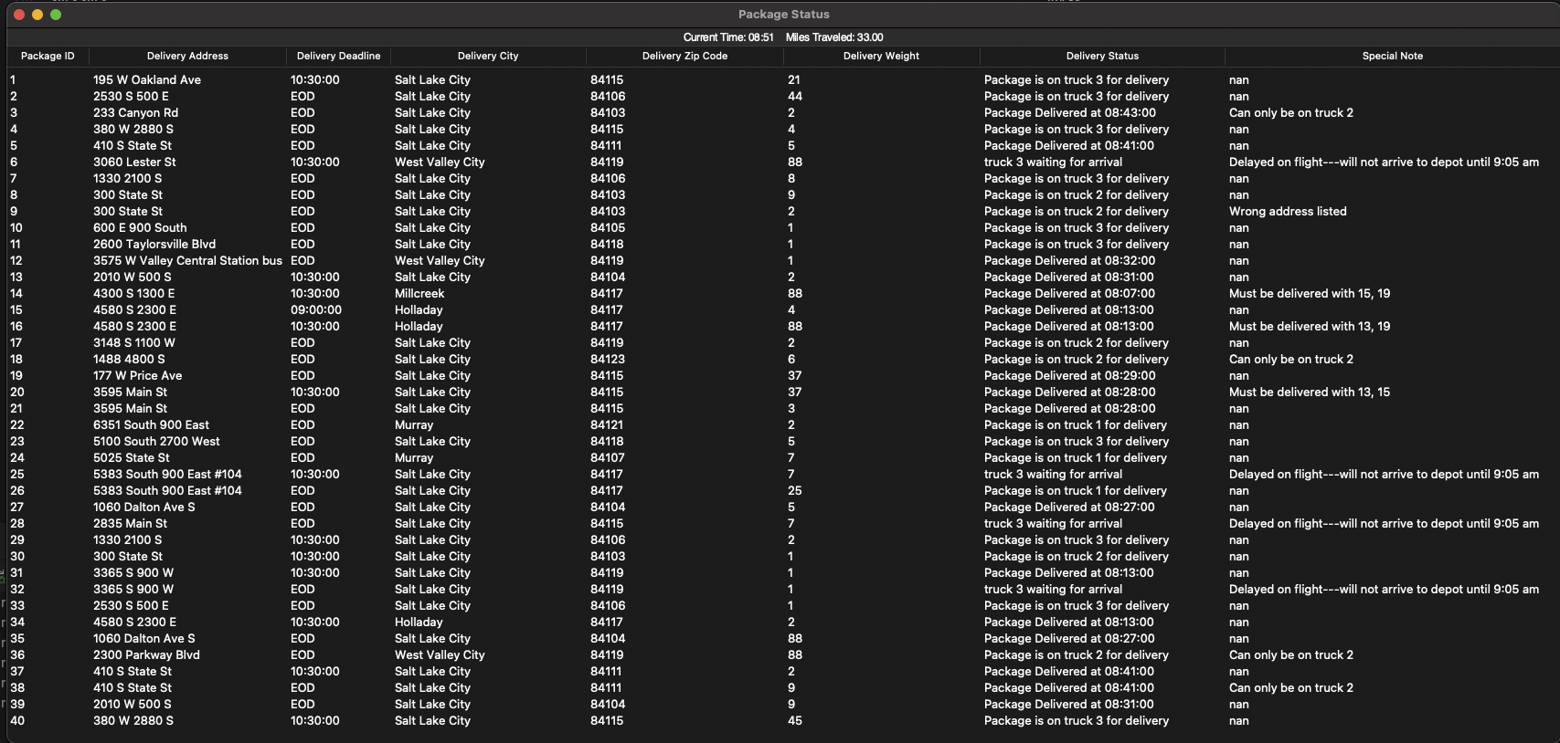

9:53 AM:
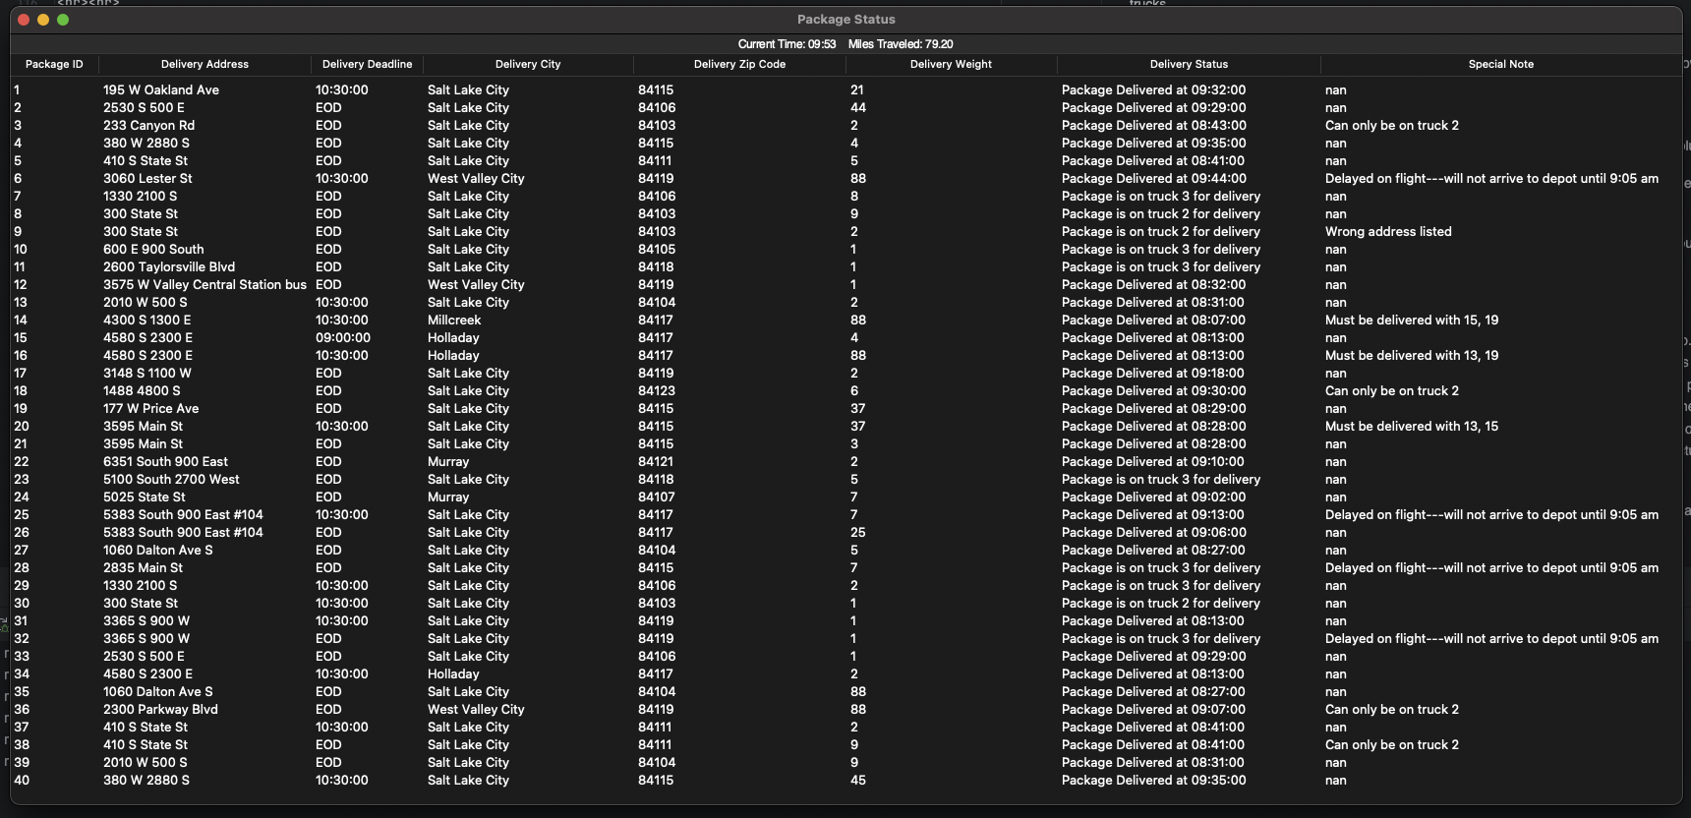

12:22 PM:
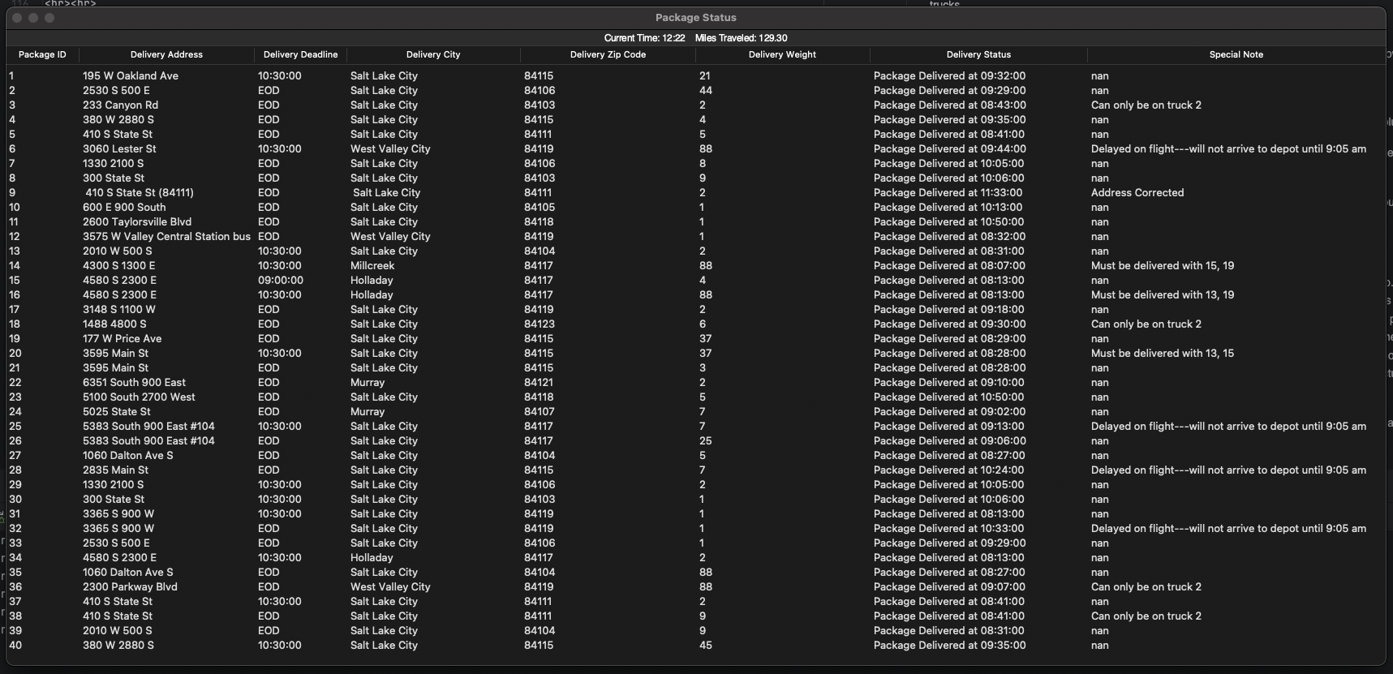

Successful Execution:
