EASTWeb V2.0 Manual

Contents

1. Installation 2

1.1 Recommended Hardware Specification 2

1.2 Installing Required Software 2

1.2.1 Installing Java 32-bit 2

1.2.2 Installing PostgresSQL 5

1.3 Configuration 9

1.3.1 config.xml 11

1.3.2 c3p0-config.xml 12

2. Project Tutorial 12

2.1 Creating a New Project 12

2.1.1 Load the EASTWeb V2.0 Main Window 12

2.1.2 Project Information Window 12

2.2 Running a Project 18

2.3 Query Database 19

3. Troubleshooting 21

# Installation

## Recommended Hardware Specification

* CPU: At least 4 cores available
* RAM: Allow the application to use up to 0.5GB of memory
* HDD: Having at least 100 GB of available space will allow multiple projects and plugins to work for some time but this is entirely dependent on the projects the users create and run. As an example, downloading about two years’ worth of files for ModisLST, ModisNBAR, NldasForcing, NldasNOAH, TRMM3B42, and TRMM3B42RT products takes up approximately 11GB. A single project for both Modis and both TRMM3B42 products takes up another 13GB while including intermediate files.

## Installing Required Software

Currently the Postgres database and Java must be installed to run EASTWeb V2.0.

### Installing Java 32-bit

Java 32-bit must be used in order to run the Gdal 32-bit libraries. For this application to run, 32-bit Java version 1.8.51 or higher must be installed.

*Step 1. Downloading Java .exe*

Open preferred browser and go to the following url: [www.oracle.com/technetwork/java/javase/downloads/index.html](http://www.oracle.com/technetwork/java/javase/downloads/index.html)

Click “Download” under JRE as shown below.

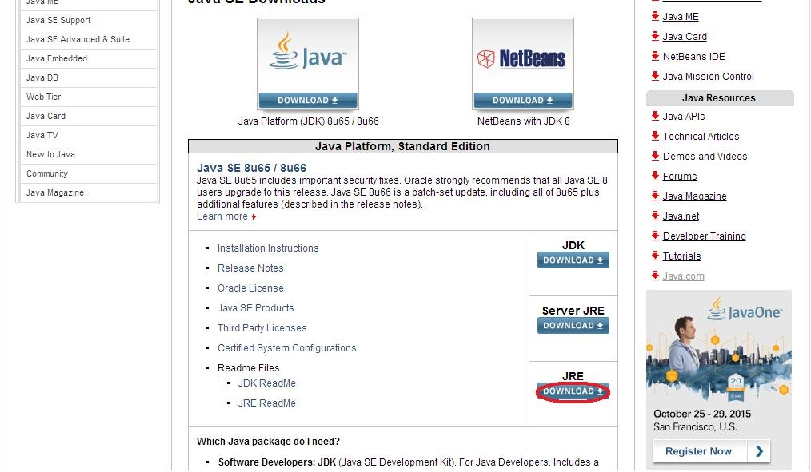

Go to the most current version of the JRE (in this case it is 1.8.66) and click the Windows x86 offline option as shown below.

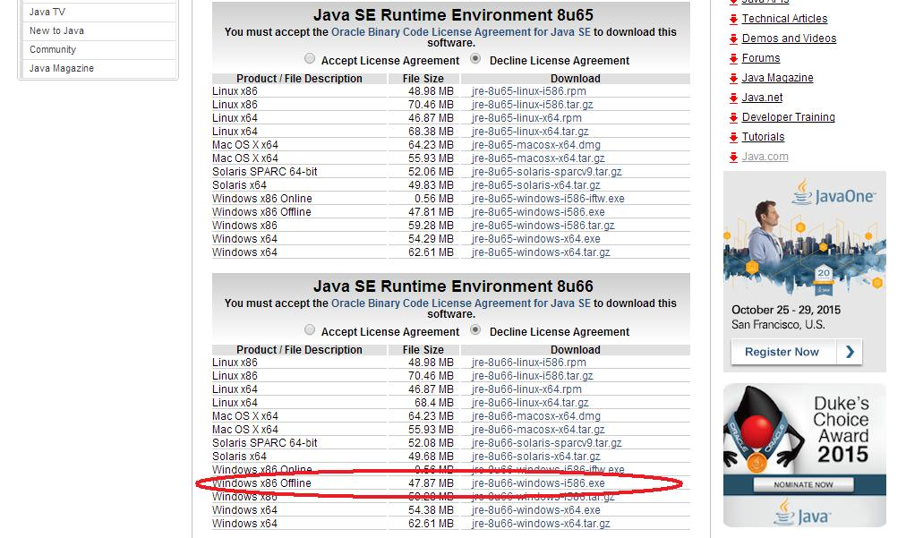

*Step 2. Installing Java*

Navigate to the folder where you downloaded the .exe file to then double click on “jre-8u66-windows-i586”

The following installation wizard will appear:

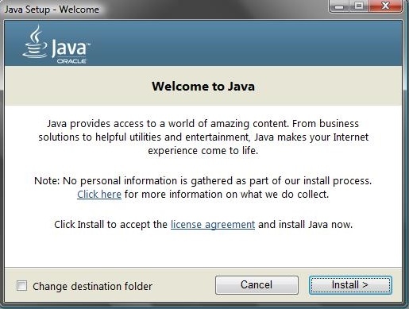

Click “Install”. Wait for the progress bar. When the progress bar completes, click “Close”.

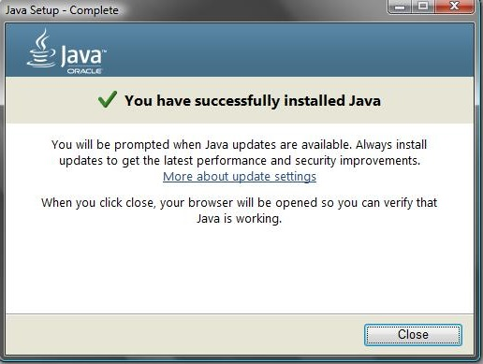

### Installing PostgresSQL

As Java 32-bit must be used it is preferable that Postgres database be a 32-bit version.

*Step 1. Downloading Postgres*

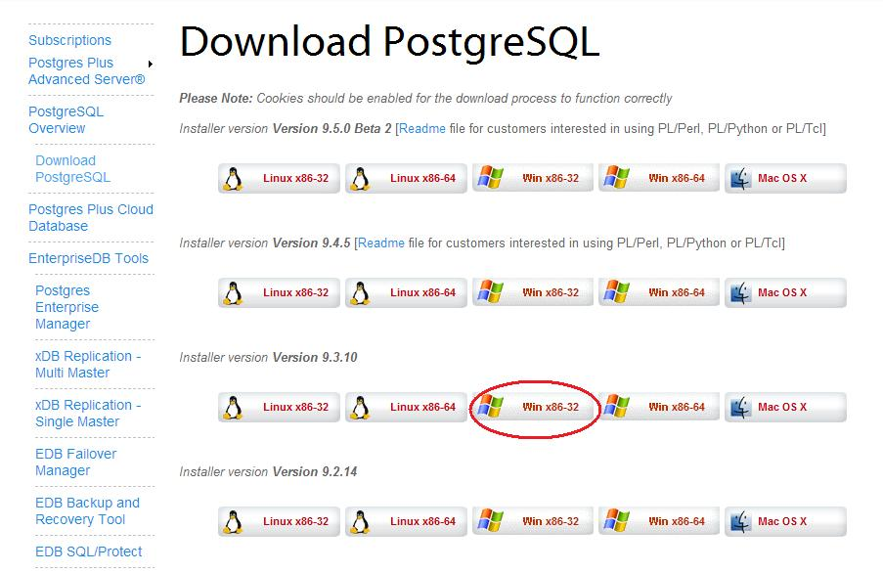Open preferred browser and go to the following url: [www.enterprisedb.com/products-services-training/pgdownload#windows](http://www.enterprisedb.com/products-services-training/pgdownload#windows)

Click “Win x86-32” for the PostgreSQL version you have chosen to install (for this example Version 9.3.10 was chosen). The download should automatically start.

*Step 2. Installing Postgres*

Navigate to the folder where you downloaded the .exe file to then double click on it.

The following installation wizard will appear:

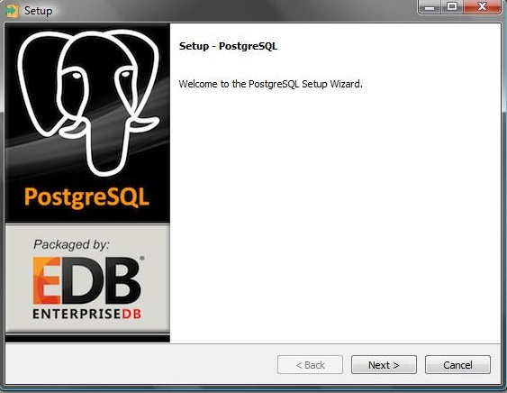

Click the “Next” button until the “Password” step is reached. Set the password to “eastweb”. This is the password that the software will need to use to access the database.

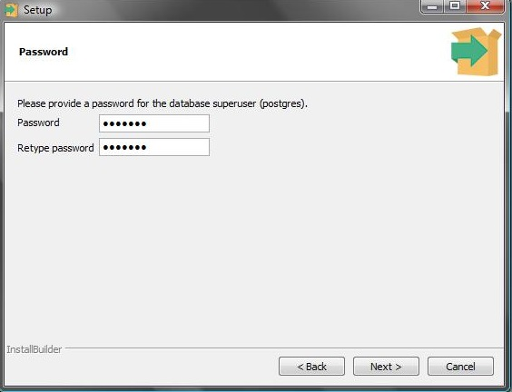

Click the “Next” button. If not already present, type “5432” in the “Port” text entry. This is the port the software will attempt to communicate with the database on.

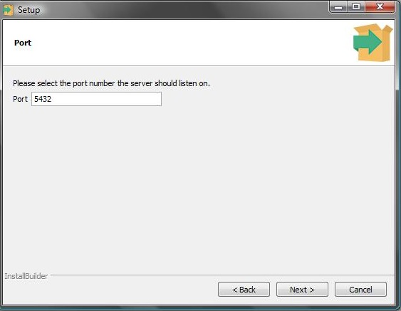

Click the “Next” button until progress bar appears. When the progress bar completes uncheck the “Launch Stack Builder at exit?” checkbox and click “Finish”.

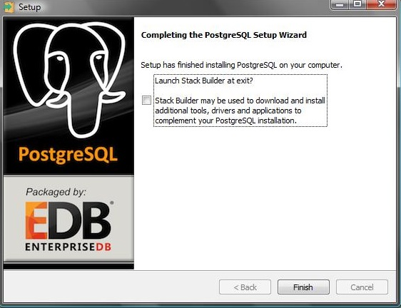

## Configuration

The software may need to be configured before use. A configuration file located within the EASTWeb V2.0 installation directory specifies the location of resources, values needed to use the resources, and advanced EASTWeb V2.0 settings.

Navigate to the installation directory. Locate the “config.xml” document.

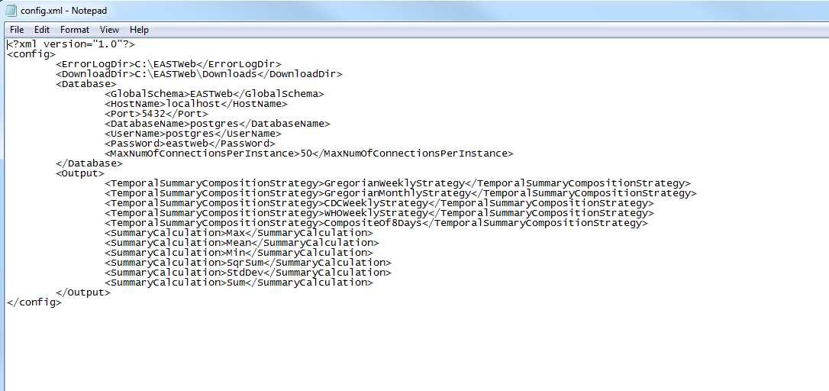Open the “config.xml” in Notepad.

The DownloadDir tag specifies the location where downloaded files will be saved. Ensure that the location specified by the DownloadDir has sufficient space for your needs. If it does not, specify an alternate location.

Open the “c3p0-config.xml” in Notepad.

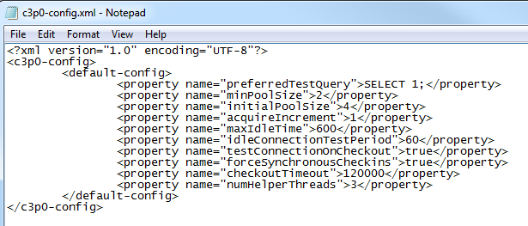

### config.xml

Valid element tag names – each tag should be defined only once unless otherwise specified.

|  |  |
| --- | --- |
| ErrorLogDir | Directory path to use when printing error logs (errors will either print here or at a location of batchfile) |
| DownloadDir | Directory path to use when saving downloaded data files |
| GlobalSchema | Name of schema to use for global information for EASTWeb V2.0 application |
| HostName | Host name to use when connecting to the database |
| Port | Port number to use when connecting to the database |
| DatabaseName | Name of the database to use for all application created schemas |
| UserName | Login user name |
| Password | Password for user account |
| MaxNumOfConnectionsPerInstance | Maximum number of simultaneous connections to allow EASTWeb V2.0 to create |
| TemporalSummaryCompositionStrategy | Name of TemporalSummaryCompositionStrategy implementing class to include in EASTWeb V2.0 (1+ can be defined) |
| SummaryCalculation | Name of SummaryCalculation implementing class to include in EASTWeb V2.0 |

### c3p0-config.xml

Valid element tag names – each tag should be defined only once unless otherwise specified. See <http://www.mchange.com/projects/c3p0/#configuration_properties> for more information.

* c3p0-config:
  + default-config:
    - property element list…

# Project Tutorial

This tutorial walks through the steps required to create, process, and query a project. The tutorial also includes discussion of important things to know when creating your own project. If an issue is encountered while following the tutorial, refer to the troubleshooting section of this document.

## Creating a New Project

### Load the EASTWeb V2.0 Main Window

Navigate to the installation directory for EASTWeb V2.0 and double click on “Run EASTWeb.bat”.

**NOTE: Do not run more multiple instances of EASTWeb at the same time.**

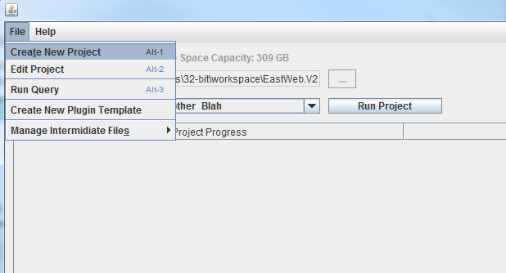

Figure 1. EASTWeb V2.0 Main window

Select File -> Create New Project and a Project information window will be prompted

### Project Information Window

#### Adding Plugins

*Step 1. Load the Plugin Information Window*

Click the “+” button on the top left corner of the Project information window (Figure 2)

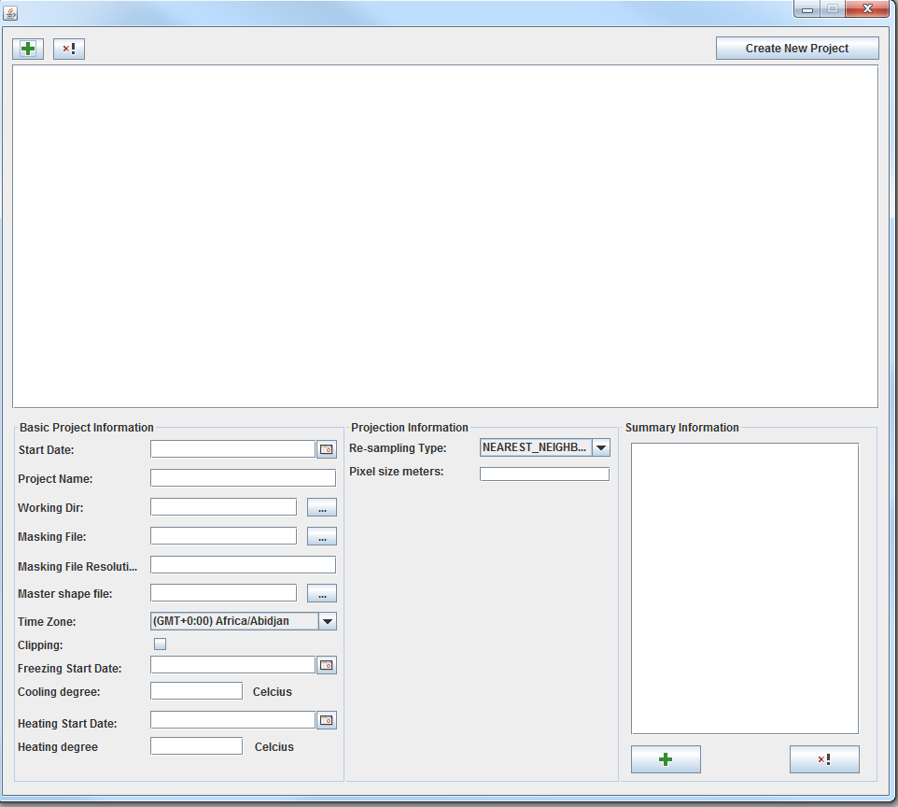

Step 1

Figure 2. Project Information window

A plugin information window will be prompted.

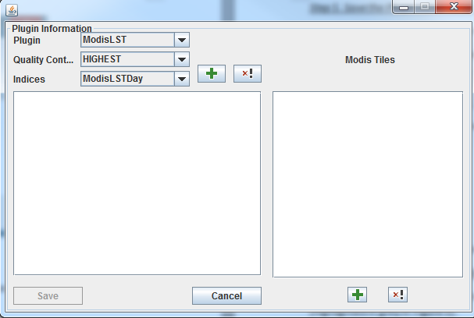

Step 2

Step 3

Step 4

Figure 3. Plugin Information window

*Step 2. select a plugin*

Use the “Plugin” dropdown box (highlighted in red in the Figure 3) to choose a plugin for a project.

*Step 3. choose quality control*

Use the “Quality control” dropdown box (highlighted in orange in the Figure 3) to choose the desired quality level.

*Step 4. Choose Indices*

Use the “Indices” dropdown box (highlighted in green in the Figure 3) to choose one index calculator, click the “+” button in green to add it in.

Repeat this step until all the desired indices are added in. Figure 4 shows ModisLST plugin with two indices selected.

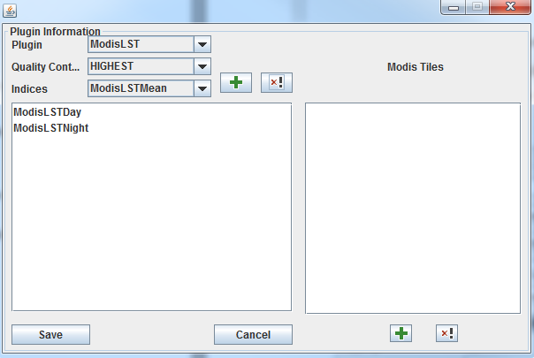

Step 5

Step 6

Figure 4. ModisLST plugin with three indices selected

To remove an index, highlight the index and click the “x!” button.

*Step5. Input MODIS tiles if MODIS products are used*

Click the “+” (highlighted in green) in the Modis Tiles section shown in Figure 4.

Enter a tile in the prompted dialog window. The format for a tile is *h* followed by two digits and *v* followed by two digits (see Figure 5). Click “OK” button to add the tile.

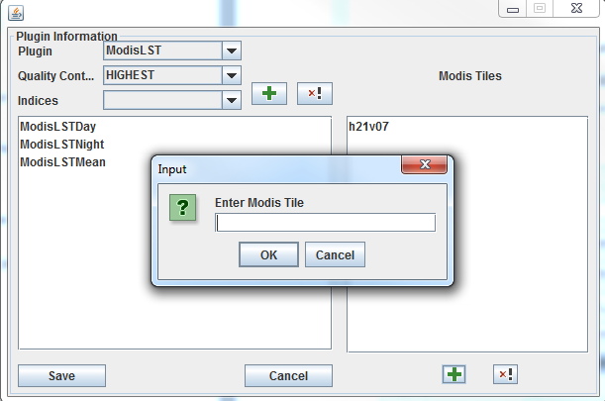

Figure 5. Plugin Information window when entering tiles

Repeat the step until all desired tiles have been added.

**NOTE: If MODIS products are used, any MODIS plugin saved will contain the same Modis Tiles as the first MODIS plugin entered (All tiles will be the same for all MODIS plugins as shown in Figure 5).**

*Step 6. Save the Plugin information*

Click “Save” button (highlighted in red in Figure 4).

The Plugin Information will be shown in the Project Information window (Figure 6).

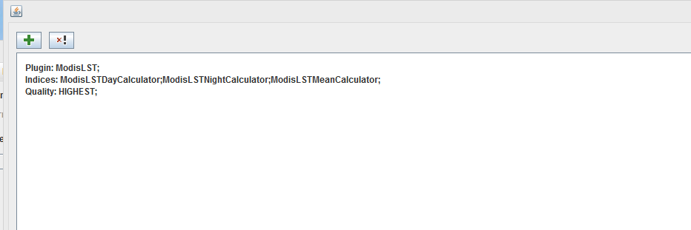

Figure 6. Project Information window after a plugin is added in

*Repeat step 1 through step 6 to add more plugins to the project.*

To remove a plugin, in the Project Information window, highlight the plugin and click “x!” button (highlighted in green in Figure 6).

#### Input Basic Project Information

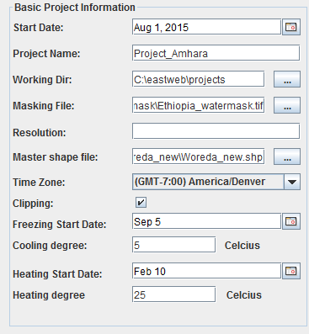

Figure 7. Basic Project Information section in the Project Information Window

Add all the needed information about the project. The sample information of a project is shown in Figure 7.

#### Inputting Projection Information

Enter desired information in the Projection Information section as shown in Figure 8.

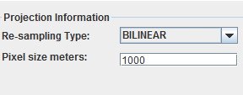

Figure 8. Projection Information section in the Project Information Window

#### Summary Information

To add summary units, please follow the three steps listed below:

*Step 1*. Click the “+” button in the Summary information section in the Project Information Window.

*Step 2:* Select the shapefile, field name and temporal summary in the prompted window (shown in Figure 10)and click the “Save” button.

*Step 3:* Repeat step 1 and step 2 until the desired summary units are all added. Figure 11 shows the display of the summary units in the Summary Information section.

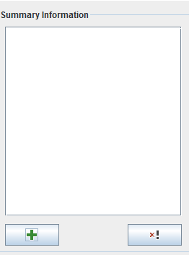 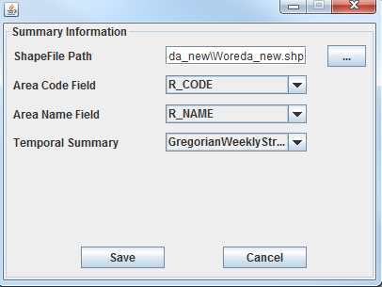

Step 2

Step 1

Figure 9. Summary Information section Figure 10. Prompt window for summary units

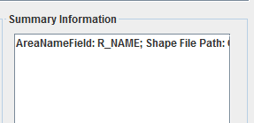

Figure 11. A summary unit is added.

**NOTE:**

* **No interpolation is done within EASTWeb V2.0 currently.**
* **If product can’t be summarized into the specified amount of days then summaries will not be produced for that product in association to the invalid temporal summary.**
* **Temporal summarizations can be left out to allow all products to be summarized via zonal summarization.**
* **MODIS products can be summarized additionally with the 8 day composite strategy allowing comparisons to be made with other products which have daily output.**

#### Create the new project

Click the “Create New Project” button on the right corner of the Project Information window. After a message “Project was saved!” prompted and the “ok” button is clicked, the Main window will be brought back.

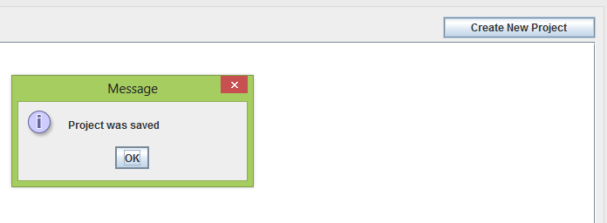

Figure 12. “Create New Project” button on the Project Information window

## Running a Project

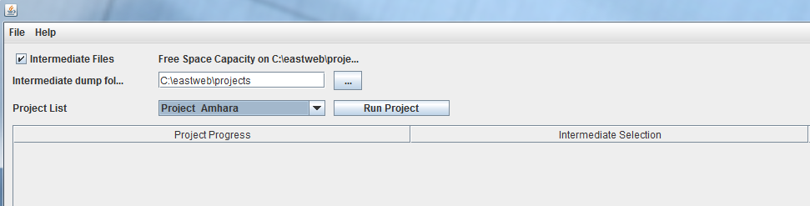

Figure 13. Main window

The created projects are listed in the “Project List”. Check “Intermediate Files” to save the files produced during processing and choose a location to store the intermediate files. If “Intermediate Files” remains unchecked the intermediated files produced during processing will be removed.

Select the project in the “Project List” and then click the “Run Project” button.

**NOTE: Do not run more than one instance of a project at the same time.**

Figure 14 shows the status of a running project.

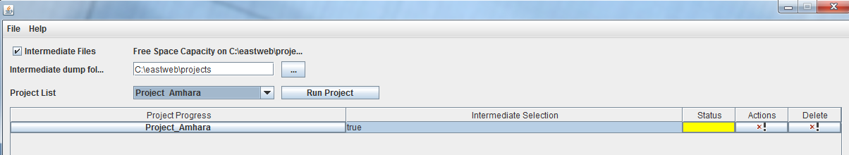

Figure 14. Project processing status

Status bar colors

Yellow – Project Processing

Red – Errors encountered in project

Green – Project has completed processing

The processing progress can be monitored by clicking on the project name. The Progress Summary will be prompted as shown in Figure 15.

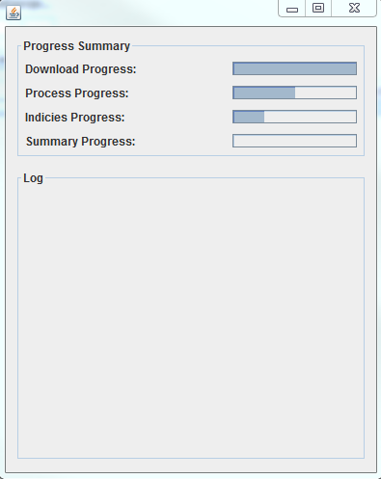

Figure 15. Progress Summary

## Query Database

To query the summary in the database, select File - > Run query in the Main window. The query UI will be prompted as shown in Figure 16.

Step 1: Select the project in the dropdown menu, then fill in the query criteria. A sample is shown in Figure 17. If you want to view the SQL click on “View SQL”. The query UI will display the SQL as shown in Figure 18.

Step 2: click “Query” button.

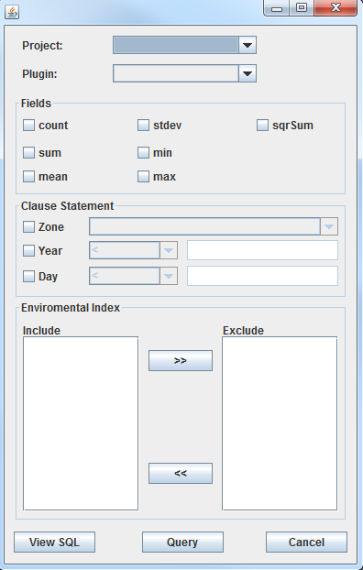 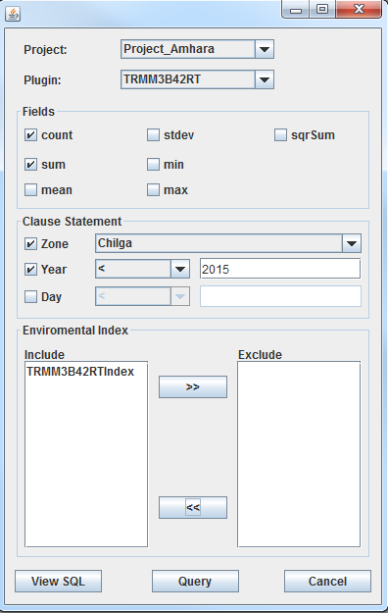

Figure 16. Query window Figure 17. Filled query

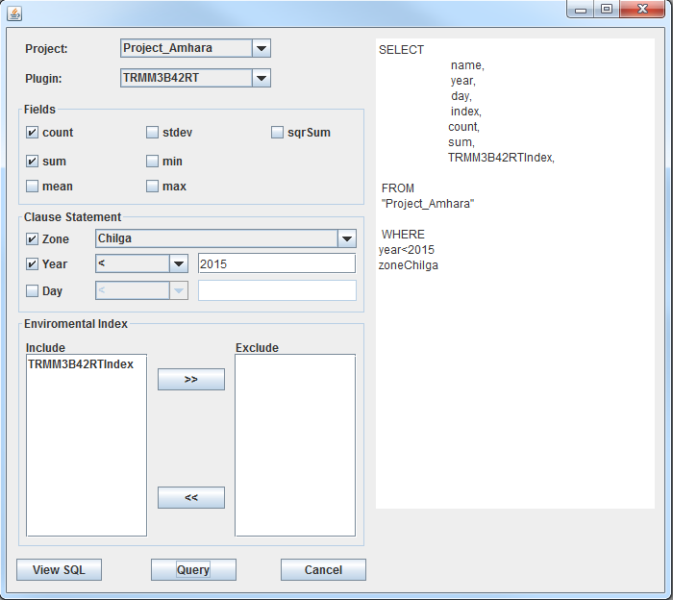

Figure 18. View SQL

Step 3: Enter the file path for where to write the csv file to then click “OK”.

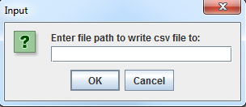

Figure 19. csv file path

# Troubleshooting

* At times it can take several minutes for EASTWeb V2.0 to close, a project to stop, or to see progress update for the Processor step.
* The Modis product’s servers have been known to be down from time to time more so than the others. When needing to download Modis data be sure to check for any new error logs.
* When starting a project with Modis product(s) the startup of the project will take noticeably longer than for other plugin products.