The location od EASTWeb V2 on Rosa.

1. Use “Remote desktop connection” to Rosa.
2. Go to Disk C and find “eastweb_v2” (as shown in Figue 0_1)

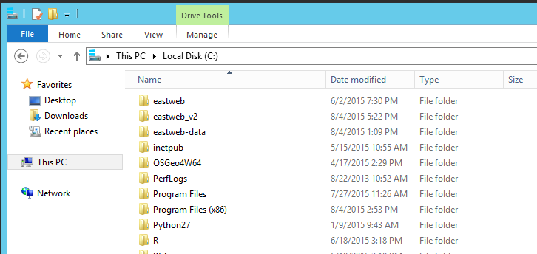

Figure 0_1. Location of EASTWeb_v2

1. Open the eastweb_v2 folder, scroll down and find the batch file “Run EASTWeb” (as shown on Figure 0_2). Double click it and the Main window (as shown in Figure 1) will be prompted.

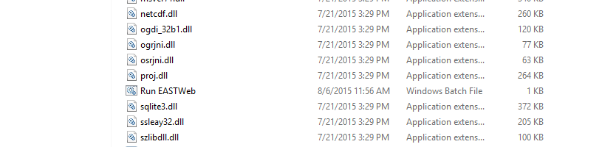

Figure 0_1. Run EASTWeb

1. **Create a new project**
2. Load the EASTWeb Main window

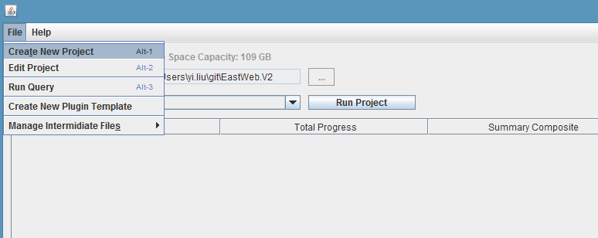

Figure 1. EASTWeb Main window

Select File -> Create New Project and a Project information window will be prompted

1. Project Information window
   1. Adding plugins

*Step 1. Load the Plugin Information Window*

Click the “+” button on the top left corner of the Project information window (Figure 2)

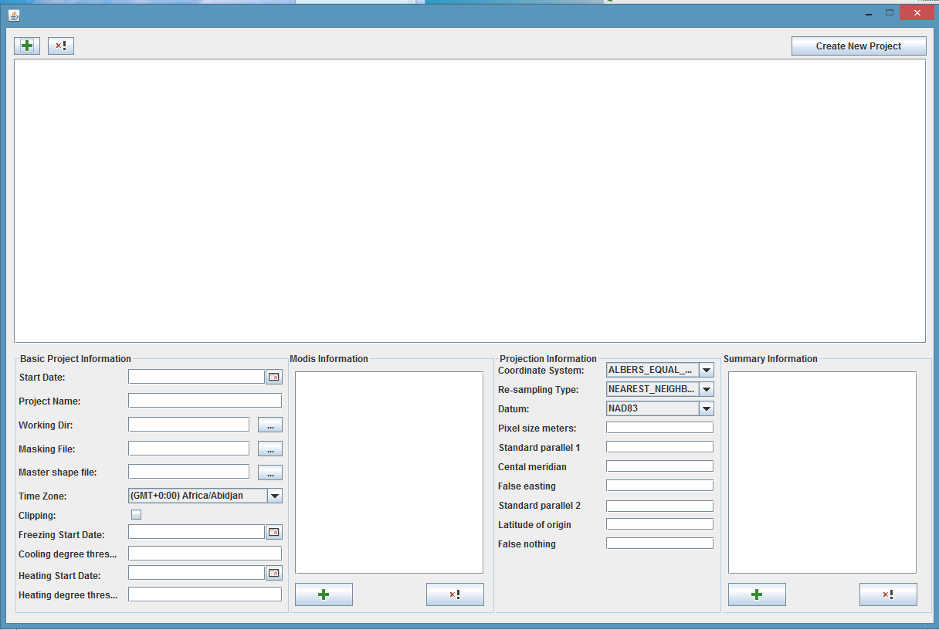

Step 1

Figure 2. Project Information window

A plugin information window (Figure 3) will be prompted.

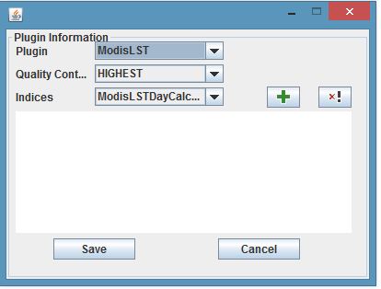

Step 4

Step 2

Step 3

Figure 3. Plugin Information window

*Step 2. select a plugin*

Use the “Plugin” dropdown box (highlighted in red in the Figure 3) to choose a plugin for a project.

*Step 3. choose quality control*

Use the “Quality control” dropdown box (highlighted in orange in the Figure 3) to choose the desired quality level.

*Step 4. Choose Indices*

Use the “Indices” dropdown box (highlighted in green in the Figure 3 ) to choose one index calculator, click the “+” button in green to add it in.

Repeat this step until all the desired indices are added in. Figure 4 shows ModisLST plugin with three indices selected.

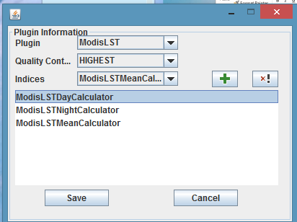

Step 5

Figure 4. ModisLST plugin with three indices selected

To remove an index, highlight the index and click the “x!” button.

*Step 5. Save the Plugin information*

Click “Save” button (highlighted in red in Figure 4).

The Plugin Information will be shown in the Project Information window (Figure 5).

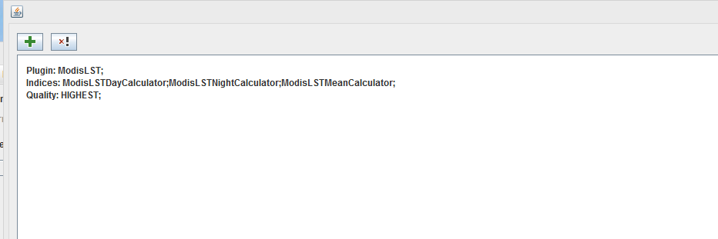

Figure 5. Project Information window after a plugin is added in

*Repeat step 1 through step 5 to add more plugins to the project.*

To remove a plugin, in the Project Information window, highlight the plugin and click “x!” button (highlighted in grey in Figure 5).

* 1. Input Basic Project Information

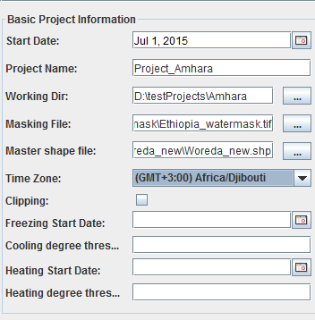

Figure 6. Basic Project Information section in the Project Information Window

Add all the needed information about the project. The sample information of a project is shown in Figure 6.

* 1. Input MODIS tiles if MODIS products are used

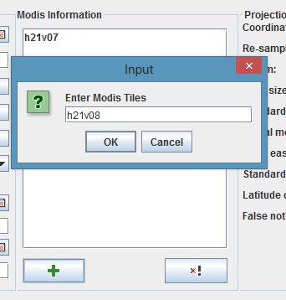

Step 2

Step 1

Figure 7. MODIS Information section in the Project Information Window

To add MODIS tiles, please follow the three steps illustrated below:

*Step 1*: Click the “+” (highlighted in red) in the MODIS Information section shown in Figure 7.

*Step 2*: Enter a tile in the prompted dialog window. The valid format for a tile is *h* followed by two digits and *v* following by two digits. Click “OK” button to add the tile.

*Step 3*: Repeat step 1 and step 2 until all the desired tiles are added.

* 1. Input Projection Information

Enter desired information in the Projection Information section as shown in Figure 8.

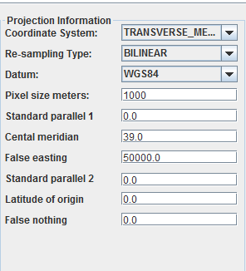

Figure 8. Projection Information section in the Project Information Window

* 1. Summary Information

To add summary units, please follow the three steps listed below:

*Step 1*. Click the “+” button in the Summary information section in the Project Information Window.

*Step 2:* Select the shapefile, field name and temporal summary in the prompted window (shown in Figure 10)and click the “Save” button.

*Step 3:* Repeat step 1 and step 2 until the desired summary units are all added. Figure 11 shows the display of the summary units in the Summary Information section.

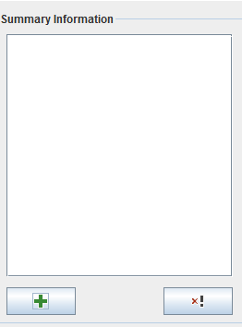 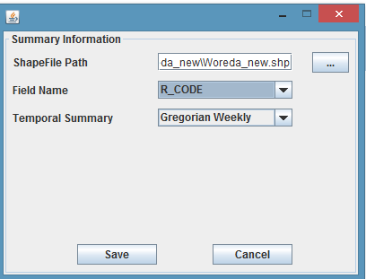

Step 2

Step 1

Figure 9. Summary Information section Figure 10. Prompt window for summary units

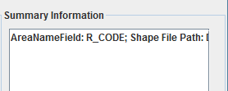

Figure 11. A summary unit is added.

* 1. Create the new project

Click the “Create New Project” button on the right corner of the Project Information window. After a message “Project was saved!” prompted and the “ok” button is clicked, the Main window will be brought back.

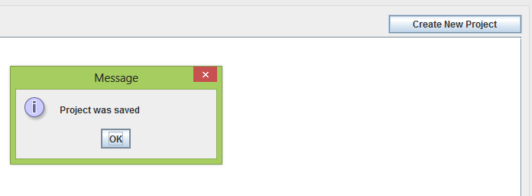

Figure 12. “Create New Project” button on the Project Information window

1. **Run Projects**

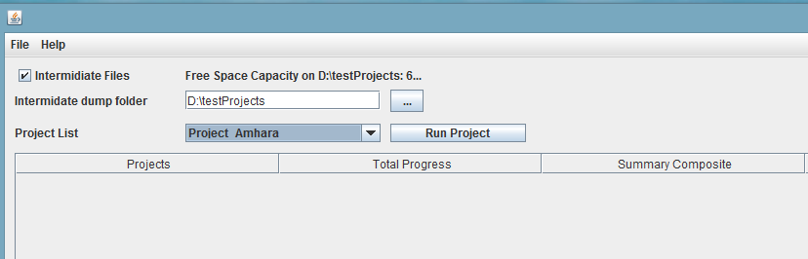

Figure 13. Main window

The created projects are listed in the “Project List”. Check the “Intermediate Files” to save the files produced during the processing and choose a location to store the intermediate files.

Select the project in the “Project List” and then click the “Run Project” button.

Figure 14 shows the status of a running project.

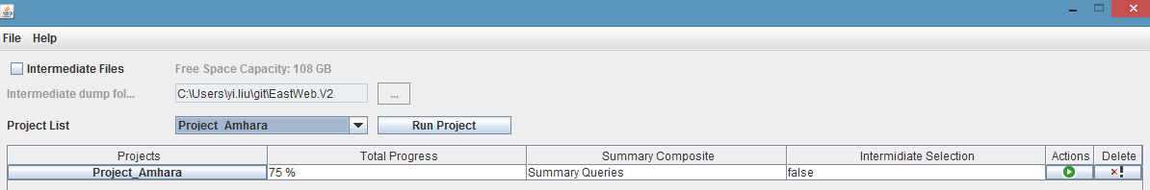

Figure 14. Project processing status

1. **Query Database**

To query the summary in the database, select File - > Run query in the Main window. The query UI will be prompted as shown in Figure 15.

Step 1: Select the project in the dropdown menu, then fill in the query criteria. A sample is shown in Figure 16.

Step 2: click “Query” button.

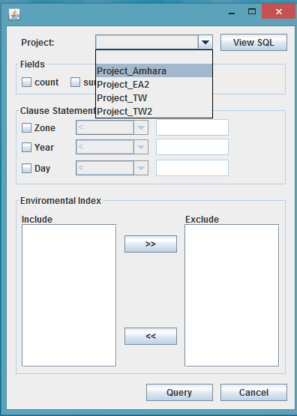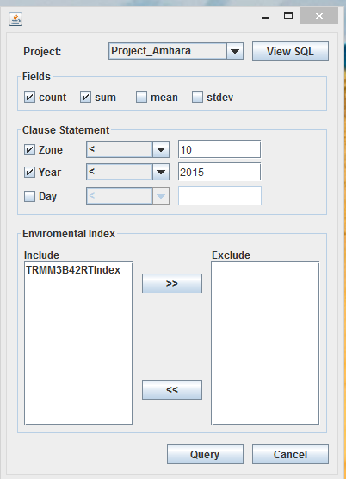

Figure 15. Query window Figure 16. Filled query