1. **Create a new project**
2. Load the EASTWeb Main window

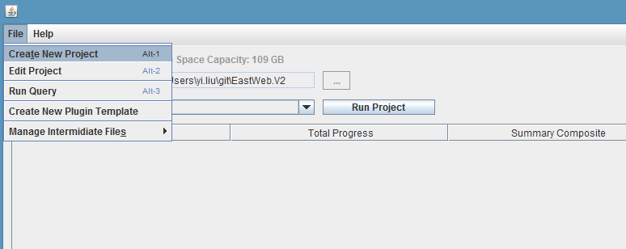

Figure 1. EASTWeb Main window

Select File -> Create New Project and a Project information window will be prompted

1. Project Information window
   1. Adding plugins

*Step 1. Load the Plugin Information Window*

Click the “+” button on the top left corner of the Project information window (Figure 2)

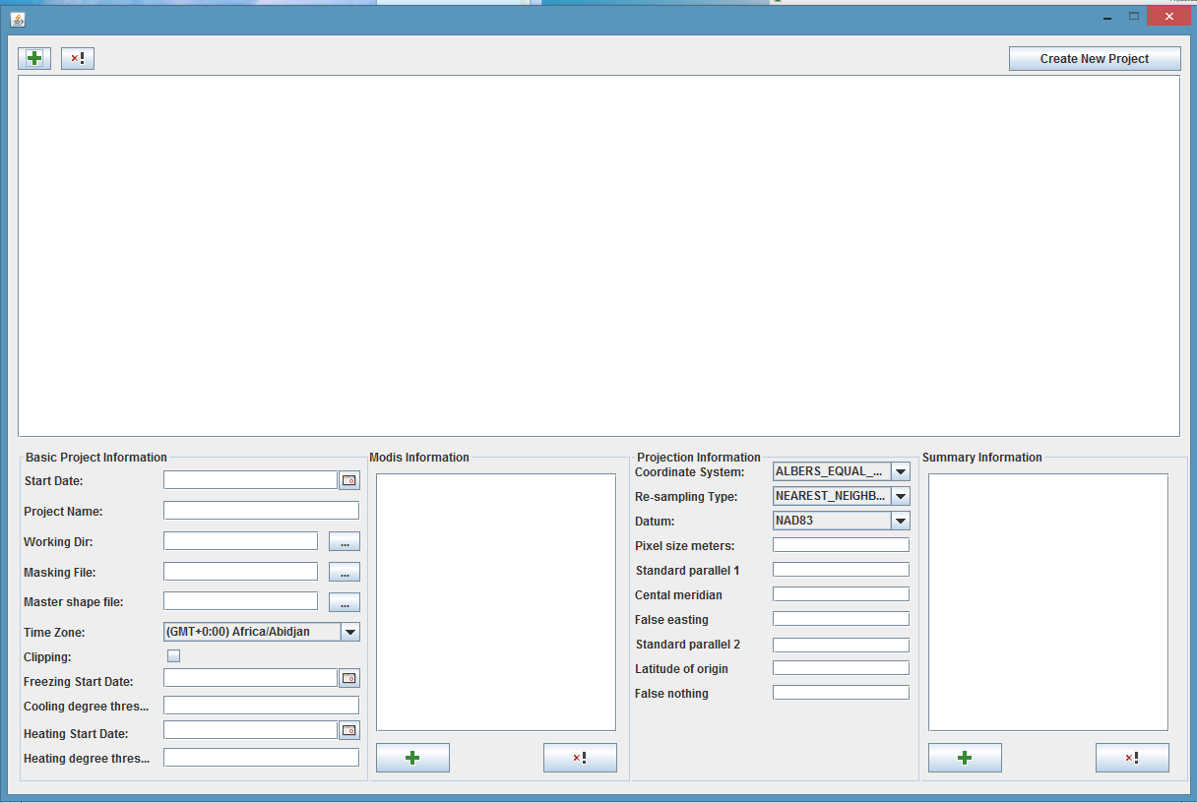

Step 1

Figure 2. Project Information window

A plugin information window (Figure 3) will be prompted.

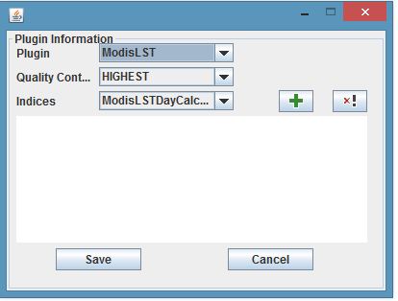

Step 4

Step 2

Step 3

Figure 3. Plugin Information window

*Step 2. select a plugin*

Use the “Plugin” dropdown box (highlighted in red in the Figure 3) to choose a plugin for a project.

*Step 3. choose quality control*

Use the “Quality control” dropdown box (highlighted in orange in the Figure 3) to choose the desired quality level.

*Step 4. Choose Indices*

Use the “Indices” dropdown box (highlighted in green in the Figure 3 ) to choose one index calculator, click the “+” button in green to add it in.

Repeat this step until all the desired indices are added in. Figure 4 shows ModisLST plugin with three indices selected.

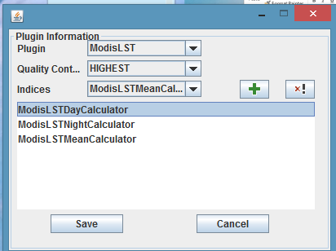

Step 5

Figure 4. ModisLST plugin with three indices selected

To remove an index, highlight the index and click the “x!” button.

*Step 5. Save the Plugin information*

Click “Save” button (highlighted in red in Figure 4).

The Plugin Information will be shown in the Project Information window (Figure 5).

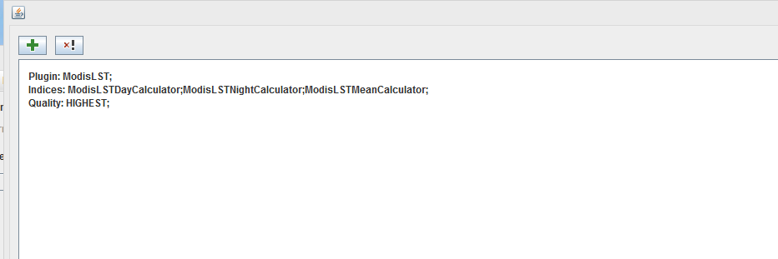

Figure 5. Project Information window after a plugin is added in

*Repeat step 1 through step 5 to add more plugins to the project.*

To remove a plugin, in the Project Information window, highlight the plugin and click “x!” button (highlighted in grey in Figure 5).

* 1. Input Basic Project Information

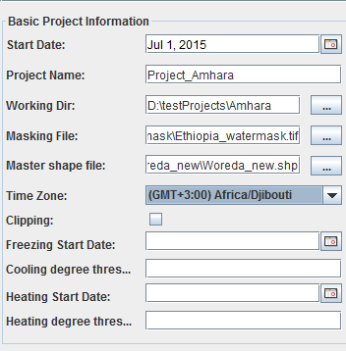

Figure 6. Basic Project Information section in the Project Information Window

Add all the needed information about the project. The sample information of a project is shown in Figure 6.

* 1. Input MODIS tiles if MODIS products are used

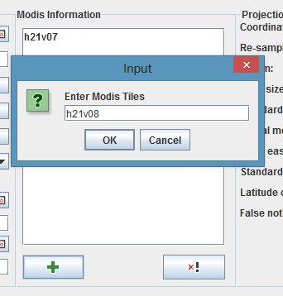

Step 2

Step 1

Figure 7. MODIS Information section in the Project Information Window

To add MODIS tiles, please follow the three steps illustrated below:

*Step 1*: Click the “+” (highlighted in red) in the MODIS Information section shown in Figure 7.

*Step 2*: Enter a tile in the prompted dialog window. The valid format for a tile is *h* followed by two digits and *v* following by two digits. Click “OK” button to add the tile.

*Step 3*: Repeat step 1 and step 2 until all the desired tiles are added.

* 1. Input Projection Information

Enter desired information in the Projection Information section as shown in Figure 8.

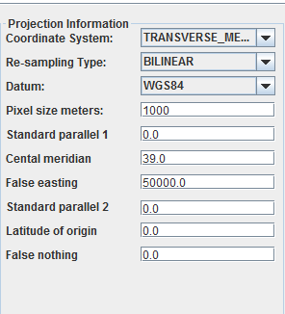

Figure 8. Projection Information section in the Project Information Window

* 1. Summary Information

To add summary units, please follow the three steps listed below:

*Step 1*. Click the “+” button in the Summary information section in the Project Information Window.

*Step 2:* Select the shapefile, field name and temporal summary in the prompted window (shown in Figure 10)and click the “Save” button.

*Step 3:* Repeat step 1 and step 2 until the desired summary units are all added. Figure 11 shows the display of the summary units in the Summary Information section.

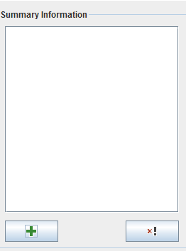 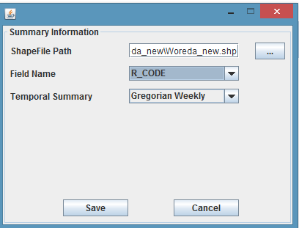

Step 2

Step 1

Figure 9. Summary Information section Figure 10. Prompt window for summary units

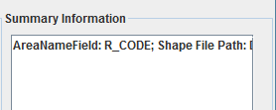

Figure 11. A summary unit is added.

* 1. Create the new project

Click the “Create New Project” button on the right corner of the Project Information window.

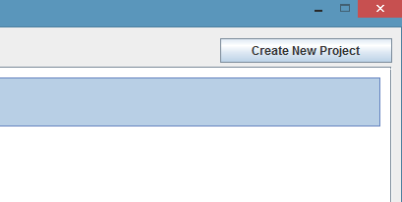

Figure 12. “Create New Project” button on the Project Information window

1. **Run Projects**