**Stellar Account Steps**

**Create New Account**

**Step1: Enter “N/n” to create new account.**

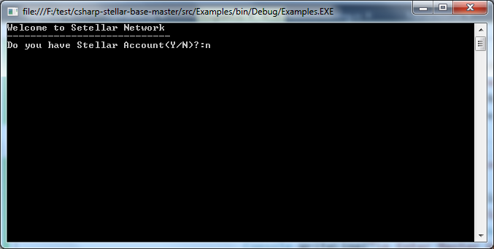

**Step2: Created Account Details**

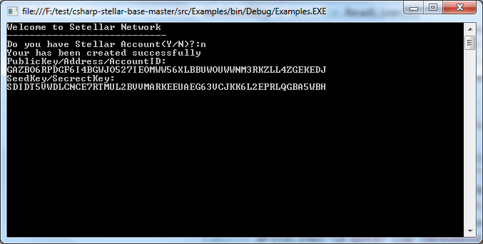

**Step3: Enter “Y/y” to do some operations.**

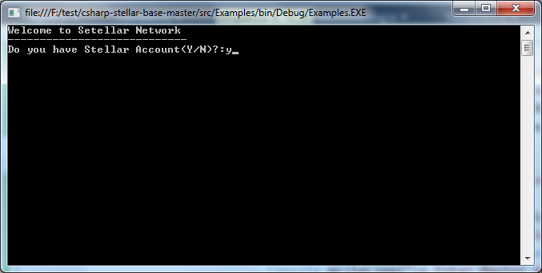

**Step4: Enter your SeedKey/Secret Key**

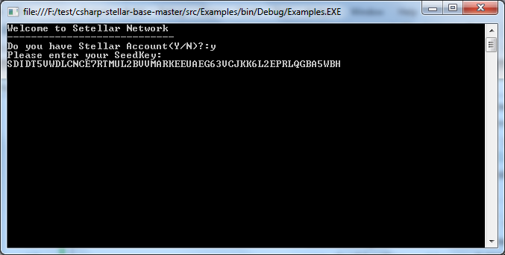

**Step5: Enter “Option 1” to Load Balance**

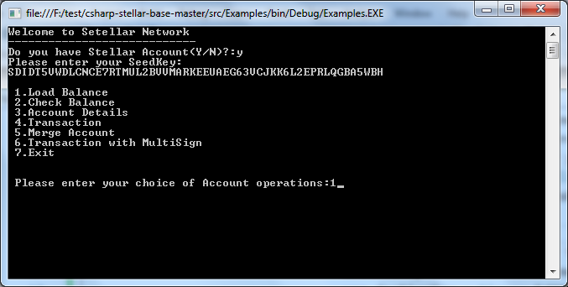

**Step6: Enter “Option 2” to Check Balance**

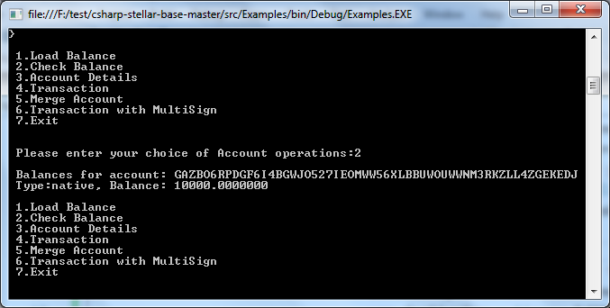

**Step7: Enter “Option 3” to Check Account Details**

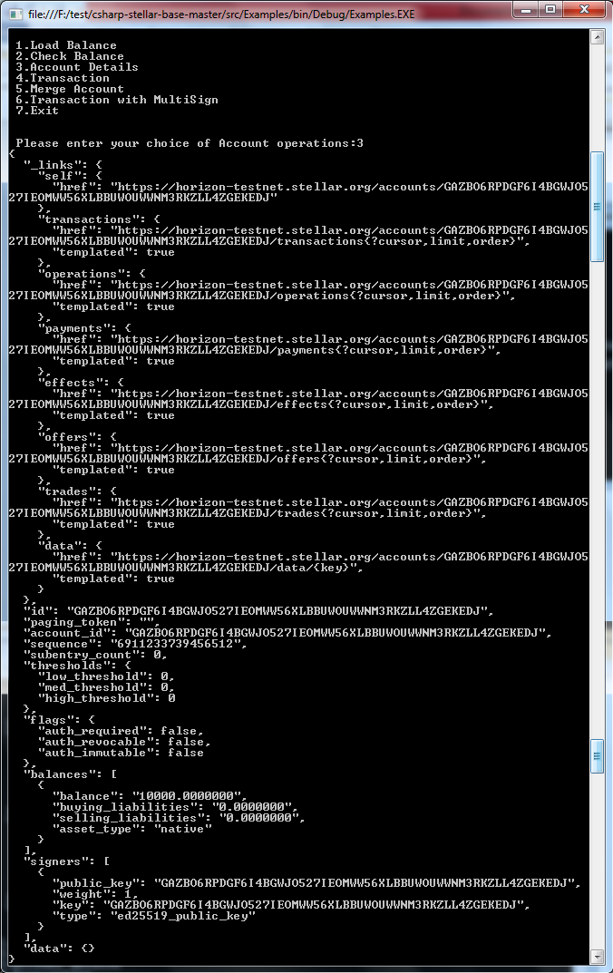

**Step8: Similar way to Repeat Step 1 to 7 to create another new account.**

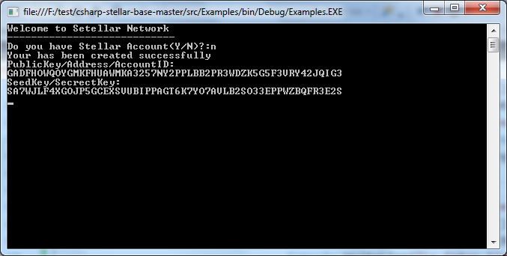

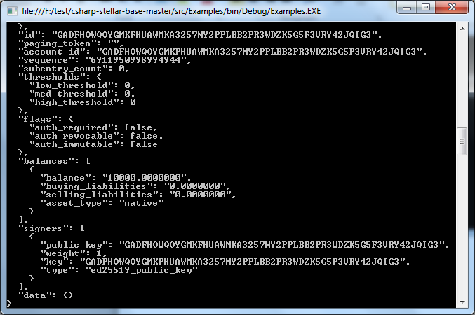

**Simple Transaction**

**Step 9: Enter “Option 4” to make simple transaction and destination seed address & amount.**

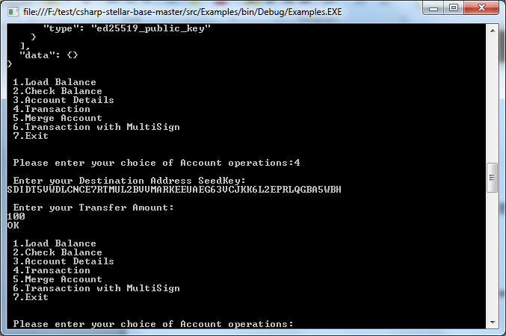

**Step 10: Check Account Balance**

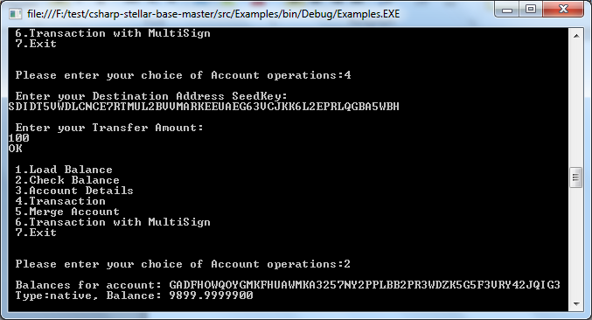

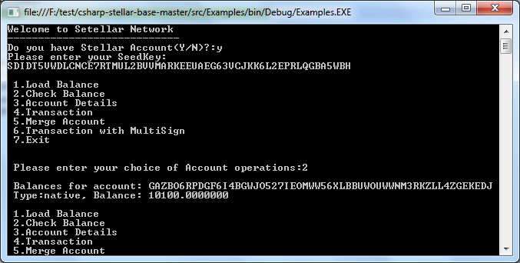

**Step11: Similar way to Repeat Step 1 to 7 to Create Another new account.**

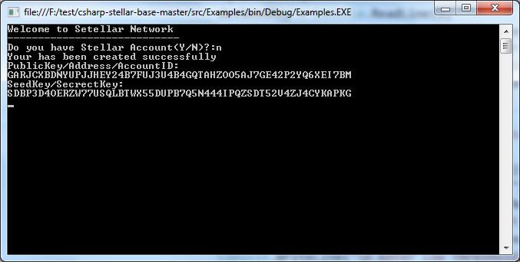

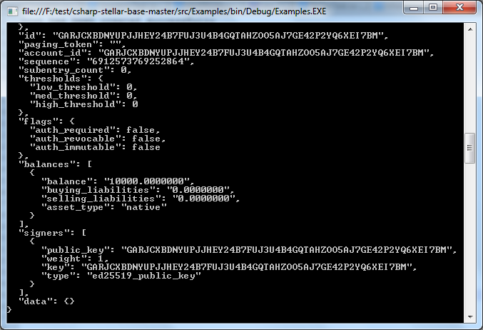

**Merge Account**

**Step12: Enter “Option 5” to Merge Stellar Account**

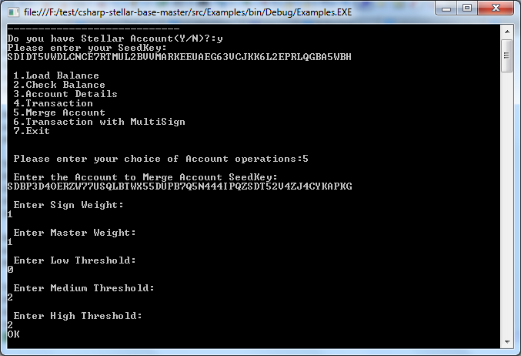

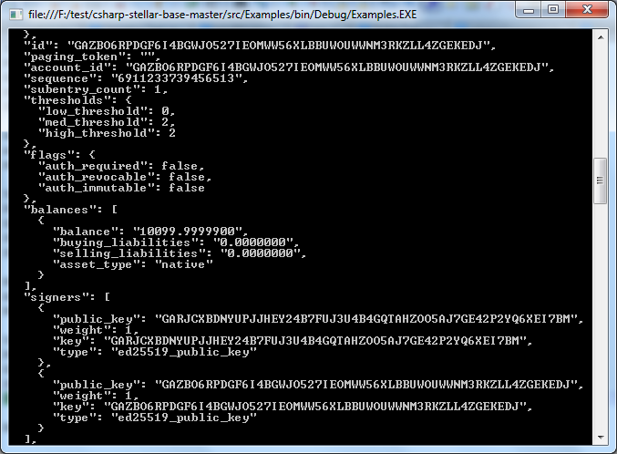

**Multi-Sign Transfer**

**Step 13: Enter “Option 6” to Make Amount Transaction using Multi-Sign**

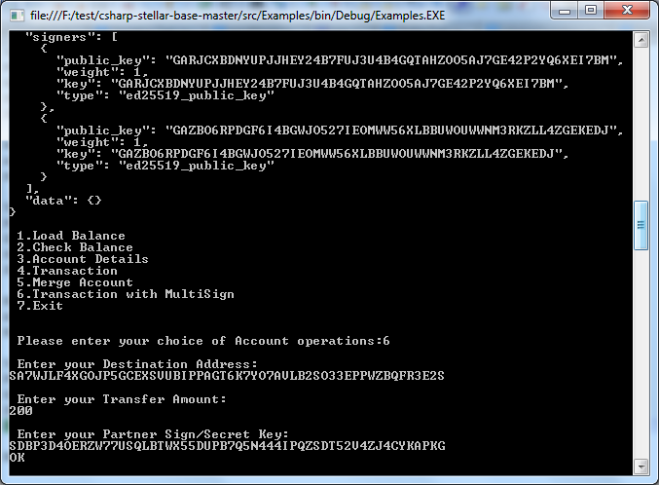

**Step 14: Check the new updated balance**

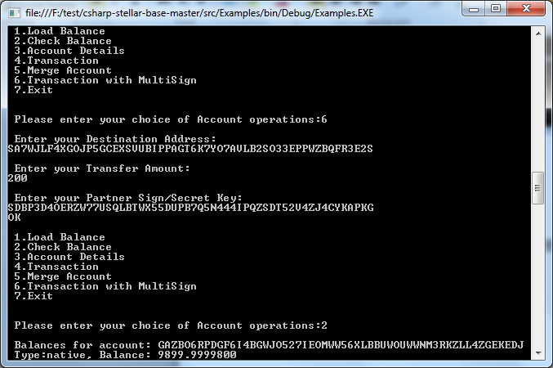

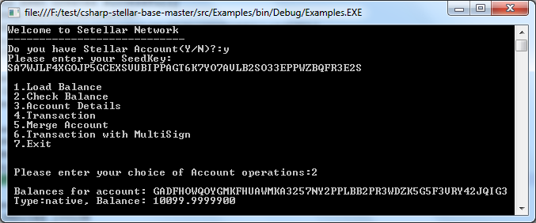

**Final Account Details**

**Account1**

**Your has been created successfully**

**PublicKey/Address/AccountID:**

**GAZBO6RPDGF6I4BGWJO527IEOMWW56XLBBUWOUWWNM3RKZLL4ZGEKEDJ**

**SeedKey/SecrectKey:**

**SDIDT5VWDLCNCE7RTMUL2BVVMARKEEUAEG63VCJKK6L2EPRLQGBA5WBH**

**Balance: 10000.0000000**

**After Credited 100LUM**

**Balance: 10100.0000000**

**After Debited 200LUM**

**Balance: 9899.9999800**

**Account2**

**Your has been created successfully**

**PublicKey/Address/AccountID:**

**GADFHOWQOYGMKFHUAWMKA3257NY2PPLBB2PR3WDZK5G5F3VRY42JQIG3**

**SeedKey/SecrectKey:**

**SA7WJLF4XGOJP5GCEXSVUBIPPAGT6K7YO7AVLB2SO33EPPWZBQFR3E2S**

**Balance: 10000.0000000**

**After Debited 100LUM**

**Balance: 9899.9999900**

**After Debited 200LUM**

**Balance: 10099.9999900**

**Account3**

**Your has been created successfully**

**PublicKey/Address/AccountID:**

**GARJCXBDNYUPJJHEY24B7FUJ3U4B4GQTAHZOO5AJ7GE42P2YQ6XEI7BM**

**SeedKey/SecrectKey:**

**SDBP3D4OERZW77USQLBTWX55DUPB7Q5N444IPQZSDT52V4ZJ4CYKAPKG**

**Balance: 10000.0000000**