1. sakdgsakd
2. asgdksagd
3. The plot showing the airy disk for all combinations of and NA is shown below:

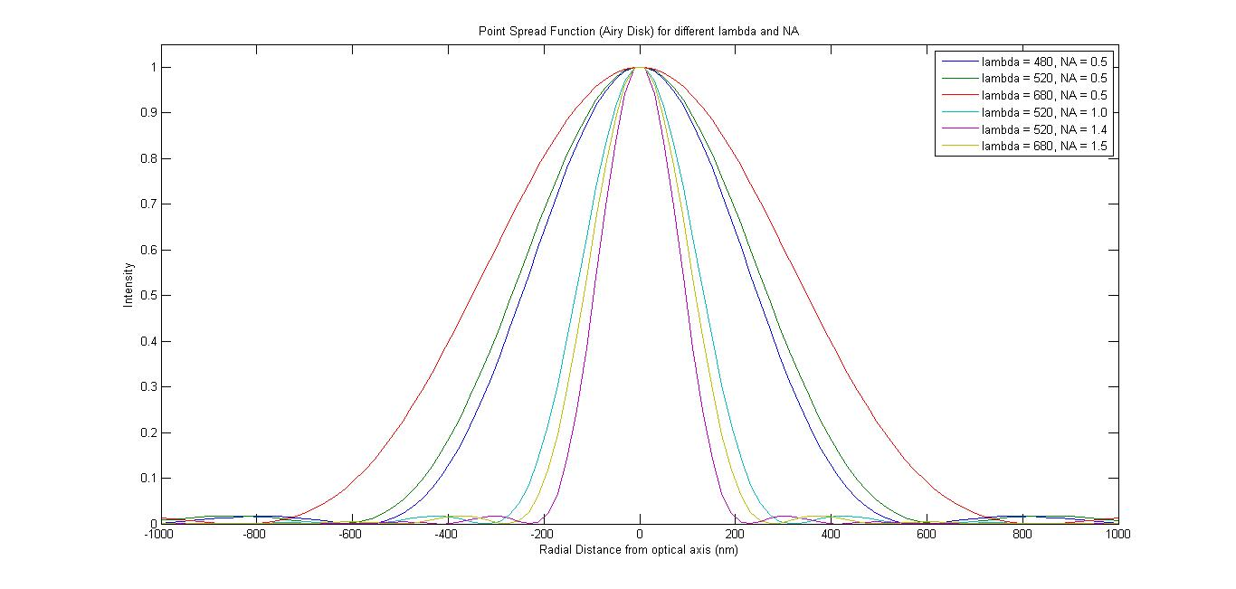

Table showing variation of airy disk radius, standard deviation of fitted Gaussians:

|  |  |  |  |
| --- | --- | --- | --- |
| (nm) | NA | Visual radius (nm) | Gaussian (nm) |
| 480 | 0.5 |  |  |
| 520 | 0.5 |  |  |
| 680 | 0.5 |  |  |
| 520 | 1.0 |  |  |
| 520 | 1.4 |  |  |
| 680 | 1.5 |  |  |

sbadksgaldas