ccwo <- read.csv("C:/Users/nando/workspaces/ufal/masters_experiment_analysis/datasetatoms.csv")  
ccwo$Minutes[ccwo$Minutes < 0] <- NA

md.pattern(ccwo)

## /\ /\  
## { `---' }  
## { O O }  
## ==> V <== No need for mice. This data set is completely observed.  
## \ \|/ /  
## `-----'

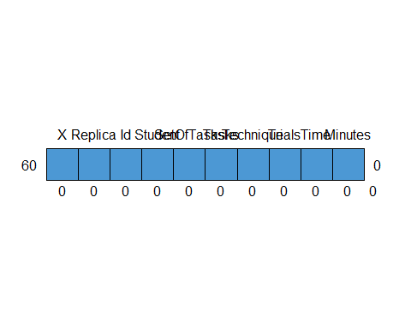

## X Replica Id Student SetOfTasks Tasks Technique Trials Time Minutes   
## 60 1 1 1 1 1 1 1 1 1 1 0  
## 0 0 0 0 0 0 0 0 0 0 0

##   
## iter imp variable  
## 1 1  
## 1 2  
## 1 3  
## 1 4  
## 1 5  
## 2 1  
## 2 2  
## 2 3  
## 2 4  
## 2 5  
## 3 1  
## 3 2  
## 3 3  
## 3 4  
## 3 5  
## 4 1  
## 4 2  
## 4 3  
## 4 4  
## 4 5  
## 5 1  
## 5 2  
## 5 3  
## 5 4  
## 5 5  
## 6 1  
## 6 2  
## 6 3  
## 6 4  
## 6 5  
## 7 1  
## 7 2  
## 7 3  
## 7 4  
## 7 5  
## 8 1  
## 8 2  
## 8 3  
## 8 4  
## 8 5  
## 9 1  
## 9 2  
## 9 3  
## 9 4  
## 9 5  
## 10 1  
## 10 2  
## 10 3  
## 10 4  
## 10 5  
## 11 1  
## 11 2  
## 11 3  
## 11 4  
## 11 5  
## 12 1  
## 12 2  
## 12 3  
## 12 4  
## 12 5  
## 13 1  
## 13 2  
## 13 3  
## 13 4  
## 13 5  
## 14 1  
## 14 2  
## 14 3  
## 14 4  
## 14 5  
## 15 1  
## 15 2  
## 15 3  
## 15 4  
## 15 5  
## 16 1  
## 16 2  
## 16 3  
## 16 4  
## 16 5  
## 17 1  
## 17 2  
## 17 3  
## 17 4  
## 17 5  
## 18 1  
## 18 2  
## 18 3  
## 18 4  
## 18 5  
## 19 1  
## 19 2  
## 19 3  
## 19 4  
## 19 5  
## 20 1  
## 20 2  
## 20 3  
## 20 4  
## 20 5  
## 21 1  
## 21 2  
## 21 3  
## 21 4  
## 21 5  
## 22 1  
## 22 2  
## 22 3  
## 22 4  
## 22 5  
## 23 1  
## 23 2  
## 23 3  
## 23 4  
## 23 5  
## 24 1  
## 24 2  
## 24 3  
## 24 4  
## 24 5  
## 25 1  
## 25 2  
## 25 3  
## 25 4  
## 25 5  
## 26 1  
## 26 2  
## 26 3  
## 26 4  
## 26 5  
## 27 1  
## 27 2  
## 27 3  
## 27 4  
## 27 5  
## 28 1  
## 28 2  
## 28 3  
## 28 4  
## 28 5  
## 29 1  
## 29 2  
## 29 3  
## 29 4  
## 29 5  
## 30 1  
## 30 2  
## 30 3  
## 30 4  
## 30 5  
## 31 1  
## 31 2  
## 31 3  
## 31 4  
## 31 5  
## 32 1  
## 32 2  
## 32 3  
## 32 4  
## 32 5  
## 33 1  
## 33 2  
## 33 3  
## 33 4  
## 33 5  
## 34 1  
## 34 2  
## 34 3  
## 34 4  
## 34 5  
## 35 1  
## 35 2  
## 35 3  
## 35 4  
## 35 5  
## 36 1  
## 36 2  
## 36 3  
## 36 4  
## 36 5  
## 37 1  
## 37 2  
## 37 3  
## 37 4  
## 37 5  
## 38 1  
## 38 2  
## 38 3  
## 38 4  
## 38 5  
## 39 1  
## 39 2  
## 39 3  
## 39 4  
## 39 5  
## 40 1  
## 40 2  
## 40 3  
## 40 4  
## 40 5  
## 41 1  
## 41 2  
## 41 3  
## 41 4  
## 41 5  
## 42 1  
## 42 2  
## 42 3  
## 42 4  
## 42 5  
## 43 1  
## 43 2  
## 43 3  
## 43 4  
## 43 5  
## 44 1  
## 44 2  
## 44 3  
## 44 4  
## 44 5  
## 45 1  
## 45 2  
## 45 3  
## 45 4  
## 45 5  
## 46 1  
## 46 2  
## 46 3  
## 46 4  
## 46 5  
## 47 1  
## 47 2  
## 47 3  
## 47 4  
## 47 5  
## 48 1  
## 48 2  
## 48 3  
## 48 4  
## 48 5  
## 49 1  
## 49 2  
## 49 3  
## 49 4  
## 49 5  
## 50 1  
## 50 2  
## 50 3  
## 50 4  
## 50 5

## Warning: Number of logged events: 1

## Replica Id SetOfTasks Technique Trials Time  
## 1 41 1 ST1 Without Atom 7 13  
## 2 41 1 ST2 With Atom 3 16  
## 3 41 2 ST1 With Atom 5 21  
## 4 41 2 ST2 Without Atom 3 15  
## 5 42 1 ST1 Without Atom 5 14  
## 6 42 1 ST2 With Atom 12 39  
## 7 42 2 ST1 With Atom 7 16  
## 8 42 2 ST2 Without Atom 12 22  
## 9 43 1 ST1 Without Atom 5 18  
## 10 43 1 ST2 With Atom 9 53  
## 11 43 2 ST1 With Atom 9 21  
## 12 43 2 ST2 Without Atom 5 15  
## 13 44 1 ST1 Without Atom 4 9  
## 14 44 1 ST2 With Atom 4 24  
## 15 44 2 ST1 With Atom 6 17  
## 16 44 2 ST2 Without Atom 6 23  
## 17 45 1 ST1 With Atom 9 25  
## 18 45 1 ST2 Without Atom 7 28  
## 19 45 2 ST1 Without Atom 5 7  
## 20 45 2 ST2 With Atom 8 18  
## 21 46 1 ST1 With Atom 7 32  
## 22 46 1 ST2 Without Atom 9 32  
## 23 46 2 ST1 Without Atom 4 10  
## 24 46 2 ST2 With Atom 12 31  
## 25 47 1 ST1 Without Atom 4 18  
## 26 47 1 ST2 With Atom 5 53  
## 27 47 2 ST1 With Atom 5 21  
## 28 47 2 ST2 Without Atom 4 24  
## 29 48 1 ST1 With Atom 7 15  
## 30 48 1 ST2 Without Atom 3 12  
## 31 48 2 ST1 Without Atom 10 25  
## 32 48 2 ST2 With Atom 29 60  
## 33 49 1 ST1 Without Atom 8 33  
## 34 49 1 ST2 With Atom 10 23  
## 35 49 2 ST1 With Atom 6 9  
## 36 49 2 ST2 Without Atom 3 2  
## 37 50 1 ST1 With Atom 8 21  
## 38 50 1 ST2 Without Atom 5 19  
## 39 50 2 ST1 Without Atom 7 19  
## 40 50 2 ST2 With Atom 10 29  
## 41 51 1 ST1 Without Atom 5 22  
## 42 51 1 ST2 With Atom 6 24  
## 43 51 2 ST1 With Atom 6 9  
## 44 51 2 ST2 Without Atom 5 15  
## 45 52 1 ST1 With Atom 9 23  
## 46 52 1 ST2 Without Atom 24 38  
## 47 52 2 ST1 Without Atom 7 16  
## 48 52 2 ST2 With Atom 14 52  
## 49 53 1 ST1 With Atom 5 11  
## 50 53 1 ST2 Without Atom 4 8  
## 51 53 2 ST1 Without Atom 5 9  
## 52 53 2 ST2 With Atom 15 31  
## 53 54 1 ST1 Without Atom 4 27  
## 54 54 1 ST2 With Atom 7 34  
## 55 54 2 ST1 With Atom 6 33  
## 56 54 2 ST2 Without Atom 3 26  
## 57 55 1 ST1 With Atom 5 23  
## 58 55 1 ST2 Without Atom 4 19  
## 59 55 2 ST1 Without Atom 5 10  
## 60 55 2 ST2 With Atom 19 46

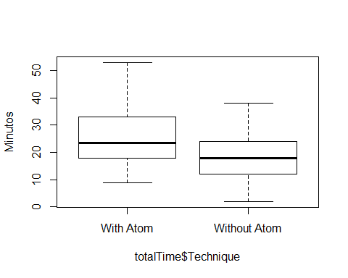

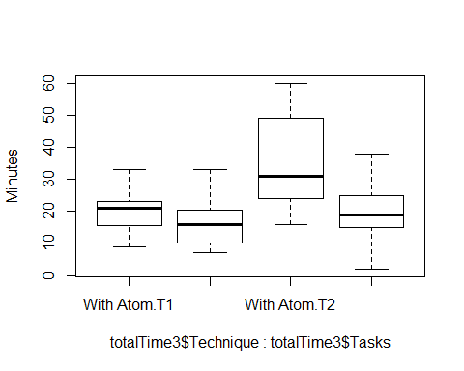

## Replica Tasks Technique Trials Time  
## 1 41 T1 With Atom 5 21  
## 2 41 T1 Without Atom 7 13  
## 3 41 T2 With Atom 3 16  
## 4 41 T2 Without Atom 3 15  
## 5 42 T1 With Atom 7 16  
## 6 42 T1 Without Atom 5 14  
## 7 42 T2 With Atom 12 39  
## 8 42 T2 Without Atom 12 22  
## 9 43 T1 With Atom 9 21  
## 10 43 T1 Without Atom 5 18  
## 11 43 T2 With Atom 9 53  
## 12 43 T2 Without Atom 5 15  
## 13 44 T1 With Atom 6 17  
## 14 44 T1 Without Atom 4 9  
## 15 44 T2 With Atom 4 24  
## 16 44 T2 Without Atom 6 23  
## 17 45 T1 With Atom 9 25  
## 18 45 T1 Without Atom 5 7  
## 19 45 T2 With Atom 8 18  
## 20 45 T2 Without Atom 7 28  
## 21 46 T1 With Atom 7 32  
## 22 46 T1 Without Atom 4 10  
## 23 46 T2 With Atom 12 31  
## 24 46 T2 Without Atom 9 32  
## 25 47 T1 With Atom 5 21  
## 26 47 T1 Without Atom 4 18  
## 27 47 T2 With Atom 5 53  
## 28 47 T2 Without Atom 4 24  
## 29 48 T1 With Atom 7 15  
## 30 48 T1 Without Atom 10 25  
## 31 48 T2 With Atom 29 60  
## 32 48 T2 Without Atom 3 12  
## 33 49 T1 With Atom 6 9  
## 34 49 T1 Without Atom 8 33  
## 35 49 T2 With Atom 10 23  
## 36 49 T2 Without Atom 3 2  
## 37 50 T1 With Atom 8 21  
## 38 50 T1 Without Atom 7 19  
## 39 50 T2 With Atom 10 29  
## 40 50 T2 Without Atom 5 19  
## 41 51 T1 With Atom 6 9  
## 42 51 T1 Without Atom 5 22  
## 43 51 T2 With Atom 6 24  
## 44 51 T2 Without Atom 5 15  
## 45 52 T1 With Atom 9 23  
## 46 52 T1 Without Atom 7 16  
## 47 52 T2 With Atom 14 52  
## 48 52 T2 Without Atom 24 38  
## 49 53 T1 With Atom 5 11  
## 50 53 T1 Without Atom 5 9  
## 51 53 T2 With Atom 15 31  
## 52 53 T2 Without Atom 4 8  
## 53 54 T1 With Atom 6 33  
## 54 54 T1 Without Atom 4 27  
## 55 54 T2 With Atom 7 34  
## 56 54 T2 Without Atom 3 26  
## 57 55 T1 With Atom 5 23  
## 58 55 T1 Without Atom 5 10  
## 59 55 T2 With Atom 19 46  
## 60 55 T2 Without Atom 4 19

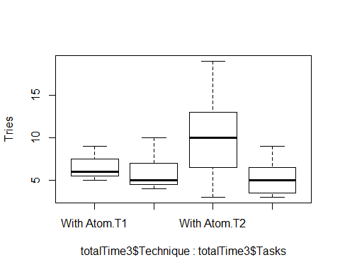

## X Replica Id Student SetOfTasks Tasks  
## 1 1 41 1 paulo ST1 AV1.2:CO1.2:DE1.2  
## 2 1 41 1 paulo ST2 AV2.1:CO2.1:DE2.1  
## 3 1 41 2 RomÃ¡rio ST1 AV1.1:CO1.1:DE1.1  
## 4 1 41 2 RomÃ¡rio ST2 AV2.2:CO2.2:DE2.2  
## 5 2 42 1 Igor ST1 AV1.2:CO1.2:DE1.2  
## 6 2 42 1 Igor ST2 AV2.1:CO2.1:DE2.1  
## 7 2 42 2 Hyago ST1 AV1.1:CO1.1:DE1.1  
## 8 2 42 2 Hyago ST2 AV2.2:CO2.2:DE2.2  
## 9 3 43 1 ST1 AV1.2:CO1.2:DE1.2  
## 10 3 43 1 ST2 AV2.1:CO2.1:DE2.1  
## 11 3 43 2 ST1 AV1.1:CO1.1:DE1.1  
## 12 3 43 2 ST2 AV2.2:CO2.2:DE2.2  
## 13 4 44 1 ST1 AV1.2:CO1.2:DE1.2  
## 14 4 44 1 ST2 AV2.1:CO2.1:DE2.1  
## 15 4 44 2 ST1 AV1.1:CO1.1:DE1.1  
## 16 4 44 2 ST2 AV2.2:CO2.2:DE2.2  
## 17 5 45 1 Matheus Costa ST1 AV1.1:CO1.1:DE1.1  
## 18 5 45 1 Matheus Costa ST2 AV2.2:CO2.2:DE2.2  
## 19 5 45 2 Davi Jose ST1 AV1.2:CO1.2:DE1.2  
## 20 5 45 2 Davi Jose ST2 AV2.1:CO2.1:DE2.1  
## 21 6 46 1 Marlon LÃºcio ST1 AV1.1:CO1.1:DE1.1  
## 22 6 46 1 Marlon LÃºcio ST2 AV2.2:CO2.2:DE2.2  
## 23 6 46 2 Jackson Barbosa da Silva ST1 AV1.2:CO1.2:DE1.2  
## 24 6 46 2 Jackson Barbosa da Silva ST2 AV2.1:CO2.1:DE2.1  
## 25 7 47 1 Allan ST1 AV1.2:CO1.2:DE1.2  
## 26 7 47 1 Allan ST2 AV2.1:CO2.1:DE2.1  
## 27 7 47 2 Dielson Sales de Carvalho ST1 AV1.1:CO1.1:DE1.1  
## 28 7 47 2 Dielson Sales de Carvalho ST2 AV2.2:CO2.2:DE2.2  
## 29 8 48 1 Thiago ST1 AV1.1:CO1.1:DE1.1  
## 30 8 48 1 Thiago ST2 AV2.2:CO2.2:DE2.2  
## 31 8 48 2 ST1 AV1.2:CO1.2:DE1.2  
## 32 8 48 2 ST2 AV2.1:CO2.1:DE2.1  
## 33 9 49 1 Rodrigo Lima ST1 AV1.2:CO1.2:DE1.2  
## 34 9 49 1 Rodrigo Lima ST2 AV2.1:CO2.1:DE2.1  
## 35 9 49 2 Jardel Costa ST1 AV1.1:CO1.1:DE1.1  
## 36 9 49 2 Jardel Costa ST2 AV2.2:CO2.2:DE2.2  
## 37 10 50 1 Felipe Pontes ST1 AV1.1:CO1.1:DE1.1  
## 38 10 50 1 Felipe Pontes ST2 AV2.2:CO2.2:DE2.2  
## 39 10 50 2 Jairo Souza ST1 AV1.2:CO1.2:DE1.2  
## 40 10 50 2 Jairo Souza ST2 AV2.1:CO2.1:DE2.1  
## 41 11 51 1 julios ST1 AV1.2:CO1.2:DE1.2  
## 42 11 51 1 julios ST2 AV2.1:CO2.1:DE2.1  
## 43 11 51 2 Romero Malaquias ST1 AV1.1:CO1.1:DE1.1  
## 44 11 51 2 Romero Malaquias ST2 AV2.2:CO2.2:DE2.2  
## 45 12 53 1 Bruno Georgevich Ferreira ST1 AV1.1:CO1.1:DE1.1  
## 46 12 53 1 Bruno Georgevich Ferreira ST2 AV2.2:CO2.2:DE2.2  
## 47 12 53 2 jadson ST1 AV1.2:CO1.2:DE1.2  
## 48 12 53 2 jadson ST2 AV2.1:CO2.1:DE2.1  
## 49 13 55 1 ST1 AV1.1:CO1.1:DE1.1  
## 50 13 55 1 ST2 AV2.2:CO2.2:DE2.2  
## 51 13 55 2 Arthur ST1 AV1.2:CO1.2:DE1.2  
## 52 13 55 2 Arthur ST2 AV2.1:CO2.1:DE2.1  
## 53 14 52 1 ST1 AV1.1:CO1.1:DE1.1  
## 54 14 52 1 ST2 AV2.2:CO2.2:DE2.2  
## 55 14 52 2 vinicius lopes ST1 AV1.2:CO1.2:DE1.2  
## 56 14 52 2 vinicius lopes ST2 AV2.1:CO2.1:DE2.1  
## 57 15 54 1 Thiago Tenorio ST1 AV1.2:CO1.2:DE1.2  
## 58 15 54 1 Thiago Tenorio ST2 AV2.1:CO2.1:DE2.1  
## 59 15 54 2 Joao Victor Ribeiro Ferro ST1 AV1.1:CO1.1:DE1.1  
## 60 15 54 2 Joao Victor Ribeiro Ferro ST2 AV2.2:CO2.2:DE2.2  
## Technique Trials Time Minutes  
## 1 Without Atom 7 13 13  
## 2 With Atom 3 16 16  
## 3 With Atom 5 21 21  
## 4 Without Atom 3 15 15  
## 5 Without Atom 5 14 14  
## 6 With Atom 12 39 39  
## 7 With Atom 7 16 16  
## 8 Without Atom 12 22 22  
## 9 Without Atom 5 18 18  
## 10 With Atom 9 53 53  
## 11 With Atom 9 21 21  
## 12 Without Atom 5 15 15  
## 13 Without Atom 4 9 9  
## 14 With Atom 4 24 24  
## 15 With Atom 6 17 17  
## 16 Without Atom 6 23 23  
## 17 With Atom 9 25 25  
## 18 Without Atom 7 28 28  
## 19 Without Atom 5 7 7  
## 20 With Atom 8 18 18  
## 21 With Atom 7 32 32  
## 22 Without Atom 9 32 32  
## 23 Without Atom 4 10 10  
## 24 With Atom 12 31 31  
## 25 Without Atom 4 18 18  
## 26 With Atom 5 53 53  
## 27 With Atom 5 21 21  
## 28 Without Atom 4 24 24  
## 29 With Atom 7 15 15  
## 30 Without Atom 3 12 12  
## 31 Without Atom 10 25 25  
## 32 With Atom 29 60 60  
## 33 Without Atom 8 33 33  
## 34 With Atom 10 23 23  
## 35 With Atom 6 9 9  
## 36 Without Atom 3 2 2  
## 37 With Atom 8 21 21  
## 38 Without Atom 5 19 19  
## 39 Without Atom 7 19 19  
## 40 With Atom 10 29 29  
## 41 Without Atom 5 22 22  
## 42 With Atom 6 24 24  
## 43 With Atom 6 9 9  
## 44 Without Atom 5 15 15  
## 45 With Atom 5 11 11  
## 46 Without Atom 4 8 8  
## 47 Without Atom 5 9 9  
## 48 With Atom 15 31 31  
## 49 With Atom 5 23 23  
## 50 Without Atom 4 19 19  
## 51 Without Atom 5 10 10  
## 52 With Atom 19 46 46  
## 53 With Atom 9 23 23  
## 54 Without Atom 24 38 38  
## 55 Without Atom 7 16 16  
## 56 With Atom 14 52 52  
## 57 Without Atom 4 27 27  
## 58 With Atom 7 34 34  
## 59 With Atom 6 33 33  
## 60 Without Atom 3 26 26

## Replica Tasks Minutes Time  
## 1 41 AV1.2:CO1.2:DE1.2 13 13  
## 2 41 AV1.1:CO1.1:DE1.1 21 21  
## 3 42 AV1.2:CO1.2:DE1.2 14 14  
## 4 42 AV1.1:CO1.1:DE1.1 16 16  
## 5 43 AV1.2:CO1.2:DE1.2 18 18  
## 6 43 AV1.1:CO1.1:DE1.1 21 21  
## 7 44 AV1.2:CO1.2:DE1.2 9 9  
## 8 44 AV1.1:CO1.1:DE1.1 17 17  
## 9 45 AV1.1:CO1.1:DE1.1 25 25  
## 10 45 AV1.2:CO1.2:DE1.2 7 7  
## 11 46 AV1.1:CO1.1:DE1.1 32 32  
## 12 46 AV1.2:CO1.2:DE1.2 10 10  
## 13 47 AV1.2:CO1.2:DE1.2 18 18  
## 14 47 AV1.1:CO1.1:DE1.1 21 21  
## 15 48 AV1.1:CO1.1:DE1.1 15 15  
## 16 48 AV1.2:CO1.2:DE1.2 25 25  
## 17 49 AV1.2:CO1.2:DE1.2 33 33  
## 18 49 AV1.1:CO1.1:DE1.1 9 9  
## 19 50 AV1.1:CO1.1:DE1.1 21 21  
## 20 50 AV1.2:CO1.2:DE1.2 19 19  
## 21 51 AV1.2:CO1.2:DE1.2 22 22  
## 22 51 AV1.1:CO1.1:DE1.1 9 9  
## 23 53 AV1.1:CO1.1:DE1.1 11 11  
## 24 53 AV1.2:CO1.2:DE1.2 9 9  
## 25 55 AV1.1:CO1.1:DE1.1 23 23  
## 26 55 AV1.2:CO1.2:DE1.2 10 10  
## 27 52 AV1.1:CO1.1:DE1.1 23 23  
## 28 52 AV1.2:CO1.2:DE1.2 16 16  
## 29 54 AV1.2:CO1.2:DE1.2 27 27  
## 30 54 AV1.1:CO1.1:DE1.1 33 33

## Replica Tasks Minutes Time  
## 1 41 AV2.1:CO2.1:DE2.1 16 16  
## 2 41 AV2.2:CO2.2:DE2.2 15 15  
## 3 42 AV2.1:CO2.1:DE2.1 39 39  
## 4 42 AV2.2:CO2.2:DE2.2 22 22  
## 5 43 AV2.1:CO2.1:DE2.1 53 53  
## 6 43 AV2.2:CO2.2:DE2.2 15 15  
## 7 44 AV2.1:CO2.1:DE2.1 24 24  
## 8 44 AV2.2:CO2.2:DE2.2 23 23  
## 9 45 AV2.2:CO2.2:DE2.2 28 28  
## 10 45 AV2.1:CO2.1:DE2.1 18 18  
## 11 46 AV2.2:CO2.2:DE2.2 32 32  
## 12 46 AV2.1:CO2.1:DE2.1 31 31  
## 13 47 AV2.1:CO2.1:DE2.1 53 53  
## 14 47 AV2.2:CO2.2:DE2.2 24 24  
## 15 48 AV2.2:CO2.2:DE2.2 12 12  
## 16 48 AV2.1:CO2.1:DE2.1 60 60  
## 17 49 AV2.1:CO2.1:DE2.1 23 23  
## 18 49 AV2.2:CO2.2:DE2.2 2 2  
## 19 50 AV2.2:CO2.2:DE2.2 19 19  
## 20 50 AV2.1:CO2.1:DE2.1 29 29  
## 21 51 AV2.1:CO2.1:DE2.1 24 24  
## 22 51 AV2.2:CO2.2:DE2.2 15 15  
## 23 53 AV2.2:CO2.2:DE2.2 8 8  
## 24 53 AV2.1:CO2.1:DE2.1 31 31  
## 25 55 AV2.2:CO2.2:DE2.2 19 19  
## 26 55 AV2.1:CO2.1:DE2.1 46 46  
## 27 52 AV2.2:CO2.2:DE2.2 38 38  
## 28 52 AV2.1:CO2.1:DE2.1 52 52  
## 29 54 AV2.1:CO2.1:DE2.1 34 34  
## 30 54 AV2.2:CO2.2:DE2.2 26 26

## [1] 18.23333

## [1] 27.7

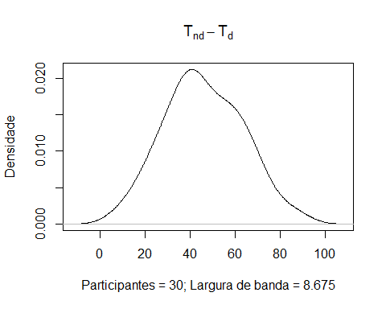

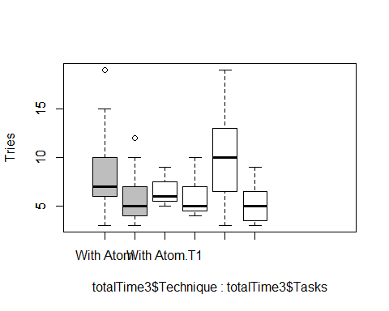

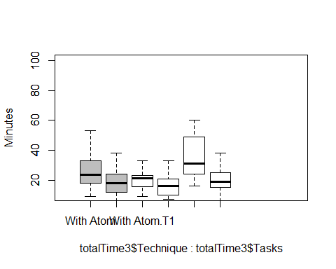

totalTrials <- sqldf("select Replica, Id, SetOfTasks,  
 Technique, sum(Trials) as Trials  
 from ccwocd  
 group by Replica, Id,SetOfTasks, Technique")  
  
totalTrials

## Replica Id SetOfTasks Technique Trials  
## 1 41 1 ST1 Without Atom 7  
## 2 41 1 ST2 With Atom 3  
## 3 41 2 ST1 With Atom 5  
## 4 41 2 ST2 Without Atom 3  
## 5 42 1 ST1 Without Atom 5  
## 6 42 1 ST2 With Atom 12  
## 7 42 2 ST1 With Atom 7  
## 8 42 2 ST2 Without Atom 12  
## 9 43 1 ST1 Without Atom 5  
## 10 43 1 ST2 With Atom 9  
## 11 43 2 ST1 With Atom 9  
## 12 43 2 ST2 Without Atom 5  
## 13 44 1 ST1 Without Atom 4  
## 14 44 1 ST2 With Atom 4  
## 15 44 2 ST1 With Atom 6  
## 16 44 2 ST2 Without Atom 6  
## 17 45 1 ST1 With Atom 9  
## 18 45 1 ST2 Without Atom 7  
## 19 45 2 ST1 Without Atom 5  
## 20 45 2 ST2 With Atom 8  
## 21 46 1 ST1 With Atom 7  
## 22 46 1 ST2 Without Atom 9  
## 23 46 2 ST1 Without Atom 4  
## 24 46 2 ST2 With Atom 12  
## 25 47 1 ST1 Without Atom 4  
## 26 47 1 ST2 With Atom 5  
## 27 47 2 ST1 With Atom 5  
## 28 47 2 ST2 Without Atom 4  
## 29 48 1 ST1 With Atom 7  
## 30 48 1 ST2 Without Atom 3  
## 31 48 2 ST1 Without Atom 10  
## 32 48 2 ST2 With Atom 29  
## 33 49 1 ST1 Without Atom 8  
## 34 49 1 ST2 With Atom 10  
## 35 49 2 ST1 With Atom 6  
## 36 49 2 ST2 Without Atom 3  
## 37 50 1 ST1 With Atom 8  
## 38 50 1 ST2 Without Atom 5  
## 39 50 2 ST1 Without Atom 7  
## 40 50 2 ST2 With Atom 10  
## 41 51 1 ST1 Without Atom 5  
## 42 51 1 ST2 With Atom 6  
## 43 51 2 ST1 With Atom 6  
## 44 51 2 ST2 Without Atom 5  
## 45 52 1 ST1 With Atom 9  
## 46 52 1 ST2 Without Atom 24  
## 47 52 2 ST1 Without Atom 7  
## 48 52 2 ST2 With Atom 14  
## 49 53 1 ST1 With Atom 5  
## 50 53 1 ST2 Without Atom 4  
## 51 53 2 ST1 Without Atom 5  
## 52 53 2 ST2 With Atom 15  
## 53 54 1 ST1 Without Atom 4  
## 54 54 1 ST2 With Atom 7  
## 55 54 2 ST1 With Atom 6  
## 56 54 2 ST2 Without Atom 3  
## 57 55 1 ST1 With Atom 5  
## 58 55 1 ST2 Without Atom 4  
## 59 55 2 ST1 Without Atom 5  
## 60 55 2 ST2 With Atom 19

boxplot(totalTrials$Trials~totalTrials$Technique,   
 #names=c("Disciplinado", "NÃ£o disciplinado")  
 #names=c("Disciplined", "Undisciplined")  
 )

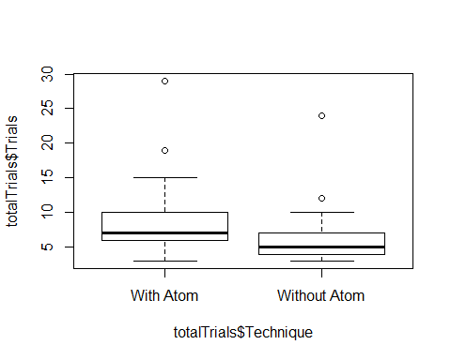

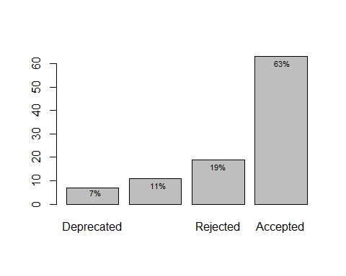

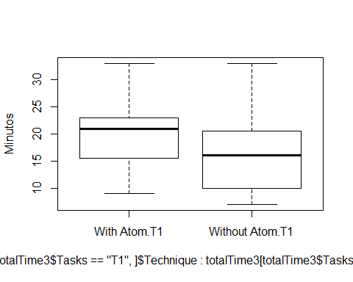 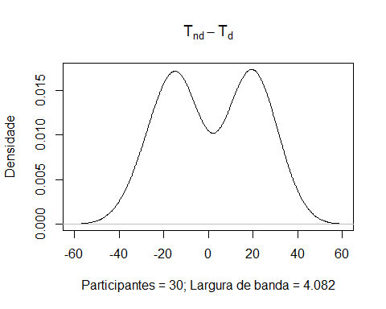

totalTime <- sqldf("select Replica, Id, SetOfTasks,   
 Technique, sum(Trials) as Trials, sum(Minutes) as Time   
 from ccwocd where Tasks = 'AV1.1:CO1.1:DE1.1' or Tasks = 'AV1.2:CO1.2:DE1.2'  
 group by Replica, Id,SetOfTasks, Technique")  
  
  
  
  
#totalTime$Trials <- with(totalTime, (Trials - min(Trials)) / (max(Trials) - min(Trials)))  
#totalTime$Time <- with(totalTime, (Time - min(Time)) / (max(Time) - min(Time)))  
#totalTime$Trials <- with(totalTime, sqrt(Trials))  
#totalTime$Time <- with(totalTime, sqrt(Time))  
totalTime$Time <- with(totalTime, log2(Time))

totalTime$Replica = as.factor(totalTime$Replica)  
totalTime$Id = as.factor(totalTime$Id)  
totalTime$SetOfTasks = as.factor(totalTime$SetOfTasks)  
totalTime$Technique = as.factor(totalTime$Technique)

totalTime.gvlma = gvlma(lm(Time ~ Technique, data=totalTime))  
summary(totalTime.gvlma)

##   
## Call:  
## lm(formula = Time ~ Technique, data = totalTime)  
##   
## Residuals:  
## Min 1Q Median 3Q Max   
## -1.1119 -0.5229 0.1858 0.3257 1.1251   
##   
## Coefficients:  
## Estimate Std. Error t value Pr(>|t|)   
## (Intercept) 4.2066 0.1609 26.147 <2e-16 ***  
## TechniqueWithout Atom -0.2873 0.2275 -1.263 0.217   
## ---  
## Signif. codes: 0 '***' 0.001 '**' 0.01 '*' 0.05 '.' 0.1 ' ' 1  
##   
## Residual standard error: 0.6231 on 28 degrees of freedom  
## Multiple R-squared: 0.05387, Adjusted R-squared: 0.02008   
## F-statistic: 1.594 on 1 and 28 DF, p-value: 0.2171  
##   
##   
## ASSESSMENT OF THE LINEAR MODEL ASSUMPTIONS  
## USING THE GLOBAL TEST ON 4 DEGREES-OF-FREEDOM:  
## Level of Significance = 0.05   
##   
## Call:  
## gvlma(x = lm(Time ~ Technique, data = totalTime))   
##   
## Value p-value Decision  
## Global Stat 2.611e+00 0.6249 Assumptions acceptable.  
## Skewness 2.499e-01 0.6171 Assumptions acceptable.  
## Kurtosis 9.031e-01 0.3419 Assumptions acceptable.  
## Link Function 1.105e-15 1.0000 Assumptions acceptable.  
## Heteroscedasticity 1.458e+00 0.2272 Assumptions acceptable.

summary(aov(lm(Time ~ Technique, data=totalTime)))

## Df Sum Sq Mean Sq F value Pr(>F)  
## Technique 1 0.619 0.6189 1.594 0.217  
## Residuals 28 10.870 0.3882

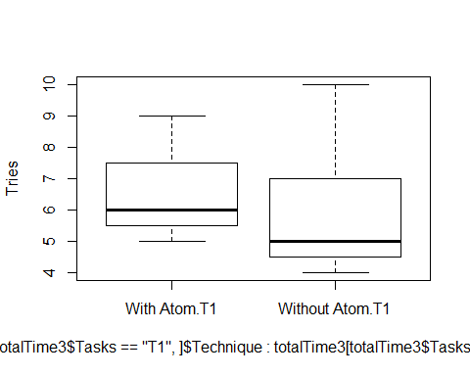

totalTrials <- sqldf("select Replica, Id, SetOfTasks,  
 Technique, sum(Trials) as Trials  
 from ccwocd where Tasks = 'AV1.1:CO1.1:DE1.1' or Tasks = 'AV1.2:CO1.2:DE1.2'  
 group by Replica, Id,SetOfTasks, Technique")  
totalTrials$Trials <- with(totalTrials, Trials + 1)  
totalTrials$Trials <- with(totalTrials, log2(Trials))

totalTrials$Replica = as.factor(totalTrials$Replica)  
totalTrials$Id = as.factor(totalTrials$Id)  
totalTrials$SetOfTasks = as.factor(totalTrials$SetOfTasks:totalTrials$Technique)  
totalTrials$Technique = as.factor(totalTrials$Technique)

summary(aov(Trials ~ Replica + Replica:Id + SetOfTasks + Technique, data=totalTrials))

## Df Sum Sq Mean Sq  
## Replica 14 1.6643 0.1189  
## SetOfTasks 1 0.3582 0.3582  
## Replica:Id 14 1.1195 0.0800

totalTrials.gvlma = gvlma(lm(Trials ~ Technique, data=totalTrials))  
summary(totalTrials.gvlma)

##   
## Call:  
## lm(formula = Trials ~ Technique, data = totalTrials)  
##   
## Residuals:  
## Min 1Q Median 3Q Max   
## -0.3732 -0.2741 -0.1063 0.2927 0.7643   
##   
## Coefficients:  
## Estimate Std. Error t value Pr(>|t|)   
## (Intercept) 2.91367 0.08141 35.789 <2e-16 ***  
## TechniqueWithout Atom -0.21854 0.11514 -1.898 0.068 .   
## ---  
## Signif. codes: 0 '***' 0.001 '**' 0.01 '*' 0.05 '.' 0.1 ' ' 1  
##   
## Residual standard error: 0.3153 on 28 degrees of freedom  
## Multiple R-squared: 0.114, Adjusted R-squared: 0.08236   
## F-statistic: 3.603 on 1 and 28 DF, p-value: 0.06803  
##   
##   
## ASSESSMENT OF THE LINEAR MODEL ASSUMPTIONS  
## USING THE GLOBAL TEST ON 4 DEGREES-OF-FREEDOM:  
## Level of Significance = 0.05   
##   
## Call:  
## gvlma(x = lm(Trials ~ Technique, data = totalTrials))   
##   
## Value p-value Decision  
## Global Stat -3.799e+01 1.0000 Assumptions acceptable.  
## Skewness 1.729e+00 0.1886 Assumptions acceptable.  
## Kurtosis 3.856e-01 0.5346 Assumptions acceptable.  
## Link Function -4.011e+01 1.0000 Assumptions acceptable.  
## Heteroscedasticity 9.333e-04 0.9756 Assumptions acceptable.

summary(aov(Trials ~ Technique, data=totalTrials))

## Df Sum Sq Mean Sq F value Pr(>F)   
## Technique 1 0.3582 0.3582 3.603 0.068 .  
## Residuals 28 2.7838 0.0994   
## ---  
## Signif. codes: 0 '***' 0.001 '**' 0.01 '*' 0.05 '.' 0.1 ' ' 1

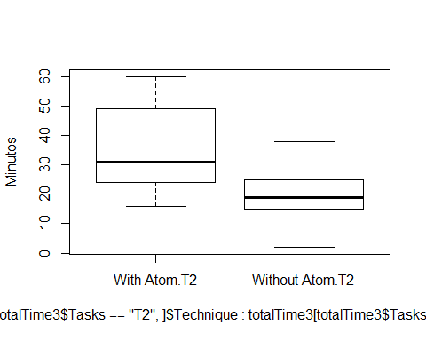 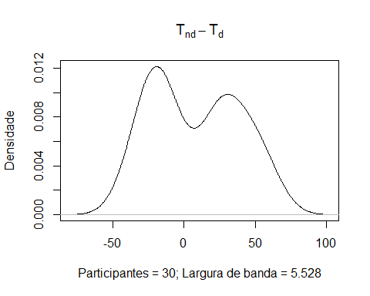

totalTime <- sqldf("select Replica, Id, SetOfTasks,   
 Technique, sum(Trials) as Trials, sum(Minutes) as Time   
 from ccwocd where Tasks = 'AV2.1:CO2.1:DE2.1' or Tasks = 'AV2.2:CO2.2:DE2.2'  
 group by Replica, Id,SetOfTasks, Technique")  
  
totalTime$Time <- with(totalTime, log2(Time))

totalTime$Replica = as.factor(totalTime$Replica)  
totalTime$Id = as.factor(totalTime$Id)  
totalTime$SetOfTasks = as.factor(totalTime$SetOfTasks:totalTime$Id)  
totalTime$Technique = as.factor(totalTime$Technique)

totalTime.gvlma = gvlma(lm(Time ~ Technique + SetOfTasks, data=totalTime))  
summary(totalTime.gvlma)

##   
## Call:  
## lm(formula = Time ~ Technique + SetOfTasks, data = totalTime)  
##   
## Residuals:  
## Min 1Q Median 3Q Max   
## -3.02383 -0.40984 0.05571 0.61837 1.11443   
##   
## Coefficients:  
## Estimate Std. Error t value Pr(>|t|)   
## (Intercept) 5.0905 0.2642 19.265 < 2e-16 ***  
## TechniqueWithout Atom -0.9570 0.3124 -3.064 0.00491 **   
## SetOfTasksST2:2 -0.1097 0.3124 -0.351 0.72825   
## ---  
## Signif. codes: 0 '***' 0.001 '**' 0.01 '*' 0.05 '.' 0.1 ' ' 1  
##   
## Residual standard error: 0.8536 on 27 degrees of freedom  
## Multiple R-squared: 0.2642, Adjusted R-squared: 0.2097   
## F-statistic: 4.847 on 2 and 27 DF, p-value: 0.01589  
##   
##   
## ASSESSMENT OF THE LINEAR MODEL ASSUMPTIONS  
## USING THE GLOBAL TEST ON 4 DEGREES-OF-FREEDOM:  
## Level of Significance = 0.05   
##   
## Call:  
## gvlma(x = lm(Time ~ Technique + SetOfTasks, data = totalTime))   
##   
## Value p-value Decision  
## Global Stat 36.4165 2.375e-07 Assumptions NOT satisfied!  
## Skewness 14.0019 1.826e-04 Assumptions NOT satisfied!  
## Kurtosis 20.9989 4.595e-06 Assumptions NOT satisfied!  
## Link Function 1.1795 2.774e-01 Assumptions acceptable.  
## Heteroscedasticity 0.2362 6.270e-01 Assumptions acceptable.

summary(aov(lm(Time ~ Technique, data=totalTime)))

## Df Sum Sq Mean Sq F value Pr(>F)   
## Technique 1 6.974 6.974 9.881 0.00393 **  
## Residuals 28 19.762 0.706   
## ---  
## Signif. codes: 0 '***' 0.001 '**' 0.01 '*' 0.05 '.' 0.1 ' ' 1

##   
## Kruskal-Wallis rank sum test  
##   
## data: Time by Technique  
## Kruskal-Wallis chi-squared = 9.1927, df = 1, p-value = 0.00243

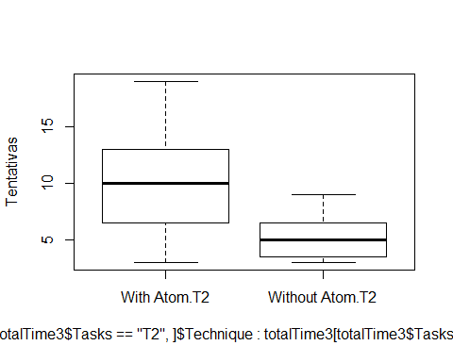

totalTrials <- sqldf("select Replica, Id, SetOfTasks,  
 Technique, sum(Trials) as Trials  
 from ccwocd where Tasks = 'AV2.1:CO2.1:DE2.1' or Tasks = 'AV2.2:CO2.2:DE2.2'  
 group by Replica, Id,SetOfTasks, Technique")  
  
totalTrials$Trials <-ifelse(totalTrials$Trials == 0, 1, totalTrials$Trials)  
totalTrials$Trials <- with(totalTrials, log2(Trials))

totalTrials$Replica = as.factor(totalTrials$Replica)  
totalTrials$Id = as.factor(totalTrials$Id)  
totalTrials$SetOfTasks = as.factor(totalTrials$SetOfTasks:totalTime$Id)  
totalTrials$Technique = as.factor(totalTrials$Technique)

summary(aov(Trials ~ Technique, data=totalTrials))

## Df Sum Sq Mean Sq F value Pr(>F)   
## Technique 1 4.852 4.852 6.608 0.0158 *  
## Residuals 28 20.560 0.734   
## ---  
## Signif. codes: 0 '***' 0.001 '**' 0.01 '*' 0.05 '.' 0.1 ' ' 1

totalTrials.gvlma = gvlma(lm(Trials ~ Technique, data=totalTrials))  
summary(totalTrials.gvlma)

##   
## Call:  
## lm(formula = Trials ~ Technique, data = totalTrials)  
##   
## Residuals:  
## Min 1Q Median 3Q Max   
## -1.62191 -0.56706 -0.08059 0.39815 2.18244   
##   
## Coefficients:  
## Estimate Std. Error t value Pr(>|t|)   
## (Intercept) 3.2069 0.2213 14.494 1.53e-14 ***  
## TechniqueWithout Atom -0.8044 0.3129 -2.571 0.0158 *   
## ---  
## Signif. codes: 0 '***' 0.001 '**' 0.01 '*' 0.05 '.' 0.1 ' ' 1  
##   
## Residual standard error: 0.8569 on 28 degrees of freedom  
## Multiple R-squared: 0.1909, Adjusted R-squared: 0.162   
## F-statistic: 6.608 on 1 and 28 DF, p-value: 0.01576  
##   
##   
## ASSESSMENT OF THE LINEAR MODEL ASSUMPTIONS  
## USING THE GLOBAL TEST ON 4 DEGREES-OF-FREEDOM:  
## Level of Significance = 0.05   
##   
## Call:  
## gvlma(x = lm(Trials ~ Technique, data = totalTrials))   
##   
## Value p-value Decision  
## Global Stat 1.636e+00 0.8023 Assumptions acceptable.  
## Skewness 1.544e+00 0.2140 Assumptions acceptable.  
## Kurtosis 7.535e-02 0.7837 Assumptions acceptable.  
## Link Function 7.228e-15 1.0000 Assumptions acceptable.  
## Heteroscedasticity 1.623e-02 0.8986 Assumptions acceptable.

summary(aov(Trials ~ Technique, data=totalTrials))

## Df Sum Sq Mean Sq F value Pr(>F)   
## Technique 1 4.852 4.852 6.608 0.0158 *  
## Residuals 28 20.560 0.734   
## ---  
## Signif. codes: 0 '***' 0.001 '**' 0.01 '*' 0.05 '.' 0.1 ' ' 1

ss = summary(aov(Trials ~ Technique, data=totalTrials))[[1]]$"Sum Sq"  
eta.sq = ss[1]/(ss[1] + ss[2])  
print(paste0("The eta-squared is ",toString(round(eta.sq,3))))

## [1] "The eta-squared is 0.191"

q <- TukeyHSD(aov(Trials~Technique, data=totalTrials))  
q

## Tukey multiple comparisons of means  
## 95% family-wise confidence level  
##   
## Fit: aov(formula = Trials ~ Technique, data = totalTrials)  
##   
## $Technique  
## diff lwr upr p adj  
## Without Atom-With Atom -0.8043511 -1.445296 -0.1634066 0.0157578

slices <- c(67, 33)   
lbls <- c("Perfectiva", "NÃ£o Perfectiva")  
pct <- round(slices/sum(slices)*100)  
lbls <- paste(lbls, pct) # add percents to labels   
lbls <- paste(lbls,"%",sep="") # ad % to labels   
pie(slices,labels = lbls, col=rainbow(length(lbls))  
 )

