Computer Communications and Networks (COMN) Course, Spring 2014

Coursework: Results Sheet

Forename and Surname: | Milan PAVLIK
Matriculation Number: | s1115104

Question 1 – Impact of retransmission timeout on number of retransmissions with stop-and-wait protocol.

Retransmission timeout (ms) | Number of  re-transmissions | Throughput  (Kilobytes per second)
10 | 3757 | 64.105
20 | 1190 | 32.946
30 | 1020 | 28.967
40 | 527 | 21.681
50 | 491 | 20.109
60 | 478 | 18.769
70 | 460 | 18.026
80 | 469 | 16.892
90 | 462 | 16.368
100 | 507 | 15.035

Question 2 – How does the throughput behave when the retransmission timeout increases and why? What is the optimal value for retransmission timeout?

The relationship of the throughput vs the timeout is negatively correlated. As timeout increases, the throughput decreases. This is reasonable as the more time spent waiting for an ACK that does not potentially ever arrive, the longer it will take to send the file.

This relationship can be seen from the number of re-transmissions. The smaller the timeout, the larger the number of re-transmissions as we may not receive the ACK before the timeout occurs.

The ideal value for retransmission timeout appears to be 40ms as the number of re-transmissions only decreases slowly as we increase the timeout. At the same time, it does not provide the highest possible throughput but it does provide a reasonable average.

Question 3 – Experiments with Go-Back-N:

 | Throughput (Kilobytes per second)
Window Size | Delay = 10ms | Delay = 100ms | Delay = 300ms
Optimal Retransmission timeout(ms) | 15 | 150 | 450
1 | 22.53 | 2.407 | 0.815
2 | 81.3 | 9.43 | 4.31
4 | 76.5 | 8.57 | 3.025
8 | 37.36 | 5.42 | 3.89
16 | 25.27 | 4.96 | 4.12
32 | 19.48 | 4.34 | 2.01
64 | 13.27 | 2.11 | 0.93
128 | 9.45 | 1.98 | 0.32
256 | 6.78 | 0.65 | 0.11

Use the results in the above table to make the following graph:

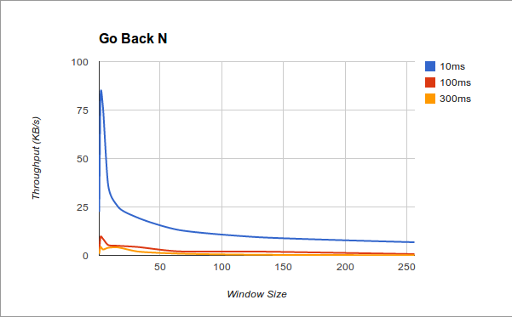

Question 4 – Explain your results from Question 3.

From the results, the fastest throughput is obtained from 10ms delay with window size of 2. These are not ideal values for the go-back-n protocol, however, it does show that increase in the window size does not necessarily correlate with an increase in the throughput. The throughput is directly affected by the transmission delay and the greater the window size, the higher chances are of missing a packet in the process and having to re-transmit. There is a general negative correlation between the the increase in window size and throughput.

These values are not optimized due to the change in the coursework specification 4 hours before the coursework deadline.

Question 5 – Experiments with Selective Repeat

 | Throughput (Kilobytes per second)
Window Size | Delay = 100ms
8 | 22.232
16 | 41.81
32 | 80.269
64 | 150.828
128 | 240.808
256 | 345.338

Question 6 - Compare the throughput obtained when using “Selective Repeat” with the corresponding results you got from the “Go Back N” experiment and explain the reasons behind any differences.

The throughput of Selective Repeat is much higher as single packets can be requested as needed. The fact that the SR protocol has only been run with one delay does not provide sufficient basis for a reasonable comparison. However, the general relationship between GBN with 100ms delay and SR with 100ms inverse. As window size increases, SR performance increases while GBN decreases.

Additionally, there is a large marginal difference between the speeds, SR with window size of 8 performs faster than GBN with any window size.

Question 7 – Experiments with iperf

 | Throughput (Kilobytes per second)
Window Size (KB) | Delay = 100ms
8 | 62.0
16 | 54.5
32 | 52.8
64 | 72.5
128 | 109
256 | Unable to run with window size KB

Question 8 - Compare the throughput obtained when using “Selective Repeat” and “Go Back N” with the corresponding results you got from the iperf experiment and explain the reasons behind any differences.

Comparably with Go Back N, iperf performs much better and achieves much higher throughput. Relatively to Selective Repeat, iperf performs slower but exhibits the same patterns. As the window size increases, the throughput increases as well. This is the opposite of what happens with Go Back N.

The reason for better performance of Selective Repeat could be the design of the protocols. TCP is designed to maintain connection and reduce network congestion while Selective Repeat does not pay much attention to the traffic.
Additionally, the header size on TCP is larger which causes larger packets to be sent, lowering throughput in turn.

