1. Overview
Team Name: QML Forecast
Team Members:
- Dongwook Kim
M.S. Computer Science, Georgia Institute of Technology
Email: dongwook.kim@outlook.com
- Youngwoo Song
M.S. Computer Science, University of Utah
Email: youngwoo.song@utah.edu

2. Abstract
This study presents an integrated framework for wildfire risk prediction and insurance premium modeling in California, combining classical machine learning and quantum approaches within a unified pipeline. The objective is to evaluate the predictive capability of wildfire occurrence models and assess their downstream impact on insurance pricing.
In Task 1, wildfire prediction is formulated as a binary classification problem at the ZIP-code level using historical data from 2018 to 2022. A structured ZIP–Year dataset is constructed through event aggregation and negative sampling. Feature engineering focuses on environmental variables such as temperature and precipitation, along with derived indicators including temperature range and dryness proxies. Classical models, including Logistic Regression, Random Forest, and Gradient Boosting, are implemented alongside a Variational Quantum Classifier (VQC). Evaluation using a time-based split demonstrates that classical ensemble models outperform the quantum model, achieving a maximum AUC of 0.735 compared to 0.596 for the VQC. These results highlight the importance of temporal evaluation and indicate that quantum advantage is not realized in structured tabular datasets under current constraints.
In Task 2, insurance premium prediction is formulated as a regression problem using historical insurance, wildfire, weather, and census data. A panel dataset is constructed at the (Year, ZIP, Category) level, and temporal dependencies are captured through lag features. Multiple models are evaluated, including Gradient Boosting, Random Forest, and panel regression. A weighted ensemble model achieves strong performance on the 2021 holdout set, with an R² of 0.942. Feature importance analysis reveals that insurance premiums are primarily driven by historical premium values, with exposure variables providing secondary contributions.
The integration of both tasks provides a key insight: although wildfire occurrence can be predicted with reasonable accuracy, its direct influence on insurance premiums is limited, suggesting that risk may already be embedded within exposure measures. Furthermore, this study contributes to the quantum machine learning community by demonstrating that the absence of quantum advantage is often due to data characteristics rather than implementation limitations. The results suggest that quantum methods may be better suited for higher-dimensional or inherently quantum problems.
Overall, this work emphasizes the importance of evaluation methodology, feature design, and domain context, while providing a reproducible hybrid framework that bridges environmental risk modeling and economic forecasting.

3. Method / Algorithm - GitHub

3.1 Task 1: Wildfire Risk Prediction

Problem Formulation
The objective of Task 1 is to estimate the probability of wildfire occurrence at the ZIP-code level using historical data from 2018 to 2022. The problem is formulated as a binary classification task, where each ZIP–Year pair is labeled as 1 if a wildfire occurred and 0 otherwise. Although the problem is not explicitly defined as a time-series task, it inherently requires temporal generalization, making forecasting-oriented evaluation essential.

Data Construction
Raw wildfire event data is transformed into a structured ZIP–Year dataset through aggregation. Environmental variables such as temperature and precipitation are averaged within each ZIP code and year, while fire-related attributes are summarized accordingly. To construct a complete supervised dataset, all possible ZIP–Year combinations are generated, and missing entries are labeled as zero, representing the absence of wildfire events. This negative sampling strategy ensures that the model learns both fire and non-fire conditions effectively.

Feature Engineering
Feature engineering focuses on capturing environmental conditions that influence wildfire risk while preventing information leakage. Derived variables are constructed to better represent physical processes. In particular, temperature variability and dryness are defined as:
temp_range = avg_tmax – avg_tmin
dryness = avg_tmax / (tot_prcp + 1)
In addition to environmental variables, contextual attributes such as ignition cause and agency identifiers are incorporated via one-hot encoding. However, variables that contain post-event information, including fire count, fire size, and fire duration, are explicitly excluded to prevent data leakage.

Modeling Approach
Two classical baseline models are implemented. Logistic Regression provides a linear baseline with balanced class weighting, while Random Forest captures nonlinear interactions among features. In addition, Gradient Boosting is introduced as a more expressive ensemble model and achieves the strongest performance among classical approaches.
To explore quantum approaches, a Variational Quantum Classifier (VQC) is implemented. Input features are standardized and reduced using Principal Component Analysis, retaining approximately 94.5% of total variance . These features are encoded into quantum states using rotation gates, and a parameterized quantum circuit is optimized via a classical optimizer. This results in a hybrid quantum-classical learning framework.

Evaluation Methodology
Model performance is evaluated using accuracy, precision, recall, F1-score, and ROC-AUC. Two evaluation strategies are employed. The primary approach uses a time-based split, where models are trained on data from 2018–2020 and evaluated on 2021 data. This setup reflects real-world forecasting conditions. A secondary baseline uses a random stratified split, which evaluates classification performance under identical data distributions but may overestimate real-world performance.

3.2 Task 2: Insurance Premium Prediction

Problem Formulation
Task 2 is formulated as a regression problem aimed at predicting insurance premiums (Earned Premium) for the year 2021 using historical data from 2018 to 2020. The model integrates wildfire risk, environmental conditions, and socioeconomic variables.

Data Construction
The dataset combines insurance, wildfire, weather, and census data into a unified panel structure. Records are aggregated at the (Year, ZIP, Category) level, ensuring that each observation uniquely represents a specific geographic and insurance segment. Duplicate entries are removed through grouping operations, preserving temporal consistency and data integrity.

Feature Engineering
The feature space includes temporal, environmental, and socioeconomic variables. Temporal dependencies are captured using lagged premium features:
Premium_(t-1), premium_(t-2), ΔPremium
Wildfire risk is incorporated through both continuous scores and exposure counts across risk levels. Socioeconomic variables such as median income, housing value, and population provide additional explanatory power. Insurance-specific features, particularly earned exposure, capture the scale of insured assets.
To ensure a valid predictive setting, variables containing current-year claims and losses are excluded to prevent leakage.

Modeling Approach
Several regression models are evaluated, including Ridge Regression, Random Forest, and Gradient Boosting. Gradient Boosting demonstrates the strongest performance due to its ability to model nonlinear relationships effectively.
To capture cross-sectional variation across ZIP codes, a panel regression model is implemented. Finally, an ensemble model is constructed as a weighted combination of individual models, with weights optimized using validation RMSE . This approach balances predictive accuracy and robustness.

Temporal Design
The dataset is split chronologically to preserve temporal integrity. Models are trained on data from 2018–2020, validated on 2020 data, and evaluated on a 2021 holdout set. This ensures that no future information is used during training.

3.3 Modeling Assumptions
To ensure a tractable and interpretable modeling framework, several assumptions are made.
First, wildfire occurrence at the ZIP–Year level is assumed to be sufficiently captured by aggregated environmental and historical features. This implies that intra-year variability and localized microclimate effects are not explicitly modeled.
Second, the negative sampling procedure assumes that the absence of recorded wildfire events corresponds to true negative cases. In reality, small or unreported fires may introduce label noise.
Third, the insurance model assumes that premium dynamics exhibit temporal continuity, allowing lag features to capture historical trends. While structural shocks such as COVID-19 are partially addressed through weighting, abrupt regime changes may still affect predictions.
Fourth, the integration of wildfire risk into the insurance model assumes that risk signals are reflected in premium pricing. However, results suggest that risk may already be indirectly embedded in exposure variables.
Finally, the quantum model assumes that dimensionality reduction via PCA preserves essential feature relationships. This assumption is necessary given current quantum hardware constraints but may limit model expressiveness.

4. Results

4.1 Task 1: Wildfire Prediction Results
The performance of the models under time-based evaluation is summarized in Table 1.
Table 1. Wildfire Prediction Performance
Model | Accuracy | F1 Score | Recall | AUC
Logistic Regression | 0.46 | 0.60 | 0.88 | 0.49
Random Forest | 0.46 | 0.34 | 0.30 | 0.41
Gradient Boosting | 0.80 | 0.39 | 0.30 | 0.73
VQC (Quantum) | 0.77 | 0.35 | 0.30 | 0.60
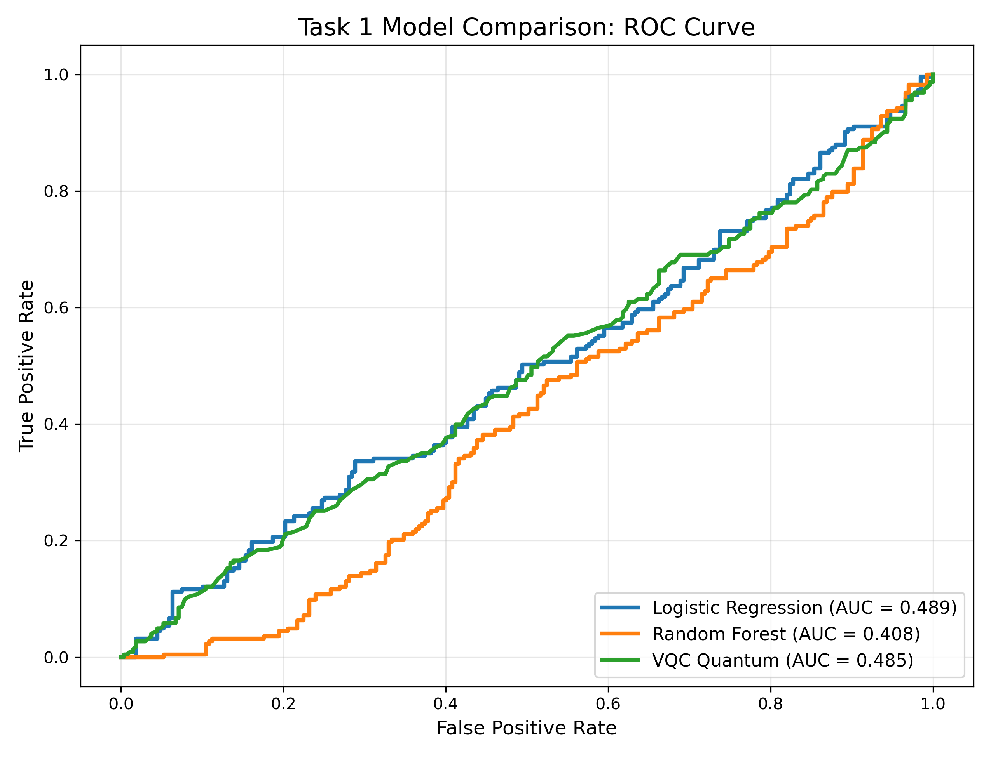
Figure 1. ROC curves comparing classical and quantum models under time-based evaluation.

As shown in Figure 1, all models exhibit limited discriminative performance under time-based evaluation, highlighting the inherent difficulty of forecasting wildfire occurrence.

The results indicate that classical ensemble models outperform the quantum model in terms of discriminative performance. Gradient Boosting achieves the highest AUC, while Logistic Regression demonstrates strong recall, capturing a large proportion of wildfire events.
A key observation is that random split evaluation significantly overestimates performance due to shared spatial patterns between training and testing data. In contrast, time-based evaluation provides a more realistic assessment of predictive capability.

4.2 Task 2: Insurance Premium Prediction Results
The regression performance is summarized in Table 2.
Table 2. Insurance Premium Prediction Performance
Model | MAE ($) | RMSE ($) | R²
Gradient Boosting | 91,908 | — | —
Random Forest | 113,824 | — | —
Ridge Regression | 272,825 | — | —
Ensemble (Final) | 137,833 | 414,605 | 0.942
The ensemble model achieves strong predictive performance on the 2021 holdout set, with an R² of 0.942.
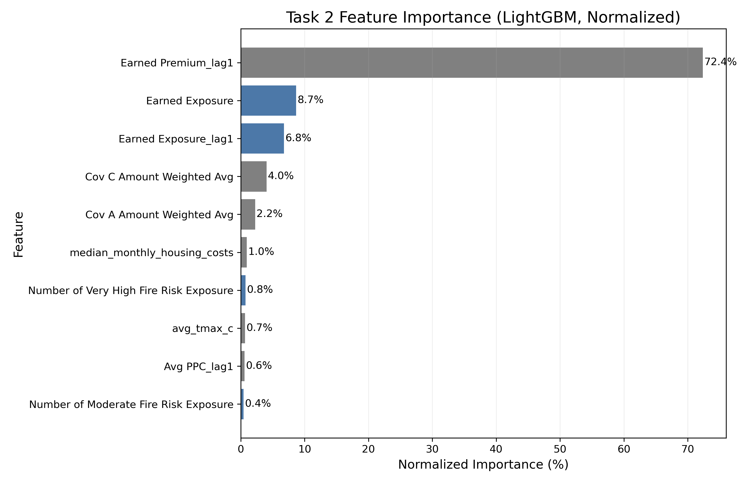
Figure 2. Normalized LightGBM-based feature importance. Lagged premium variables dominate the model, while exposure variables provide secondary contributions, and wildfire-related features contribute marginally.

As shown in Figure 2, lagged premium variables dominate prediction, while exposure variables provide secondary contributions, and wildfire-related features have relatively minor impact.

Feature Importance Analysis
Feature importance analysis reveals that insurance premiums are primarily driven by historical premium values, particularly lagged premium features such as Earned Premium_lag1, which account for the majority of predictive importance. This indicates strong temporal persistence in insurance pricing.
Exposure-related variables, such as Earned Exposure, provide secondary but meaningful contributions, reflecting the scale of insured assets. In contrast, wildfire-related variables contribute relatively less to the overall prediction.

4.3 Integrated Insight
Combining Task 1 and Task 2 results provides a broader perspective. While wildfire occurrence can be reasonably predicted using environmental and historical features, its direct impact on insurance premiums appears limited. This indicates that risk may already be implicitly incorporated into exposure variables or that pricing mechanisms prioritize asset value over hazard probability.

4.4 Quantum vs Classical Analysis
The comparison between classical and quantum models highlights a key limitation of current quantum machine learning approaches. Although quantum models offer theoretical advantages through superposition and entanglement, these benefits are not realized in structured tabular datasets with limited dimensionality. Classical models remain more efficient, scalable, and better suited to this type of problem.

4.5 Quantum Community Impact
This work contributes to the quantum machine learning community by providing an empirical evaluation of quantum models in a real-world sustainability application. The findings demonstrate that quantum models do not inherently outperform classical approaches and that the absence of quantum advantage is often due to data characteristics rather than implementation issues.
Furthermore, the study presents a reproducible hybrid pipeline that integrates classical preprocessing with quantum classification, offering a practical reference for future research. The results suggest that quantum advantage is more likely to emerge in problems involving higher-dimensional feature spaces or inherently quantum phenomena.
Finally, by integrating quantum-derived wildfire risk into an economic modeling task, this work illustrates a potential pathway for hybrid systems in which quantum models serve as exploratory or feature-generating components within larger classical pipelines.

4.6 Limitations
The study is subject to several limitations, including missing environmental variables such as humidity and wind speed, limited temporal coverage, and data noise. In addition, quantum models are constrained by current hardware and simulation capabilities.

4.7 Conclusion
This study demonstrates that model performance is primarily driven by data quality, feature engineering, and evaluation methodology. Time-based evaluation reveals the true difficulty of forecasting tasks, while classical machine learning models remain dominant for structured data. Although quantum models offer promising theoretical advantages, their practical impact is currently limited, highlighting the need for further advancements in both data complexity and quantum hardware.

5. Future Work and Scalability
While this study establishes a foundational hybrid pipeline integrating wildfire risk prediction and insurance premium modeling, several avenues for future research and scalability remain.
First, the inclusion of higher-resolution environmental data is expected to improve predictive performance in wildfire modeling. In particular, variables such as wind speed, wind direction, and real-time humidity are known to be critical drivers of wildfire ignition and spread. Incorporating these features would enable the model to capture more granular physical dynamics that are not reflected in aggregated annual averages.
Second, future work will explore more advanced quantum machine learning architectures to better leverage potential quantum advantages. Models such as Quantum Restricted Boltzmann Machines (QRBMs) and Quantum Generative Adversarial Networks (QGANs) may provide improved capability in capturing complex, high-dimensional feature distributions. These approaches could help uncover nonlinear relationships that may not be fully captured by classical ensemble methods.
Third, extending the temporal scope of the dataset will allow the model to account for long-term climate variability. Incorporating additional years of data would enable the analysis of multi-year climate cycles, such as El Niño and La Niña, thereby improving the robustness and stability of both wildfire and insurance forecasting models.
Finally, future research will focus on identifying domains where quantum machine learning can demonstrate measurable advantages over classical approaches. In particular, high-dimensional and structurally complex applications—such as multi-peril insurance modeling or reinsurance portfolio optimization—may provide more suitable environments for leveraging the exponential state space of quantum systems.

