**Starter / YAML Pipeline**

* Create new service connection for ACR

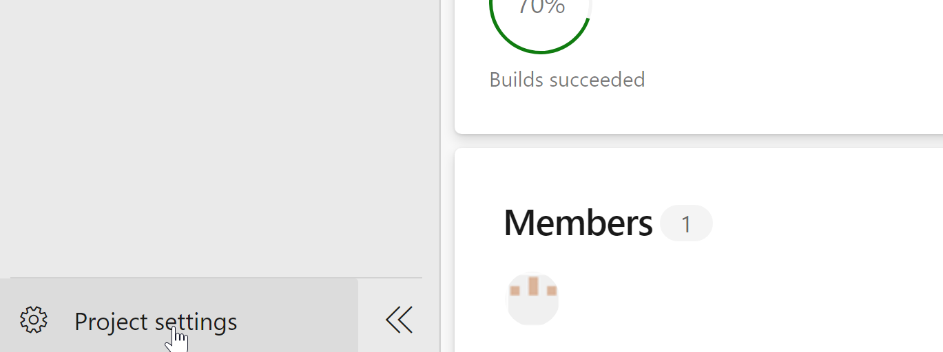

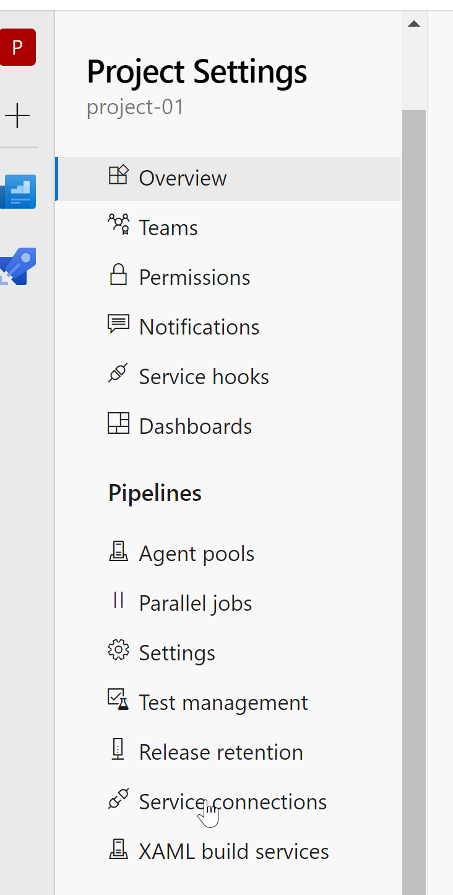

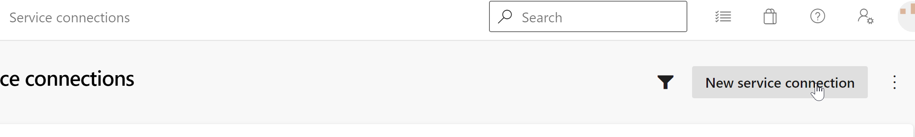

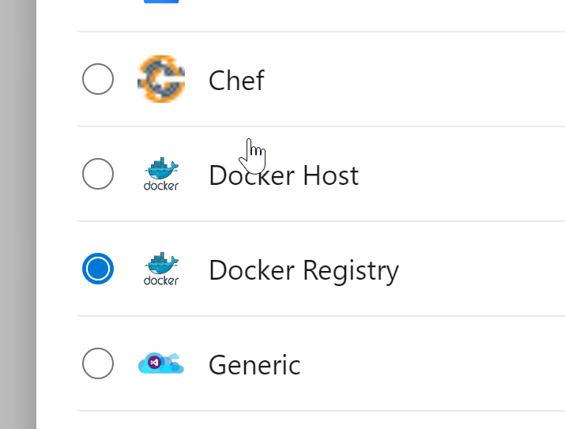

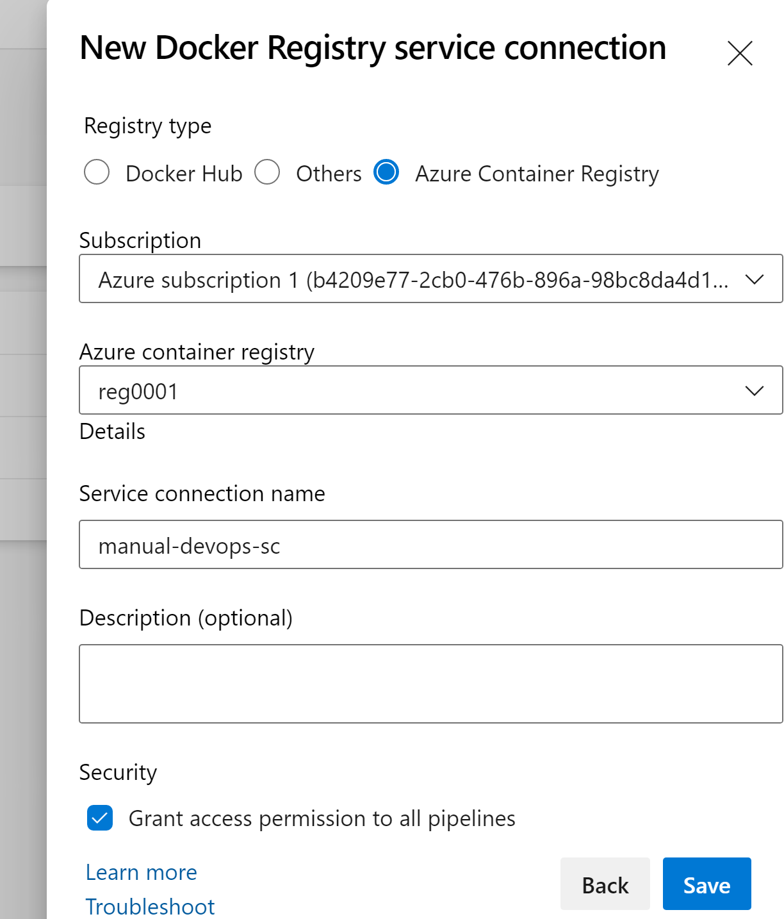

* Create a new starter pipeline

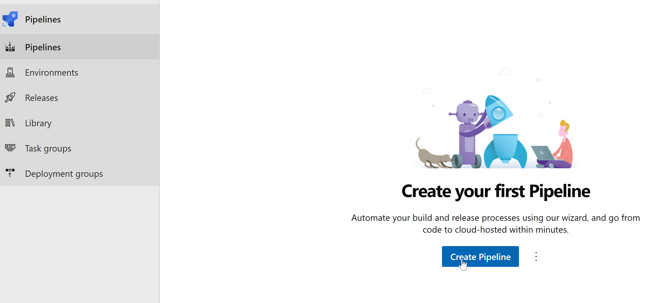

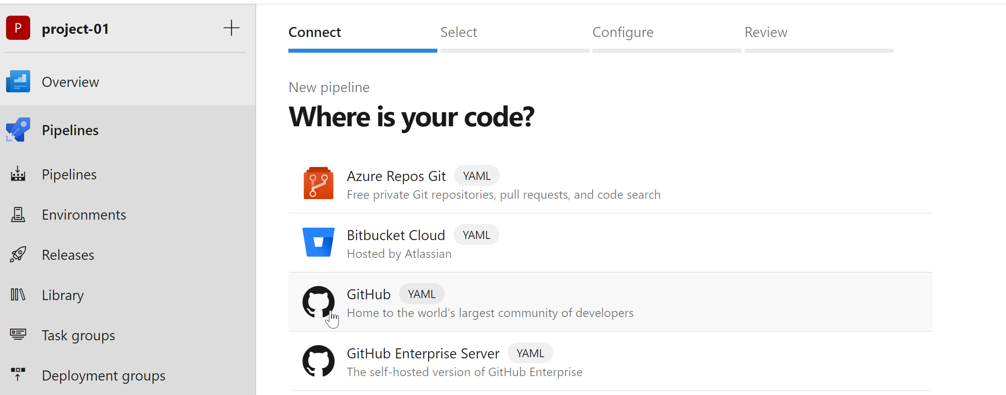

Select <https://github.com/easycloudcompute/pythonrestapi-azuredevops.git> from the list

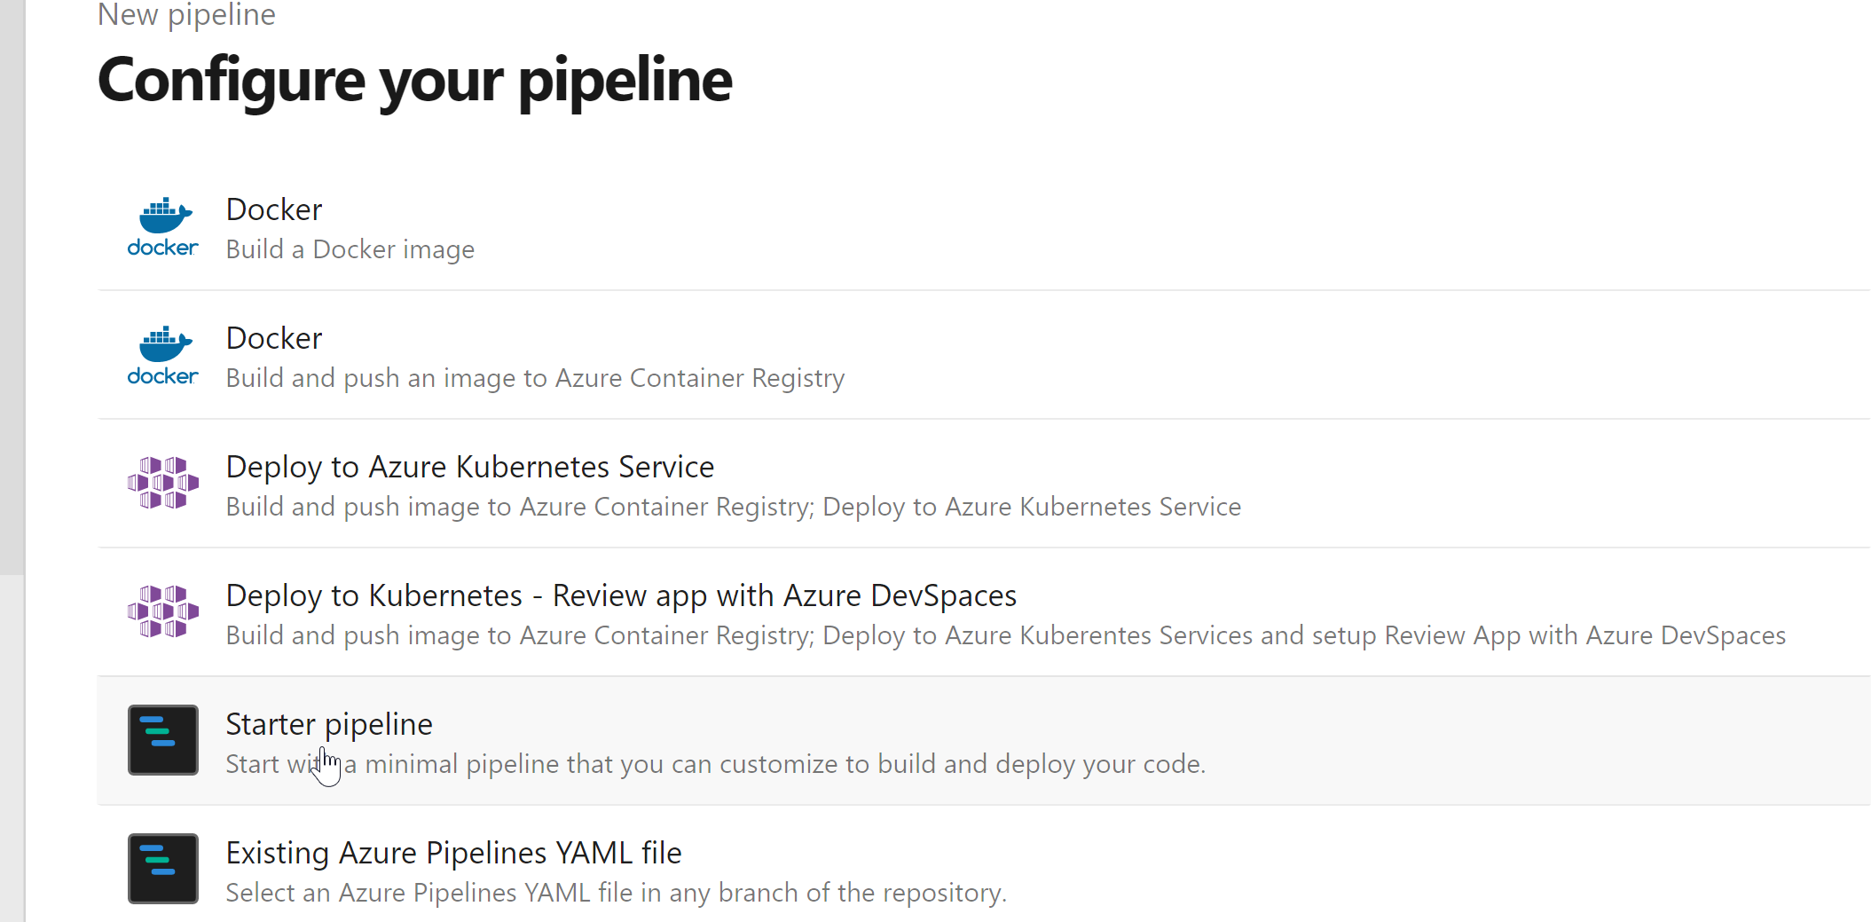

* Rename pipeline

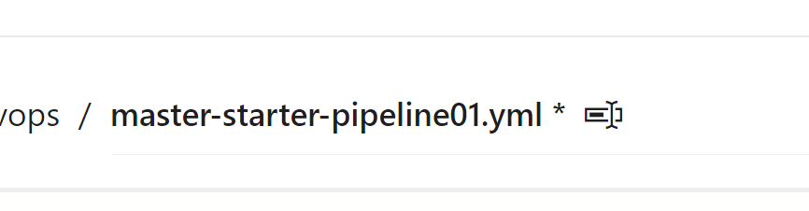

* We now start writing pipeline in YAML . To get some code snippets we use the Assistant, example:
* For getting build code, use below:

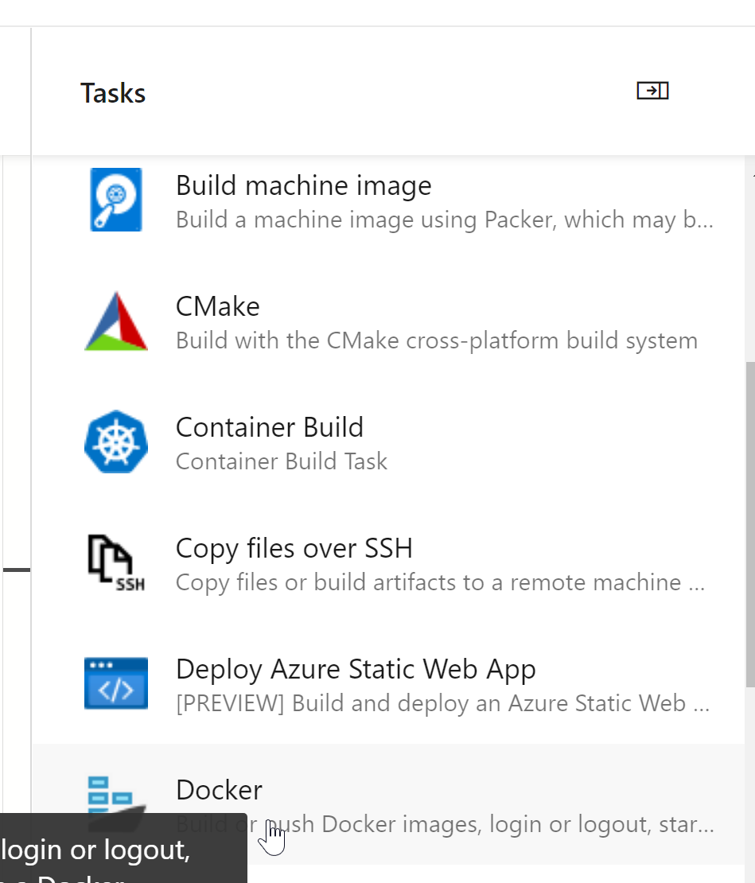

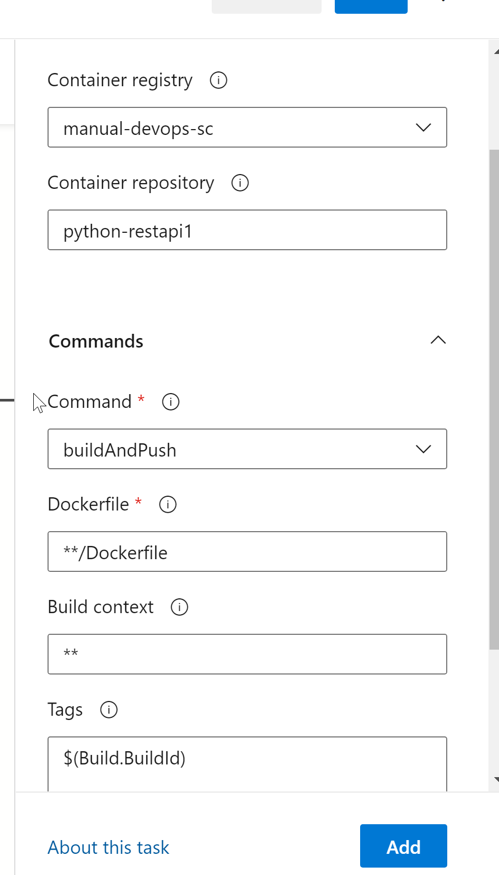

* To copy files from a source folder to target folder

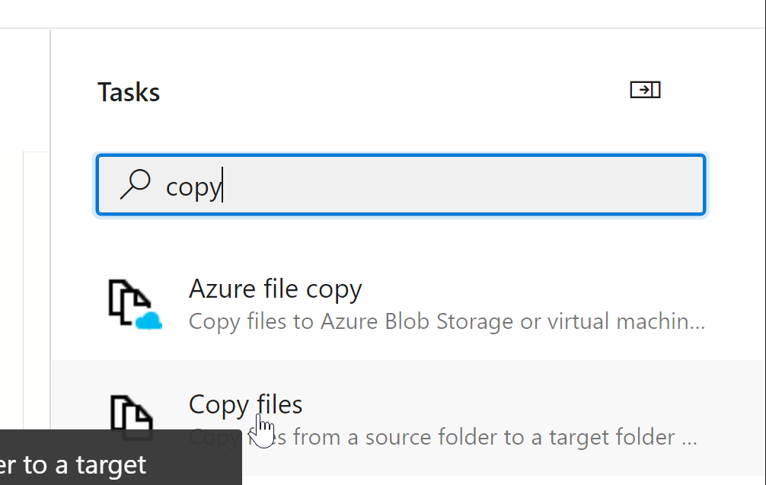

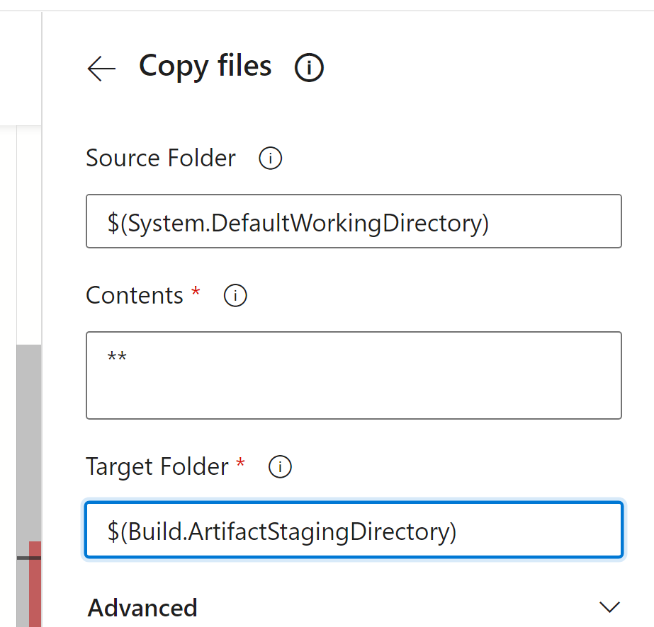

* To publish artifacts to azure pipeline

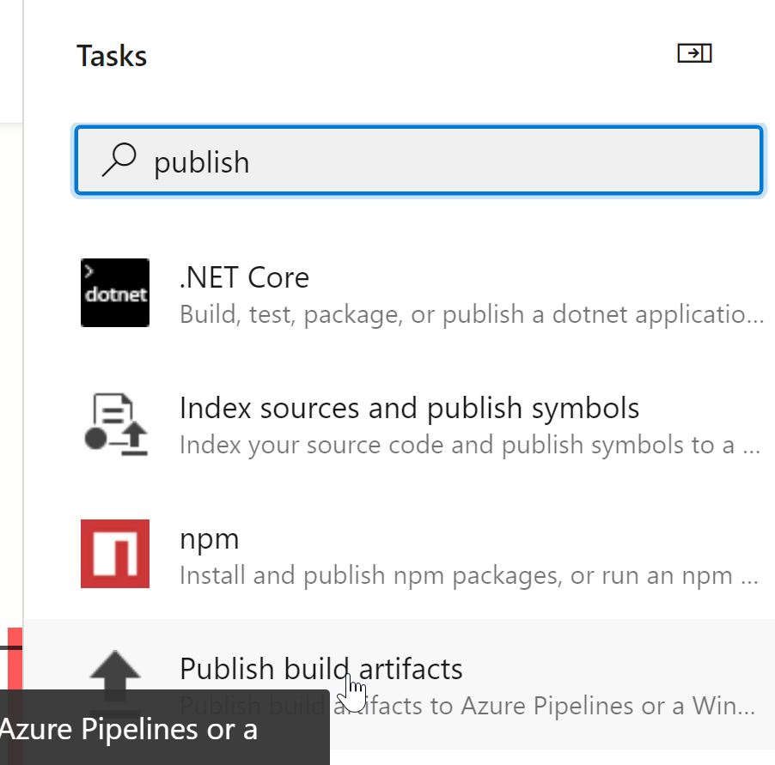

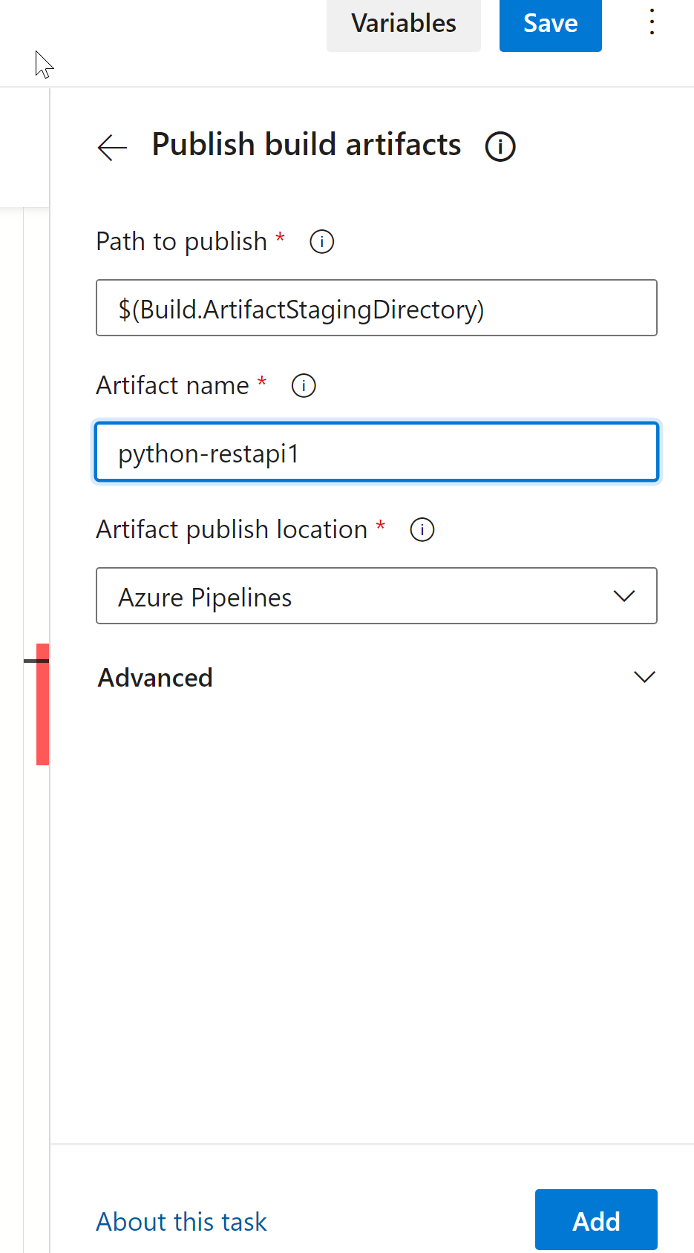

* Run pipeline and verify

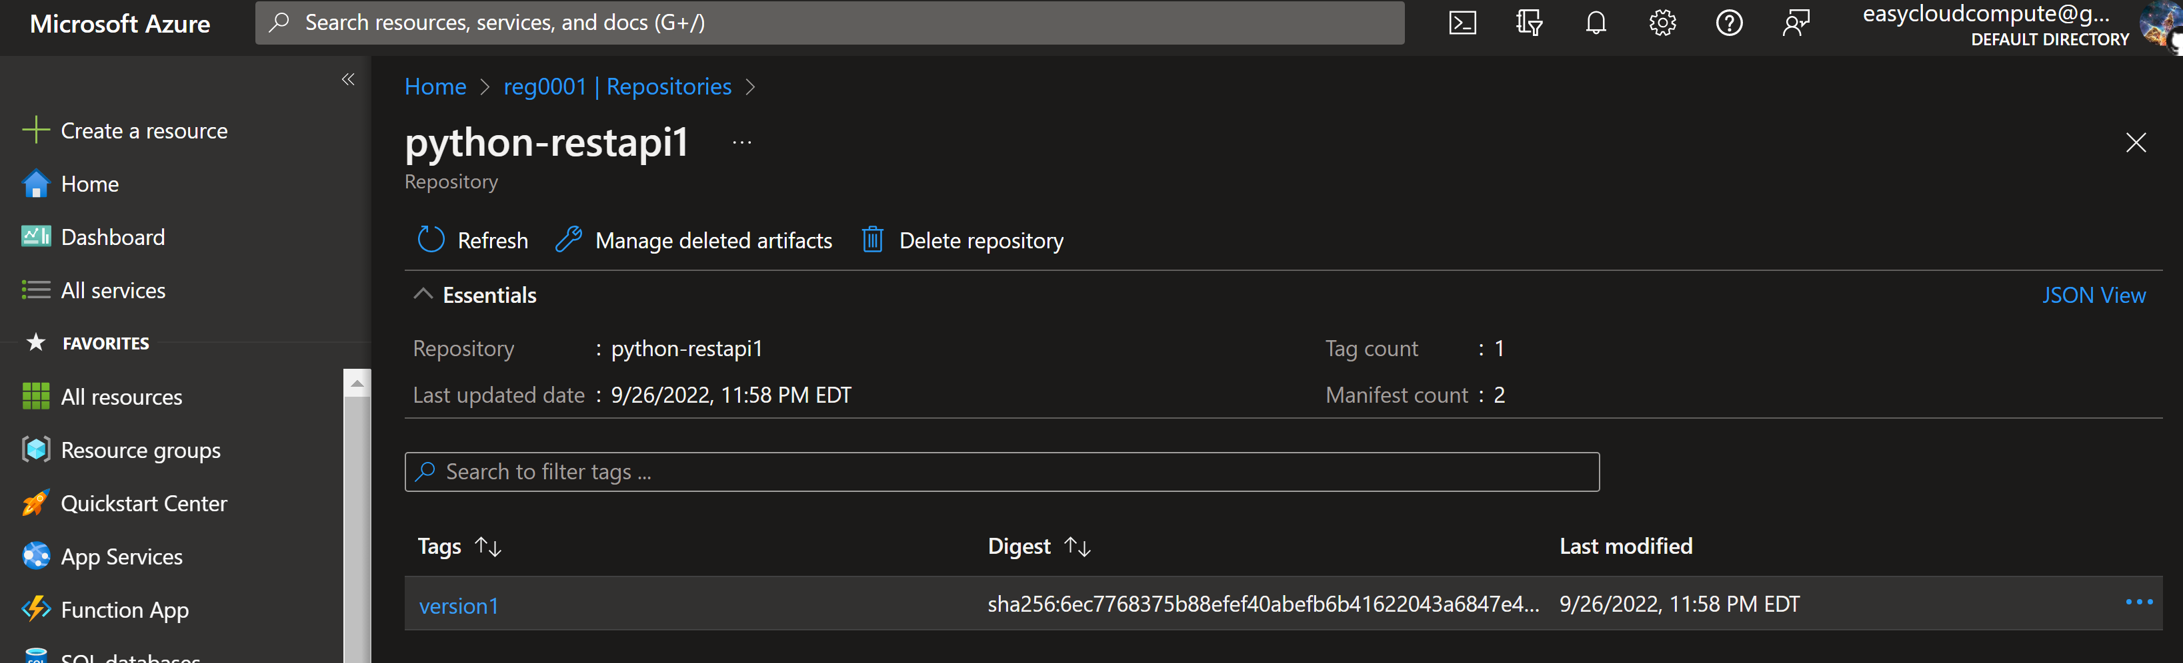

**Release Pipeline**

* Create a new namespace called dev

The Cosmos@[~/Desktop/Tech/pythonrestapi-azuredevops]: kubectl create ns dev

namespace/dev created

The Cosmos@[~/Desktop/Tech/pythonrestapi-azuredevops]: kubectl get ns

NAME STATUS AGE

default Active 9d

dev Active 5s

kube-node-lease Active 9d

kube-public Active 9d

kube-system Active 9d

* Create new service connection for AKS

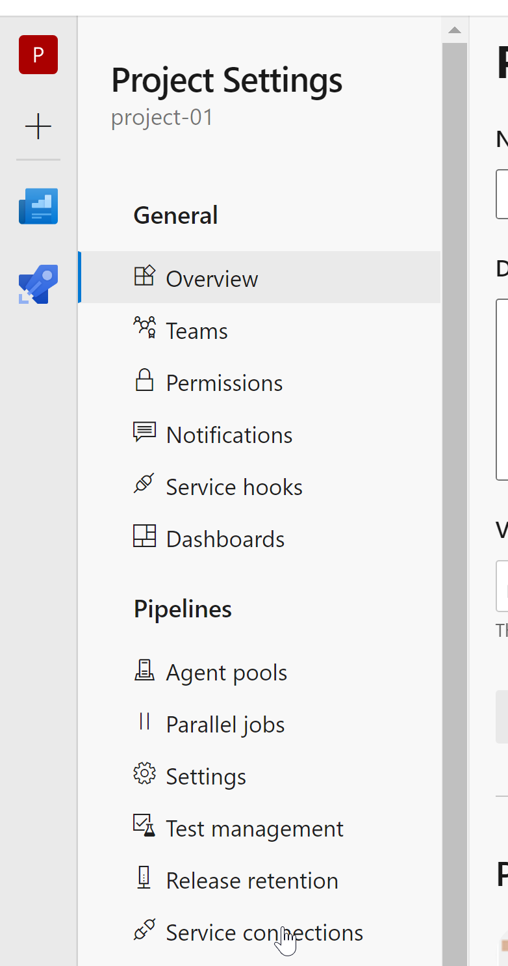

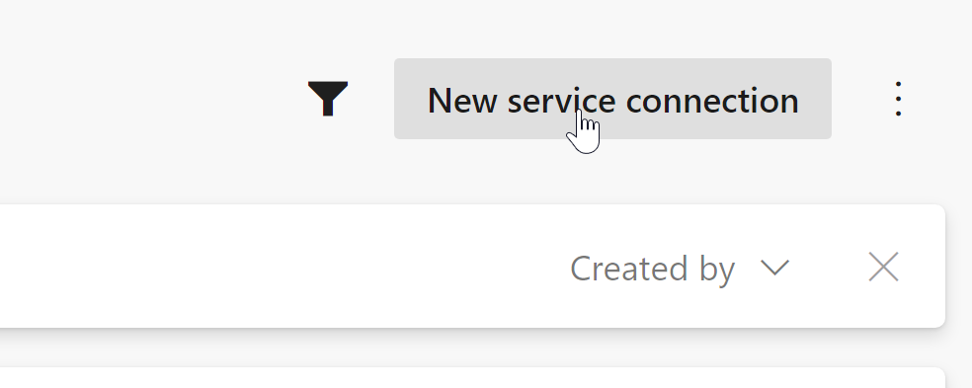

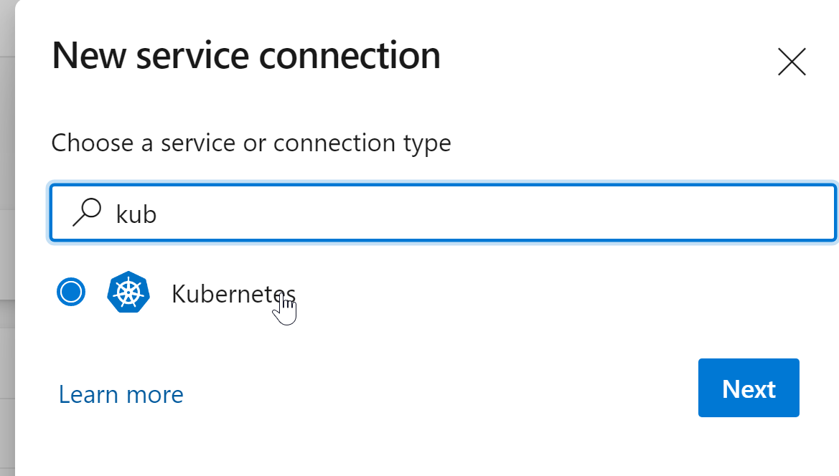

Get the kubeconfig file and paste below

The Cosmos@[~/Desktop/Tech/pythonrestapi-assignment]: cat ~/.kube/config

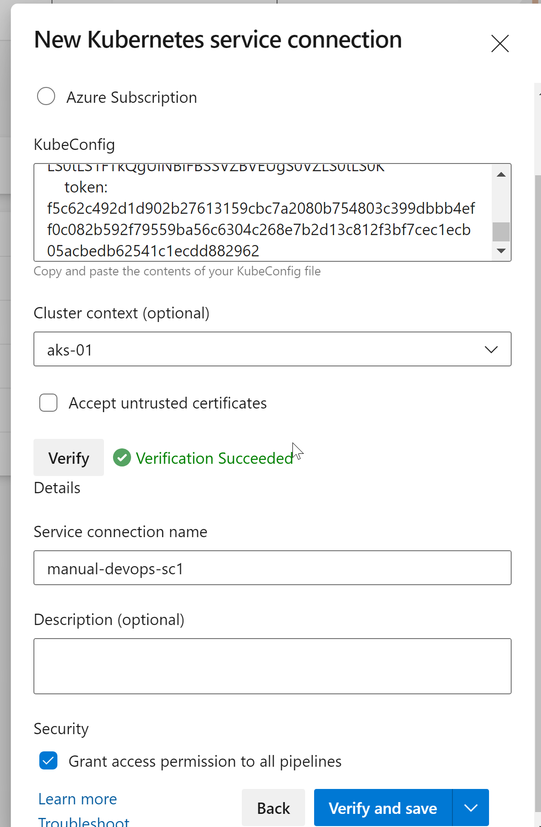

* Create new release pipeline

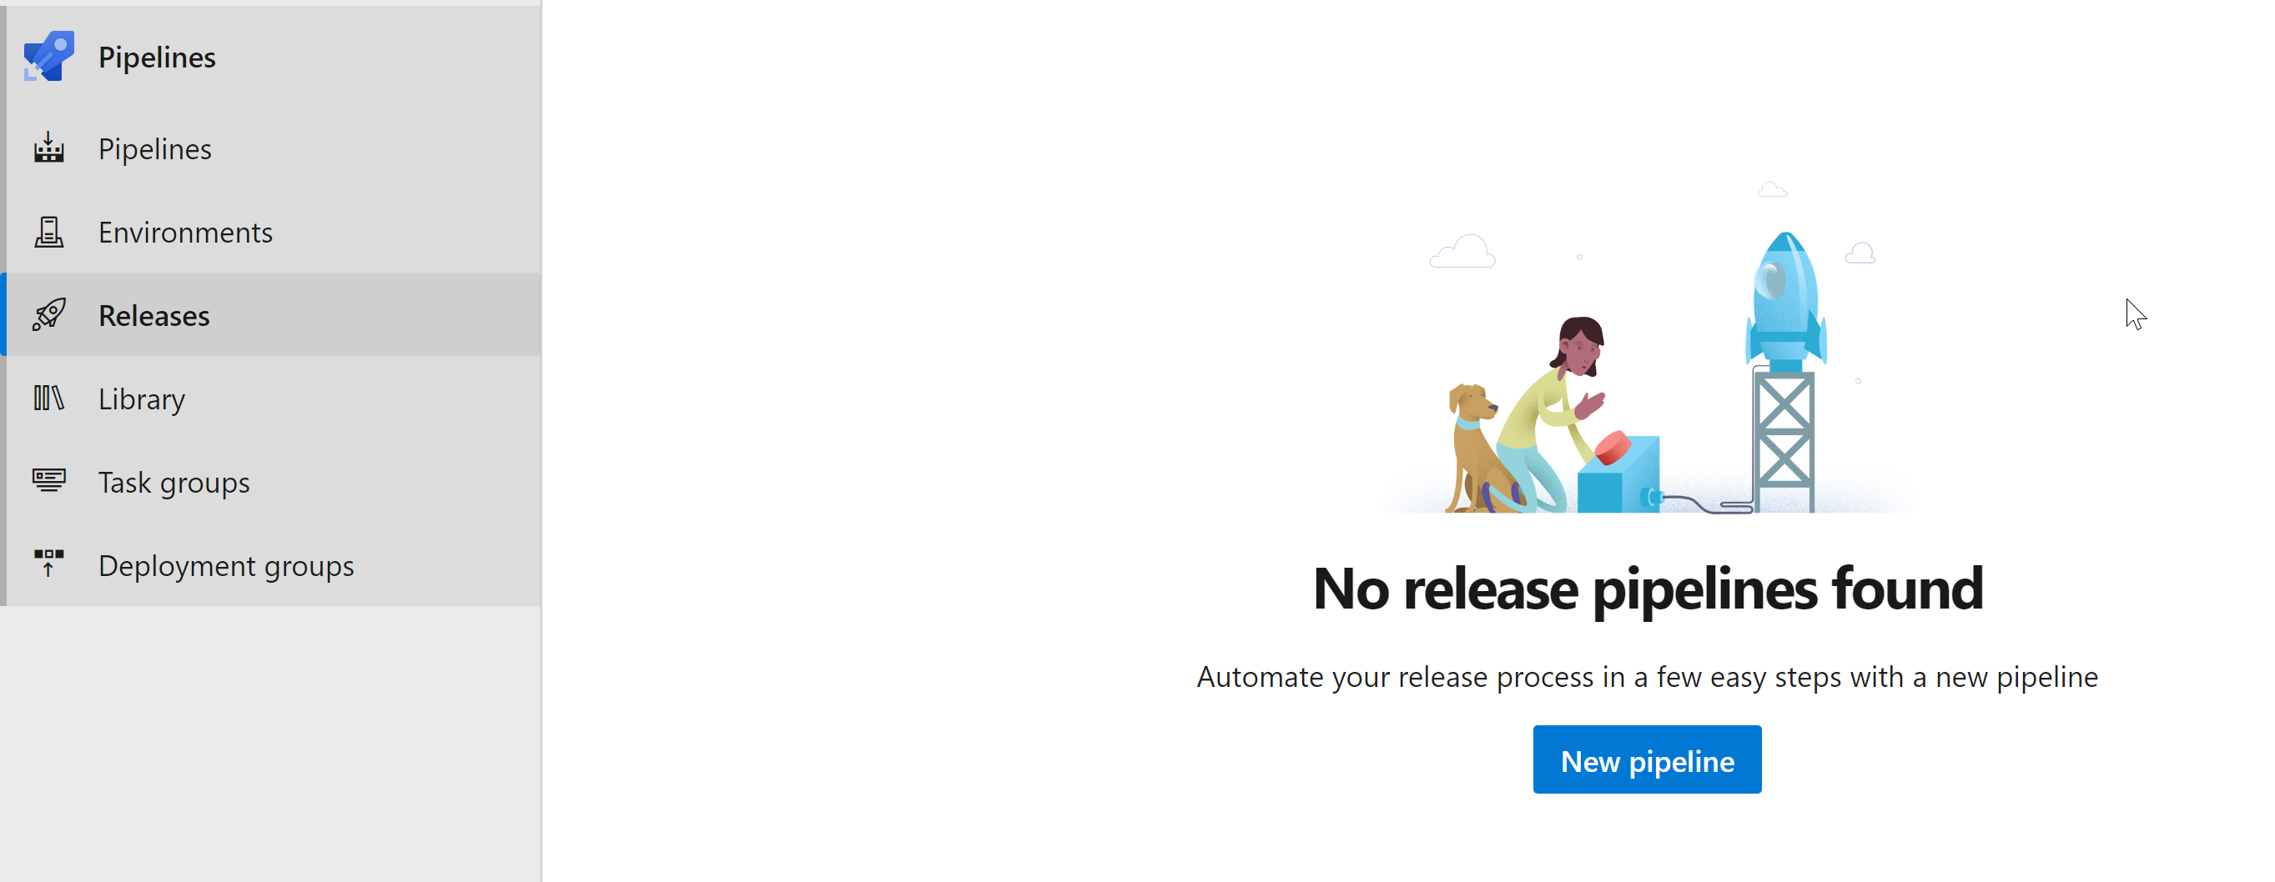

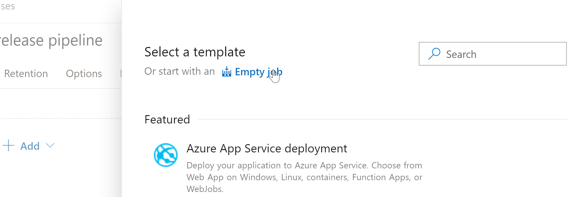

* Add artifact

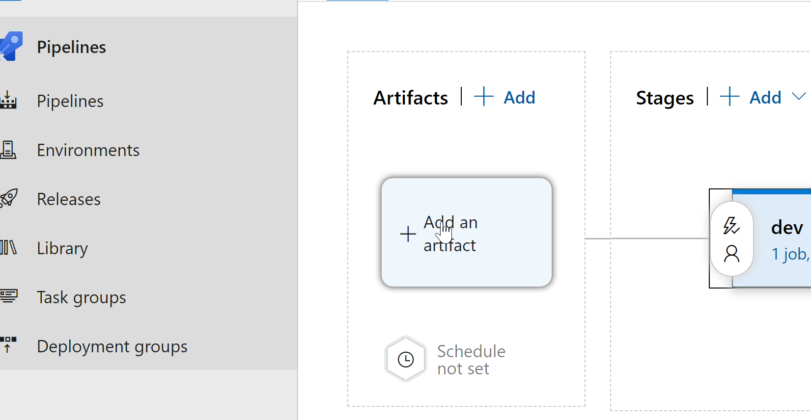

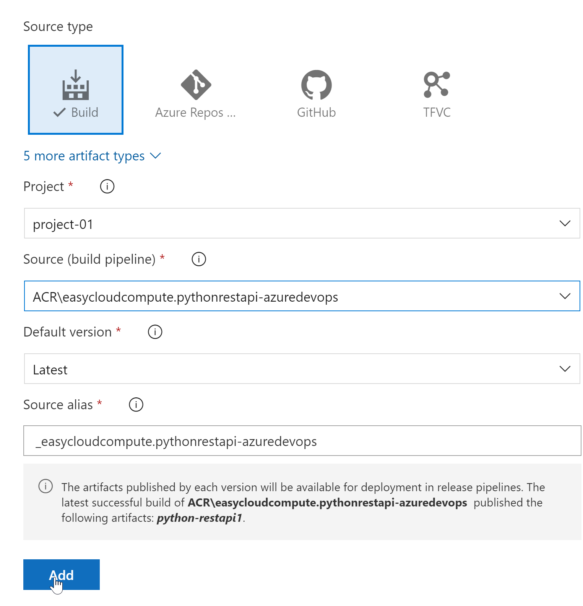

* Enable continuous deployment trigger that ensures that as soon as the CI / Starter pipeline has built an artifact , it trigger this new Release pipeline

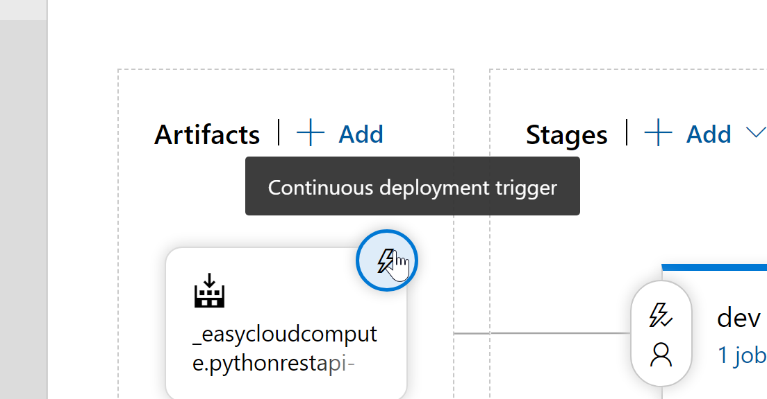

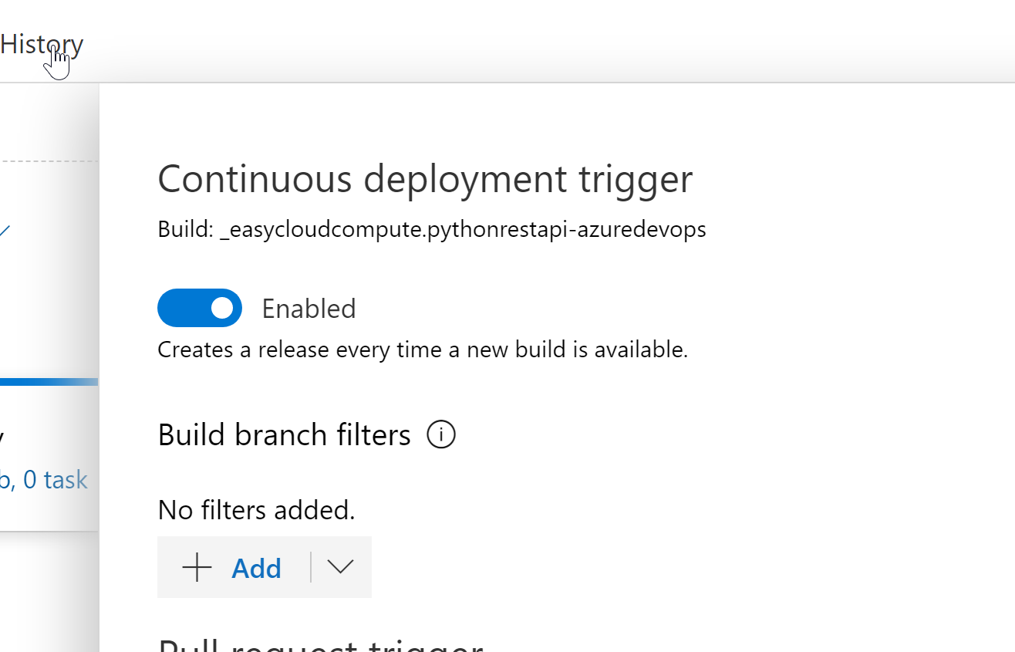

* Create a new dev stage as below

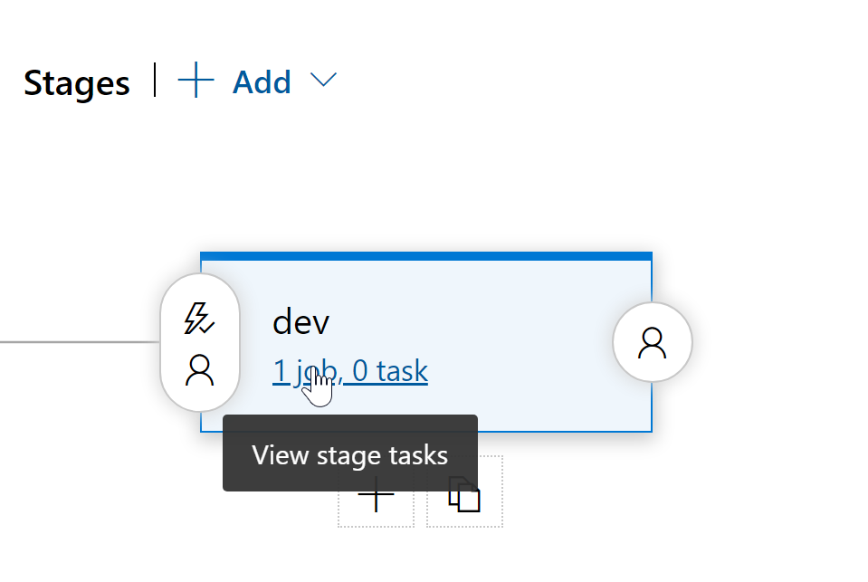

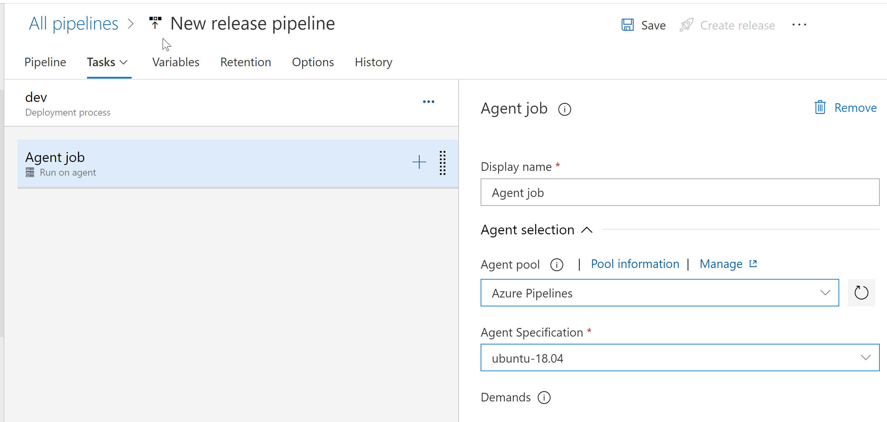

* Add a new task to Agent to create secret to allow to pull from ACR

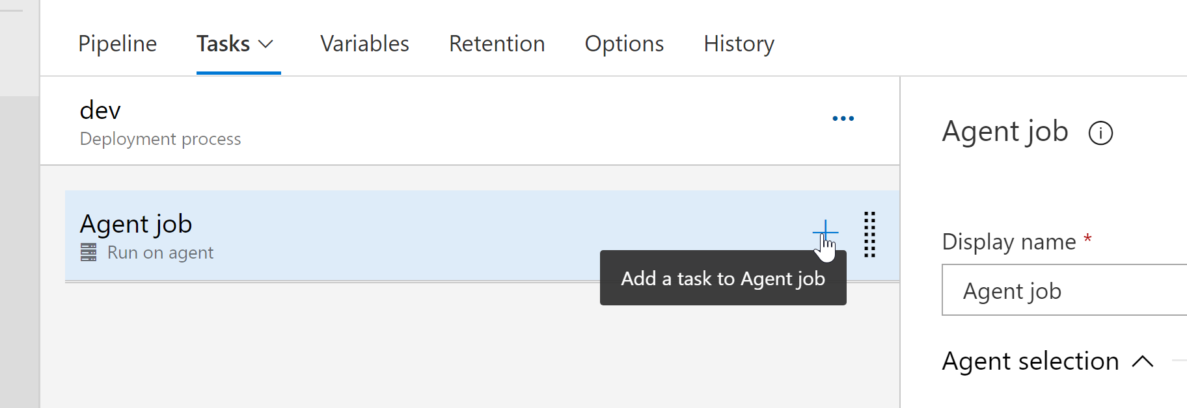

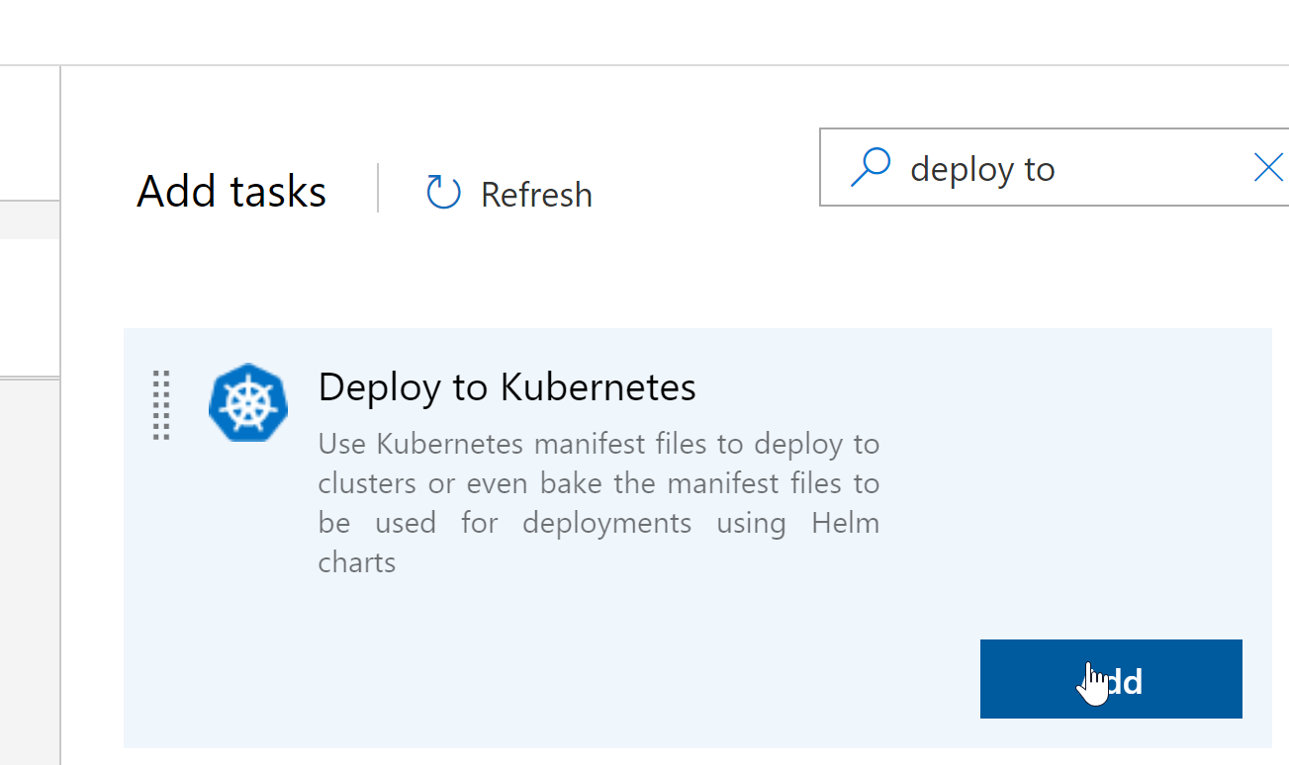

Enter below details and save

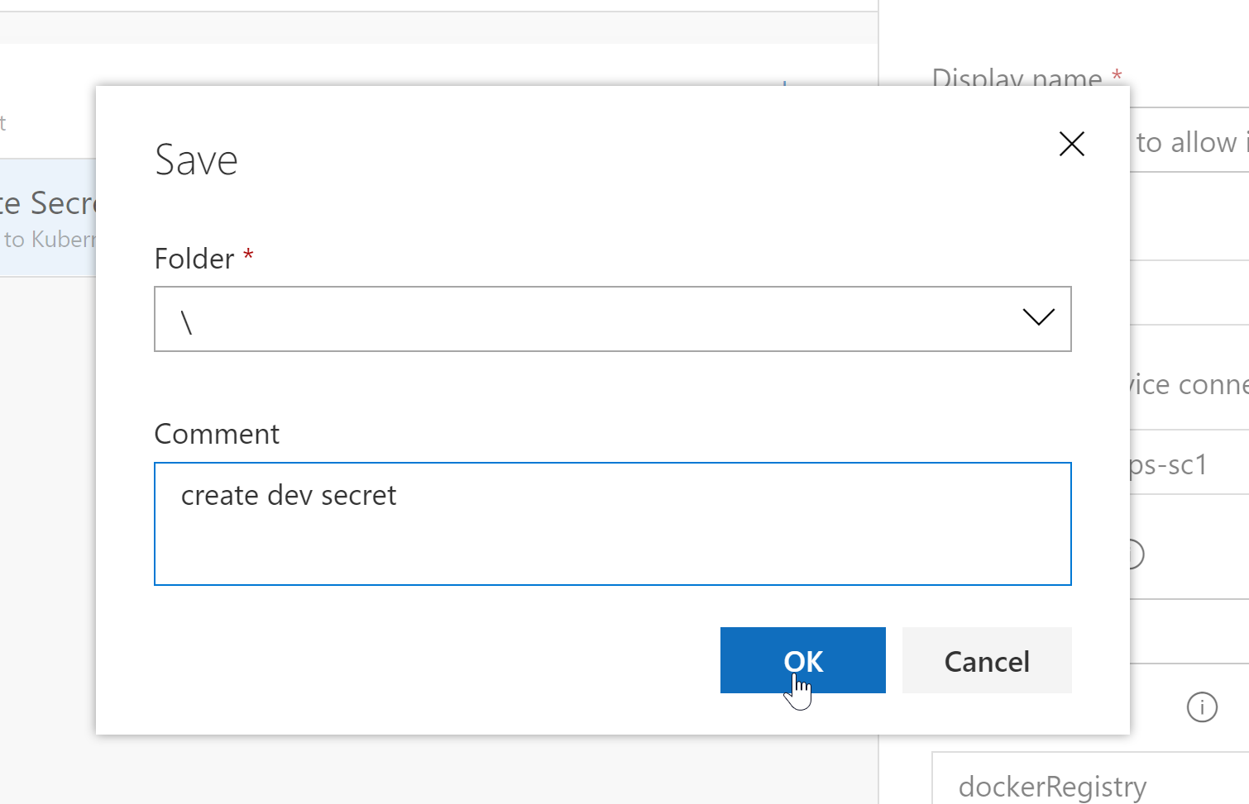

* Create another new task for deploying to AKS

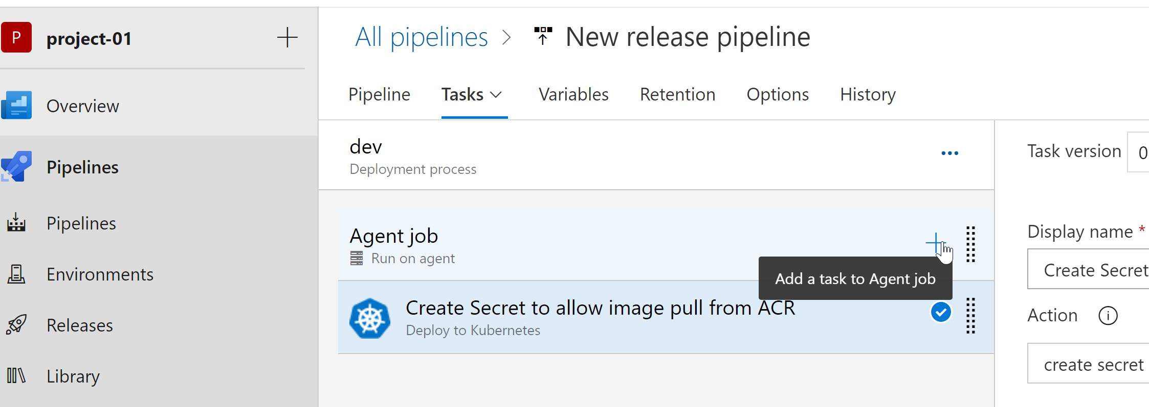

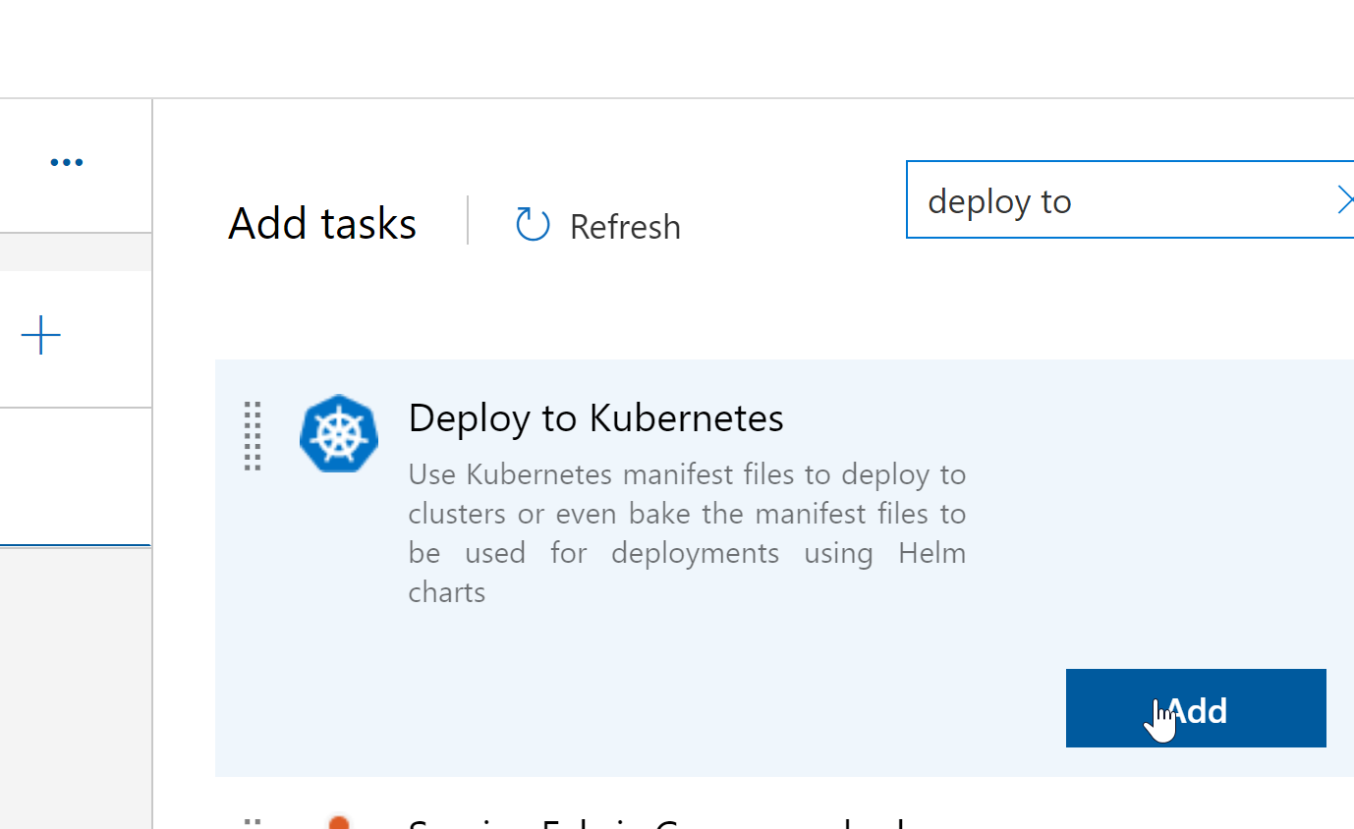

Select the artifact or manifest

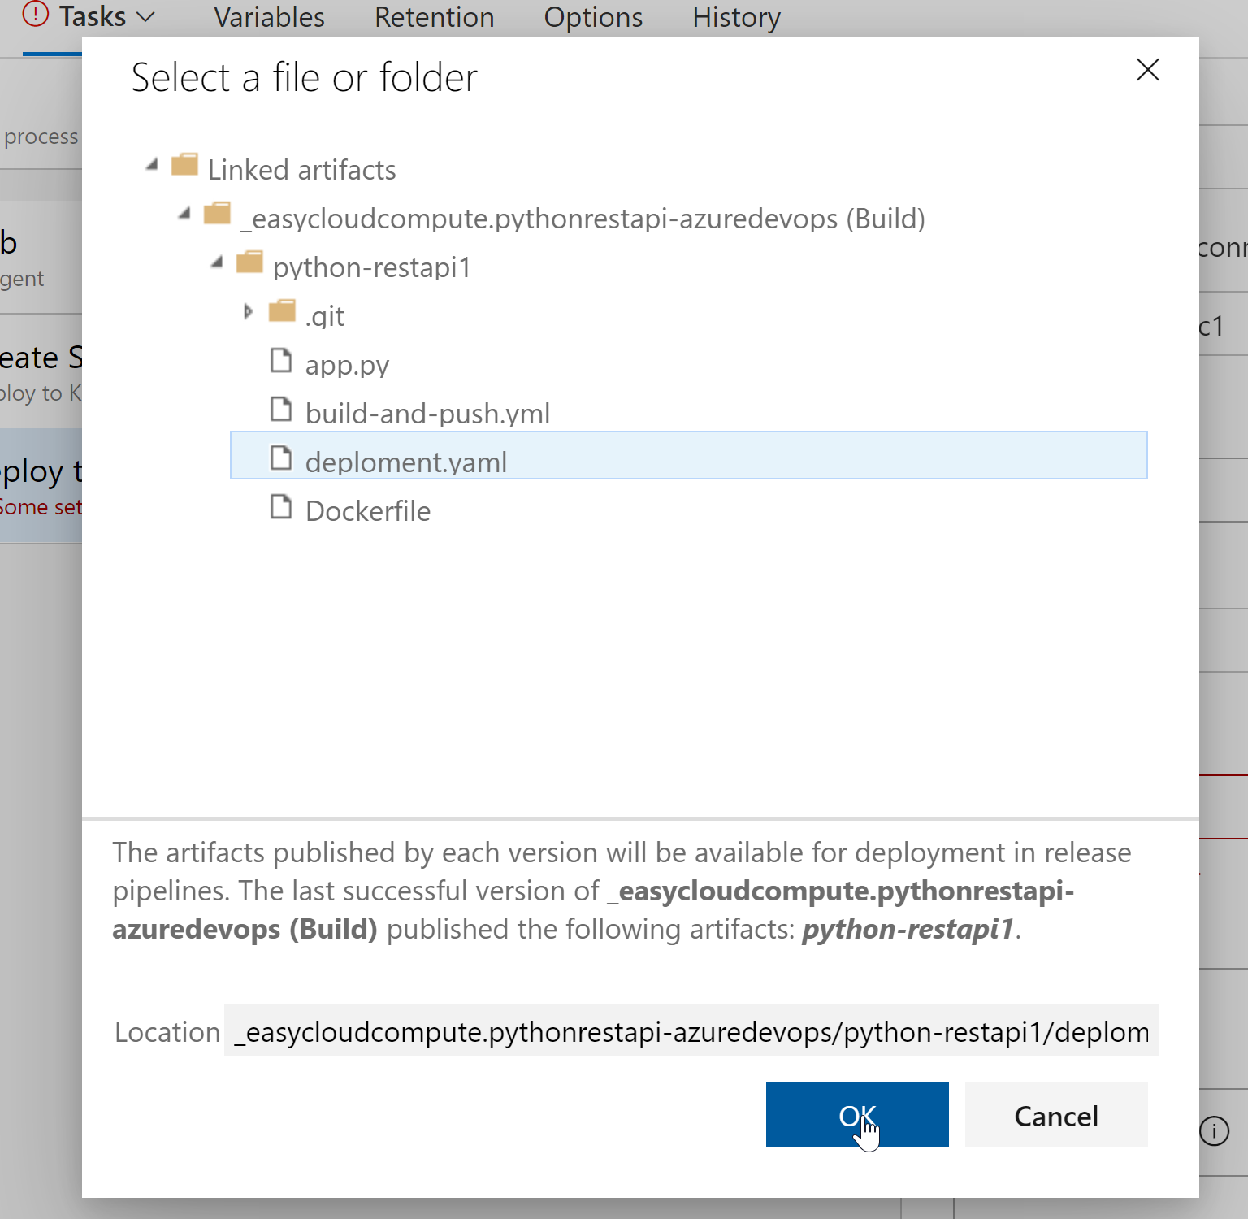

Enter below details and save

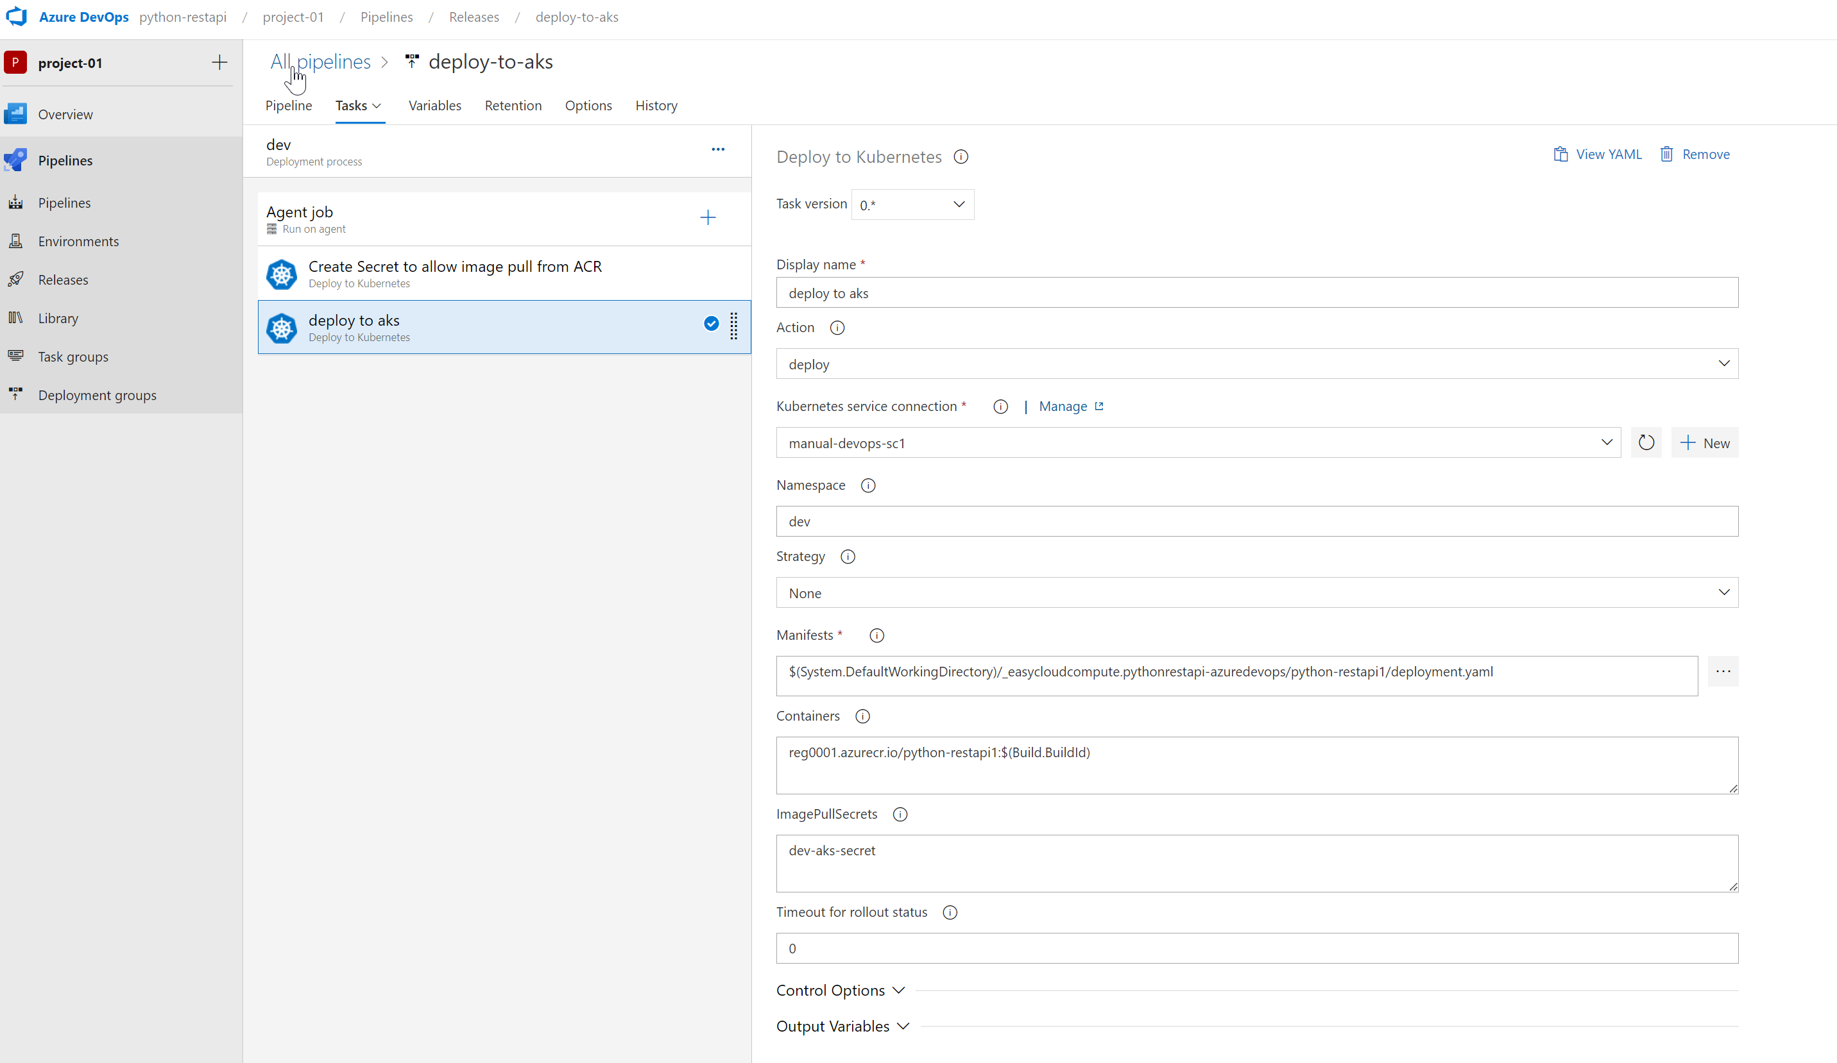

Save And Exit

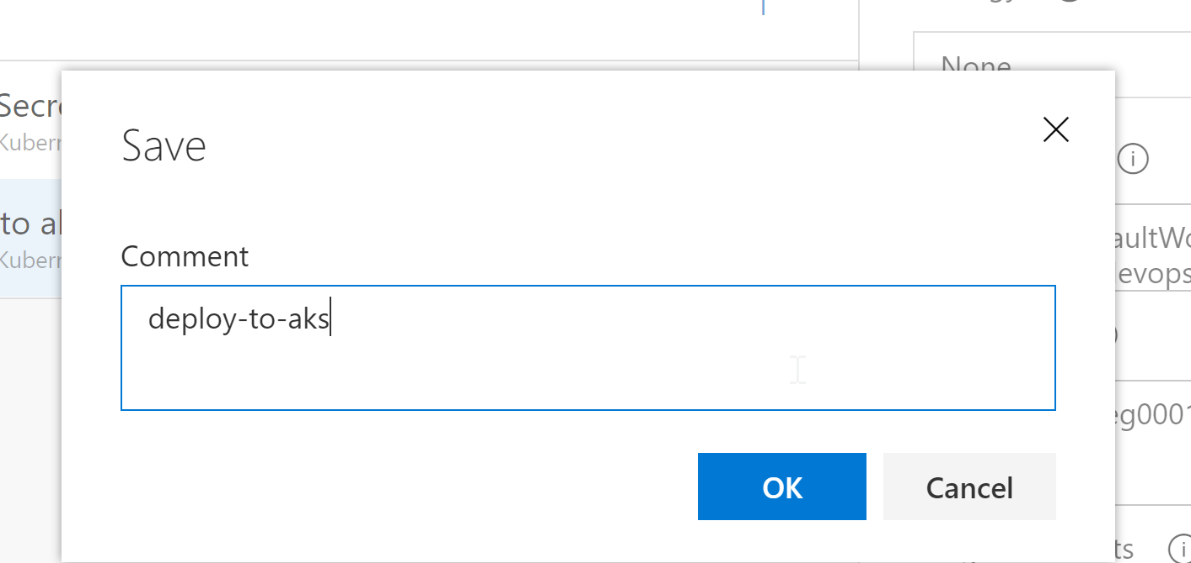

====================================================================================



* Rename pipeline and save

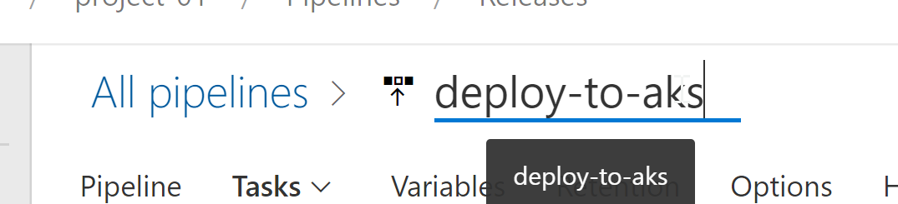

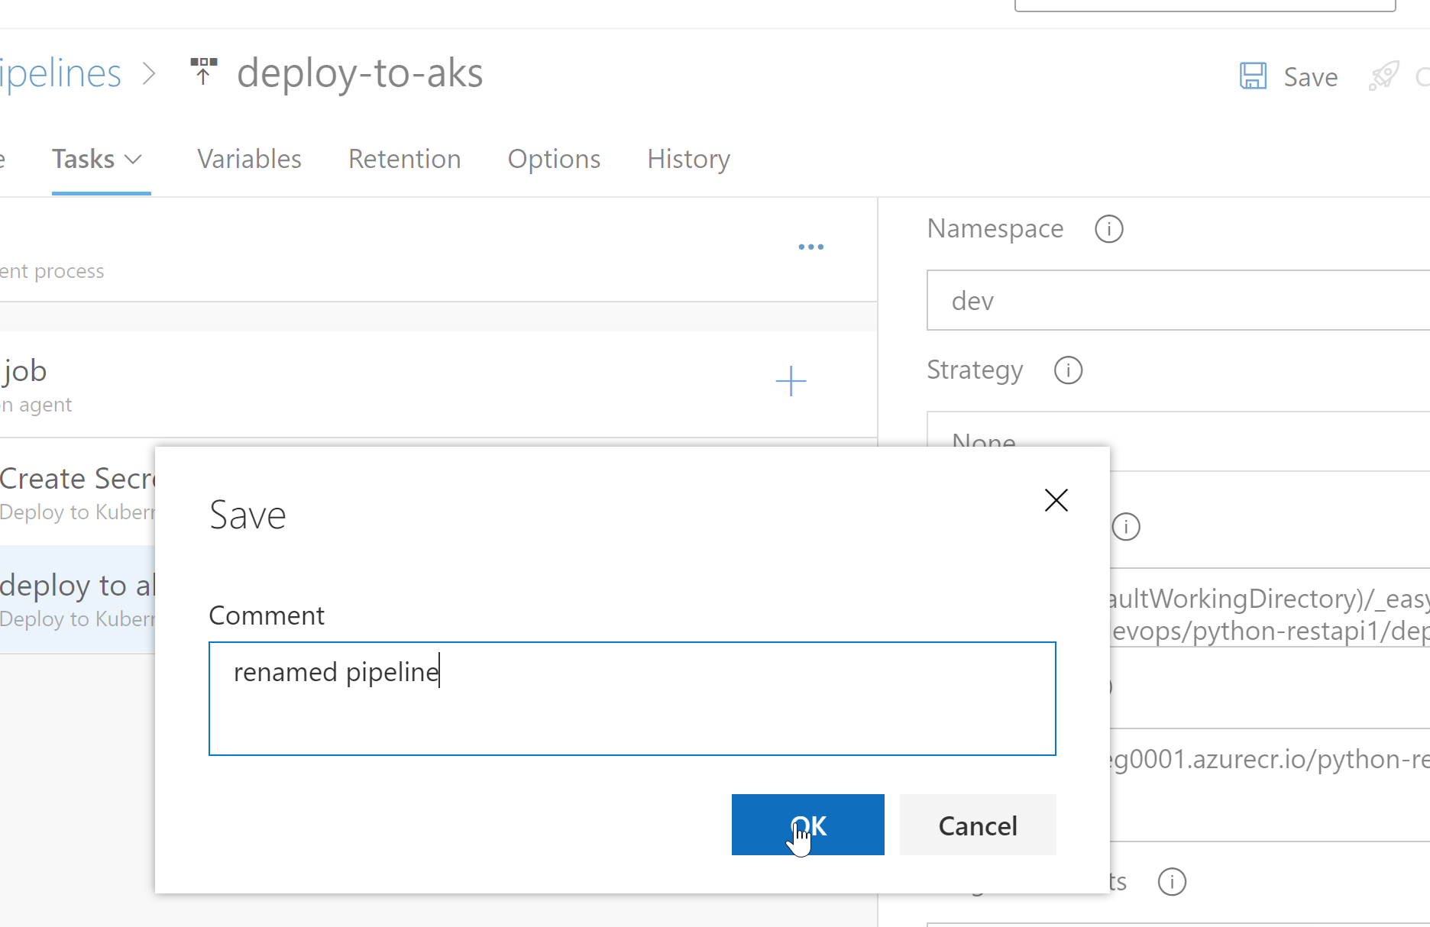

Verification

* Make any changes to github code and build pipeline will trigger
* This will trigger the release pipline that deploys the app finally

