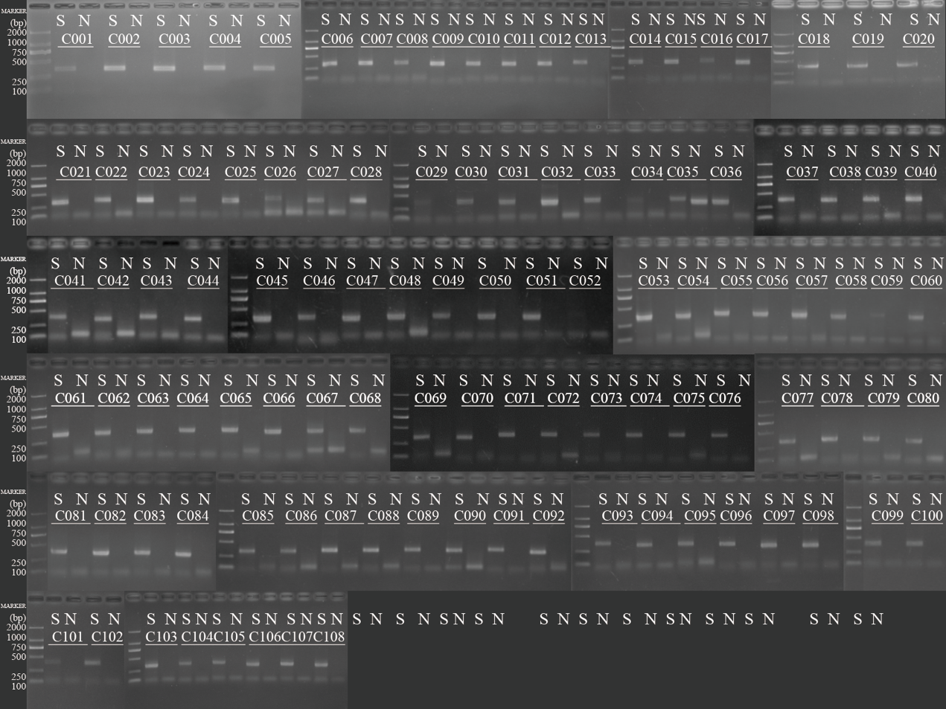
Figure S1 Amplification specificity and efficiencies validation of single primer pairs. S refers to the human genome DNA sample, and N refers to the water negative control. Primer pair ID were listed in Table S2.

